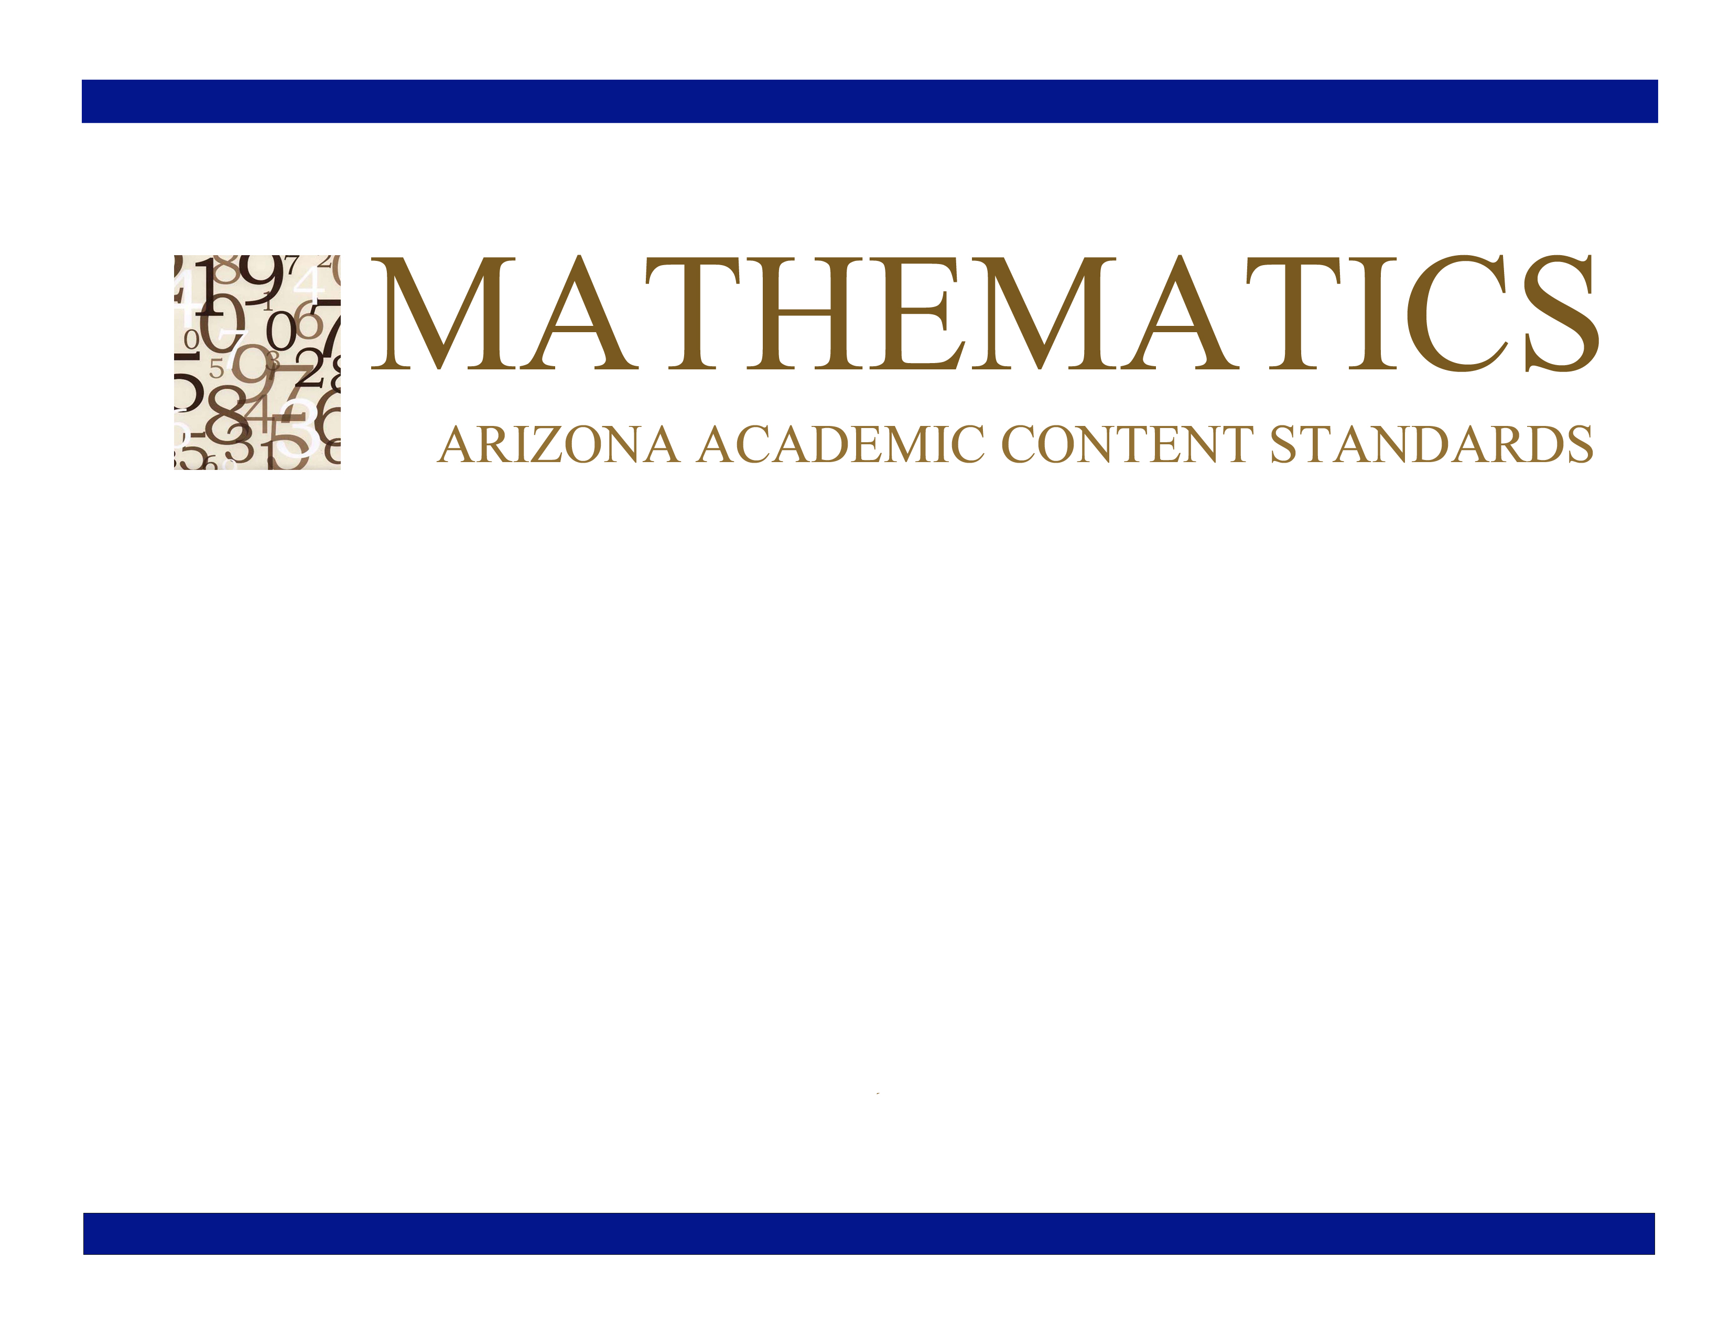
Grade 8

Approved by the Arizona State Board of Education
June 28, 2010

Grade 8

Grade 8 Overview

The Number System (NS)  - Know that there are numbers that are not rational, and approximate them by rational numbers.  Expressions and Equations (EE)  - Work with radicals and integer exponents.  - Understand the connections between proportional relationships, lines, and linear equations.  - Analyze and solve linear equations and pairs of simultaneous linear equations.  Functions (F)  - Define, evaluate, and compare functions.  - Use functions to model relationships between quantities.  Geometry (G)  - Understand congruence and similarity using physical models, transparencies, or geometry software.  - Understand and apply the Pythagorean Theorem.  - Solve real-world and mathematical problems involving volume of cylinders, cones and spheres.  Statistics and Probability (SP)  - Investigate patterns of association in bivariate data. | Mathematical Practices (MP)  - Make sense of problems and persevere in solving them.  - Reason abstractly and quantitatively.  - Construct viable arguments and critique the reasoning of others.  - Model with mathematics.  - Use appropriate tools strategically.  - Attend to precision.  - Look for and make use of structure.  - Look for and express regularity in repeated reasoning.

In Grade 8, instructional time should focus on three critical areas: (1) formulating and reasoning about expressions and equations, including modeling an association in bivariate data with a linear equation, and solving linear equations and systems of linear equations; (2) grasping the concept of a function and using functions to describe quantitative relationships; (3) analyzing two- and three-dimensional space and figures using distance, angle, similarity, and congruence, and understanding and applying the Pythagorean Theorem.

(1) Students use linear equations and systems of linear equations to represent, analyze, and solve a variety of problems. Students recognize equations for proportions (y/x = m or y = mx) as special linear equations (y = mx + b), understanding that the constant of proportionality (m) is the slope, and the graphs are lines through the origin. They understand that the slope (m) of a line is a constant rate of change, so that if the input or x-coordinate changes by an amount A, the output or y-coordinate changes by the amount m⋅A. Students also use a linear equation to describe the association between two quantities in bivariate data (such as arm span vs. height for students in a classroom). At this grade, fitting the model, and assessing its fit to the data are done informally. Interpreting the model in the context of the data requires students to express a relationship between the two quantities in question and to interpret components of the relationship (such as slope and y-intercept) in terms of the situation.

Students strategically choose and efficiently implement procedures to solve linear equations in one variable, understanding that when they use the properties of equality and the concept of logical equivalence, they maintain the solutions of the original equation. Students solve systems of two linear equations in two variables and relate the systems to pairs of lines in the plane; these intersect, are parallel, or are the same line. Students use linear equations, systems of linear equations, linear functions, and their understanding of slope of a line to analyze situations and solve problems.

(2) Students grasp the concept of a function as a rule that assigns to each input exactly one output. They understand that functions describe situations where one quantity determines another. They can translate among representations and partial representations of functions (noting that tabular and graphical representations may be partial representations), and they describe how aspects of the function are reflected in the different representations.

(3) Students use ideas about distance and angles, how they behave under translations, rotations, reflections, and dilations, and ideas about congruence and similarity to describe and analyze two-dimensional figures and to solve problems. Students show that the sum of the angles in a triangle is the angle formed by a straight line, and that various configurations of lines give rise to similar triangles because of the angles created when a transversal cuts parallel lines. Students understand the statement of the Pythagorean Theorem and its converse, and can explain why the Pythagorean Theorem holds, for example, by decomposing a square in two different ways. They apply the Pythagorean Theorem to find distances between points on the coordinate plane, to find lengths, and to analyze polygons. Students complete their work on volume by solving problems involving cones, cylinders, and spheres.

The Number System (NS)
Know that there are numbers that are not rational, and approximate them by rational numbers.
Standards | Mathematical Practices | Explanations and Examples
Students are expected to:
8.NS.1. Know that numbers that are not rational are called irrational. Understand informally that every number has a decimal expansion; for rational numbers show that the decimal expansion repeats eventually, and convert a decimal expansion which repeats eventually into a rational number.  Connections: 8.EE.4; 8.EE.7b; 6-8.RST.4;  6-8.RST.7 | 8.MP.2. Reason abstractly and quantitatively.  8.MP.6. Attend to precision.  8.MP.7. Look for and make use of structure. | Students can use graphic organizers to show the relationship between the subsets of the real number system.  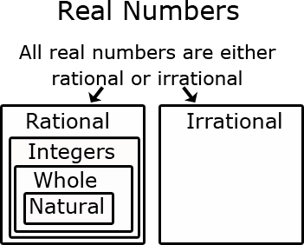
8.NS.2. Use rational approximations of irrational numbers to compare the size of irrational numbers, locate them approximately on a number line diagram, and estimate the value of expressions (e.g., π²). For example, by truncating the decimal expansion of √2, show that √2 is between 1and 2, then between 1.4 and 1.5, and explain how to continue on to get better approximations.  Connections: 8.G.7; 8.G.8; 6-8.RST.5;  ET08-S1C2-01 | 8.MP.2. Reason abstractly and quantitatively.  8.MP.4. Model with mathematics.  8.MP.7. Look for and make use of structure.  8.MP.8. Look for and express regularity in repeated reasoning. | Students can approximate square roots by iterative processes.  Examples:  - Approximate the value of to the nearest hundredth.  Solution: Students start with a rough estimate based upon perfect squares. falls between 2 and 3 because 5 falls between 2² = 4 and 3² = 9. The value will be closer to 2 than to 3. Students continue the iterative process with the tenths place value. falls between 2.2 and 2.3 because 5 falls between 2.2² = 4.84 and 2.3² = 5.29. The value is closer to 2.2. Further iteration shows that the value of is between 2.23 and 2.24 since 2.23² is 4.9729 and 2.24² is 5.0176.  Continued on next page  - Compare √2 and √3 by estimating their values, plotting them on a number line, and making comparative statements.  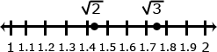  Solution: Statements for the comparison could include:  √2 is approximately 0.3 less than √3  √2 is between the whole numbers 1 and 2  √3 is between 1.7 and 1.8

Expressions and Equations (EE)
Work with radicals and integer exponents.
Standards | Mathematical Practices | Explanations and Examples
Students are expected to:
8.EE.1. Know and apply the properties of integer exponents to generate equivalent numerical expressions. For example, 3²×3^{–5} = 3^{–3} = 1/3³ = 1/27. | 8.MP.2. Reason abstractly and quantitatively.  8.MP.5. Use appropriate tools strategically.  8.MP.6. Attend to precision.  8.MP.7. Look for and make use of structure. | Examples:
8.EE.2. Use square root and cube root symbols to represent solutions to equations of the form x² = p and x³ = p, where p is a positive rational number. Evaluate square roots of small perfect squares and cube roots of small perfect cubes. Know that √2 is irrational.  Connections: 8.G.7; 8.G.8; 6-8.RST.4 | 8.MP.2. Reason abstractly and quantitatively.  8.MP.5. Use appropriate tools strategically.  8.MP.6. Attend to precision.  8.MP.7. Look for and make use of structure. | Examples:  - and  - and  - Solve  Solution:  - Solve  Solution:
8.EE.3. Use numbers expressed in the form of a single digit times an integer power of 10 to estimate very large or very small quantities, and to express how many times as much one is than the other. For example, estimate the population of the United States as 3×10⁸ and the population of the world as 7×10⁹, and determine that the world population is more than 20 times larger. | 8.MP.2. Reason abstractly and quantitatively.  8.MP.5. Use appropriate tools strategically.  8.MP.6. Attend to precision.
8.EE.4. Perform operations with numbers expressed in scientific notation, including problems where both decimal and scientific notation are used. Use scientific notation and choose units of appropriate size for measurements of very large or very small quantities (e.g., use millimeters per year for seafloor spreading). Interpret scientific notation that has been generated by technology.  Connections: 8.NS.1; 8.EE.1; ET08-S6C1-03 | 8.MP.2. Reason abstractly and quantitatively.  8.MP.5. Use appropriate tools strategically.  8.MP.6. Attend to precision. | Students can convert decimal forms to scientific notation and apply rules of exponents to simplify expressions. In working with calculators or spreadsheets, it is important that students recognize scientific notation. Students should recognize that the output of 2.45E+23 is 2.45 x 10²³ and 3.5E-4 is 3.5 x 10⁻⁴. Students enter scientific notation using E or EE (scientific notation), * (multiplication), and ^ (exponent) symbols.

Expressions and Equations (EE)
Understand the connections between proportional relationships, lines, and linear equations
Standards | Mathematical Practices | Explanations and Examples
Students are expected to:
8.EE.5. Graph proportional relationships, interpreting the unit rate as the slope of the graph. Compare two different proportional relationships represented in different ways. For example, compare a distance-time graph to a distance-time equation to determine which of two moving objects has greater speed.  Connections: 8.F.2; 8.F.3; 6-8.RST.7; 6-8.WHST.2b; SC08-S5C2-01; SC08-S5C2-05 | 8.MP.1. Make sense of problems and persevere in solving them.  8.MP.2. Reason abstractly and quantitatively.  8.MP.3. Construct viable arguments and critique the reasoning of others.  8.MP.4. Model with mathematics.  8.MP.5. Use appropriate tools strategically.  8.MP.6. Attend to precision.  8.MP.7. Look for and make use of structure.  8.MP.8. Look for and express regularity in repeated reasoning. | Using graphs of experiences that are familiar to students increases accessibility and supports understanding and interpretation of proportional relationship. Students are expected to both sketch and interpret graphs.  Example:  - Compare the scenarios to determine which represents a greater speed. Include a description of each scenario including the unit rates in your explanation.  Scenario 1: Scenario 2:  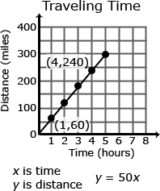  y = 50x  x is time in hours  y is distance in miles
8.EE.6. Use similar triangles to explain why the slope m is the same between any two distinct points on a non-vertical line in the coordinate plane; derive the equation y = mx for a line through the origin and the equation y = mx + b for a line intercepting the vertical axis at b.  Connections: 8.F.3; 8.G.4; 6-8.RST.3;  6-8.WHST.1b; ET08-S1C2-01; ET08-S6C1-03 | 8.MP.2. Reason abstractly and quantitatively.  8.MP.3. Construct viable arguments and critique the reasoning of others.  8.MP.4. Model with mathematics.  8.MP.5. Use appropriate tools strategically.  8.MP.7. Look for and make use of structure.  8.MP.8. Look for and express regularity in repeated reasoning. | Example:  - Explain why is similar to, and deduce that has the same slope as. Express each line as an equation.  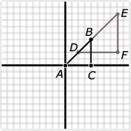

Expressions and Equations (EE)
Analyze and solve linear equations and pairs of simultaneous linear equations.
Standards | Mathematical Practices | Explanations and Examples
Students are expected to:
8.EE.7. Solve linear equations in one variable.  - Give examples of linear equations in one variable with one solution, infinitely many solutions, or no solutions. Show which of these possibilities is the case by successively transforming the given equation into simpler forms, until an equivalent equation of the form x = a, a = a, or a = b results (where a and b are different numbers).  - Solve linear equations with rational number coefficients, including equations whose solutions require expanding expressions using the distributive property and collecting like terms.  Connections: 8.F.3; 8.NS.1; 6-8.RST.3;  ET08-S1C3-01 | 8.MP.2. Reason abstractly and quantitatively.  8.MP.5. Use appropriate tools strategically.  8.MP.6. Attend to precision.  8.MP.7. Look for and make use of structure. | As students transform linear equations in one variable into simpler forms, they discover the equations can have one solution, infinitely many solutions, or no solutions.  When the equation has one solution, the variable has one value that makes the equation true as in 12-4y=16. The only value for y that makes this equation true is -1.  When the equation has infinitely many solutions, the equation is true for all real numbers as in 7x + 14 = 7 (x+2). As this equation is simplified, the variable terms cancel leaving 14 = 14 or 0 = 0. Since the expressions are equivalent, the value for the two sides of the equation will be the same regardless which real number is used for the substitution.  When an equation has no solutions it is also called an inconsistent equation. This is the case when the two expressions are not equivalent as in 5x - 2 = 5(x+1). When simplifying this equation, students will find that the solution appears to be two numbers that are not equal or -2 = 1. In this case, regardless which real number is used for the substitution, the equation is not true and therefore has no solution.  Examples:  - Solve for x:  - Solve:
8.EE.8. Analyze and solve pairs of simultaneous linear equations.  - Understand that solutions to a system of two linear equations in two variables correspond to points of intersection of their graphs, because points of intersection satisfy both equations simultaneously.  - Solve systems of two linear equations in two variables algebraically, and estimate solutions by graphing the equations. Solve simple cases by inspection. For example, 3x + 2y = 5 and 3x + 2y = 6 have no solution because 3x + 2y cannot simultaneously be 5 and 6.  - Solve real-world and mathematical problems leading to two linear equations in two variables. For example, given coordinates for two pairs of points, determine whether the line through the first pair of points intersects the line through the second pair.  Connections: 6-8.RST.7; ET08-S1C2-01;  ET08-S1C2-02 | 8.MP.1. Make sense of problems and persevere in solving them.  8.MP.2. Reason abstractly and quantitatively.  8.MP.3. Construct viable arguments and critique the reasoning of others.  8.MP.4. Model with mathematics.  8.MP.5. Use appropriate tools strategically.  8.MP.6. Attend to precision.  8.MP.7. Look for and make use of structure.  8.MP.8. Look for and express regularity in repeated reasoning. | Systems of linear equations can also have one solution, infinitely many solutions or no solutions. Students will discover these cases as they graph systems of linear equations and solve them algebraically.  A system of linear equations whose graphs meet at one point (intersecting lines) has only one solution, the ordered pair representing the point of intersection. A system of linear equations whose graphs do not meet (parallel lines) has no solutions and the slopes of these lines are the same. A system of linear equations whose graphs are coincident (the same line) has infinitely many solutions, the set of ordered pairs representing all the points on the line.  By making connections between algebraic and graphical solutions and the context of the system of linear equations, students are able to make sense of their solutions. Students need opportunities to work with equations and context that include whole number and/or decimals/fractions.  Examples:  - Find x and y using elimination and then using substitution.  3x + 4y = 7  -2x + 8y = 10  - Plant A and Plant B are on different watering schedules. This affects their rate of growth. Compare the growth of the two plants to determine when their heights will be the same.  Let W = number of weeks  Let H = height of the plant after W weeks  Continued on next page  - Given each set of coordinates, graph their corresponding lines.  Solution:  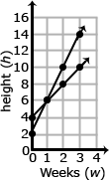  - Write an equation that represent the growth rate of Plant A and Plant B.  Solution:  Plant A H = 2W + 4  Plant B H = 4W + 2  - At which week will the plants have the same height?  Solution:  The plants have the same height after one week.  Plant A: H = 2W + 4 Plant B: H = 4W + 2  Plant A: H = 2(1) + 4 Plant B: H = 4(1) + 2  Plant A: H = 6 Plant B: H = 6  After one week, the height of Plant A and Plant B are both 6 inches.
  Plant A |  |  |  | Plant B
  W | H |  |  | W | H
  0 | 4 | (0,4) |  | 0 | 2 | (0,2)
  1 | 6 | (1,6) |  | 1 | 6 | (1,6)
  2 | 8 | (2,8) |  | 2 | 10 | (2,10)
  3 | 10 | (3,10) |  | 3 | 14 | (3,14)

Functions (F)
Define, evaluate, and compare functions.
Standards | Mathematical Practices | Explanations and Examples
Students are expected to:
8.F.1. Understand that a function is a rule that assigns to each input exactly one output. The graph of a function is the set of ordered pairs consisting of an input and the corresponding output. (Function notation is not required in Grade 8.)  Connection: SC08-S5C2-05 | 8.MP.2. Reason abstractly and quantitatively.  8.MP.6. Attend to precision. | For example, the rule that takes x as input and gives x²+5x+4 as output is a function. Using y to stand for the output we can represent this function with the equation y = x²+5x+4, and the graph of the equation is the graph of the function. Students are not yet expected use function notation such as f(x) = x²+5x+4.
8.F.2. Compare properties of two functions each represented in a different way (algebraically, graphically, numerically in tables, or by verbal descriptions). For example, given a linear function represented by a table of values and a linear function represented by an algebraic expression, determine which function has the greater rate of change.  Connections: 8.EE.5; 8.F.2; 6-8.RST.7;  6-8.WHST.1b; ET08-S1C3-01 | 8.MP.1. Make sense of problems and persevere in solving them.  8.MP.2. Reason abstractly and quantitatively.  8.MP.3. Construct viable arguments and critique the reasoning of others.  8.MP.4. Model with mathematics.  8.MP.5. Use appropriate tools strategically.  8.MP.6. Attend to precision.  8.MP.7. Look for and make use of structure.  8.MP.8. Look for and express regularity in repeated reasoning. | Examples:  - Compare the two linear functions listed below and determine which equation represents a greater rate of change.  Function 2:  The function whose input x and output y are related by  y = 3x + 7  Function 1:  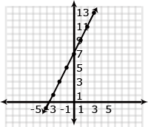  Continued on next page  - Compare the two linear functions listed below and determine which has a negative slope.  Function 1: Gift Card  Samantha starts with $20 on a gift card for the book store. She spends $3.50 per week to buy a magazine. Let y be the amount remaining as a function of the number of weeks, x.  Function 2:  The school bookstore rents graphing calculators for $5 per month. It also collects a non-refundable fee of $10.00 for the school year. Write the rule for the total cost (c) of renting a calculator as a function of the number of months (m).  Solution:  Function 1 is an example of a function whose graph has negative slope. Samantha starts with $20 and spends money each week. The amount of money left on the gift card decreases each week. The graph has a negative slope of -3.5, which is the amount the gift card balance decreases with Samantha’s weekly magazine purchase. Function 2 is an example of a function whose graph has positive slope. Students pay a yearly nonrefundable fee for renting the calculator and pay $5 for each month they rent the calculator. This function has a positive slope of 5 which is the amount of the monthly rental fee. An equation for Example 2 could be c = 5m + 10.
  x | y
  0 | 20
  1 | 16.50
  2 | 13.00
  3 | 9.50
  4 | 6.00
8.F.3. Interpret the equation y = mx + b as defining a linear function, whose graph is a straight line; give examples of functions that are not linear. For example, the function A = s² giving the area of a square as a function of its side length is not linear because its graph contains the points (1,1), (2,4) and (3,9), which are not on a straight line.  Connections: 8.EE.5; 8.EE.7a ; 6-8.WHST.1b; ET08-S6C1-03 | 8.MP.2. Reason abstractly and quantitatively.  8.MP.4. Model with mathematics.  8.MP.5. Use appropriate tools strategically.  8.MP.6. Attend to precision.  8.MP.7. Look for and make use of structure. | Example:  - Determine which of the functions listed below are linear and which are not linear and explain your reasoning.  - y = -2x² + 3 non linear  - y = 2x linear  - A = πr² non linear  - y = 0.25 + 0.5(x – 2) linear

Functions (F)
Use functions to model relationships between quantities.
Standards | Mathematical Practices | Explanations and Examples
Students are expected to:
8.F.4. Construct a function to model a linear relationship between two quantities. Determine the rate of change and initial value of the function from a description of a relationship or from two (x, y) values, including reading these from a table or from a graph. Interpret the rate of change and initial value of a linear function in terms of the situation it models, and in terms of its graph or a table of values.  Connections: 8.EE.5; 8.SP2; 8.SP.3;  ET08-S1C2-01; SC08-S5C2-01;  SC08-S1C3-02 | 8.MP.1. Make sense of problems and persevere in solving them.  8.MP.2. Reason abstractly and quantitatively.  8.MP.3. Construct viable arguments and critique the reasoning of others.  8.MP.4. Model with mathematics.  8.MP.5. Use appropriate tools strategically.  8.MP.6. Attend to precision.  8.MP.7. Look for and make use of structure.  8.MP.8. Look for and express regularity in repeated reasoning. | Examples:  - The table below shows the cost of renting a car. The company charges $45 a day for the car as well as charging a one-time $25 fee for the car’s navigation system (GPS).Write an expression for the cost in dollars, c, as a function of the number of days, d.  Students might write the equation c = 45d + 25 using the verbal description or by first making a table.  Students should recognize that the rate of change is 45 (the cost of renting the car) and that initial cost (the first day charge) also includes paying for the navigation system. Classroom discussion about one time fees vs. recurrent fees will help students model contextual situations.  - When scuba divers come back to the surface of the water, they need to be careful not to ascend too quickly. Divers should not come to the surface more quickly than a rate of 0.75 ft per second. If the divers start at a depth of 100 feet, the equation d = 0.75t – 100 shows the relationship between the time of the ascent in seconds (t) and the distance from the surface in feet (d).  - Will they be at the surface in 5 minutes? How long will it take the divers to surface from their dive?  - Make a table of values showing several times and the corresponding distance of the divers from the surface. Explain what your table shows. How do the values in the table relate to your equation?
  Days (d) | Cost (c) in dollars
  1 | 70
  2 | 115
  3 | 160
  4 | 205
8.F.5. Describe qualitatively the functional relationship between two quantities by analyzing a graph (e.g., where the function is increasing or decreasing, linear or nonlinear). Sketch a graph that exhibits the qualitative features of a function that has been described verbally.  Connections: 6-8.WHST.2a-f; ET08-S1C2-01; SC08-S5C2-05 | 8.MP.2. Reason abstractly and quantitatively.  8.MP.3. Construct viable arguments and critique the reasoning of others.  8.MP.4. Model with mathematics.  8.MP.5. Use appropriate tools strategically.  8.MP.6. Attend to precision.  8.MP.7. Look for and make use of structure. | Example:  - The graph below shows a student’s trip to school. This student walks to his friend’s house and, together, they ride a bus to school. The bus stops once before arriving at school.  Describe how each part A-E of the graph relates to the story.  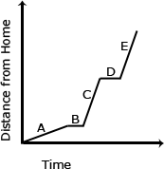

Geometry (G)
Understand congruence and similarity using physical models, transparencies, or geometry software.
Standards | Mathematical Practices | Explanations and Examples
Students are expected to:
8.G.1. Verify experimentally the properties of rotations, reflections, and translations:  - Lines are taken to lines, and line segments to line segments of the same length.  - Angles are taken to angles of the same measure.  - Parallel lines are taken to parallel lines. | 8.MP.4. Model with mathematics.  8.MP.5. Use appropriate tools strategically.  8.MP.6. Attend to precision.  8.MP.7. Look for and make use of structure.  8.MP.8. Look for and express regularity in repeated reasoning. | Students need multiple opportunities to explore the transformation of figures so that they can appreciate that points stay the same distance apart and lines stay at the same angle after they have been rotated, reflected, and/or translated.  Students are not expected to work formally with properties of dilations until high school.
8.G.2. Understand that a two-dimensional figure is congruent to another if the second can be obtained from the first by a sequence of rotations, reflections, and translations; given two congruent figures, describe a sequence that exhibits the congruence between them.  Connections: 6-8.WHST.2b,f; ET08-S6C1-03 | 8.MP.2. Reason abstractly and quantitatively.  8.MP.4. Model with mathematics.  8.MP.6. Attend to precision.  8.MP.7. Look for and make use of structure. | Examples:  - Is Figure A congruent to Figure A’? Explain how you know.  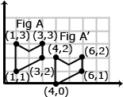  - Describe the sequence of transformations that results in the transformation of Figure A to Figure A’.  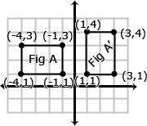
8.G.3. Describe the effect of dilations, translations, rotations, and reflections on two-dimensional figures using coordinates.  Connections: 6-8.WHST.2b,f; ET08-S6C1-03 | 8.MP.3. Construct viable arguments and critique the reasoning of others.  8.MP.4. Model with mathematics.  8.MP.5. Use appropriate tools strategically.  8.MP.6. Attend to precision.  8.MP.7. Look for and make use of structure. | A dilation is a transformation that moves each point along a ray emanating from a fixed center, and multiplies distances from the center by a common scale factor. In dilated figures, the dilated figure is similar to its pre-image.  Translation: A translation is a transformation of an object that moves the object so that every point of the object moves in the same direction as well as the same distance. In a translation, the translated object is congruent to its pre-image. has been translated 7 units to the right and 3 units up. To get from A (1,5) to A’ (8,8), move A 7 units to the right (from x = 1 to x = 8) and 3 units up (from y = 5 to y = 8). Points B + C also move in the same direction (7 units to the right and 3 units up).  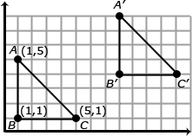  Reflection: A reflection is a transformation that flips an object across a line of reflection (in a coordinate grid the line of reflection may be the x or y axis). In a rotation, the rotated object is congruent to its pre-image.  Continued on next page 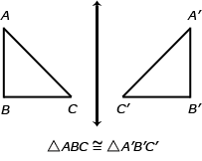  When an object is reflected across the y axis, the reflected x coordinate is the opposite of the pre-image x coordinate.  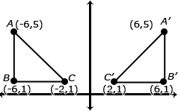  Rotation: A rotated figure is a figure that has been turned about a fixed point. This is called the center of rotation. A figure can be rotated up to 360˚. Rotated figures are congruent to their pre-image figures.  Consider when is rotated 180˚ clockwise about the origin. The coordinates of are D(2,5), E(2,1), and F(8,1). When rotated 180˚, has new coordinates D’(-2,-5), E’(-2,-1) and F’(-8,-1). Each coordinate is the opposite of its pre-image.  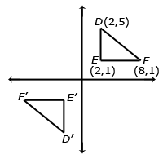
8.G.4. Understand that a two-dimensional figure is similar to another if the second can be obtained from the first by a sequence of rotations, reflections, translations, and dilations; given two similar two-dimensional figures, describe a sequence that exhibits the similarity between them.  Connections: 8.EE.6; 6-8.WHST.2b,f;  ET08-S6C1-03; ET08-S1C1-01 | 8.MP.2. Reason abstractly and quantitatively.  8.MP.4. Model with mathematics.  8.MP.5. Use appropriate tools strategically.  8.MP.6. Attend to precision.  8.MP.7. Look for and make use of structure. | Examples:  - Is Figure A similar to Figure A’? Explain how you know.  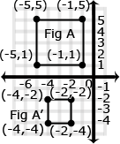  - Describe the sequence of transformations that results in the transformation of Figure A to Figure A’.  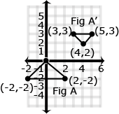
8.G.5. Use informal arguments to establish facts about the angle sum and exterior angle of triangles, about the angles created when parallel lines are cut by a transversal, and the angle-angle criterion for similarity of triangles. For example, arrange three copies of the same triangle so that the sum of the three angles appears to form a line, and give an argument in terms of transversals why this is so.  Connections: 6-8.WHST.2b,f; 6-8.WHST.1b; ET08-S6C1-03; ET08-S1C1-01; ET08-S1C3-03 | 8.MP.3. Construct viable arguments and critique the reasoning of others.  8.MP.4. Model with mathematics.  8.MP.5. Use appropriate tools strategically.  8.MP.6. Attend to precision.  8.MP.7. Look for and make use of structure. | - Examples: Students can informally prove relationships with transversals.  Show that m$∠3$ + m + m = 180˚ if l and m are parallel lines and t₁ & t₂ are transversals.  + + = 180˚. Angle 1 and Angle 5 are congruent because they are corresponding angles (). can be substituted for .  : because alternate interior angles are congruent.  can be substituted for  Therefore m + m + m = 180˚  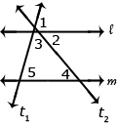  Continued on next page  Students can informally conclude that the sum of a triangle is 180º (the angle-sum theorem) by applying their understanding of lines and alternate interior angles. In the figure below, line x is parallel to line yz:  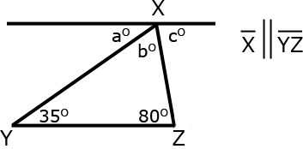  Angle a is 35º because it alternates with the angle inside the triangle that measures 35º. Angle c is 80º because it alternates with the angle inside the triangle that measures 80º. Because lines have a measure of 180º, and angles a + b + c form a straight line, then angle b must be 65 º (180 – 35 + 80 = 65). Therefore, the sum of the angles of the triangle are 35º + 65 º + 80 º

Geometry (G)
Understand and apply the Pythagorean Theorem.
Standards | Mathematical Practices | Explanations and Examples
Students are expected to:
8.G.6. Explain a proof of the Pythagorean Theorem and its converse.  Connections: 6-8.WHST.2a-f; ET08-S1C2-01 | 8.MP.3. Construct viable arguments and critique the reasoning of others.  8.MP.4. Model with mathematics.  8.MP.6. Attend to precision.  8.MP.7. Look for and make use of structure. | Students should verify, using a model, that the sum of the squares of the legs is equal to the square of the hypotenuse in a right triangle. Students should also understand that if the sum of the squares of the 2 smaller legs of a triangle is equal to the square of the third leg, then the triangle is a right triangle.
8.G.7. Apply the Pythagorean Theorem to determine unknown side lengths in right triangles in real-world and mathematical problems in two and three dimensions.  Connections: 8.NS.2; ET08-S2C2-01 | 8.MP.1. Make sense of problems and persevere in solving them.  8.MP.2. Reason abstractly and quantitatively.  8.MP.4. Model with mathematics.  8.MP.5. Use appropriate tools strategically.  8.MP.6. Attend to precision.  8.MP.7. Look for and make use of structure. | Through authentic experiences and exploration, students should use the Pythagorean Theorem to solve problems. Problems can include working in both two and three dimensions. Students should be familiar with the common Pythagorean triplets.
8.G.8. Apply the Pythagorean Theorem to find the distance between two points in a coordinate system.  Connections: 8.NS.2; ET08-S6C1-03 | 8.MP.1. Make sense of problems and persevere in solving them.  8.MP.2. Reason abstractly and quantitatively.  8.MP.4. Model with mathematics.  8.MP.5. Use appropriate tools strategically.  8.MP.6. Attend to precision.  8.MP.7. Look for and make use of structure. | Example:  - Students will create a right triangle from the two points given (as shown in the diagram below) and then use the Pythagorean Theorem to find the distance between the two given points.  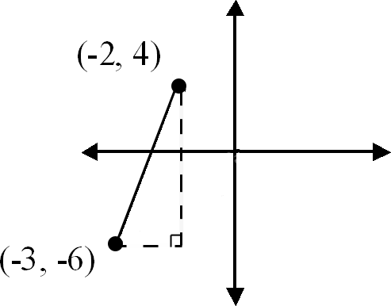

Geometry (G)
Solve real-world and mathematical problems involving volume of cylinders, cones, and spheres
Standards | Mathematical Practices | Explanations and Examples
Students are expected to:
8.G.9. Know the formulas for the volumes of cones, cylinders, and spheres and use them to solve real-world and mathematical problems.  Connections: 6-8.RST.3; 6-8.RST.7;  ET08-S2C2-01; ET08-S1C4-01 | 8.MP.1. Make sense of problems and persevere in solving them.  8.MP.2. Reason abstractly and quantitatively.  8.MP.3. Construct viable arguments and critique the reasoning of others.  8.MP.4. Model with mathematics.  8.MP.5. Use appropriate tools strategically.  8.MP.6. Attend to precision.  8.MP.7. Look for and make use of structure.  8.MP.8. Look for and express regularity in repeated reasoning. | Example:  - James wanted to plant pansies in his new planter. He wondered how much potting soil he should buy to fill it. Use the measurements in the diagram below to determine the planter’s volume.  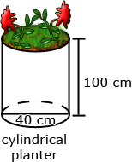

Statistics and Probability (SP)
Investigate patterns of association in bivariate data.
Standards | Mathematical Practices | Explanations and Examples
Students are expected to:
8.SP.1. Construct and interpret scatter plots for bivariate measurement data to investigate patterns of association between two quantities. Describe patterns such as clustering, outliers, positive or negative association, linear association, and nonlinear association.  Connections: 6-8.WHST.2b,f; ET08-S1C3-01; ET08-S1C3-02; ET08-S6C1-03;  SS08-S4C1-01;SS08-S4C2-03;  SS08-S4C1-05; SC08-S1C3-02;  SC08-S1C3-03 | 8.MP.2. Reason abstractly and quantitatively.  8.MP.4. Model with mathematics.  8.MP.5. Use appropriate tools strategically.  8.MP.6. Attend to precision.  8.MP.7. Look for and make use of structure. | Students build on their previous knowledge of scatter plots examine relationships between variables. They analyze scatterplots to determine positive and negative associations, the degree of association, and type of association. Students examine outliers to determine if data points are valid or represent a recording or measurement error. Students can use tools such as those at the National Center for Educational Statistics to create a graph or generate data sets. (http://nces.ed.gov/nceskids/createagraph/default.aspx)  Examples:  - Data for 10 students’ Math and Science scores are provided in the chart. Describe the association between the Math and Science scores.  - Data for 10 students’ Math scores and the distance they live from school are provided in the table below. Describe the association between the Math scores and the distance they live from school.  Continued on next page  - Data from a local fast food restaurant is provided showing the number of staff members and the average time for filling an order are provided in the table below. Describe the association between the number of staff and the average time for filling an order.  - The chart below lists the life expectancy in years for people in the United States every five years from 1970 to 2005. What would you expect the life expectancy of a person in the United States to be in 2010, 2015, and 2020 based upon this data? Explain how you determined your values.
  Student | 1 | 2 | 3 | 4 | 5 | 6 | 7 | 8 | 9 | 10
  Math | 64 | 50 | 85 | 34 | 56 | 24 | 72 | 63 | 42 | 93
  Science | 68 | 70 | 83 | 33 | 60 | 27 | 74 | 63 | 40 | 96
  Student | 1 | 2 | 3 | 4 | 5 | 6 | 7 | 8 | 9 | 10
  Math score | 64 | 50 | 85 | 34 | 56 | 24 | 72 | 63 | 42 | 93
  Dist from school (miles) | 0.5 | 1.8 | 1 | 2.3 | 3.4 | 0.2 | 2.5 | 1.6 | 0.8 | 2.5
  Number of staff | 3 | 4 | 5 | 6 | 7 | 8
  Average time to fill order (seconds) | 180 | 138 | 120 | 108 | 96 | 84
  Date | 1970 | 1975 | 1980 | 1985 | 1990 | 1995 | 2000 | 2005
  Life Expectancy (in years) | 70.8 | 72.6 | 73.7 | 74.7 | 75.4 | 75.8 | 76.8 | 77.4
8.SP.2. Know that straight lines are widely used to model relationships between two quantitative variables. For scatter plots that suggest a linear association, informally fit a straight line, and informally assess the model fit by judging the closeness of the data points to the line.  Connections: 8.EE.5; 8.F.3;  ET08-S1C3-01; ET08-S6C1-03;  SS08-S4C1-05; | 8.MP.2. Reason abstractly and quantitatively.  8.MP.4. Model with mathematics.  8.MP.5. Use appropriate tools strategically.  8.MP.6. Attend to precision.  8.MP.7. Look for and make use of structure. | Examples:  - The capacity of the fuel tank in a car is 13.5 gallons. The table below shows the number of miles traveled and how many gallons of gas are left in the tank. Describe the relationship between the variables. If the data is linear, determine a line of best fit. Do you think the line represents a good fit for the data set? Why or why not? What is the average fuel efficiency of the car in miles per gallon?
  Miles Traveled | 0 | 75 | 120 | 160 | 250 | 300
  Gallons Used | 0 | 2.3 | 4.5 | 5.7 | 9.7 | 10.7
8.SP.3. Use the equation of a linear model to solve problems in the context of bivariate measurement data, interpreting the slope and intercept. For example, in a linear model for a biology experiment, interpret a slope of 1.5 cm/hr as meaning that an additional hour of sunlight each day is associated with an additional 1.5 cm in mature plant height.  Connections: 8.EE.5; 8.F.3; 8.F.4;  ET08-S1C3-03; ET08-S2C2-01; | 8.MP.2. Reason abstractly and quantitatively.  8.MP.4. Model with mathematics.  8.MP.5. Use appropriate tools strategically.  8.MP.6. Attend to precision.  8.MP.7. Look for and make use of structure. | Examples:  - 1. Given data from students’ math scores and absences, make a scatterplot.  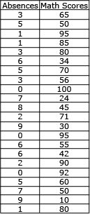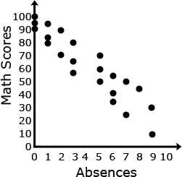  - 2. Draw a line of best fit, paying attention to the closeness of the data points on either side of the line.  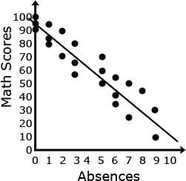  Continued on next page  - 3. From the line of best fit, determine an approximate linear equation that models the given data (about y = $−\frac{\text{25}}{3}x+\text{95}$)  - 4. Students should recognize that 95 represents the y intercept and $−\frac{\text{25}}{3}$represents the slope of the line.  - 5. Students can use this linear model to solve problems. For example, through substitution, they can use the equation to determine that a student with 4 absences should expect to receive a math score of about 62. They can then compare this value to their line.
8.SP.4. Understand that patterns of association can also be seen in bivariate categorical data by displaying frequencies and relative frequencies in a two-way table. Construct and interpret a two-way table summarizing data on two categorical variables collected from the same subjects. Use relative frequencies calculated for rows or columns to describe possible association between the two variables. For example, collect data from students in your class on whether or not they have a curfew on school nights and whether or not they have assigned chores at home. Is there evidence that those who have a curfew also tend to have chores?  Connections: 6-8.WHST.2b,f; ET08-S1C1-01; ET08-S1C3-02; ET08-S1C3-03;  SS08-S4C2-03; SS08-S4C1-05;  SC08-S1C3-02 | 8.MP.2. Reason abstractly and quantitatively.  8.MP.3. Construct viable arguments and critique the reasoning of others.  8.MP.4. Model with mathematics.  8.MP.5. Use appropriate tools strategically.  8.MP.6. Attend to precision.  8.MP.7. Look for and make use of structure. | Example:  - The table illustrates the results when 100 students were asked the survey questions: Do you have a curfew? and Do you have assigned chores? Is there evidence that those who have a curfew also tend to have chores?  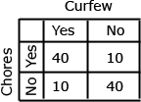  Solution: Of the students who answered that they had a curfew, 40 had chores and 10 did not. Of the students who answered they did not have a curfew, 10 had chores and 40 did not. From this sample, there appears to be a positive correlation between having a curfew and having chores.

Standards for Mathematical Practice
Standards |  | Explanations and Examples
Students are expected to: | Mathematical Practices are listed throughout the grade level document in the 2nd column to reflect the need to connect the mathematical practices to mathematical content in instruction.
8.MP.1. Make sense of problems and persevere in solving them. |  | In grade 8, students solve real world problems through the application of algebraic and geometric concepts. Students seek the meaning of a problem and look for efficient ways to represent and solve it. They may check their thinking by asking themselves, “What is the most efficient way to solve the problem?”, “Does this make sense?”, and “Can I solve the problem in a different way?”
8.MP.2. Reason abstractly and quantitatively. |  | In grade 8, students represent a wide variety of real world contexts through the use of real numbers and variables in mathematical expressions, equations, and inequalities. They examine patterns in data and assess the degree of linearity of functions. Students contextualize to understand the meaning of the number or variable as related to the problem and decontextualize to manipulate symbolic representations by applying properties of operations.
8.MP.3. Construct viable arguments and critique the reasoning of others. |  | In grade 8, students construct arguments using verbal or written explanations accompanied by expressions, equations, inequalities, models, and graphs, tables, and other data displays (i.e. box plots, dot plots, histograms, etc.). They further refine their mathematical communication skills through mathematical discussions in which they critically evaluate their own thinking and the thinking of other students. They pose questions like “How did you get that?”, “Why is that true?” “Does that always work?” They explain their thinking to others and respond to others’ thinking.
8.MP.4. Model with mathematics. |  | In grade 8, students model problem situations symbolically, graphically, tabularly, and contextually. Students form expressions, equations, or inequalities from real world contexts and connect symbolic and graphical representations. Students solve systems of linear equations and compare properties of functions provided in different forms. Students use scatterplots to represent data and describe associations between variables. Students need many opportunities to connect and explain the connections between the different representations. They should be able to use all of these representations as appropriate to a problem context.
8.MP.5. Use appropriate tools strategically. |  | Students consider available tools (including estimation and technology) when solving a mathematical problem and decide when certain tools might be helpful. For instance, students in grade 8 may translate a set of data given in tabular form to a graphical representation to compare it to another data set. Students might draw pictures, use applets, or write equations to show the relationships between the angles created by a transversal.
8.MP.6. Attend to precision. |  | In grade 8, students continue to refine their mathematical communication skills by using clear and precise language in their discussions with others and in their own reasoning. Students use appropriate terminology when referring to the number system, functions, geometric figures, and data displays.
8.MP.7. Look for and make use of structure. |  | Students routinely seek patterns or structures to model and solve problems. In grade 8, students apply properties to generate equivalent expressions and solve equations. Students examine patterns in tables and graphs to generate equations and describe relationships. Additionally, students experimentally verify the effects of transformations and describe them in terms of congruence and similarity.
8.MP.8. Look for and express regularity in repeated reasoning. |  | In grade 8, students use repeated reasoning to understand algorithms and make generalizations about patterns. Students use iterative processes to determine more precise rational approximations for irrational numbers. During multiple opportunities to solve and model problems, they notice that the slope of a line and rate of change are the same value. Students flexibly make connections between covariance, rates, and representations showing the relationships between quantities.

