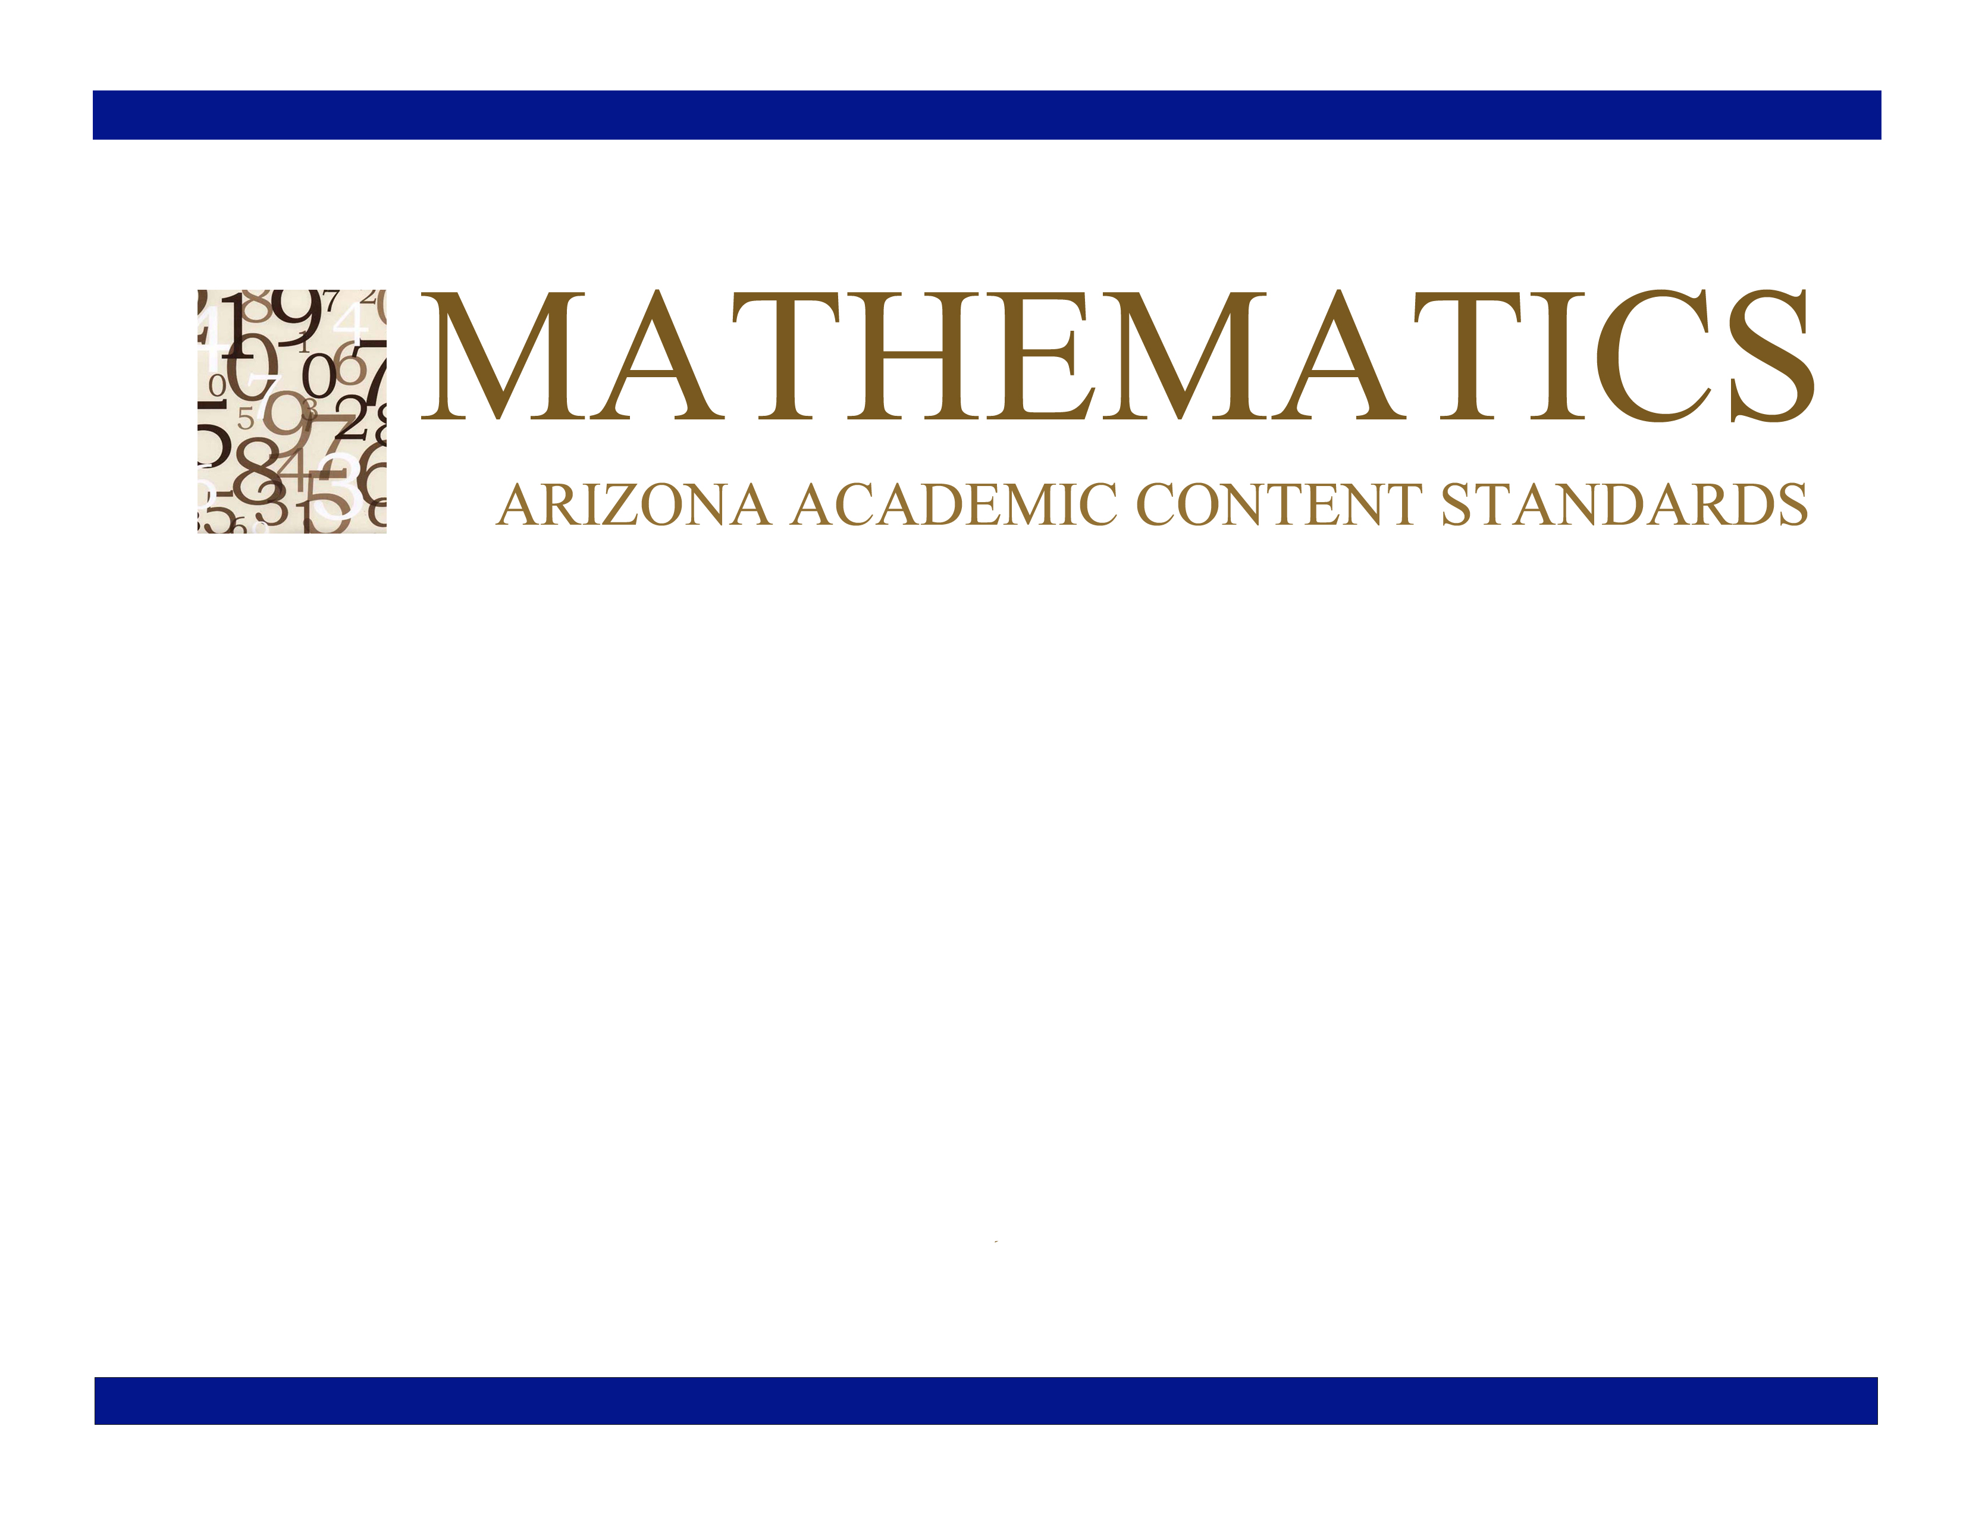
Grade 4

Approved by the Arizona State Board of Education
June 28, 2010

Grade 4

Grade 4 Overview

Operations and Algebraic Thinking (OA)  - Use the four operations with whole numbers to solve problems.  - Gain familiarity with factors and multiples.  - Generate and analyze patterns.  Number and Operations in Base Ten (NBT)  - Generalize place value understanding for multidigit whole numbers.  - Use place value understanding and properties of operations to perform multi-digit arithmetic.  Number and Operations—Fractions (NF)  - Extend understanding of fraction equivalence and ordering.  - Build fractions from unit fractions by applying and extending previous understandings of operations on whole numbers.  - Understand decimal notation for fractions, and compare decimal fractions.  Measurement and Data (MD)  - Solve problems involving measurement and conversion of measurements from a larger unit to a smaller unit.  - Represent and interpret data.  - Geometric measurement: understand concepts of angle and measure angles.  Geometry (G)  - Draw and identify lines and angles, and classify shapes by properties of their lines and angles. | Mathematical Practices (MP)  - Make sense of problems and persevere in solving them.  - Reason abstractly and quantitatively.  - Construct viable arguments and critique the reasoning of others.  - Model with mathematics.  - Use appropriate tools strategically.  - Attend to precision.  - Look for and make use of structure.  - Look for and express regularity in repeated reasoning.

In Grade 4, instructional time should focus on three critical areas: (1) developing understanding and fluency with multi-digit multiplication, and developing understanding of dividing to find quotients involving multi-digit dividends; (2) developing an understanding of fraction equivalence, addition and subtraction of fractions with like denominators, and multiplication of fractions by whole numbers; (3) understanding that geometric figures can be analyzed and classified based on their properties, such as having parallel sides, perpendicular sides, particular angle measures, and symmetry.

(1) Students generalize their understanding of place value to 1,000,000, understanding the relative sizes of numbers in each place. They apply their understanding of models for multiplication (equal-sized groups, arrays, area models), place value, and properties of operations, in particular the distributive property, as they develop, discuss, and use efficient, accurate, and generalizable methods to compute products of multi-digit whole numbers. Depending on the numbers and the context, they select and accurately apply appropriate methods to estimate or mentally calculate products. They develop fluency with efficient procedures for multiplying whole numbers; understand and explain why the procedures work based on place value and properties of operations; and use them to solve problems. Students apply their understanding of models for division, place value, properties of operations, and the relationship of division to multiplication as they develop, discuss, and use efficient, accurate, and generalizable procedures to find quotients involving multi-digit dividends. They select and accurately apply appropriate methods to estimate and mentally calculate quotients, and interpret remainders based upon the context.

(2) Students develop understanding of fraction equivalence and operations with fractions. They recognize that two different fractions can be equal (e.g., 15/9 = 5/3), and they develop methods for generating and recognizing equivalent fractions. Students extend previous understandings about how fractions are built from unit fractions, composing fractions from unit fractions, decomposing fractions into unit fractions, and using the meaning of fractions and the meaning of multiplication to multiply a fraction by a whole number.

(3) Students describe, analyze, compare, and classify two-dimensional shapes. Through building, drawing, and analyzing two-dimensional shapes, students deepen their understanding of properties of two-dimensional objects and the use of them to solve problems involving symmetry.

Operations and Algebraic Thinking (OA)
Use the four operations with whole numbers to solve problems.
Standards | Mathematical Practices | Explanations and Examples
Students are expected to:
4.OA.1. Interpret a multiplication equation as a comparison, e.g., interpret 35 = 5 × 7 as a statement that 35 is 5 times as many as 7 and 7 times as many as 5. Represent verbal statements of multiplicative comparisons as multiplication equations.  Connections: 4.OA.3; 4.SL.1d; ET04-S1C2-01; ET04-S1C2-02 | 4.MP.2. Reason abstractly and quantitatively.  4.MP.4. Model with mathematics. | A multiplicative comparison is a situation in which one quantity is multiplied by a specified number to get another quantity (e.g., “a is n times as much as b”). Students should be able to identify and verbalize which quantity is being multiplied and which number tells how many times.
4.OA.2. Multiply or divide to solve word problems involving multiplicative comparison, e.g., by using drawings and equations with a symbol for the unknown number to represent the problem, distinguishing multiplicative comparison from additive comparison. (see Table 2)  Connections: 4.RI.7; ET04-S1C2-01;  ET04-S1C2-02 | 4.MP.2. Reason abstractly and quantitatively.  4.MP.4. Model with mathematics.  4.MP.5. Use appropriate tools strategically.  4.MP.7. Look for and make use of structure. | Students need many opportunities to solve contextual problems. Table 2 includes the following multiplication problem:  “A blue hat costs $6. A red hat costs 3 times as much as the blue hat.  How much does the red hat cost?”  In solving this problem, the student should identify $6 as the quantity that is being multiplied by 3. The student should write the problem using a symbol to represent the unknown.  ($6 x 3 = )  Table 2 includes the following division problem:  A red hat costs $18 and a blue hat costs $6. How many times as much does the red hat cost as the blue hat?  In solving this problem, the student should identify $18 as the quantity being divided into shares of $6.  Continued on next page  The student should write the problem using a symbol to represent the unknown. ($18 ÷ $6 = )  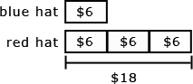  When distinguishing multiplicative comparison from additive comparison, students should note that  - additive comparisons focus on the difference between two quantities (e.g., Deb has 3 apples and Karen has 5 apples. How many more apples does Karen have?). A simple way to remember this is, “How many more?”  - multiplicative comparisons focus on comparing two quantities by showing that one quantity is a specified number of times larger or smaller than the other (e.g., Deb ran 3 miles. Karen ran 5 times as many miles as Deb. How many miles did Karen run?). A simple way to remember this is “How many times as much?” or “How many times as many?”
4.OA.3. Solve multistep word problems posed with whole numbers and having whole-number answers using the four operations, including problems in which remainders must be interpreted. Represent these problems using equations with a letter standing for the unknown quantity. Assess the reasonableness of answers using mental computation and estimation strategies including rounding.  Connections: 4.NBT.3; 4.NBT.4; 4.NBT.5; 4.NBT.6; ET04-S1C2-02 | 4.MP.1. Make sense of problems and persevere in solving them.  4.MP.2. Reason abstractly and quantitatively.  4.MP.4. Model with mathematics.  4.MP.5. Use appropriate tools strategically.  4.MP.6. Attend to precision.  4.MP.7. Look for and make use of structure. | Students need many opportunities solving multistep story problems using all four operations.  An interactive whiteboard, document camera, drawings, words, numbers, and/or objects may be used to help solve story problems.  Example:  Chris bought clothes for school. She bought 3 shirts for $12 each and a skirt for $15. How much money did Chris spend on her new school clothes?  3 x $12 + $15 = a  Continued on next page  In division problems, the remainder is the whole number left over when as large a multiple of the divisor as possible has been subtracted.  Example:  Kim is making candy bags. There will be 5 pieces of candy in each bag. She had 53 pieces of candy. She ate 14 pieces of candy. How many candy bags can Kim make now?  (7 bags with 4 leftover)  Kim has 28 cookies. She wants to share them equally between herself and 3 friends. How many cookies will each person get?  (7 cookies each) 28 ÷ 4 = a  There are 29 students in one class and 28 students in another class going on a field trip. Each car can hold 5 students. How many cars are needed to get all the students to the field trip?  (12 cars, one possible explanation is 11 cars holding 5 students and the 12th holding the remaining 2 students) 29 + 28 = 11 x 5 + 2  Estimation skills include identifying when estimation is appropriate, determining the level of accuracy needed, selecting the appropriate method of estimation, and verifying solutions or determining the reasonableness of situations using various estimation strategies. Estimation strategies include, but are not limited to:  - front-end estimation with adjusting (using the highest place value and estimating from the front end, making adjustments to the estimate by taking into account the remaining amounts),  - clustering around an average (when the values are close together an average value is selected and multiplied by the number of values to determine an estimate),  - rounding and adjusting (students round down or round up and then adjust their estimate depending on how much the rounding affected the original values),  - using friendly or compatible numbers such as factors (students seek to fit numbers together - e.g., rounding to factors and grouping numbers together that have round sums like 100 or 1000),  Continued on next page  - using benchmark numbers that are easy to compute (students select close whole numbers for fractions or decimals to determine an estimate).
AZ.4.OA.3.1 Solve a variety of problems based on the multiplication principle of counting.  - Represent a variety of counting problems using arrays, charts, and systematic lists, e.g., tree diagram.  - Analyze relationships among representations and make connections to the multiplication principle of counting.  Connections: 4.RI.3; 4.RI.7; ET04-S1C2-01 | 4.MP.1. Make sense of problems and persevere in solving them.  4.MP.2. Reason abstractly and quantitatively.  4.MP.3. Construct viable arguments and critique the reasoning of others.  4.MP.4. Model with mathematics.  4.MP.5. Use appropriate tools strategically.  4.MP.7. Look for and make use of structure.  4.MP.8. Look for and express regularity in repeated reasoning. | As students solve counting problems, they should begin to organize their initial random enumeration of possibilities into a systematic way of counting and organizing the possibilities in a chart (array), systematic list, or tree diagram. They note the similarities and differences among the representations and connect them to the multiplication principle of counting.  Examples:  - List all the different two-topping pizzas that a customer can order from a pizza shop that only offers four toppings: pepperoni, sausage, mushrooms, and onion.  - A Systematic List  Mushroom-Onion Mushroom-Pepperoni  Mushroom-Sausage Onion-Pepperoni  Onion-Sausage Pepperoni-Sausage  - A Chart (Array)  - At Manuel’s party, each guest must choose a meal, a drink, and a cupcake. There are two choices for a meal – hamburger or spaghetti; three choices for a drink – milk, tea, or soda; and three choices for a cupcake -- chocolate, lemon, or vanilla. Draw a tree diagram to show all possible selections for the guests. What are some conclusions that can be drawn from the tree diagram?  Continued on next page  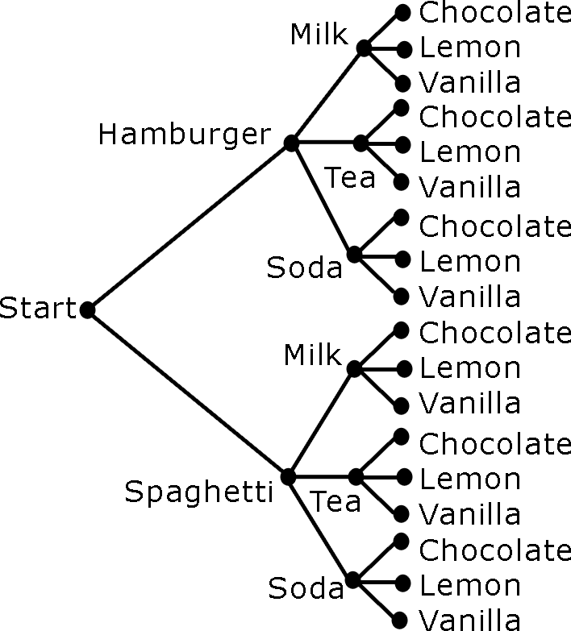  Sample conclusions:  - There are 18 different dinner choices that include a meal, a drink, and a cupcake.  - Nine dinner choices are possible for the guest that wants spaghetti for her meal.  - A guest cannot choose a meal, no drink, and two cupcakes  Continued on next page  - Use multiple representations to show the number of meals possible if each meal consists of one main dish and one drink. The menu is shown below. Analyze the various representations and describe how the representations illustrate the multiplication principle of counting.  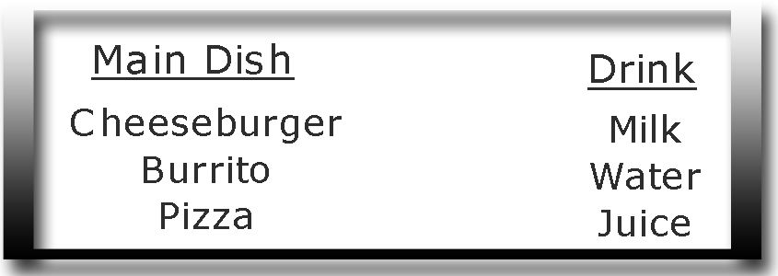  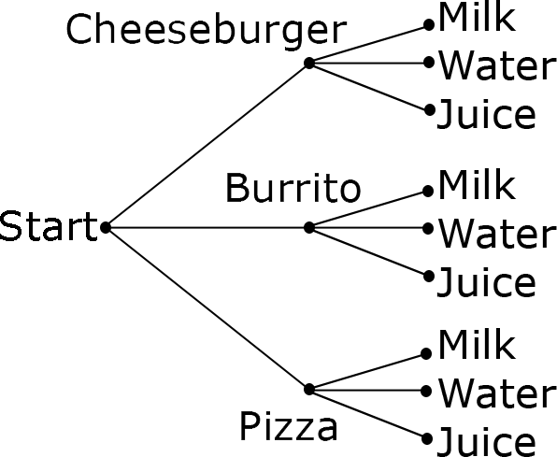  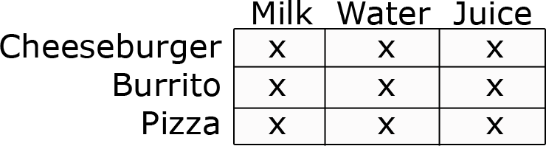  Both of the representations above illustrate a 3 • 3 relationship, which connects to the multiplication principle. Students explain where the multiplication principle appears in each representation. In this example, there are 3 • 3 = 9 possible meals.
   | 1 | 2 | 3 | 4 | 5 | 6 | 7 | 8
  Pepperoni | x |  |  | x | x
  Sausage | x | x |  |  |  | x
  Mushroom |  | x | x | x
  Onion |  |  | x |  | x | x

Operations and Algebraic Thinking (OA)
Gain familiarity with factors and multiples.
Standards | Mathematical Practices | Explanations and Examples
Students are expected to:
4.OA.4. Find all factor pairs for a whole number in the range 1–100. Recognize that a whole number is a multiple of each of its factors. Determine whether a given whole number in the range 1–100 is a multiple of a given one-digit number. Determine whether a given whole number in the range 1–100 is prime or composite. | 4.MP.2. Reason abstractly and quantitatively.  4.MP.7. Look for and make use of structure. | Students should understand the process of finding factor pairs so they can do this for any number 1 -100,  Example:  Factor pairs for 96: 1 and 96, 2 and 48, 3 and 32, 4 and 24, 6 and 16, 8 and 12.  Multiples can be thought of as the result of skip counting by each of the factors. When skip counting, students should be able to identify the number of factors counted e.g., 5, 10, 15, 20 (there are 4 fives in 20).  Example:  Factors of 24: 1, 2, 3, 4, 6, 8,12, 24  Multiples : 1,2,3,4,5…24  2,4,6,8,10,12,14,16,18,20,22,24  3,6,9,12,15,18,21,24  4,8,12,16,20,24  8,16,24  12,24  24  To determine if a number between1-100 is a multiple of a given one-digit number, some helpful hints include the following:  - all even numbers are multiples of 2  - all even numbers that can be halved twice (with a whole number result) are multiples of 4  - all numbers ending in 0 or 5 are multiples of 5  Prime vs. Composite:  A prime number is a number greater than 1 that has only 2 factors, 1 and itself. Composite numbers have more than 2 factors.  Students investigate whether numbers are prime or composite by  - building rectangles (arrays) with the given area and finding which numbers have more than two rectangles (e.g. 7 can be made into only 2 rectangles, 1 x 7 and 7 x 1, therefore it is a prime number)  - finding factors of the number

Operations and Algebraic Thinking (OA)
Generate and analyze patterns.
Standards | Mathematical Practices | Explanations and Examples
Students are expected to:
4.OA.5. Generate a number or shape pattern that follows a given rule. Identify apparent features of the pattern that were not explicit in the rule itself. For example, given the rule “Add 3” and the starting number 1, generate terms in the resulting sequence and observe that the terms appear to alternate between odd and even numbers. Explain informally why the numbers will continue to alternate in this way.  Connections: 4.OA.4; 4.RI.3; 4.RI.7; 4.W.2b; 4.W.2d; ET04-S1C1-01; ET04-S1C3-01 | 4.MP.2. Reason abstractly and quantitatively.  4.MP.4. Model with mathematics.  4.MP.5. Use appropriate tools strategically.  4.MP.7. Look for and make use of structure. | Patterns involving numbers or symbols either repeat or grow. Students need multiple opportunities creating and extending number and shape patterns. Numerical patterns allow students to reinforce facts and develop fluency with operations.  Patterns and rules are related. A pattern is a sequence that repeats the same process over and over. A rule dictates what that process will look like. Students investigate different patterns to find rules, identify features in the patterns, and justify the reason for those features.  Examples:  After students have identified rules and features from patterns, they need to generate a numerical or shape pattern from a given rule.  Example:  Rule: Starting at 1, create a pattern that starts at 1 and multiplies each number by 3. Stop when you have 6 numbers.  Students write 1, 3, 9, 27, 81, 243. Students notice that all the numbers are odd and that the sums of the digits of the 2 digit numbers are each 9. Some students might investigate this beyond 6 numbers. Another feature to investigate is the patterns in the differences of the numbers (3 - 1 = 2, 9 - 3 = 6, 27 - 9 = 18, etc.)
  Pattern | Rule | Feature(s)
  3, 8, 13, 18, 23, 28, … | Start with 3, add 5 | The numbers alternately end with a 3 or 8
  5, 10, 15, 20 … | Start with 5, add 5 | The numbers are multiples of 5 and end with either 0 or 5. The numbers that end with 5 are products of 5 and an odd number.  The numbers that end in 0 are products of 5 and an even number.

Number and Operations in Base Ten (NBT) (Grade 4 expectations in this domain are limited to whole numbers less than or equal to 1,000,000.)
Generalize place value understanding for multi-digit whole numbers.
Standards | Mathematical Practices | Explanations and Examples
Students are expected to:
4.NBT.1. Recognize that in a multi-digit whole number, a digit in one place represents ten times what it represents in the place to its right. For example, recognize that 700 ¸ 70 = 10 by applying concepts of place value and division. | 4.MP.2. Reason abstractly and quantitatively.  4.MP.6. Attend to precision.  4.MP.7. Look for and make use of structure. | Students should be familiar with and use place value as they work with numbers. Some activities that will help students develop understanding of this standard are:  - Investigate the product of 10 and any number, then justify why the number now has a 0 at the end. (7 x 10 = 70 because 70 represents 7 tens and no ones, 10 x 35 = 350 because the 3 in 350 represents 3 hundreds, which is 10 times as much as 3 tens, and the 5 represents 5 tens, which is 10 times as much as 5 ones.) While students can easily see the pattern of adding a 0 at the end of a number when multiplying by 10, they need to be able to justify why this works.  - Investigate the pattern, 6, 60, 600, 6,000, 60,000, 600,000 by dividing each number by the previous number.
4.NBT.2. Read and write multi-digit whole numbers using base-ten numerals, number names, and expanded form. Compare two multi-digit numbers based on meanings of the digits in each place, using >, =, and < symbols to record the results of comparisons.  Connections: 4.NBT.1 | 4.MP.2. Reason abstractly and quantitatively.  4.MP.4. Model with mathematics.  4.MP.6. Attend to precision.  4.MP.7. Look for and make use of structure. | The expanded form of 275 is 200 + 70 + 5. Students use place value to compare numbers. For example, in comparing 34,570 and 34,192, a student might say, both numbers have the same value of 10,000s and the same value of 1000s however, the value in the 100s place is different so that is where I would compare the two numbers.
4.NBT.3. Use place value understanding to round multi-digit whole numbers to any place.  Connections: 4.NBT.3; 4.RI.3 | 4.MP.2. Reason abstractly and quantitatively.  4.MP.6. Attend to precision. | When students are asked to round large numbers, they first need to identify which digit is in the appropriate place.  Example: Round 76,398 to the nearest 1000.  - Step 1: Since I need to round to the nearest 1000, then the answer is either 76,000 or 77,000.  - Step 2: I know that the halfway point between these two numbers is 76,500.  - Step 3: I see that 76,398 is between 76,000 and 76,500.  - Step 4: Therefore, the rounded number would be 76,000.

Number and Operations in Base Ten (NBT) (Grade 4 expectations in this domain are limited to whole numbers less than or equal to 1,000,000.)
Use place value understanding and properties of operations to perform multi-digit arithmetic.
Standards | Mathematical Practices | Explanations and Examples
Students are expected to:
4.NBT.4. Fluently add and subtract multi-digit whole numbers using the standard algorithm.  Connections: 4.NBT.2 | 4.MP.2. Reason abstractly and quantitatively.  4.MP.5. Use appropriate tools strategically.  4.MP.7. Look for and make use of structure.  4.MP.8. Look for and express regularity in repeated reasoning. | Students build on their understanding of addition and subtraction, their use of place value and their flexibility with multiple strategies to make sense of the standard algorithm. They continue to use place value in describing and justifying the processes they use to add and subtract.  When students begin using the standard algorithm their explanation may be quite lengthy. After much practice with using place value to justify their steps, they will develop fluency with the algorithm. Students should be able to explain why the algorithm works.  3892  + 1567  Student explanation for this problem:  - Two ones plus seven ones is nine ones.  - Nine tens plus six tens is 15 tens.  - I am going to write down five tens and think of the10 tens as one more hundred.(notates with a 1 above the hundreds column)  - Eight hundreds plus five hundreds plus the extra hundred from adding the tens is 14 hundreds.  - I am going to write the four hundreds and think of the 10 hundreds as one more 1000. (notates with a 1 above the thousands column)  - Three thousands plus one thousand plus the extra thousand from the hundreds is five thousand.  3546  - 928  Continued on next page  Student explanation for this problem:  - There are not enough ones to take 8 ones from 6 ones so I have to use one ten as 10 ones. Now I have 3 tens and 16 ones. (Marks through the 4 and notates with a 3 above the 4 and writes a 1 above the ones column to be represented as 16 ones.)  - Sixteen ones minus 8 ones is 8 ones. (Writes an 8 in the ones column of answer.)  - Three tens minus 2 tens is one ten. (Writes a 1 in the tens column of answer.)  - There are not enough hundreds to take 9 hundreds from 5 hundreds so I have to use one thousand as 10 hundreds. (Marks through the 3 and notates with a 2 above it. (Writes down a 1 above the hundreds column.) Now I have 2 thousand and 15 hundreds.  - Fifteen hundreds minus 9 hundreds is 6 hundreds. (Writes a 6 in the hundreds column of the answer).  - I have 2 thousands left since I did not have to take away any thousands. (Writes 2 in the thousands place of answer.)  Note: Students should know that it is mathematically possible to subtract a larger number from a smaller number but that their work with whole numbers does not allow this as the difference would result in a negative number.
4.NBT.5. Multiply a whole number of up to four digits by a one-digit whole number, and multiply two two-digit numbers, using strategies based on place value and the properties of operations. Illustrate and explain the calculation by using equations, rectangular arrays, and/or area models.  Connections: 4.OA.2; 4.OA.3; 4.NBT.1; 4.RI.7; 4.W.2b; 4.W.2d; ET04-S1C2-01;  ET04-S1C4-01 | 4.MP.2. Reason abstractly and quantitatively.  4.MP.3. Construct viable arguments and critique the reasoning of others.  4.MP.4. Model with mathematics.  4.MP.5. Use appropriate tools strategically.  4.MP.7. Look for and make use of structure. | Students who develop flexibility in breaking numbers apart have a better understanding of the importance of place value and the distributive property in multi-digit multiplication. Students use base ten blocks, area models, partitioning, compensation strategies, etc. when multiplying whole numbers and use words and diagrams to explain their thinking. They use the terms factor and product when communicating their reasoning. Multiple strategies enable students to develop fluency with multiplication and transfer that understanding to division. Use of the standard algorithm for multiplication is an expectation in the 5th grade.  Students may use digital tools to express their ideas.  Continued on next page  Use of place value and the distributive property are applied in the scaffolded examples below.  - To illustrate 154 x 6 students use base 10 blocks or use drawings to show 154 six times. Seeing 154 six times will lead them to understand the distributive property, 154 X 6 = (100 + 50 + 4) x 6 = (100 x 6) + (50 X 6) + (4 X 6) = 600 + 300 + 24 = 924.  - The area model shows the partial products.  14 x 16 = 224  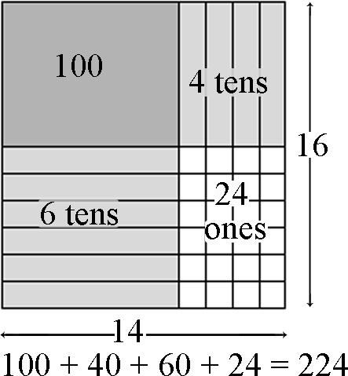  Using the area model, students first verbalize their understanding:  - 10 x 10 is 100  - 4 x 10 is 40  - 10 x 6 is 60, and  - 4 x 6 is 24.  They use different strategies to record this type of thinking.  - Students explain this strategy and the one below with base 10 blocks, drawings, or numbers.  25  x24  400 (20 x 20)  100 (20 x 5)  80 (4 x 20)  20 (4 x 5)  600  Continued on next page  - 25  x24  500 (20 x 25)  100 (4 x 25)  600  - Matrix model  This model should be introduced after students have facility with the strategies shown above.  20 5  20 400 100 500  4 80 20 100  480 + 120 600
4.NBT.6. Find whole-number quotients and remainders with up to four-digit dividends and one-digit divisors, using strategies based on place value, the properties of operations, and/or the relationship between multiplication and division. Illustrate and explain the calculation by using equations, rectangular arrays, and/or area models.  Connections: 4.OA.2; 4.OA.3; 4.NBT.1; 4.RI.7; 4.W.2b; 4.W.2d; ET04-S1C4-01 | 4.MP.2. Reason abstractly and quantitatively.  4.MP.3. Construct viable arguments and critique the reasoning of others.  4.MP.4. Model with mathematics.  4.MP.5. Use appropriate tools strategically.  4.MP.7. Look for and make use of structure. | In fourth grade, students build on their third grade work with division within 100. Students need opportunities to develop their understandings by using problems in and out of context.  Examples:  A 4th grade teacher bought 4 new pencil boxes. She has 260 pencils. She wants to put the pencils in the boxes so that each box has the same number of pencils. How many pencils will there be in each box?  - Using Base 10 Blocks: Students build 260 with base 10 blocks and distribute them into 4 equal groups. Some students may need to trade the 2 hundreds for tens but others may easily recognize that 200 divided by 4 is 50.  - Using Place Value: 260 ÷ 4 = (200 ÷ 4) + (60 ÷ 4)  - Using Multiplication: 4 x 50 = 200, 4 x 10 = 40, 4 x 5 = 20; 50 + 10 + 5 = 65; so 260 ÷ 4 = 65  Students may use digital tools to express ideas.  Continued on next page  - Using an Open Array or Area Model  After developing an understanding of using arrays to divide, students begin to use a more abstract model for division. This model connects to a recording process that will be formalized in the 5th grade.  Example: 150 ÷ 6  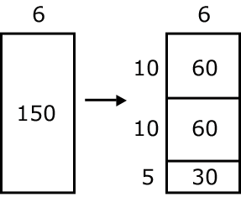  Students make a rectangle and write 6 on one of its sides. They express their understanding that they need to think of the rectangle as representing a total of 150.  - Students think, 6 times what number is a number close to 150? They recognize that 6 x 10 is 60 so they record 10 as a factor and partition the rectangle into 2 rectangles and label the area aligned to the factor of 10 with 60. They express that they have only used 60 of the 150 so they have 90 left.  - Recognizing that there is another 60 in what is left they repeat the process above. They express that they have used 120 of the 150 so they have 30 left.  - Knowing that 6 x 5 is 30. They write 30 in the bottom area of the rectangle and record 5 as a factor.  Continued on next page  - Students express their calculations in various ways:  - 150 150 ÷ 6 = 10 + 10 + 5 = 25  - 60 (6 x 10)  90  - 60 (6 x 10)  30  - 30 (6 x 5)  0  - 150 ÷ 6 = (60 ÷ 6) + (60 ÷ 6) + (30 ÷ 6) = 10 + 10 + 5 = 25  Example 2:  1917 ÷ 9  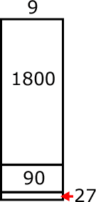  A student’s description of his or her thinking may be:  I need to find out how many 9s are in 1917. I know that 200 x 9 is 1800. So if I use 1800 of the 1917, I have 117 left. I know that 9 x 10 is 90. So if I have 10 more 9s, I will have 27 left. I can make 3 more 9s. I have 200 nines, 10 nines and 3 nines. So I made 213 nines. 1917 ÷ 9 = 213.

Number and Operations—Fractions (NF)
(Grade 4 expectations in this domain are limited to fractions with denominators 2, 3, 4, 5, 6, 8, 10, 12 and 100.)
Extend understanding of fraction equivalence and ordering.
Standards | Mathematical Practices | Explanations and Examples
Students are expected to:
4.NF.1. Explain why a fraction a/b is equivalent to a fraction (n x a)/(n x b) by using visual fraction models, with attention to how the number and size of the parts differ even though the two fractions themselves are the same size. Use this principle to recognize and generate equivalent fractions.  Connections: 4.RI.7; 4.SL.1b; 4.SL.1c; 4.SL.1d; ET04-S1C2-02 | 4.MP.2. Reason abstractly and quantitatively.  4.MP.4. Model with mathematics.  4.MP.7. Look for and make use of structure.  4.MP.8. Look for and express regularity in repeated reasoning. | This standard extends the work in third grade by using additional denominators (5, 10, 12, and 100).  Students can use visual models or applets to generate equivalent fractions.  All the models show 1/2. The second model shows 2/4 but also shows that 1/2 and 2/4 are equivalent fractions because their areas are equivalent. When a horizontal line is drawn through the center of the model, the number of equal parts doubles and size of the parts is halved.  Students will begin to notice connections between the models and fractions in the way both the parts and wholes are counted and begin to generate a rule for writing equivalent fractions.  1/2 x 2/2 = 2/4.  1 2 = 2 x 1 3 = 3 x 1 4 = 4 x 1  2 4 2 x 2 6 3 x 2 8 4 x 2  Technology Connection: http://illuminations.nctm.org/activitydetail.aspx?id=80
4.NF.2. Compare two fractions with different numerators and different denominators, e.g., by creating common denominators or numerators, or by comparing to a benchmark fraction such as 1/2. Recognize that comparisons are valid only when the two fractions refer to the same whole. Record the results of comparisons with symbols >, =, or <, and justify the conclusions, e.g., by using a visual fraction model.  Connection: 4.RI.5; ET04-S1C4-01 | 4.MP.2. Reason abstractly and quantitatively.  4.MP.4. Model with mathematics.  4.MP.5. Use appropriate tools strategically.  4.MP.7. Look for and make use of structure. | Benchmark fractions include common fractions between 0 and 1 such as halves, thirds, fourths, fifths, sixths, eighths, tenths, twelfths, and hundredths.  Fractions can be compared using benchmarks, common denominators, or common numerators. Symbols used to describe comparisons include <, >, =.  Continued on next page  Fractions may be compared using as a benchmark.  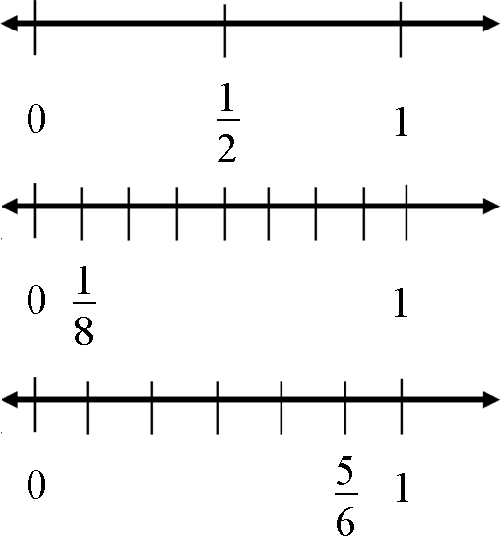  Possible student thinking by using benchmarks:  - is smaller than because when 1 whole is cut into 8 pieces, the pieces are much smaller than when 1 whole is cut into 2 pieces.  Possible student thinking by creating common denominators:  - $\frac{5}{6}$ > because $\frac{3}{6}$= and $\frac{5}{6}$> $\frac{3}{6}$  Fractions with common denominators may be compared using the numerators as a guide.  - $\frac{2}{6}$ < $\frac{3}{6}$ < $\frac{5}{6}$  Fractions with common numerators may be compared and ordered using the denominators as a guide.  - $\frac{3}{\text{10}}$ < $\frac{3}{8}$ < $\frac{3}{4}$

Number and Operations—Fractions (NF)
(Grade 4 expectations in this domain are limited to fractions with denominators 2, 3, 4, 5, 6, 8, 10, 12 and 100.)
Build fractions from unit fractions by applying and extending previous understandings
Standards | Mathematical Practices | Explanations and Examples
Students are expected to:
4.NF.3. Understand a fraction a/b with a > 1 as a sum of fractions 1/b.  - Understand addition and subtraction of fractions as joining and separating parts referring to the same whole.  - Decompose a fraction into a sum of fractions with the same denominator in more than one way, recording each decomposition by an equation. Justify decompositions, e.g., by using a visual fraction model.  Examples: 3/8=1/8+1/8+1/8 ; 3/8=1/8+2/8; 2 1/8=1 + 1+1/8=8/8+8/8 +1/8.  - Add and subtract mixed numbers with like denominators, e.g., by replacing each mixed number with an equivalent fraction, and/or by using properties of operations and the relationship between addition and subtraction.  - Solve word problems involving addition and subtraction of fractions referring to the same whole and having like denominators, e.g., by using visual fraction models and equations to represent the problem.  Connections: 4.RI.7; 4.W.2b; ET04-S1C2-02; ET04-S1C4-01 | 4.MP.1. Make sense of problems and persevere in solving them.  4.MP.2. Reason abstractly and quantitatively.  4.MP.4. Model with mathematics.  4.MP.5. Use appropriate tools strategically.  4.MP.6. Attend to precision.  4.MP.7. Look for and make use of structure.  4.MP.8. Look for and express regularity in repeated reasoning. | A fraction with a numerator of one is called a unit fraction. When students investigate fractions other than unit fractions, such as 2/3, they should be able to decompose the non-unit fraction into a combination of several unit fractions.  Example: 2/3 = 1/3 + 1/3  Being able to visualize this decomposition into unit fractions helps students when adding or subtracting fractions. Students need multiple opportunities to work with mixed numbers and be able to decompose them in more than one way. Students may use visual models to help develop this understanding.  Example:  - 1 ¼ - ¾ =  4/4 + ¼ = 5/4  5/4 – ¾ = 2/4 or ½  Example of word problem:  - Mary and Lacey decide to share a pizza. Mary ate 3/6 and Lacey ate 2/6 of the pizza. How much of the pizza did the girls eat together?  Solution: The amount of pizza Mary ate can be thought of a 3/6 or 1/6 and 1/6 and 1/6. The amount of pizza Lacey ate can be thought of a 1/6 and 1/6. The total amount of pizza they ate is 1/6 + 1/6 + 1/6 + 1/6 + 1/6 or 5/6 of the whole pizza.  A separate algorithm for mixed numbers in addition and subtraction is not necessary. Students will tend to add or subtract the whole numbers first and then work with the fractions using the same strategies they have applied to problems that contained only fractions.  Continued on next page  Example:  - Susan and Maria need 8 3/8 feet of ribbon to package gift baskets. Susan has 3 1/8 feet of ribbon and Maria has 5 3/8 feet of ribbon. How much ribbon do they have altogether? Will it be enough to complete the project? Explain why or why not.  The student thinks: I can add the ribbon Susan has to the ribbon Maria has to find out how much ribbon they have altogether. Susan has 3 1/8 feet of ribbon and Maria has 5 3/8 feet of ribbon. I can write this as 3 1/8 + 5 3/8. I know they have 8 feet of ribbon by adding the 3 and 5. They also have 1/8 and 3/8 which makes a total of 4/8 more. Altogether they have 8 4/8 feet of ribbon. 8 4/8 is larger than 8 3/8 so they will have enough ribbon to complete the project. They will even have a little extra ribbon left, 1/8 foot.  Example:  - Trevor has 4 1/8 pizzas left over from his soccer party. After giving some pizza to his friend, he has 2 4/8 of a pizza left. How much pizza did Trevor give to his friend?  Solution: Trevor had 4 1/8 pizzas to start. This is 33/8 of a pizza. The x’s show the pizza he has left which is 2 4/8 pizzas or 20/8 pizzas. The shaded rectangles without the x’s are the pizza he gave to his friend which is 13/8 or 1 5/8 pizzas.  x  x  x  x  x  x  x  x  x  x  x  x  x  x  x  x  x  x  x  x
4.NF.4. Apply and extend previous understandings of multiplication to multiply a fraction by a whole number.  - Understand a fraction a/b as a multiple of 1/b. For example, use a visual fraction model to represent 5/4 as the product 5´(1/4), recording the conclusion by the equation 5/4 = 5´(1/4).  - Understand a multiple of a/b as a multiple of 1/b, and use this understanding to multiply a fraction by a whole number. For example, use a visual fraction model to express 3´(2/5) as 6´(1/5), recognizing this product as 6/5. (In general, n´(a/b)=(n´a)/b.)  - Solve word problems involving multiplication of a fraction by a whole number, e.g., by using visual fraction models and equations to represent the problem. For example, if each person at a party will eat 3/8 of a pound of roast beef, and there will be 5 people at the party, how many pounds of roast beef will be needed? Between what two whole numbers does your answer lie?  Connections: 4.RI.5; 4.W.2e; ET04-S1C2-02 | 4.MP.1. Make sense of problems and persevere in solving them.  4.MP.2. Reason abstractly and quantitatively.  4.MP.4. Model with mathematics.  4.MP.5. Use appropriate tools strategically.  4.MP.6. Attend to precision.  4.MP.7. Look for and make use of structure.  4.MP.8. Look for and express regularity in repeated reasoning. | Students need many opportunities to work with problems in context to understand the connections between models and corresponding equations. Contexts involving a whole number times a fraction lend themselves to modeling and examining patterns.  Examples:  - 3 x (2/5) = 6 x (1/5) = 6/5  - If each person at a party eats 3/8 of a pound of roast beef, and there are 5 people at the party, how many pounds of roast beef are needed? Between what two whole numbers does your answer lie?  A student may build a fraction model to represent this problem:  3/8 3/8 3/8 3/8 3/8  3/8 + 3/8 + 3/8 + 3/8 + 3/8 = 15/8 = 1 7/8

Number and Operations—Fractions (NF)
(Grade 4 expectations in this domain are limited to fractions with denominators 2, 3, 4, 5, 6, 8, 10, 12 and 100.)
Understand decimal notation for fractions, and compare decimal fractions.
Standards | Mathematical Practices | Explanations and Examples
Students are expected to:
4.NF.5. Express a fraction with denominator 10 as an equivalent fraction with denominator 100, and use this technique to add two fractions with respective denominators 10 and 100. For example, express 3/10 as 30/100, and add 3/10 + 4/100 = 34/100. (Students who can generate equivalent fractions can develop strategies for adding fractions with unlike denominators in general. But addition and subtraction with unlike denominators in general is not a requirement at this grade.) | 4.MP.2. Reason abstractly and quantitatively.  4.MP.4. Model with mathematics.  4.MP.5. Use appropriate tools strategically.  4.MP.7. Look for and make use of structure. | Students can use base ten blocks, graph paper, and other place value models to explore the relationship between fractions with denominators of 10 and denominators of 100.  Students may represent 3/10 with 3 longs and may also write the fraction as 30/100 with the whole in this case being the flat (the flat represents one hundred units with each unit equal to one hundredth). Students begin to make connections to the place value chart as shown in 4.NF.6.  This work in fourth grade lays the foundation for performing operations with decimal numbers in fifth grade.
4.NF.6. Use decimal notation for fractions with denominators 10 or 100. For example, rewrite 0.62 as 62/100; describe a length as 0.62 meters; locate 0.62 on a number line diagram.  Connection: ET04-S1C2-03 | 4.MP.2. Reason abstractly and quantitatively.  4.MP.4. Model with mathematics.  4.MP.5. Use appropriate tools strategically.  4.MP.7. Look for and make use of structure. | Students make connections between fractions with denominators of 10 and 100 and the place value chart. By reading fraction names, students say 32/100 as thirty-two hundredths and rewrite this as 0.32 or represent it on a place value model as shown below.  Students use the representations explored in 4.NF.5 to understand 32/100 can be expanded to 3/10 and 2/100.  Students represent values such as 0.32 or 32/100 on a number line. 32/100 is more than 30/100 (or 3/10) and less than 40/100 (or 4/10). It is closer to 30/100 so it would be placed on the number line near that value.  0.5  0.8  0.1  0  0.2  0.3  0.4  0.6  0.7  0.9  1.0  0.32
  Hundreds | Tens | Ones | • | Tenths | Hundredths
   |  |  | • | 3 | 2
4.NF.7. Compare two decimals to hundredths by reasoning about their size. Recognize that comparisons are valid only when the two decimals refer to the same whole. Record the results of comparisons with the symbols >, =, or <, and justify the conclusions, e.g., by using a visual model.  Connections: 4.RI.7; 4.SL.1b; 4.SL.1c; 4.SL.1d; ET04-S1C2-02 | 4.MP.2. Reason abstractly and quantitatively.  4.MP.4. Model with mathematics.  4.MP.5. Use appropriate tools strategically.  4.MP.7. Look for and make use of structure. | Students build area and other models to compare decimals. Through these experiences and their work with fraction models, they build the understanding that comparisons between decimals or fractions are only valid when the whole is the same for both cases. Each of the models below shows 3/10 but the whole on the right is much bigger than the whole on the left. They are both 3/10 but the model on the right is a much larger quantity than the model on the left.  When the wholes are the same, the decimals or fractions can be compared.  Example:  - Draw a model to show that 0.3 < 0.5. (Students would sketch two models of approximately the same size to show the area that represents three-tenths is smaller than the area that represents five-tenths.

Measurement and Data (MD)
Solve problems involving measurement and conversion of measurements from a larger unit to a smaller unit.
Standards | Mathematical Practices | Explanations and Examples
Students are expected to:
4.MD.1. Know relative sizes of measurement units within one system of units including km, m, cm; kg, g; lb, oz.; l, ml; hr, min, sec. Within a single system of measurement, express measurements in a larger unit in terms of a smaller unit. Record measurement equivalents in a two-column table. For example, know that 1 ft is 12 times as long as 1 in. Express the length of a 4 ft snake as 48 in. Generate a conversion table for feet and inches listing the number pairs (1, 12), (2, 24), (3, 36),  Connections: 4.OA.5; 4.NBT.5; ET04-S1C2-01; ET04-S1C2-02 | 4.MP.2. Reason abstractly and quantitatively.  4.MP.5. Use appropriate tools strategically.  4.MP.6. Attend to precision. | The units of measure that have not been addressed in prior years are pounds, ounces, kilometers, milliliters, and seconds. Students’ prior experiences were limited to measuring length, mass, liquid volume, and elapsed time. Students did not convert measurements. Students need ample opportunities to become familiar with these new units of measure.  Students may use a two-column chart to convert from larger to smaller units and record equivalent measurements. They make statements such as, if one foot is 12 inches, then 3 feet has to be 36 inches because there are 3 groups of 12.  Example:
  kg | g |  | ft | in |  | lb | oz
  1 | 1000 |  | 1 | 12 |  | 1 | 16
  2 | 2000 |  | 2 | 24 |  | 2 | 32
  3 | 3000 |  | 3 | 36 |  | 3 | 48
4.MD.2. Use the four operations to solve word problems involving distances, intervals of time, liquid volumes, masses of objects, and money, including problems involving simple fractions or decimals, and problems that require expressing measurements given in a larger unit in terms of a smaller unit. Represent measurement quantities using diagrams such as number line diagrams that feature a measurement scale.  Connections: 4.OA.2; 4.OA.3; 4.NBT.4; 4.NF4.a; 4.NF.4c; 4.RI.5; 4.RI.7; 4.W.2e;  ET04-S1C4-01 | 4.MP.1. Make sense of problems and persevere in solving them.  4.MP.2. Reason abstractly and quantitatively.  4.MP.4. Model with mathematics.  4.MP.5. Use appropriate tools strategically.  4.MP.6. Attend to precision. | Examples:  Division/fractions: Susan has 2 feet of ribbon. She wants to give her ribbon to her 3 best friends so each friend gets the same amount. How much ribbon will each friend get?  Students may record their solutions using fractions or inches. (The answer would be 2/3 of a foot or 8 inches. Students are able to express the answer in inches because they understand that 1/3 of a foot is 4 inches and 2/3 of a foot is 2 groups of 1/3.)  Addition: Mason ran for an hour and 15 minutes on Monday, 25 minutes on Tuesday, and 40 minutes on Wednesday. What was the total number of minutes Mason ran?  Subtraction: A pound of apples costs $1.20. Rachel bought a pound and a half of apples. If she gave the clerk a $5.00 bill, how much change will she get back?  Continued on next page  Multiplication: Mario and his 2 brothers are selling lemonade. Mario brought one and a half liters, Javier brought 2 liters, and Ernesto brought 450 milliliters. How many total milliliters of lemonade did the boys have?  Number line diagrams that feature a measurement scale can represent measurement quantities. Examples include: ruler, diagram marking off distance along a road with cities at various points, a timetable showing hours throughout the day, or a volume measure on the side of a container.
4.MD.3. Apply the area and perimeter formulas for rectangles in real world and mathematical problems. For example, find the width of a rectangular room given the area of the flooring and the length, by viewing the area formula as a multiplication equation with an unknown factor.  Connections: 4.NBT.5; ET04-S1C1-01 | 4.MP.2. Reason abstractly and quantitatively.  4.MP.4. Model with mathematics.  4.MP.5. Use appropriate tools strategically.  4.MP.6. Attend to precision.  4.MP.7. Look for and make use of structure. | Students developed understanding of area and perimeter in 3rd grade by using visual models.  While students are expected to use formulas to calculate area and perimeter of rectangles, they need to understand and be able to communicate their understanding of why the formulas work.  The formula for area is I x w and the answer will always be in square units.  The formula for perimeter can be 2 l + 2 w or 2 (l + w) and the answer will be in linear units.

Measurement and Data (MD)
Represent and interpret data.
Standards | Mathematical Practices | Explanations and Examples
Students are expected to:
4.MD.4. Make a line plot to display a data set of measurements in fractions of a unit (1/2, 1/4, 1/8). Solve problems involving addition and subtraction of fractions by using information presented in line plots. For example, from a line plot find and interpret the difference in length between the longest and shortest specimens in an insect collection.  Connections: 4.NF.3d | 4.MP.2. Reason abstractly and quantitatively.  4.MP.4. Model with mathematics.  4.MP.5. Use appropriate tools strategically.  4.MP.6. Attend to precision.  4.MP.7. Look for and make use of structure. | Example:  Ten students in Room 31 measured their pencils at the end of the day. They recorded their results on the line plot below.  X X  X X X  X X X X X  _________________________________________  3 ½” 4” 4 ¼” 5 1/8” 5 1/2”  Possible questions:  - What is the difference in length from the longest to the shortest pencil?  - If you were to line up all the pencils, what would the total length be?  - If the 5 1/8” pencils are placed end to end, what would be their total length?

Measurement and Data (MD)
Geometric measurement: understand concepts of angle and measure angles.
Standards | Mathematical Practices | Explanations and Examples
Students are expected to:
4.MD.5. Recognize angles as geometric shapes that are formed wherever two rays share a common endpoint, and understand concepts of angle measurement:  - An angle is measured with reference to a circle with its center at the common endpoint of the rays, by considering the fraction of the circular arc between the points where the two rays intersect the circle. An angle that turns through 1/360 of a circle is called a “one-degree angle,” and can be used to measure angles.  - An angle that turns through n one-degree angles is said to have an angle measure of n degrees  Connection: ET04-S1C2-02 | 4.MP.6. Attend to precision.  4.MP.7. Look for and make use of structure. | The diagram below will help students understand that an angle measurement is not related to an area since the area between the 2 rays is different for both circles yet the angle measure is the same.  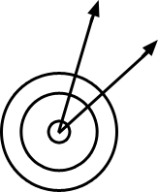
4.MD.6. Measure angles in whole-number degrees using a protractor. Sketch angles of specified measure.  Connections: 4.MD.5; 4.G.1; 4.G.2 | 4.MP.2. Reason abstractly and quantitatively.  4.MP.5. Use appropriate tools strategically.  4.MP.6. Attend to precision. | Before students begin measuring angles with protractors, they need to have some experiences with benchmark angles. They transfer their understanding that a 360º rotation about a point makes a complete circle to recognize and sketch angles that measure approximately 90º and 180º. They extend this understanding and recognize and sketch angles that measure approximately 45º and 30º. They use appropriate terminology (acute, right, and obtuse) to describe angles and rays (perpendicular).
4.MD.7. Recognize angle measure as additive. When an angle is decomposed into non-overlapping parts, the angle measure of the whole is the sum of the angle measures of the parts. Solve addition and subtraction problems to find unknown angles on a diagram in real world and mathematical problems, e.g., by using an equation with a symbol for the unknown angle measure.  Connections: 4.OA.3; 4.OA.4; 4.MD.5; 4.MD.6; 4.G.1; 4.G.2; ET04-S1C3-01 | 4.MP.1. Make sense of problems and persevere in solving them.  4.MP.2. Reason abstractly and quantitatively.  4.MP.4. Model with mathematics.  4.MP.6. Attend to precision. | Examples  If the two rays are perpendicular, what is the value of m?  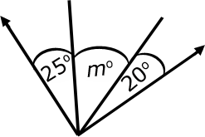  Continued on next page  Examples:  - Joey knows that when a clock’s hands are exactly on 12 and 1, the angle formed by the clock’s hands measures 30º. What is the measure of the angle formed when a clock’s hands are exactly on the 12 and 4?  - The five shapes in the diagram are the exact same size. Write an equation that will help you find the measure of the indicated angle. Find the angle measurement.  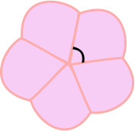

Geometry (G)
Draw and identify lines and angles, and classify shapes by properties of their lines and angles.
Standards | Mathematical Practices | Explanations and Examples
Students are expected to:
4.G.1. Draw points, lines, line segments, rays, angles (right, acute, obtuse), and perpendicular and parallel lines. Identify these in two-dimensional figures.  Connections: 4.MD.5; 4.MD.6; 4.G.2;  ET04-S1C4-01 | 4.MP.5. Use appropriate tools strategically.  4.MP.6. Attend to precision. | Examples of points, line segments, lines, angles, parallelism, and perpendicularity can be seen daily. Students do not easily identify lines and rays because they are more abstract.  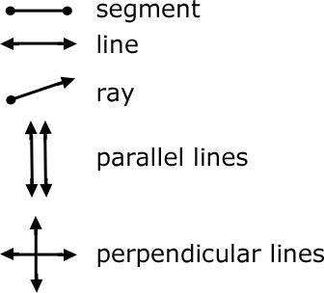
  Right angle | 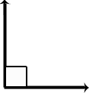
  Acute angle | 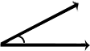
  Obtuse angle | 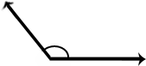
  Straight angle
4.G.2. Classify two-dimensional figures based on the presence or absence of parallel or perpendicular lines, or the presence or absence of angles of a specified size. Recognize right triangles as a category, and identify right triangles.  Connections: 4.MD.5; 4.MD.6; 4.G.1 |  | Two-dimensional figures may be classified using different characteristics such as, parallel or perpendicular lines or by angle measurement.  Parallel or Perpendicular Lines:  Students should become familiar with the concept of parallel and perpendicular lines. Two lines are parallel if they never intersect and are always equidistant. Two lines are perpendicular if they intersect in right angles (90º).  Students may use transparencies with lines to arrange two lines in different ways to determine that the 2 lines might intersect in one point or may never intersect. Further investigations may be initiated using geometry software. These types of explorations may lead to a discussion on angles.  Parallel and perpendicular lines are shown below:  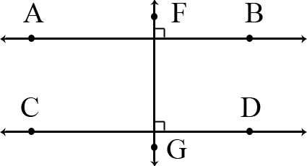  Example:  - Identify which of these shapes have perpendicular or parallel sides and justify your selection.  Continued on next page
A possible justification that students might give is:
The square has perpendicular lines because the sides meet at a corner, forming right angles.
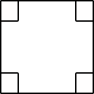

Angle Measurement:

This expectation is closely connected to 4.MD.5, 4.MD.6, and 4.G.1. Students’ experiences with drawing and identifying right, acute, and obtuse angles support them in classifying two-dimensional figures based on specified angle measurements. They use the benchmark angles of 90°, 180°, and 360° to approximate the measurement of angles.

Right triangles can be a category for classification. A right triangle has one right angle. There are different types of right triangles. An isosceles right triangle has two or more congruent sides and a scalene right triangle has no congruent sides.
4.G.3. Recognize a line of symmetry for a two-dimensional figure as a line across the figure such that the figure can be folded along the line into matching parts. Identify line-symmetric figures and draw lines of symmetry. | 4.MP.4. Model with mathematics.  4.MP.5. Use appropriate tools strategically.  4.MP.6. Attend to precision.  4.MP.7. Look for and make use of structure. | Students need experiences with figures which are symmetrical and non-symmetrical. Figures include both regular and non-regular polygons. Folding cut-out figures will help students determine whether a figure has one or more lines of symmetry.

Standards for Mathematical Practice
Standards |  | Explanations and Examples
Students are expected to: | Mathematical Practices are listed throughout the grade level document in the 2nd column to reflect the need to connect the mathematical practices to mathematical content in instruction.
4.MP.1. Make sense of problems and persevere in solving them. |  | In fourth grade, students know that doing mathematics involves solving problems and discussing how they solved them. Students explain to themselves the meaning of a problem and look for ways to solve it. Fourth graders may use concrete objects or pictures to help them conceptualize and solve problems. They may check their thinking by asking themselves, “Does this make sense?” They listen to the strategies of others and will try different approaches. They often will use another method to check their answers.
4.MP.2. Reason abstractly and quantitatively. |  | Fourth graders should recognize that a number represents a specific quantity. They connect the quantity to written symbols and create a logical representation of the problem at hand, considering both the appropriate units involved and the meaning of quantities. They extend this understanding from whole numbers to their work with fractions and decimals. Students write simple expressions, record calculations with numbers, and represent or round numbers using place value concepts.
4.MP.3. Construct viable arguments and critique the reasoning of others. |  | In fourth grade, students may construct arguments using concrete referents, such as objects, pictures, and drawings. They explain their thinking and make connections between models and equations. They refine their mathematical communication skills as they participate in mathematical discussions involving questions like “How did you get that?” and “Why is that true?” They explain their thinking to others and respond to others’ thinking.
4.MP.4. Model with mathematics. |  | Students experiment with representing problem situations in multiple ways including numbers, words (mathematical language), drawing pictures, using objects, making a chart, list, or graph, creating equations, etc. Students need opportunities to connect the different representations and explain the connections. They should be able to use all of these representations as needed. Fourth graders should evaluate their results in the context of the situation and reflect on whether the results make sense.
4.MP.5. Use appropriate tools strategically. |  | Fourth graders consider the available tools (including estimation) when solving a mathematical problem and decide when certain tools might be helpful. For instance, they may use graph paper or a number line to represent and compare decimals and protractors to measure angles. They use other measurement tools to understand the relative size of units within a system and express measurements given in larger units in terms of smaller units.
4.MP.6. Attend to precision. |  | As fourth graders develop their mathematical communication skills, they try to use clear and precise language in their discussions with others and in their own reasoning. They are careful about specifying units of measure and state the meaning of the symbols they choose. For instance, they use appropriate labels when creating a line plot.
4.MP.7. Look for and make use of structure. |  | In fourth grade, students look closely to discover a pattern or structure. For instance, students use properties of operations to explain calculations (partial products model). They relate representations of counting problems such as tree diagrams and arrays to the multiplication principal of counting. They generate number or shape patterns that follow a given rule.
4.MP.8. Look for and express regularity in repeated reasoning. |  | Students in fourth grade should notice repetitive actions in computation to make generalizations Students use models to explain calculations and understand how algorithms work. They also use models to examine patterns and generate their own algorithms. For example, students use visual fraction models to write equivalent fractions.

Table 2. Common multiplication and division situations.⁷

 | Unknown Product | Group Size Unknown  (“How many in each group?” Division) | Number of Groups Unknown  (“How many groups?” Division)
 | 3 x 6 = ? | 3 x ? = 18, and 18 ÷ 3 = ? | ? x 6 = 18, and 18 ÷ 6 = ?
Equal  Groups | There are 3 bags with 6 plums in each bag. How many plums are there in all?  Measurement example.  You need 3 lengths of string, each 6 inches long. How much string will you need altogether? | If 18 plums are shared equally into 3 bags, then how many plums will be in each bag?  Measurement example.  You have 18 inches of string, which you will cut into 3 equal pieces. How long will each piece of string be? | If 18 plums are to be packed 6 to a bag, then how many bags are needed?  Measurement example.  You have 18 inches of string, which you will cut into pieces that are 6 inches long. How many pieces of string will you have?
Arrays,⁴  Area⁵ | There are 3 rows of apples with 6 apples in each row. How many apples are there?  Area example.  What is the area of a 3 cm by 6 cm rectangle? | If 18 apples are arranged into 3 equal rows, how many apples will be in each row?  Area example.  A rectangle has area 18 square centimeters. If one side is 3 cm long, how long is a side next to it? | If 18 apples are arranged into equal rows of 6 apples, how many rows will there be?  Area example.  A rectangle has area 18 square centimeters. If one side is 6 cm long, how long is a side next to it?
Compare | A blue hat costs $6. A red hat costs 3 times as much as the blue hat. How much does the red hat cost?  Measurement example.  A rubber band is 6 cm long. How long will the rubber band be when it is stretched to be 3 times as long? | A red hat costs $18 and that is 3 times as much as a blue hat costs. How much does a blue hat cost?  Measurement example.  A rubber band is stretched to be 18 cm long and that is 3 times as long as it was at first. How long was the rubber band at first? | A red hat costs $18 and a blue hat costs $6. How many times as much does the red hat cost as the blue hat?  Measurement example.  A rubber band was 6 cm long at first. Now it is stretched to be 18 cm long. How many times as long is the rubber band now as it was at first?
General | General a x  b = ? | a x  ? = p, and p ÷  a = ? | ? x  b = p, and p ÷  b = ?

⁷The first examples in each cell are examples of discrete things. These are easier for students and should be given before the measurement examples.
⁴The language in the array examples shows the easiest form of array problems. A harder form is to use the terms rows and columns: The apples in the grocery window are in 3 rows and 6 columns. How many apples are in there? Both forms are valuable.
⁵Area involves arrays of squares that have been pushed together so that there are no gaps or overlaps, so array problems include these especially important measurement situations.

