A Curriculum Guide for

Mathematics
Grade 6



Newark Public Schools
Office of Mathematics
2003
NEWARK PUBLIC SCHOOLS
2003-04

ADMINISTRATION

District Superintendent Ms. Marion A. Bolden

State District Deputy Superintendent Ms. Anzella K. Nelms

Assistant Superintendent Ms. Joanne C. Bergamotto

for School Leadership Team I

Assistant Superintendent Mr. Benjamin O’Neal

for School Leadership Team II

Assistant Superintendent Ms. Doris Culver

for School Leadership Team III

Assistant Superintendent Ms. Lydia Silva

for School Leadership Team IV

Assistant Superintendent Dr. Don Marinaro

for School Leadership Team V

Assistant Superintendent Dr. Gayle W. Griffin

Department of Teaching and Learning

Associate Superintendent Dr. Lawrence Ashley

Department of Special Programs

Department
of
Teaching and Learning

Dr. Gayle W. Griffin

Assistant Superintendent

Office of Mathematics

May L. Samuels
Director

GRADE 6 MATHEMATICS
CURRICULUM
GUIDE

Table of Contents

Mission Statement 5

Philosophy 6

To the Teacher 7

Course Description 9

Course Proficiencies 10

Suggested Timeline 13

Suggested Pacing and Objectives (with New Jersey Core Content Standards) 14

Open Ended Problem Solving and Scoring 21

Reference:

Instructional Technology (Web Sources) 32

NJCCCS and Cumulative Progress Indicators 33

Holistic Scoring Guide for Math Open-Ended Items 45

National Council of Teachers of Mathematics Principles and Standards 46

Glossary 47

Mission Statement

The Newark Public Schools recognizes that each child is a unique individual possessing talents, abilities, goals, and dreams. We further recognize that each child can be successful only when we acknowledge all aspects of that child’s life: addressing their needs; enhancing their intellect; developing their character; and uplifting their spirit. Finally, we recognize that individuals learn, grow, and achieve differently; and it is therefore critical that, as a district, we provide a diversity of programs based on student needs.

As a district we recognize that education does not exist in a vacuum. In recognizing the rich diversity of our student population, we also acknowledge the richness of the diverse environment that surrounds us. The numerous cultural, educational, and economic institutions that are part of the greater Newark community play a critical role in the lives of our children. It is equally essential that these institutions become an integral part of our educational program.

To this end, the Newark Public Schools is dedicated to providing a quality education, embodying a philosophy of critical and creative thinking and designed to equip each graduate with the knowledge and skills needed to be a productive citizen. Our educational program is informed by high academic standards, high expectations, and equal access to programs that provide and motivate a variety of interests and abilities for every student based on his or her needs. Accountability at every level is an integral part of our approach. As a result of the conscientious, committed, and coordinated efforts of teachers, administrators, parents, and the community, all children will learn.

Adapted from: The Newark Public Schools Strategic Plan
Philosophy

“Imagine a classroom, a school, or a school district where all students have access to high-quality, engaging mathematics instruction. There are ambitious expectations for all, with accommodation for those who need it. Knowledgeable teachers have adequate resources to support their work and are continually growing as professionals. The curriculum is mathematically rich, offering students opportunities to learn important mathematical concepts and procedures with understanding. Technology is an essential component of the environment. Students confidently engage in complex mathematical tasks chosen carefully by teachers. They draw on knowledge from a wide variety of mathematical topics, sometimes approaching the same problem from different mathematical perspectives or representing the mathematics in different ways until they find methods that enable them to make progress. Teachers help students make, refine, and explore conjectures on the basis of evidence and use a variety of reasoning and proof techniques to confirm or disprove those conjectures. Students are flexible and resourceful problem solvers. Alone or in groups and with access to technology, they work productively and reflectively, with the skilled guidance of their teachers. Orally and in writing, students communicate their ideas and results effectively. They value mathematics and engage actively in learning it.” *

This model, envisioned in the NCTM Standards 2000, is the ideal which Newark Public Schools hopes to achieve in all mathematics classrooms. We believe the classroom described above is attainable through the cooperative efforts of all Newark Public Schools stakeholders.

*A Vision for School Mathematics
National Council of Teachers of Mathematics

Standards 2000

To the Teacher

The Connected Mathematics Program is a standards-based, problem-centered curriculum. The role of the teacher in a problem-centered curriculum differs from the traditional role, in which the teacher explains ideas thoroughly and demonstrates procedures so students can quickly and accurately duplicate these procedures. A problem-centered curriculum is best suited to an inquiry model of instruction. The teacher and students investigate a series of problems; through discussion of solution methods, embedded mathematics, and appropriate generalizations students grow in their ability to become reflective learners. Teachers have a crucial role to play in establishing the expectations for discussion in the classroom and for orchestrating discourse on a daily basis.

The Connected Mathematics materials are designed to help students and teachers build an effective pattern of instruction in the classroom. A community of mutually supportive learners works together to make sense of the mathematics through: the problems themselves; the justification the students are asked to provide on a regular basis; student opportunities to discuss and write about their ideas. To help teachers think about their teaching, the Connected Mathematics Program uses a three-phase instructional model, which contains a Launch of the lesson, an Exploration of the central problem, and a Summary of the new learning.

The Launch of a lesson is typically done as a whole class; yet during this launch phase of instruction students are sometimes asked to think about a question individually before discussing their ideas as a whole class. The launch phase is also the time when the teacher introduces new ideas, clarifies definitions, reviews old concepts, and connects the problem to past experiences of the students. It is critical that, while giving students a clear picture of what is expected, the teacher is careful not to reveal too much and lower the challenge of the task to something routine, or limit the rich array of strategies that may evolve from an open launch of the problem.

In the Explore phase, students may work individually, in pairs, in small groups, or occasionally as a whole class to solve the problem. As they work, they gather data, share ideas, look for patterns, make conjectures, and develop problem-solving strategies. The teacher's role during this phase is to move about the classroom, observing individual performance and encouraging on-task behavior. The teacher helps students persevere in their work by asking appropriate questions and providing confirmation or redirection where needed. For students who are interested in deeper investigation, the teacher may provide extra challenges related to the problem. These challenges are provided in the Teacher's Guide.

Substantive whole-class discussion most often occurs during the Summarize phase when individuals and groups share their results. Led by the teacher's questions, the students investigate ideas and strategies and discuss their thoughts. Questioning by other students and the teacher, challenges students' ideas, driving the development of important concepts. Working together, the students synthesize information, look for generalities, and extract the strategies and skills involved in solving the problem. Since the goal of the summarize phase is to make the mathematics in the problem more explicit, teachers often pose, toward the end of the summary, a quick problem or two to be done individually as a check of student progress.

Connected Mathematics is different from traditional programs. Because important concepts are embedded within problems rather than explicitly stated and demonstrated in the student text, the teacher plays a critical role in helping students develop appropriate understanding, strategies, and skills. It is the teachers' thoughtful reflections on student learning that will create a productive classroom environment. Teachers who have experienced success with Connected Mathematics have made two noteworthy suggestions:
(i) The teacher should work through each investigation prior to the initiation of instruction. Teachers who invest time in doing the problems in at least two different ways will be better equipped to Launch the investigation, facilitate the Exploration and Summary of the problem, and know what mathematics assessment is appropriate.
(ii) The teacher should engage in ongoing professional conversations about the mathematics in the Connected Mathematics Program they are using, sharing strategies for improving student achievement.

The format of the student books is also much different from traditional mathematics texts. The student pages are uncluttered and have few non-essential features. Because students develop strategies and understanding by solving problems, the books do not contain worked-out examples that demonstrate solution methods. Since it is also important that students develop understanding of mathematical definitions and rules, the books contain few formal definitions and rules. These non-consumable student books should be kept in a three-ring binder during instruction and collected when instruction has been completed. It is essential that the teacher develops and maintains a notebook management system. "Getting to Know Connected Mathematics: An Implementation Guide” provides strategies to assist the teacher with the purposes and organizational format for student notebooks.

Course Description

The grade six curriculum helps students develop understanding of important concepts, skills, procedures, and ways of thinking mathematically. PrimeTime addresses the basics of number theory: factors, multiples, prime and composite numbers, even, odd, and square numbers, greatest common factors, and least common multiples. Bits and Pieces I focuses on interpretations of fractions such as: fractions as parts of a whole; fractions as measures or quantities; fractions as indicated division; fractions as decimals; and fractions as percents. Data About Us explores statistics as a process of data investigation by posing the question, collecting the data, analyzing the data, and then interpreting the results. Shapes and Designs develops understanding of patterns and regularities in the relations among sides and angles of basic polygons and how those patterns can be helpful in using polygonal shapes to create interesting designs and useful structures. Covering and Surrounding takes an experimental approach to developing students' understanding of measuring perimeter and area using tiles, transparent grids, grid paper, string, and rulers to develop a dynamic sense of "covering" and "surrounding". How Likely Is It? applies the terms chance and probability to situations that have uncertain outcomes in individual trials but predictable regularity over many trials (experimental probability), and to analyzing situations mathematically (theoretical probability). Ruins of Montarek allows students to construct, manipulate, and interpret two- and three-dimensional representations of objects and to develop an understanding of the relationships among representations (such as building plans, isometric dot paper representations, and cube models).

Prerequisite
None

Course Requirements

Students are expected to:
- meet district attendance policy
- participate in class discussions, cooperative learning exercises, and individual and group classwork assignments
- complete homework assignments
- keep an updated, accurate notebook
- demonstrate an acceptable level of proficiency in course objectives through teacher-developed quizzes and tests, alternative and project-based assessments, and district assessments

Grade 6 Mathematics Course Proficiencies

 | Students will be able to...
1 | Understand the relationships among factors, multiples, divisors, and products.
2 | Recognize that factors come in pairs.
3 | Link area and dimensions of rectangles with products and factors.
4 | Recognize numbers as prime or composite and as odd or even based on their factors.
5 | Use factors and multiples to explain some numerical factors of everyday life.
6 | Develop strategies for finding factors and multiples of whole numbers.
7 | Recognize that a number can be written in exactly one way as a product of primes. (Fundamental Theorem of Arithmetic)
8 | Recognize situations in which problems can be solved by finding factors and multiples.
9 | Develop a variety of strategies - such as building a physical model, making a table or list, and solving a simpler problem - to solve problems involving factors and multiples.
10 | Build an understanding of fractions, decimals, and percents and the relationships between and among these concepts and their representations.
11 | Develop ways to model situations involving fractions, decimals, and percents.
12 | Understand and use equivalent fractions to reason about situations.
13 | Compare and order fractions.
14 | Move flexibly between fraction, decimal, and percent representations.
15 | Use 0, , 1, and as benchmarks to help estimate the size of a number.
16 | Develop and use benchmarks that relate different forms of representations of rational numbers (for example, 50% is the same as and 0.5).
17 | Use physical models and drawings to help reason about a situation.
18 | Look for patterns and describe how to continue the pattern.
19 | Use context to help reason about a situation.
20 | Use estimation to understand a situation.
21 | Engage in the process of data investigation: posing questions, collecting data, analyzing data, and making interpretations to answer questions.
22 | Represent data using line plots, bar graphs, stem-and-leaf plots, and coordinate graphs.
23 | Explore concepts that relate to ways of describing data, such as the shape of a distribution, what's typical in the data, measures of center (mode, median, and mean), and range or variability in the data.
24 | Develop a variety of strategies - such as using comparative representations and concepts related to describing the shape of the data - for comparing data sets.
25 | Acquire knowledge of some important properties of polygons and a general ability to recognize those shapes and their properties.
26 | Describe decorative and structural applications in which polygons of various shapes appear.
27 | Explain the property of the triangle that makes it useful as a stable structure.
28 | Explain the side and angle relationships that make parallelograms useful for designs and for structures such as windows, doors, and tilings.
29 | Estimate the size of any angle using reference to a right angle and other benchmark angles.
30 | Use an angle ruler to make more accurate angle measurements.
31 | Develop a variety of strategies for solving problems involving polygons and their properties. Possible strategies include testing many different cases and looking for patterns in the results, finding extreme cases, and organizing results in a systematic way so that patterns are revealed.
32 | Develop strategies for finding areas and perimeters of rectangular shapes and of nonrectangular shapes.
33 | Discover relationships between perimeter and area.
34 | Understand how the area of a rectangle is related to the area of a triangle and of a parallelogram.
35 | Develop formulas or procedures - stated in words or symbols - for finding areas and perimeters of rectangles, parallelograms, triangles, and circles.
36 | Use area and perimeter to solve applied problems.
37 | Recognize situations in which measuring perimeter or area will answer practical problems.
38 | Find perimeters and areas of rectangular and nonrectangular figures by using transparent grids, tiles, or other objects to cover the figures and string, straight-line segments, rulers, or other objects to surround the figures.
39 | Cut and rearrange figures - in particular, parallelograms, triangles, and rectangles - to see relationships between them and then devise strategies for finding areas by using the observed relationships.
40 | Observe and reason from patterns in data by organizing tables to represent the data.
41 | Reason to find, confirm, and use relationships involving area and perimeter.
42 | Use multiple representations - in particular, physical pictorial, tabular, and symbolic models - and verbal descriptions of data.
43 | Become acquainted with probability informally through experiments.
44 | Understand that probabilities are useful for predicting what will happen over the long run.
45 | Understand that probabilities are useful for making decisions.
46 | Understand the two ways to obtain probabilities: by gathering data from experiments (experimental probability) and by analyzing the possible equally likely outcomes (theoretical probability).

47 | Understand the concepts of equally likely and unequally likely.
48 | Understand the relationship between experimental and theoretical probabilities: experimental probabilities are better estimates of theoretical probabilities when they are based on a larger number of trials.
49 | Determine and critically interpret statements of probability.
50 | Develop strategies for finding both experimental and theoretical probabilities.
51 | Organize data into lists or charts of equally likely outcomes as a strategy for finding theoretical probabilities.
52 | Use graphs and tallies to summarize and display data.
53 | Use data displayed in graphs and tallies to find experimental probabilities.
The following proficiencies are optional but highly recommended (Ruins of Montarek).
54 | Read and create two-dimensional representations of three-dimensional cube buildings.
55 | Communicate spatial information.
56 | Observe that the back view of a cube building is the mirror image of the front view and that the left view is the mirror image of the right view.
57 | Understand and recognize line symmetry.
58 | Explain how drawings of the base outline, front view, and right view describe a building.
59 | Construct cube buildings that fit two-dimensional building plans.
60 | Develop a way to describe all buildings that can be made from a set of plans.
61 | Understand that a set of plans can have more than one minimal building but only one maximal building.
62 | Explain how a cube can be represented on isometric dot paper, how the angles on a cube are represented with angles on the dot paper, and how the representations fit what the eye sees when viewing the corner of a cube building.
63 | Make isometric drawings of cube buildings.
64 | Visualize transformations of cube buildings and make isometric drawings of the transformed buildings.
65 | Reason about spatial relationships.
66 | Use models and representations of models to solve problems.

Suggested Timeline

SEMESTER 1 | Topic |  |  | Number of Days
SEMESTER 1 | I | Prime Time | The Factor Game  The Product Game  Factor Pairs  Common Factors and Multiples  Factorizations  The Locker Problem | 27
SEMESTER 1 | II | Bits and Pieces I | Fund-Raising Fractions  Comparing Fractions  Cooking with Fractions  From Fractions to Decimals  Moving Between Fractions and Decimals  Out of One Hundred | 29
SEMESTER 1 | III | Data About Us | Looking at Data  Types of Data  Using Graphs to Group Data  Coordinate Graphs  What Do We Mean by Mean? | 20
SEMESTER 1 |  | subtotal |  | 76
SEMESTER 2 | IV | Shapes and Designs | Bees and Polygons  Building Polygons  Polygons and Angles  Polygon Properties and Tiling  Side-Angle-Shape Connections  Turtle Tracks | 24
SEMESTER 2 | V | Covering and Surrounding | Measuring Perimeter and Area  Measuring Odd Shapes  Constant Area, Changing Perimeter  Constant Perimeter, Changing Area  Measuring Parallelograms  Measuring Triangles  Going Around in Circles | 29
SEMESTER 2 | VI | How Likely Is It? | A First Look at Chance  More Experiments with Chance  Using Spinners to Predict Chances  Theoretical Probabilities  Analyzing Games of Chance  More About Games of Chance  Probability and Genetics | 21
SEMESTER 2 | VII | Ruins of Montarek | Building Plans  Making Buildings  Describing Unique Buildings  Isometric Dot Paper Representations  Ziggurats  Seeing the Isometric View | As time permits  (highly recommended)
SEMESTER 2 |  | subtotal |  | 74+
 |  | total |  | 150+
Note that this plan accounts for a total of 150 teaching days, based on the maximums listed. The teacher should have enough flexibility within this framework to allow for the needs of different groups.
Suggested Pacing and Objectives
(with N.J. Core Curriculum Content Standards)

 | Investigation | Objective: The student will be able to … | Number of Days
Prime Time | The Factor Game | - Understand the relationships among factors, multiples, divisors, and products.  - Recognize that factors come in pairs.  - Link area and dimensions of rectangles with products and factors.  - Recognize numbers as prime or composite and as odd or even based on their factors.  - Use factors and multiples to explain some numerical factors of everyday life.  - Develop strategies for finding factors and multiples of whole numbers.  - Recognize that a number can be written in exactly one way as a product of primes. (Fundamental Theorem of Arithmetic)  - Recognize situations in which problems can be solved by finding factors and multiples.  - Develop a variety of strategies - such as building a physical model, making a table or list, and solving a simpler problem - to solve problems involving factors and multiples. | 3
Prime Time | The Product Game |  | 5
Prime Time | Factor Pairs |  | 4
Prime Time | Common Factors and Multiples |  | 3
Prime Time | Factorizations |  | 4
Prime Time | The Locker Problem |  | 2
New Jersey Core Curriculum Content Standards:
4.1.6A1; 4.1.6A2; 4.1.6A3; 4.1.6A7; 4.1.6B1; 4.1.6B7; 4.1.6B8; 4.1.6C1; 4.1.6C2; 4.1.6C3; 4.1.6C4; 4.2.6E1; 4.5A1; 4.5A2; 4.5A3; 4.5A4; 4.5A5; 4.5B1; 4.5B2; 4.5B3; 4.5B4; 4.5C1; 4.5C2; 4.5C3; 4.5C4; 4.5C5; 4.5C6; 4.5D1; 4.5D2; 4.5D3; 4.5D4; 4.5D5; 4.5E1; 4.5E2; 4.5E3

Materials Used:
Calculators; Paper Clips; Colored chips (about 12 each of 2 colors per pair); Colored pens, pencils, or markers; Square tiles (about 30 per student); Blank transparencies and transparency markers; 12 signs with an open locker on one side and a closed door on the other (optional; provided as blackline masters)

Essential Vocabulary:
common factor; common multiple; composite number; even number; exponent; factor; multiple; odd number; prime factorization; prime number; proper factor

 | Investigation | Objective: The student will be able to … | Number of Days
Bits and Pieces I | Fund-Raising Fractions | - Build an understanding of fractions, decimals, and percents and the relationships between and among these concepts and their representations.  - Develop ways to model situations involving fractions, decimals, and percents.  - Understand and use equivalent fractions to reason about situations.  - Compare and order fractions.  - Move flexibly between fraction, decimal, and percent representations.  - Use 0, , 1, and as benchmarks to help estimate the size of a number.  - Develop and use benchmarks that relate different forms of representations of rational numbers (for example, 50% is the same as and 0.5).  - Use physical models and drawings to help reason about a situation.  - Look for patterns and describe how to continue the pattern.  - Use context to help reason about a situation.  - Use estimation to understand a situation. | 5
Bits and Pieces I | Comparing Fractions |  | 5
Bits and Pieces I | Cooking with Fractions |  | 2
Bits and Pieces I | From Fractions to Decimals |  | 4
Bits and Pieces I | Moving Between Fractions and Decimals |  | 4
Bits and Pieces I | Out of One Hundred |  | 4
New Jersey Core Curriculum Content Standards:
4.1.6A1; 4.1.6A2; 4.1.6A3; 4.1.6A4; 4.1.6A5; 4.1.6A6; 4.1.6A8; 4.1.6B2; 4.1.6B3; 4.1.6B4; 4.1.6B6; 4.1.6C1; 4.1.6C2; 4.1.6C4; 4.2.6D3; 4.2.6D4; 4.2.6D5; 4.3.6C2; 4.5A1; 4.5A2; 4.5A3; 4.5A4; 4.5A5; 4.5B1; 4.5B2; 4.5B3; 4.5B4; 4.5C1; 4.5C2; 4.5C3; 4.5C4; 4.5C5; 4.5C6; 4.5D1; 4.5D2; 4.5D3; 4.5D4; 4.5D5; 4.5E1; 4.5E2; 4.5E3

Materials Used:
Calculators; 8.5" strips of paper for making fraction strips; Distinguishing Digits Puzzle Cards (provided as BLM); Square tiles (about 24 per student); Colored cubes or tiles (optional); Index cards (optional); 8.5" fraction strips for the overhead projector; 16 cm fraction strips for the overhead projector (optional; copy Labsheet 1.5 onto blank transparency film); " strips of paper (optional); A transparent centimeter ruler (optional); Transparency of newspaper advertisement (optional)

Essential Vocabulary:
decimal; denominator; equivalent fractions; fraction; numerator; percent

 | Investigation | Objective: The student will be able to … | Number of Days
Data About Us | Looking at Data | - Engage in the process of data investigation: posing questions, collecting data, analyzing data, and making interpretations to answer questions.  - Represent data using line plots, bar graphs, stem-and-leaf plots, and coordinate graphs.  - Explore concepts that relate to ways of describing data, such as the shape of a distribution, what's typical in the data, measures of center (mode, median, and mean), and range or variability in the data.  - Develop a variety of strategies - such as using comparative representations and concepts related to describing the shape of the data - for comparing data sets. | 5
Data About Us | Types of Data |  | 2
Data About Us | Using Graphs to Group Data |  | 2
Data About Us | Coordinate Graphs |  | 2
Data About Us | What Do We Mean by Mean? |  | 5
New Jersey Core Curriculum Content Standards:
4.1.6A7; 4.1.6B1; 4.1.6B5; 4.2.6C1; 4.3.6C2; 4.3.6D1; 4.3.6D3; 4.3.6D4; 4.4.6A1; 4.4.6A2; 4.4.6A3; 4.5A1; 4.5A2; 4.5A3; 4.5A4; 4.5A5; 4.5B1; 4.5B2; 4.5B3; 4.5B4; 4.5C1; 4.5C2; 4.5C3; 4.5C4; 4.5C5; 4.5C6; 4.5D1; 4.5D2; 4.5D3; 4.5D4; 4.5D5; 4.5E1; 4.5E2; 4.5E3

Materials Used:
Calculators; Index cards; Cubes (10 each of 6 different colors per student); Stick-on notes; Colored pens, pencils, or markers; Large sheets of unlined paper; Yardsticks, metersticks, or tape measures

Essential Vocabulary:
axis or axes; bar graph (bar chart); categorical data; coordinate graph (scatter plot); data; line plot; mean; median; mode; numerical data; outlier; range; scale; stem-and-leaf plot (stem plot); survey; table

 | Investigation | Objective: The student will be able to … | Number of Days
Shapes and Designs | Bees and Polygons | - Acquire knowledge of some important properties of polygons and a general ability to recognize those shapes and their properties.  - Describe decorative and structural applications in which polygons of various shapes appear.  - Hypothesize why hexagonal shapes appear on the surface of honeycombs.  - Explain the property of the triangle that makes it useful as a stable structure.  - Explain the side and angle relationships that make parallelograms useful for designs and for structures such as windows, doors, and tilings.  - Estimate the size of any angle using reference to a right angle and other benchmark angles.  - Use an angle ruler to make more accurate angle measurements.  - Develop a variety of strategies for solving problems involving polygons and their properties. Possible strategies include testing many different cases and looking for patterns in the results, finding extreme cases, and organizing results in a systematic way so that patterns are revealed. | 2
Shapes and Designs | Building Polygons |  | 3
Shapes and Designs | Polygons and Angles |  | 6
Shapes and Designs | Polygon Properties and Tiling |  | 3
Shapes and Designs | Side-Angle-Shape Connections |  | 2
Shapes and Designs | Turtle Tracks |  | 3
New Jersey Core Curriculum Content Standards:
4.1.6A7; 4.1.6B1; 4.2.6A1; 4.2.6A4; 4.2.6A5; 4.2.6A6; 4.2.6A7; 4.2.6A8; 4.2.6B1; 4.2.6B2; 4.3.6D3; 4.3.6D4; 4.3.6D5; 4.2.6E1; 4.2.6E3; 4.3.6A1; 4.3.6C1; 4.4.6D1; 4.4.6D2; 4.4.6D3; 4.5A1; 4.5A2; 4.5A3; 4.5A4; 4.5A5; 4.5B1; 4.5B2; 4.5B3; 4.5B4; 4.5C1; 4.5C2; 4.5C3; 4.5C4; 4.5C5; 4.5C6; 4.5D1; 4.5D2; 4.5D3; 4.5D4; 4.5D5; 4.5E1; 4.5E2; 4.5E3; 4.5F1; 4.5F2; 4.5F3; 4.5F4; 4.5F5; 4.5F6

Materials Used:
Calculators; ShapeSet (1 per group); Polystrips (1 per group); Brass fasteners; Number cubes (3 per group; optional); Angle rulers; Large sheets of unlined paper; Colored pens, pencils, or markers; ShapeSet for use on the overhead projector; Macintosh computer with Turtle Math software (optional)

Essential Vocabulary:
angle; degree; hexagon; octagon; parallelogram; pentagon; polygon; quadrilateral; rectangle; regular polygon; right angle; side; square; symmetry; triangle; vertex

 | Investigation | Objective: The student will be able to … | Number of Days
Covering and Surrounding | Measuring Perimeter and Area | - Develop strategies for finding areas and perimeters of rectangular shapes and of nonrectangular shapes.  - Discover relationships between perimeter and area.  - Understand how the area of a rectangle is related to the area of a triangle and of a parallelogram.  - Develop formulas or procedures - stated in words or symbols - for finding areas and perimeters of rectangles, parallelograms, triangles, and circles.  - Use area and perimeter to solve applied problems.  - Recognize situations in which measuring perimeter or area will answer practical problems.  - Find perimeters and areas of rectangular and nonrectangular figures by using transparent grids, tiles, or other objects to cover the figures and string, straight-line segments, rulers, or other objects to surround the figures.  - Cut and rearrange figures - in particular, parallelograms, triangles, and rectangles - to see relationships between them and then devise strategies for finding areas by using the observed relationships.  - Observe and reason from patterns in data by organizing tables to represent the data.  - Reason to find, confirm, and use relationships involving area and perimeter.  - Use multiple representations - in particular, physical pictorial, tabular, and symbolic models - and verbal descriptions of data. | 4
Covering and Surrounding | Measuring Odd Shapes |  | 2
Covering and Surrounding | Constant Area, Changing Perimeter |  | 2
Covering and Surrounding | Constant Perimeter, Changing Area |  | 2
Covering and Surrounding | Measuring Parallelograms |  | 3
Covering and Surrounding | Measuring Triangles |  | 4
Covering and Surrounding | Going Around in Circles |  | 6
New Jersey Core Curriculum Content Standards:
4.1.6A7; 4.1.6B1; 4.2.6A1; 4.2.6A2; 4.2.6A3; 4.2.6A5; 4.2.6D1; 4.2.6D2; 4.2.6D3; 4.2.6D4; 4.2.6D5; 4.2.6E2; 4.2.6E3; 4.2.6E4; 4.2.6E5; 4.3.6B1; 4.3.6C1; 4.5A1; 4.5A2; 4.5A3; 4.5A4; 4.5A5; 4.5B1; 4.5B2; 4.5B3; 4.5B4; 4.5C1; 4.5C2; 4.5C3; 4.5C4; 4.5C5; 4.5C6; 4.5D1; 4.5D2; 4.5D3; 4.5D4; 4.5D5; 4.5E1; 4.5E2; 4.5E3

Materials Used:
Square tiles; Compasses; String; Several circular objects; Transparencies and markers; Grid paper

Essential Vocabulary:
area; center (of a circle); circle; circumference; diameter; perimeter; radius (radii);
pi or

 | Investigation | Objective: The student will be able to … | Number of Days
How Likely Is It? | A First Look at Chance | - Become acquainted with probability informally through experiments.  - Understand that probabilities are useful for predicting what will happen over the long run.  - Understand that probabilities are useful for making decisions.  - Understand the two ways to obtain probabilities: by gathering data from experiments (experimental probability) and by analyzing the possible equally likely outcomes (theoretical probability).  - Understand the concepts of equally likely and unequally likely.  - Understand the relationship between experimental and theoretical probabilities: experimental probabilities are better estimates of theoretical probabilities when they are based on a larger number of trials.  - Determine and critically interpret statements of probability.  - Develop strategies for finding both experimental and theoretical probabilities.  - Organize data into lists or charts of equally likely outcomes as a strategy for finding theoretical probabilities.  - Use graphs and tallies to summarize and display data.  - Use data displayed in graphs and tallies to find experimental probabilities. | 2
How Likely Is It? | More Experiments with Chance |  | 2
How Likely Is It? | Using Spinners to Predict Chances |  | 2
How Likely Is It? | Theoretical Probabilities |  | 3
How Likely Is It? | Analyzing Games of Chance |  | 2
How Likely Is It? | More About Games of Chance |  | 2
How Likely Is It? | Probability and Genetics |  | 3
New Jersey Core Curriculum Content Standards:
4.1.6A7; 4.1.6B1; 4.3.6C2; 4.4.6A1; 4.4.6A2; 4.4.6A3; 4.4.6B1; 4.4.6B2; 4.4.6B3; 4.4.6B4; 4.4.6B5; 4.4.6C1; 4.4.6C2; 4.4.6C3; 4.5A1; 4.5A2; 4.5A3; 4.5A4; 4.5A5; 4.5B1; 4.5B2; 4.5B3; 4.5B4; 4.5C1; 4.5C2; 4.5C3; 4.5C4; 4.5C5; 4.5C6; 4.5D1; 4.5D2; 4.5D3; 4.5D4; 4.5D5; 4.5E1; 4.5E2; 4.5E3; 4.5F1; 4.5F2; 4.5F3; 4.5F4; 4.5F5; 4.5F6

Materials Used:
Pennies (3 per pair or group); Number cubes (1 per pair); Large and small marshmallows (10 of each size per pair or group); Game markers, such as buttons (12 per pair); Bobby pins or paper clips (for making spinner; 1 per pair or group); Game chips (3 per student; for the Quiz and Unit Test); Sheets of card stock; Paper cups (1 per pair or group); Computer and the Coin Game program; Blocks or other objects (in 3 colors); Opaque bucket or bag (2 per group); Opaque container with blocks (9 red, 6 yellow, 3 blue)

Essential Vocabulary:
certain event; chances; equally likely events; event; experimental probability; impossible event; outcome; probability; theoretical probability

 | Investigation | Objective: The student will be able to | Number of Days
Ruins of Montarek | Building Plans | - Read and create two-dimensional representations of three-dimensional cube buildings.  - Communicate spatial information.  - Observe that the back view of a cube building is the mirror image of the front view and that the left view is the mirror image of the right view.  - Understand and recognize line symmetry.  - Explain how drawings of the base outline, front view, and right view describe a building.  - Construct cube buildings that fit two-dimensional building plans.  - Develop a way to describe all buildings that can be made from a set of plans.  - Understand that a set of plans can have more than one minimal building but only one maximal building.  - Explain how a cube can be represented on isometric dot paper, how the angles on the cube are represented with angles on the dot paper, and how the representations fit what the eye sees when viewing the corner of a cube building.  - Make isometric drawings of cube buildings.  - Visualize transformations of cube buildings and make isometric drawings of the transformed buildings.  - Reason about spatial relationships.  - Use models and representations of models to solve problems. | 6
Ruins of Montarek | Making Buildings |  | 3
Ruins of Montarek | Describing Unique Buildings |  | 3
Ruins of Montarek | Isometric Dot Paper Representations |  | 4
Ruins of Montarek | Ziggurats |  | 3
Ruins of Montarek | Seeing the Isometric View |  | 4
New Jersey Core Curriculum Content Standards:
4.1.6A7; 4.1.6B1; 4.2.6A1; 4.2.6A1; 4.2.6A4; 4.2.6A5; 4.2.6B1; 4.2.6D2; 4.2.6E3; 4.5A1; 4.5A2; 4.5A3; 4.5A4; 4.5A5; 4.5B1; 4.5B2; 4.5B3; 4.5B4; 4.5C1; 4.5C2; 4.5C3; 4.5C4; 4.5C5; 4.5C6; 4.5D1; 4.5D2; 4.5D3; 4.5D4; 4.5D5; 4.5E1; 4.5E2; 4.5E3

Materials Used:
Cubes (20 per student); Sugar cubes (optional); Isometric dot paper; Rectangular dot paper; Envelopes (1 per student); Angle rulers; Transparencies of isometric dot paper and grid paper; Interlocking cubes

Essential Vocabulary:
base plan; maximal building; minimal building; set of building plans

Open-Ended Problem Solving and Scoring

The material on the following pages provides students with experience in solving open-ended tasks and in rubric-based scoring. Students should score the open-ended work samples using the scoring rubric on the following page and the New Jersey Holistic Scoring Guide, which is included in the Reference section of this document. Two purposes of these activities are: (1) to give students experience in formulating complete and accurate responses to open-ended questions, and (2) to generate greater understanding of the process by which they will be assessed. The content of the items is less significant than the answering and scoring process.

A suggested procedure for presenting each task is given below. Time limits are not set, because the nature of the task and the characteristics of the class should be taken into account.

Component 1 | Introduce the problem. (For the first problem, you may want to conduct a discussion of what constitutes a complete solution.) Students work in groups to read and discuss the solution of the problem.
Component 2 | Groups write a solution for scoring.
Component 3 | Present the sample solution and scoring rubric. Discuss given solution and alternate methods of solution, and make sure students understand the rubric. Groups self assess using the scoring rubric and/or exchange work to assess each other.
Component 4 | Discuss and justify scores, and discuss how scores could be improved. Class generates a “perfect” solution, which can be used as a model.
Component 5 | Assess understanding through quiz, individual work, or other method of choice.

It is important that students have a thorough understanding of the scoring process. Be as specific as possible in validating scores and suggesting improvements to solutions.

Harvest Dinner Problem and Rubric

It is once again time for the Warren School's annual Harvest Dinner. We are expecting about 300 people. Our class will be making ratatouille for this special event. The ingredients for the recipe we will be using are listed below. If the ingredients listed serve six people, how much of each ingredient do we need to feed 300?
Ratatouille Ingredients - serves 6
¹/₃ cup olive oil | 3 cloves garlic | 1 ¹/₂ large onions
2-3 zucchini | 2 green peppers | 5 ripe tomatoes
¹/₄ teaspoon salt | ¹/₂ teaspoon pepper | black olives
Remember to show all of your work and explain how you arrived at your answer.

The rubric below was used to score sixth graders' solutions.
Scoring Rubric for the Harvest Dinner problem

3 points | The student correctly determines the amount of each ingredient needed for 300 people, executes procedures completely, and writes a clear explanation of how they solved the problem.
2 points | The student correctly determines the amount of each ingredient needed for 300 people, but fails to execute procedures completely, and/or provides an explanation that is not clear or complete.
1 point | The student response shows limited understanding of the problem.
0 points | The response shows insufficient understanding of the problem's mathematical concepts.

Grade 6 Student Sample 1

It is once again time for the Warren School's annual Harvest Dinner. We are expecting about 300 people. Our class will be making ratatouille for this special event. The ingredients for the recipe we will be using are listed below. If the ingredients listed serve six people, how much of each ingredient do we need to feed 300?
Ratatouille Ingredients - serves 6
¹/₃ cup olive oil | 3 cloves garlic | 1 ¹/₂ large onions
2-3 zucchini | 2 green peppers | 5 ripe tomatoes
¹/₄ teaspoon salt | ¹/₂ teaspoon pepper | black olives
Remember to show all of your work and explain how you arrived at your answer.

Work area for question
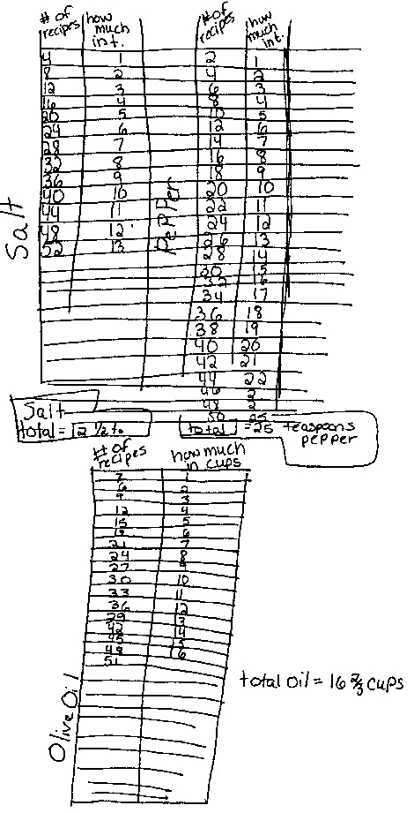

Grade 6 Student Sample 2

It is once again time for the Warren School's annual Harvest Dinner. We are expecting about 300 people. Our class will be making ratatouille for this special event. The ingredients for the recipe we will be using are listed below. If the ingredients listed serve six people, how much of each ingredient do we need to feed 300?
Ratatouille Ingredients - serves 6
¹/₃ cup olive oil | 3 cloves garlic | 1 ¹/₂ large onions
2-3 zucchini | 2 green peppers | 5 ripe tomatoes
¹/₄ teaspoon salt | ¹/₂ teaspoon pepper | black olives
Remember to show all of your work and explain how you arrived at your answer.

Work area for question
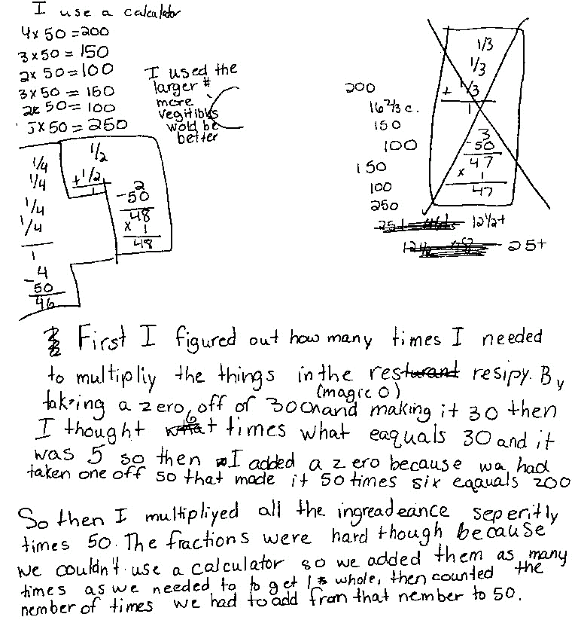

Grade 6 Student Sample 3

It is once again time for the Warren School's annual Harvest Dinner. We are expecting about 300 people. Our class will be making ratatouille for this special event. The ingredients for the recipe we will be using are listed below. If the ingredients listed serve six people, how much of each ingredient do we need to feed 300?
Ratatouille Ingredients - serves 6
¹/₃ cup olive oil | 3 cloves garlic | 1 ¹/₂ large onions
2-3 zucchini | 2 green peppers | 5 ripe tomatoes
¹/₄ teaspoon salt | ¹/₂ teaspoon pepper | black olives
Remember to show all of your work and explain how you arrived at your answer.

Work area for question
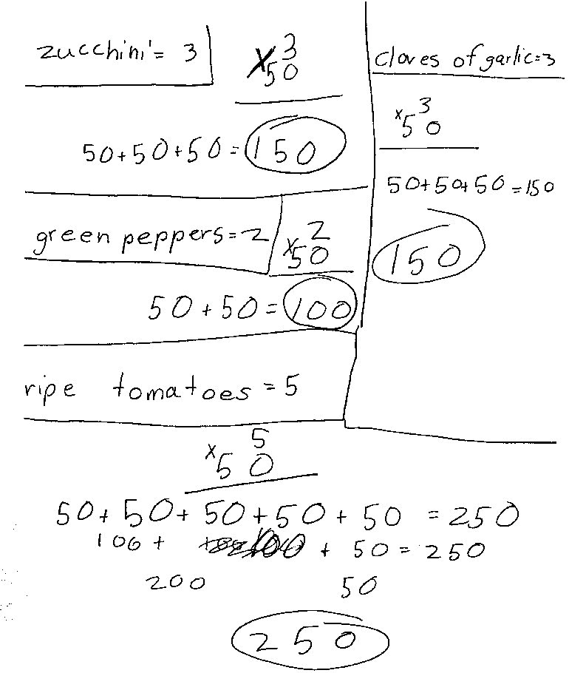

Grade 6 Student Sample 4

It is once again time for the Warren School's annual Harvest Dinner. We are expecting about 300 people. Our class will be making ratatouille for this special event. The ingredients for the recipe we will be using are listed below. If the ingredients listed serve six people, how much of each ingredient do we need to feed 300?
Ratatouille Ingredients - serves 6
¹/₃ cup olive oil | 3 cloves garlic | 1 ¹/₂ large onions
2-3 zucchini | 2 green peppers | 5 ripe tomatoes
¹/₄ teaspoon salt | ¹/₂ teaspoon pepper | black olives
Remember to show all of your work and explain how you arrived at your answer.

Work area for question
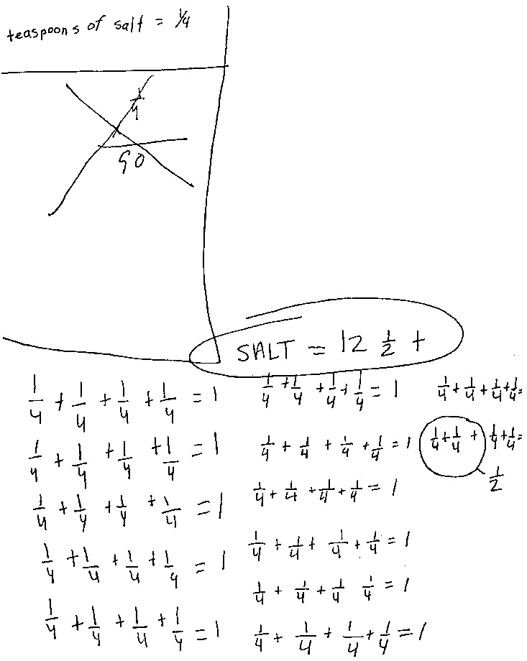

Grade 6 Student Sample 5

It is once again time for the Warren School's annual Harvest Dinner. We are expecting about 300 people. Our class will be making ratatouille for this special event. The ingredients for the recipe we will be using are listed below. If the ingredients listed serve six people, how much of each ingredient do we need to feed 300?
Ratatouille Ingredients - serves 6
¹/₃ cup olive oil | 3 cloves garlic | 1 ¹/₂ large onions
2-3 zucchini | 2 green peppers | 5 ripe tomatoes
¹/₄ teaspoon salt | ¹/₂ teaspoon pepper | black olives
Remember to show all of your work and explain how you arrived at your answer.

Work area for question
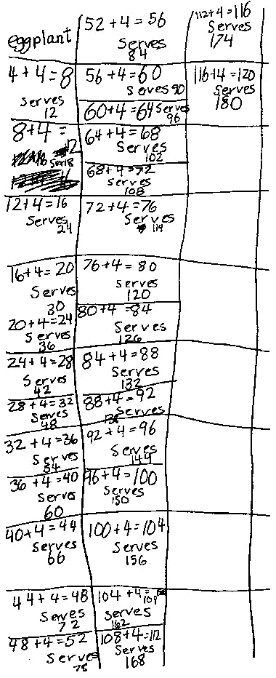

Grade 6 Student Sample 6

It is once again time for the Warren School's annual Harvest Dinner. We are expecting about 300 people. Our class will be making ratatouille for this special event. The ingredients for the recipe we will be using are listed below. If the ingredients listed serve six people, how much of each ingredient do we need to feed 300?
Ratatouille Ingredients - serves 6
¹/₃ cup olive oil | 3 cloves garlic | 1 ¹/₂ large onions
2-3 zucchini | 2 green peppers | 5 ripe tomatoes
¹/₄ teaspoon salt | ¹/₂ teaspoon pepper | black olives
Remember to show all of your work and explain how you arrived at your answer.

Work area for question
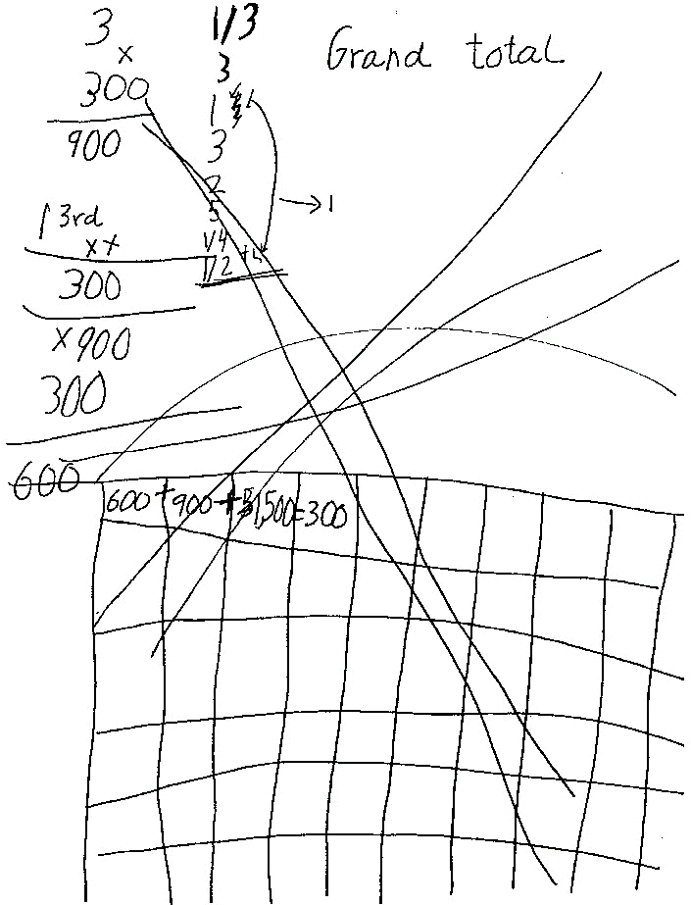

Grade 6 Student Sample 7

It is once again time for the Warren School's annual Harvest Dinner. We are expecting about 300 people. Our class will be making ratatouille for this special event. The ingredients for the recipe we will be using are listed below. If the ingredients listed serve six people, how much of each ingredient do we need to feed 300?
Ratatouille Ingredients - serves 6
¹/₃ cup olive oil | 3 cloves garlic | 1 ¹/₂ large onions
2-3 zucchini | 2 green peppers | 5 ripe tomatoes
¹/₄ teaspoon salt | ¹/₂ teaspoon pepper | black olives
Remember to show all of your work and explain how you arrived at your answer.

Work area for question
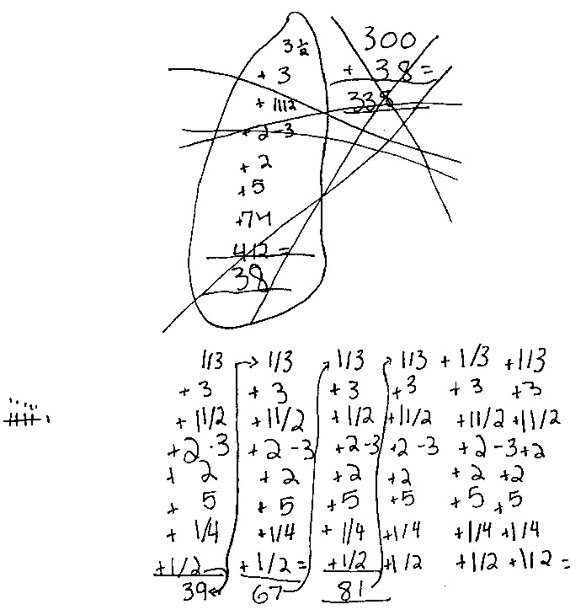

Grade 6 Student Sample 8

It is once again time for the Warren School's annual Harvest Dinner. We are expecting about 300 people. Our class will be making ratatouille for this special event. The ingredients for the recipe we will be using are listed below. If the ingredients listed serve six people, how much of each ingredient do we need to feed 300?
Ratatouille Ingredients - serves 6
¹/₃ cup olive oil | 3 cloves garlic | 1 ¹/₂ large onions
2-3 zucchini | 2 green peppers | 5 ripe tomatoes
¹/₄ teaspoon salt | ¹/₂ teaspoon pepper | black olives
Remember to show all of your work and explain how you arrived at your answer.

Work area for question
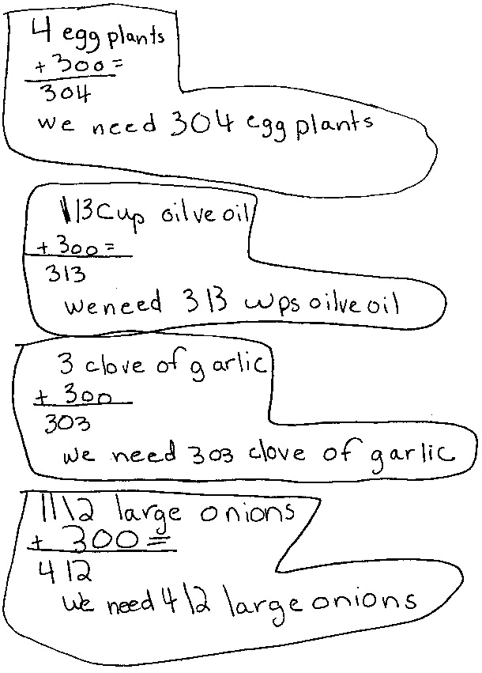

Reference

Instructional Technology (Web Sources)

New Jersey Core Curriculum Content Standards
Cumulative Progress Indicators

Holistic Scoring Guide for Math Open-Ended Items

National Council of Teachers of Mathematics
Principles and Standards

Glossary for Selected Mathematics Terms

Instructional Technology (Web Sources)

Teachers and students who have access to the Internet, and the World Wide Web, can take advantage of a variety of useful sites. These have been selected because they are well -established and impressive.

National Council of Teachers of Mathematics  Contains news and information of interest to math teachers. | http://www.nctm.org
New Jersey State Department of Education  Information on the department’s proposals and regulations, including state testing program. | http://www.state.nj.us/education/
Connected Mathematics Home Page  Information, teacher resources, professional development opportunities, and more for the Connected Math Project | http://www.mth.msu.edu/cmp/
Math Goodies  Interactive math lessons, as well as homework help, puzzles, calculators. | http://www.mathgoodies.com
The Math Forum  A center for teachers, students, parents, and citizens at all levels who have an interest in mathematics education (includes lesson plans, open-ended problems with multiple solutions, homework helper ask Dr. Math, and more). | http://mathforum.org/
Math Stories.com  Offers over 5,000 word problems for K-8 that help students improve their math problem solving and critical-thinking skills. An excellent resource for teachers who need additional, creative problems. | http://www.mathstories.com

New Jersey Core Curriculum Content Standards

The following pages contain the New Jersey Core Standards for mathematics. The vision of these standards revolves around what takes place in classrooms and is focused on achieving one crucial goal:

GOAL: To enable ALL of New Jersey’s children to move into the twenty-first century with the mathematical skills, understandings, and attitudes that they will need to be successful in their careers and daily lives.

The use of the term "all students" in the content standards is intended to convey the idea that these standards are universally achievable.

As more and more teachers incorporate the recommendations of the Mathematics Standards into their teaching, we should be able to see the following results (as described in Mathematics to Prepare Our Children for the 21st Century: A Guide for New Jersey Parents, published by the New Jersey Mathematics Coalition in September 1994.).

- Students who are excited by and interested in their activities.
- Students who are learning important mathematical concepts rather than simply memorizing and practicing procedures.
- Students who are posing and solving meaningful problems.
- Students who are working together to learn mathematics.
- Students who write and talk about math topics every day.
- Calculators and computers being used as important tools of learning.
- Teachers who have high expectations for ALL of their students.
- A variety of assessment strategies rather than sole reliance on traditional short-answer tests.

New Jersey Mathematics Core Standards

4.1 | NUMBER AND NUMERICAL OPERATIONS  All students will develop number sense and will perform standard numerical operations and estimations on all types of numbers in a variety of ways.
4.2 | GEOMETRY AND MEASUREMENT  All students will develop spatial sense and the ability to use geometric properties, relationships, and measurement to model, describe, and analyze phenomena.
4.3 | PATTERNS AND ALGEBRA  All students will represent and analyze relationships among variable quantities and solve problems involving patterns, functions, and algebraic concepts and processes.
4.4 | DATA ANALYSIS, PROBABILITY, AND DISCRETE MATHEMATICS  All students will develop an understanding of the concepts and techniques of data analysis, probability, and discrete mathematics, and will use them to model situations, solve problems, and analyze and draw appropriate inferences from data.
4.5 | MATHEMATICAL PROCESSES  All students will use mathematical processes of problem solving, communication, connections, reasoning, representations, and technology to solve problems and communicate mathematical ideas.
Cumulative Progress Indicators for Grade 6

Bulleted items that appear below expectations indicate terminology, concepts, or content material addressed in that expectation. When an indicator is followed by bulleted content material, the list provided is intended to be exhaustive; content material not mentioned is therefore not included in the expectation at that grade level. When examples are provided, they are always introduced with "e.g." and are not intended to be exhaustive.

Items presented at one grade level are not repeated at subsequent grade levels. Teachers will need to refer to the standards at earlier grade levels to know what topics their students should be assumed to have learned at earlier grades.

Each cumulative progress indicator is assigned a value consisting of the standard, grade level, macro, and indicator. For example, 4.1.6A3 represents Mathematics Standard 4.1 (Number and Numerical Operations), grade 6, macro A (Number Sense), and cumulative progress indicator 3 (demonstrate a sense of the relative magnitude of numbers).

In the suggested pacing and objectives section of this document, each mathematics unit is aligned to the New Jersey Core Curriculum Content Standards. The Cumulative Progress Indicators are listed at the bottom of the table.

Standard 4.1 Number and Numerical Operations

Macro A Number Sense
1. | Use real-life experiences, physical materials, and technology to construct meanings for numbers (unless otherwise noted, all indicators for grade 6 pertain to these sets of numbers as well).  - All integers  - All fractions as part of a whole, as subset of a set, as a location on a number line, and as divisions of whole numbers  - All decimals
2. | Recognize the decimal nature of United States currency and compute with money.
3. | Demonstrate a sense of the relative magnitudes of numbers.
4. | Explore the use of ratios and proportions in a variety of situations.
5. | Understand and use whole-number percents between 1 and 100 in a variety of situations.
6. | Use whole numbers, fractions, and decimals to represent equivalent forms of the same number.
7. | Develop and apply number theory concepts in problem solving situations.  - Primes, factors, multiples  - Common multiples, common factors
8. | Compare and order numbers.
Macro B Numerical Operations
1. | Use real-life experiences, physical materials, and technology to construct meanings for numbers (unless otherwise noted, all indicators for grade 6 pertain to these sets of numbers as well).
2. | Construct, use, and explain procedures for performing calculations with fractions and decimals with:  - Pencil-and-paper  - Mental math  - Calculator
3. | Use an efficient and accurate pencil-and-paper procedure for division of a 3-digit number by a 2-digit number.
4. | Select pencil-and-paper, mental math, or a calculator as the appropriate computational method in a given situation depending on the context and numbers.
5. | Find squares and cubes of whole numbers.
6. | Check the reasonableness of results of computations.
7. | Understand and use the various relationships among operations and properties of operations.
8. | Understand and apply the standard algebraic order of operations for the four basic operations, including appropriate use of parentheses.
Standard 4.1 Number and Numerical Operations

Macro C Estimation
1. | Use a variety of strategies for estimating both quantities and the results of computations.
2. | Recognize when an estimate is appropriate, and understand the usefulness of an estimate as distinct from an exact answer.
3. | Determine the reasonableness of an answer by estimating the result of operations.
4. | Determine whether a given estimate is an overestimate or an underestimate.

Standard 4.2 Geometry and Measurement

Macro A Geometric Properties
1. | Understand and apply concepts involving lines and angles.  - Notation for line, ray, angle, line segment  - Properties of parallel, perpendicular, and intersecting lines  - Sum of the measures of the interior angles of a triangle is 180°
2. | Identify, describe, compare, and classify polygons and circles.  - Triangles by angles and sides  - Quadrilaterals, including squares, rectangles, parallelograms, trapezoids, rhombi  - Polygons by number of sides  - Equilateral, equiangular, regular  - All points equidistant from a given point form a circle
3. | Identify similar figures.
4. | Understand and apply the concepts of congruence and symmetry (line and rotational).
5. | Compare properties of cylinders, prisms, cones, pyramids, and spheres.
6. | Identify, describe, and draw the faces or shadows (projections) of three-dimensional geometric objects from different perspectives.
7. | Identify a three-dimensional shape with given projections (top, front and side views).
8. | Identify a three-dimensional shape with a given net (i.e., a flat pattern that folds into a 3D shape).
Macro B Transforming Shapes
1. | Use a translation, a reflection, or a rotation to map one figure onto another congruent figure.
2. | Recognize, identify, and describe geometric relationships and properties, as they exist in nature, art, and other real-world settings.
Macro C Coordinate Geometry
1. | Create geometric shapes with specified properties in the first quadrant on a coordinate grid.
Macro D Units of Measurement
1. | Select and use appropriate units to measure angles, area, surface area, and volume.
2. | Use a scale to find a distance on a map or a length on a scale drawing.  Convert measurement units within a system (e.g., 3 feet = ___ inches).
3. | Know approximate equivalents between the standard and metric systems (e.g., one kilometer is approximately 6/10 of a mile).
4. | Use measurements and estimates to describe and compare phenomena.
Standard 4.2 Geometry and Measurement

Macro E Measuring Geometric Objects
1. | Use a protractor to measure angles.
2. | Develop and apply strategies and formulas for finding perimeter and area.  - Triangle, square, rectangle, parallelogram, and trapezoid  - Circumference and area of a circle
3. | Develop and apply strategies and formulas for finding the surface area and volume of rectangular prisms and cylinders.
4. | Recognize that shapes with the same perimeter do not necessarily have the same area and vice versa.
5. | Develop informal ways of approximating the measures of familiar objects (e.g., use a grid to approximate the area of the bottom of one's foot).

Standard 4.3 Patterns and Algebra

Macro A Patterns and Relationships
1. | Recognize, describe, extend, and create patterns involving whole numbers and rational numbers.  - Descriptions using tables, verbal rules, simple equations, and graphs  - Formal iterative formulas (e.g., NEXT = NOW * 3)  - Recursive patterns, including Pascal's Triangle (where each entry is the sum of the entries above it) and the Fibonacci Sequence: 1, 1, 2, 3, 5, 8, . . . (where NEXT = NOW + PREVIOUS)
Macro B Functions
1. | Describe the general behavior of functions given by formulas or verbal rules (e.g., graph to determine whether increasing or decreasing, linear or not).
Macro C Modeling
1. | Use patterns, relations, and linear functions to model situations.  - Using variables to represent unknown quantities  - Using concrete materials, tables, graphs, verbal rules, algebraic expressions/equations/inequalities
2. | Draw freehand sketches of graphs that model real phenomena and use such graphs to predict and interpret events.  - Changes over time  - Relations between quantities  - Rates of change (e.g., when is plant growing slowly/rapidly, when is temperature dropping most rapidly/slowly)
Macro D Procedures
1. | Solve simple linear equations with manipulatives and informally.  - Whole-number coefficients only, answers also whole numbers  - Variables on one or both sides of equation
2. | Understand and apply the properties of operations and numbers.  - Distributive property  - The product of a number and its reciprocal is 1
3. | Evaluate numerical expressions.
4. | Extend understanding and use of inequality.  - Symbols ()

Standard 4.4 Data Analysis, Probability, and Discrete Mathematics

Macro A Data Analysis (Statistics)
1. | Collect, generate, organize, and display data.  - Data generated from surveys
2. | Read, interpret, select, construct, analyze, generate questions about, and draw inferences from displays of data.  - Bar graph, line graph, circle graph, table, histogram  - Range, median, and mean  - Calculators and computers used to record and process information
3. | Respond to questions about data, generate their own questions and hypotheses, and formulate strategies for answering their questions and testing their hypotheses.
Macro B Probability
1. | Determine probabilities of events.  - Event, complementary event, probability of an event  - Multiplication rule for probabilities  - Probability of certain event is 1 and of impossible event is 0  - Probabilities of event and complementary event add up to 1
2. | Determine probability using intuitive, experimental, and theoretical methods (e.g., using model of picking items of different colors from a bag).  - Given numbers of various types of items in a bag, what is the probability that an item of one type will be picked  - Given data obtained experimentally, what is the likely distribution of items in the bag
3. | Explore compound events.
4. | Model situations involving probability using simulations (with spinners, dice) and theoretical models.
5. | Recognize and understand the connections among the concepts of independent outcomes, picking at random, and fairness.
Macro C Discrete Mathematics - Systematic Listing and Counting
1. | Solve counting problems and justify that all possibilities have been enumerated without duplication.  - Organized lists, charts, tree diagrams, tables  - Venn diagrams
2. | Apply the multiplication principle of counting.  - Simple situations (e.g., you can make 3 x 4 = 12 outfits using 3 shirts and 4 skirts).  - Number of ways a specified number of items can be arranged in order (concept of permutation)  - Number of ways of selecting a slate of officers from a class (e.g., if there are 23 students and 3 officers, the number is 23 x 22 x 21)
3. | List the possible combinations of two elements chosen from a given set (e.g., forming a committee of two from a group of 12 students, finding how many handshakes there will be among ten people if everyone shakes each other persons hand once).

Standard 4.4 Data Analysis, Probability, and Discrete Mathematics

Macro D Discrete Mathematics - Vertex-Edge Graphs and Algorithms
1. | Devise strategies for winning simple games (e.g., start with two piles of objects, each of two players in turn removes any number of objects from a single pile, and the person to take the last group of objects wins) and express those strategies as sets of directions.
2. | Analyze vertex-edge graphs and tree diagrams.  - Can a picture or a vertex-edge graph be drawn with a single line? (degree of vertex)  - Can you get from any vertex to any other vertex? (connectedness)
3. | Use vertex-edge graphs to find solutions to practical problems.  - Delivery route that stops at specified sites but involves least travel  - Shortest route from one site on a map to another

Standard 4.5 Mathematical Processes

Macro A Problem Solving
1. | Learn mathematics through problem solving, inquiry, and discovery.
2. | Solve problems that arise in mathematics and in other contexts  - Open-ended problems  - Non-routine problems  - Problems with multiple solutions  - Problems that can be solved in several ways
3. | Select and apply a variety of appropriate problem-solving strategies (e.g., "try a simpler problem" or "make a diagram") to solve problems.
4. | Pose problems of various types and levels of difficulty.
5. | Monitor their progress and reflect on the process of their problem solving activity.
Macro B Communication
1. | Use communication to organize and clarify their mathematical thinking.  - Reading and writing  - Discussion, listening, and questioning
2. | Communicate their mathematical thinking coherently and clearly to peers, teachers, and others, both orally and in writing.
3. | Analyze and evaluate the mathematical thinking and strategies of others.
4. | Use the language of mathematics to express mathematical ideas precisely.
Macro C Connections
1. | Recognize recurring themes across mathematical domains (e.g., patterns in number, algebra, and geometry).
2. | Use connections among mathematical ideas to explain concepts (e.g., two linear equations have a unique solution because the lines they represent intersect at a single point).
3. | Recognize that mathematics is used in a variety of contexts outside of mathematics.
4. | Apply mathematics in practical situations and in other disciplines.
5. | Trace the development of mathematical concepts over time and across cultures (world languages and social studies standards).
6. | Understand how mathematical ideas interconnect and build on one another to produce a coherent whole.
Macro D Reasoning
1. | Recognize that mathematical facts, procedures, and claims must be justified.
2. | Use reasoning to support their mathematical conclusions and problem solutions.
3. | Select and use various types of reasoning and methods of proof.
4. | Rely on reasoning, rather than answer keys, teachers, or peers, to check the correctness of their problem solutions.
5. | Make and investigate mathematical conjectures.  - Counterexamples as a means of disproving conjectures  - Verifying conjectures using informal reasoning or proofs
6. | Evaluate examples of mathematical reasoning and determine whether they are valid.

Standard 4.5 Mathematical Processes

Macro E Representations
1. | Create and use representations to organize, record, and communicate mathematical ideas.  - Concrete representations (e.g., base-ten blocks or algebra tiles)  - Pictorial representations (e.g., diagrams, charts, or tables)  - Symbolic representations (e.g., a formula)  - Graphical representations (e.g., a line graph)
2. | Select, apply, and translate among mathematical representations to solve problems.
3. | Use representations to model and interpret physical, social, and mathematical phenomena.

Macro F Technology
1. | Use technology to gather, analyze, and communicate mathematical information.
2. | Use computer spreadsheets, software, and graphing utilities to organize and display quantitative information.
3. | Use graphing calculators and computer software to investigate properties of functions and their graphs.
4. | Use calculators as problem-solving tools (e.g. to explore patterns, to validate solutions)
5. | Use computer software to make and verify conjectures about geometric objects.
6. | Use computer-based laboratory technology for mathematical applications in the sciences.

Holistic Scoring Guide for Mathematics Open-Ended Items
(Generic Rubric)

The generic rubric below is used as a guide to develop specific scoring guides or rubrics for each of the open-ended items, which appear on the grade eight proficiency assessment (GEPA) in mathematics. The generic rubric helps insure that students are scored in the same way for the same demonstration of knowledge and skills regardless of the test question.

3-Point Response
The response shows complete understanding of the problem’s essential mathematical concepts. The student executes procedures completely and gives relevant responses to all parts of the task. The response contains few minor errors, if any. The response contains a clear, effective explanation detailing how the problem was solved so that the reader does not need to infer how and why decisions were made.

2-Point Response
The response shows nearly complete understanding of the problem’s essential mathematical concepts. The student executes nearly all procedures and gives relevant responses to most parts of the task. The response may have minor errors. The explanation detailing how the problem was solved may not be clear, causing the reader to make some inferences.

1-Point Response
The response shows limited understanding of the problem’s essential mathematical concepts. The response and procedures may be incomplete and/or may contain major errors. An incomplete explanation of how the problem was solved may contribute to questions as to how and why decisions were made.

0-Point Response
The response shows insufficient understanding of the problem’s essential mathematical concepts. The procedures, if any, contain major errors. There may be no explanation of the solution or the reader may not be able to understand the explanation. The reader may not be able to understand how and why decisions were made.

National Council of Teachers of Mathematics
Principles and Standards

In the National Council of Teachers of Mathematics document Principles and Standards for School Mathematics, six principles are identified as overarching themes:

The Equity Principle
Excellence in mathematics education requires equity – high expectations and strong support for all students.

The Curriculum Principle
A curriculum is more than a collection of activities: it must be coherent, focused on important mathematics, and well articulated across the grades.

The Teaching Principle
Effective mathematics teaching requires understanding what students know and need to learn and then challenging and supporting them to learn it well.

The Learning Principle
Students must learn mathematics with understanding, actively building new knowledge from experience and prior knowledge.

The Assessment Principle
Assessment should support the learning of important mathematics and furnish useful information to both teachers and students.

The Technology Principle
Technology is essential in teaching and learning mathematics; it influences the mathematics that is taught and enhances students’ learning.

Visit the Standards 2000 web site at http://nctm.org/standards/

Glossary for Selected Mathematics Terms

ABSOLUTE VALUE | The absolute value of a number is its distance from 0 on a number line. It can be thought of as the value of a number when its sign is ignored. For example, -3 and 3 both have an absolute value of 3.
ALGORITHM | An algorithm is a set of rules for performing a procedure. Some examples of algorithms are the rules for long division or the rules for adding two fractions.
ANGLE | The opening between two straight lines that meet at a vertex, measured in degrees or radians.
AREA | The measure of the amount of surface enclosed by the sides of a figure.
AXIS, AXES | The number lines that are used to make a graph. There are usually two axes perpendicular to each other.
BAR GRAPH | A graphic representation of a table (discrete or counted data) in which the height of each bar indicates its value or frequency. Bar graphs may be used to display categorical or numerical data.
BASE | The bottom of a three-dimensional shape.
BASE PLAN | A drawing of the base outline of a building with a number on each square indicating the number of cubes in the stack at that position.
BASE TEN NUMBER SYSTEM | The base ten number system is the common number system we use. Our number system is based on the number 10 because we have ten fingers with which to group.
BENCHMARK | A benchmark is a “nice” number that can be used to estimate the size of other numbers. For work with fractions, 0, , and 1 are good benchmarks. We often estimate fractions or decimals with benchmarks because it is easier to do arithmetic with them, and estimates often give enough accuracy for the situation.
BUILDING MAT | A sheet of paper labeled “Front”, “Back”, “Left”, and “Right” on which cube buildings are constructed.
CATEGORICAL DATA | Values that are “words” that represent possible responses within a given category. For example, months of a year or favorite color to wear.

CERTAIN EVENT | An event that is bound to happen – for example, the sun rising tomorrow. The probability of a certain outcome is 1.
CHANCES | The likelihood that something will happen. For example, “What are the chances that it will rain tomorrow?”
CHANGE | To become different. For example, temperatures rise and fall, and prices increase and decrease. In mathematics, quantities that change are called variables.
CIRCLE | A two-dimensional object in which every point is the same distance from a point (not on the circle) called the center.
CIRCUMFERENCE | The distance around (or perimeter of) a circle.
COEFFICIENT | A number that is multiplied by a variable in an equation or expression. In a linear equation of the form y=mx+b, the coefficient, m, of x is the slope of the graph of the line. For example, in the equation y=3x+5, the coefficient of x is 3.
COMMON FACTOR | A factor that two or more numbers share. For example, 7 is a common factor of 14 and 35.
COMMON MULTIPLE | A multiple that two or numbers share. For example, two common multiples of 5 and 7 are 35 and 70.
COMPARE | When we compare objects, we examine them to determine how they are alike and how they are different. We compare when we classify objects by size, color, weight, or shape. We compare when we decide that two figures have the same shape or that they are not similar.
COMPOSITE NUMBER | A whole number with factors other than itself and 1 (i.e., a whole number that is not prime). Some composite numbers are 6, 12, 20, and 1001.
CONE | A three-dimensional shape with a circular end and a pointed end.
CONGRUENT FIGURES | Two figures are congruent if one is an image of the other under a translation, a reflection, a rotation, or some combination of these transformations. Put more simply, two figures are congruent if you can slide, flip, or turn one figure so that it fits exactly on the other.
CONSTANT TERM | A number in an equation that is not multiplied by a variable – an amount added to or subtracted from the terms involving variables.

COORDINATE GRAPH | A graphic representation of pairs of related numerical values. The data are sorted into pairs of numbers with each pair associated with one percent (for example, height and arm span of each person measured) or object (for example, length and width of different-sized rectangles).
COORDINATE PAIR | An ordered pair of numbers used to locate a point on a coordinate grid. The first number in a coordinate pair is the value for the x-coordinate, and the second number is the value for the y-coordinate.
CORRESPONDS | Corresponding sides or angles have the same relative position in similar figures.
COUNTING TREE | A diagram used to determine the number of possible outcomes in a probability situation. The number of final branches is equal to the number of possible outcomes.
CUBE | A three-dimensional shape with six identical square faces.
CUSTOMARY SYSTEM | A complex measurement system that originated primarily in the British empire and includes the units of measure inch, yard, pound, and gallon. The system was in use in the United States from the nation’s beginnings and is still used today in many situations.
CYLINDER | A three-dimensional shape with two opposite faces that are congruent circles. A rectangle (the lateral surface) is “wrapped around” the circular ends.
DATA | Values such as counts, ratings, measurements, or opinions that are gathered to answer questions.
DECIMAL | A decimal, or decimal fraction, is a special form of a fraction. Decimals are based on the base ten place-value system.
DEGREE | A unit of measure of angles equal to of a complete circle.
DENOMINATOR | The denominator is the number written below the line in a fraction. In the part-whole interpretation of fractions, the denominator shows the number of equal-size parts into which the whole has been split.
DEPENDENT VARIABLE | One of the two variables in a relationship. Its value depends upon or is determined by the other variable, called the independent variable. For example, the cost of a long-distance phone call (dependent variable) depends on how long you talk (independent variable).
DIAGONAL | A line segment connecting two nonadjacent vertices of a polygon.
DIAMETER | A segment that goes from one point on a circle, through the center, to another point on the circle. The length of this segment is also called the diameter.
DIMENSIONS | The dimensions of a rectangle are its length and its width.
DISTANCE/TIME  RATE OF SPEED | The relationship of these terms can be defined as: distance d is determined by multiplying the rate r by the time t, or d=rt. For example, If you drive a car 55 miles per hour (rate) for 3 hours (time), you will travel 165 miles (distance).
DIVISOR | A factor.
EDGE | The line segment formed where two sides of the polygons that make up the faces of a three-dimensional shape meet.
EQUALLY LIKELY EVENTS | Two or more events that have the same chance of happening. For example, when you toss a fair coin heads and tails are equally likely; each has a 50% chance of happening.
EQUATION, FORMULA | A rule containing variables that represents a mathematical relationship. An example is the formula for finding the area of a circle: .
EQUATION MODEL | An equation that describes the relationship between two variables. An equation model allows you to make predictions about values between and beyond the values in a set of data.
EQUILATERAL TRIANGLE | A triangle with all three sides the same length.
EQUIVALENT FRACTIONS | Equivalent fractions are equal in value but have different numerators and denominators. For example, and are equivalent fractions.
EVEN NUMBER | A multiple of 2. Examples of even numbers are 2, 4, 6, 8, and 10.
EVENT | A set of outcomes. For example, when two coins are tossed, getting two matching coins is an event consisting of the outcomes HH and TT.
EXPECTED VALUE | The average payoff over many trials. For example, suppose you are playing a game with two number cubes in which you score 2 points when a sum of 6 is rolled, 1 point for a sum of 3, and 0 points for anything else. If you were to roll the cubes 36 times, you would expect to roll a sum of 6 about 5 times and a sum of 3 about twice. This means that you could expect to score (5x2)+(2x1)=12 points for 36 rolls, an average of point per roll. One-third is the expected value of a roll.
EXPERIMENTAL PROBABILITY | A probability that is found through experimentation. Experimental probabilities are used to predict what might happen over the long run.
EXPONENT | The small raised number that tells how many times a factor is used. For example, means .
FACE | A polygon that forms one of the flat surfaces of some three-dimensional shapes.
FACTOR | One of two or more numbers that are multiplied to get a product. For example, 13 and 4 are both factors of 52 because .
FAIR GAME | A game in which each player has the same chance of winning. A game that is not fair can be made fair by adjusting the scoring system.
FAVORABLE OUTCOME | An outcome in which you are interested. A favorable outcome is sometimes called a success. For example, when you toss two coins to find the probability of the coins matching, HH and TT are favorable outcomes.
FLAT PATTERN | An arrangement of attached polygons that can be folded into a three-dimensional shape.
FRACTION | A number (a quantity) of the form where a and b are whole numbers. A fraction can indicate a part of a whole object or set, a ratio of two quantities, or a division.
FULCRUM | The balance point of a teeter-totter.
FUNCTION | A relationship (usually) between two variables. A relationship is a function if there is only one value of the second variable for each value of the first variable. For example, distance depends on, or is a function of, time: the distance traveled depends on the time.
FUNDAMENTAL THEOREM OF ARITHMETIC | The theory stating that, except for the order of the factors, a whole number can be factored into prime factors in only one way.
GRAPH MODEL | A straight line or curve that represents a mathematical relationship. If the data plotted shows a trend, you can draw a graph model that fits the pattern of change in the data. A graph model allows you to make predictions about values between and beyond the values in a set of data.
HYPOTENUSE | The side of a right triangle that is opposite the right angle. They hypotenuse is the longest side of a right triangle.
IMAGE | An image is the figure that results from some transformation of a figure. It is often of interest to consider what is the same and what is different between a figure and its image.
IMPOSSIBLE EVENT | An event that cannot happen. For example, the probability of putting a quarter in a gumball and getting the moon is zero.
INDEPENDENT VARIABLE | One of the two variables in a relationship. Its value determines the value of the other variable, called the dependent variable. If you organize a bike tour, for example, the number of people who register (independent variable) determines the cost for renting bikes (dependent variable).
INTEGER | The integers are the whole numbers and their opposites. The integers from –4 to 4 are {-4, -3, -2, -1, 0, 1, 2, 3, 4}.
INVERSE RELATIONSHIP | A nonlinear relationship in which the product of two variables is a constant. In an inverse relationship, the values of one variable decrease as the values of the other variable increase.
IRRATIONAL NUMBER | A number that cannot be written as a fraction with a numerator and a denominator that are integers. The decimal representation of an irrational number never ends and never shows a repeating pattern of digits. The numbers , , and are examples of irrational numbers.
ISOMETRIC DOT PAPER | Dot paper in which the distances from a dot to each of the six surrounding dots are all equivalent. The word isometric comes from the Greek words iso, which means “same”, and metric, which means “measure”.
ISOSCELES TRIANGLE | A triangle with two sides the same length.
KALEIDOSCOPE | A tube containing colored beads or pieces of glass and carefully placed mirrors. When a kaleidoscope is held to the eye and rotated, the viewer sees colorful, symmetric patterns.
LAW OF LARGE NUMBERS | This law states, in effect, that the more trials of an experiment that are conducted, the more the experimental probability will approximate the theoretical probability.
LINEAR DIMENSIONS | Linear measurements, such as length, width, base, and height, describe the size of figures.
LINEAR RELATIONSHIP | A relationship in which there is a constant rate of change between two variables. A linear relationship can be represented by a straight-line graph and by an equation of the form . In the equation, is the slope of the line, and is the y-intercept.
LINE PLOT | A quick, simple way to organize data along a number line where the symbols above a number represent the frequency tally of data for that value of the data.
LINE REFLECTION | A transformation that matches each point on a figure with its mirror image over a line. If you drew a line segment from a point to its image, the segment would be perpendicular to and bisected by the line of reflection.
LINE OF SYMMETRY | A line through a figure so that if the figure were folded on the line, the two parts of the figure would match up exactly.
MATHEMATICAL MODEL | A mathematical representation, such as a graph or an equation, of the relationship in a set of data.
MAXIMAL BUILDING | The building satisfying a given set of building plans and having the greatest possible number of cubes. The maximal building for a set of plans is unique.
MEAN | Of a distribution, a value calculated from the data. It can be thought of as a number that represents the central tendency of the data.
MEDIAN | Of a distribution, the numerical value that marks the middle of an ordered set of data. Half the data occur above the median, and half the data occur below the median.
METRIC SYSTEM  (SI SYSTEM) | A measurement system used throughout the world that is based on the power of 10. The basic units of length, volume, and mass are the meter, liter, and gram, respectively.
MINIMAL BUILDING | A building satisfying a given set of plans and having the least possible number of cubes. The minimal building for a set of plans is not necessarily unique.
MODE | Of a distribution, the category or numerical value that occurs most often. It is possible to have more than one mode or no mode.
MULTIPLE | The product of a given whole number and another whole number. For example, 12 is a multiple of 3, and 3 is a factor of 12.
NEGATIVE INTEGER | A negative integer is an integer less than 0. On a number line, negative numbers are located to the left of 0 (on a vertical number line, negative numbers are located below 0.)
NUMBER SENTENCE | A number sentence gives the relationship between two expressions, which are composed of numbers and operation signs. For example, and are number sentences; and 10 are expressions.
NUMERATOR | The numerator is the number written above the line in a fraction. When you interpret fractions as a part of a whole, the numerator tells the number of parts in the whole.
NUMERICAL DATA | Values that are numbers such as counts, measurements, and ratings. For example, numbers of children in families or how much time people spend reading in one day.
OBLIQUE PRISM | A prism whose vertical faces are not all rectangles.
ODD NUMBER | A whole number that is not a multiple of 2. Examples of odd numbers are 1, 3, 5, 7, and 9.
OPPOSITES | Two numbers that add to 0 are called opposites. For example, -3 and 3 are opposites. On a number line, opposites are the same distance  but in different directions from 0. The number 0 is its own opposite.
ORIGIN | The point where the x- and y-axes intersect on a coordinate graph. With coordinates (0, 0), the origin is the center of the coordinate plane.
OUTCOME | A possible result of an action. For example, when one number cube is rolled, the possible outcomes are 1, 2, 3, 4, 5, and 6.
OUTLIER | One or more values that lie “outside” of a distribution of the data. An outlier is a value that may be questioned because it is unusual or because there may have been an error in recording or reporting the data.
PARALLEL LINES | Lines that never meet no matter how long they are extended.
PARALLELOGRAM | A quadrilateral in which both pairs of opposite sides are equal and parallel.
PATTERN | A change that occurs in a predictable way.
PAYOFF | The number of points (or dollars or the like) a player in a game receives for a particular event.
PERCENT | Percent means “out of 100.” A percent is a special decimal fraction in which the denominator is 100.
PERIMETER | The measure of the distance around a figure. Perimeter is a measure of length.
PERPENDICULAR | Meeting at right angles. For example, the sides of a right triangle that form the right angle are perpendicular.
POINT OF INTERSECTION | The point where two graphs cross. We are usually interested in the coordinates of this point because those x and y values are solutions to both equations. The graphs of the equations and intersect at the point (3, 3). This ordered pair is a solution to each equation.
POLYGON | A closed, flat (two-dimensional) shape whose sides are formed by line segments.
POPULATION DENSITY | The population density is the average number of things (people, animals, and so on) per unit of area (or less commonly, the average amount of space per person or animal). Population density indicates how crowded a region is and can be calculated as the ratio population/area.
POSITIVE INTEGER | A positive integer is an integer greater than 0. (The number 0 is neither positive nor negative.)
POSSIBLE | A word used to describe an event that can happen. “Possible” does not imply anything about how likely the outcome is. For example, it is possible to toss a coin 200 times and get heads every time, but it is not at all likely.
PRISM | A three-dimensional shape with a top and a bottom that are congruent polygons and faces that are parallelograms.
PROBABILITY | A number between 0 and 1 that describes the likelihood that an event will occur. For example, if a bag contains a red marble, a white marble, and a blue marble, then the probability of drawing a red marble is .
PROBABLE | Another way to say likely. An event that is probable is likely to happen.
PROPERTIES OF SHAPES | Characteristics of shapes that are always valid.
PROPORTION | An equation stating that two ratios are equal.
PYTHAGOREAN THEOREM  b  a  c | A statement about the relationship between the lengths of the sides of a right triangle. The theorem states that if a and b are the lengths of the legs of a right triangle and c is the length of the hypotenuse, then .
QUADRANT | The quadrants are the four sections into which the coordinate plane is divided.
QUADRILATERAL | A polygon with four sides.
RADIUS | A segment from the center of a circle to a point on the circle. The length of this segment is also called the radius. The radius is half the diameter. The plural of radius is radii. All the radii of a circle have the same length.
RANDOM EVENTS | Events that are uncertain when viewed individually but which may exhibit a regular pattern when observed over many trials.
RANGE | The range of a distribution is computed by stating the lowest and highest values. Less frequently, the range is computed by finding the difference between the lowest and highest values.
RANGE OF VALUES | Those values for the variables that make sense for the data being considered. You use the range when you ask yourself these questions before making a graph a set of data: What are the values of the data that will fit on the graph? What scale must I choose for the graph so that all of the data will fit?
RATE | A comparison of the measurements of two different units or objects is called a rate. A rate can be thought of as a direct comparison of two sets (20 cookies for 5 children) or as an average amount (4 cookies per child).
RATIO | A ratio is a comparison of two quantities that tells the scale between them. Ratios may be expressed as quotients, fractions, decimals, percents, or given in the form a:b.
RATIONAL NUMBER | A number that can be written as a fraction with a numerator and a denominator that are integers. The decimal representation of a rational number either ends or repeats. Examples of rational numbers are , , 7, 0.2, and .191919.
REAL NUMBERS | The set of all rational numbers and all irrational numbers. The number line represents the set of real numbers.
RECIPROCAL | A factor by which you can multiply a given number so that their product is 1. The reciprocal of is because .
RECTANGLE | A parallelogram with all right angles.
RECTANGULAR PRISM | A prism with a top and bottom that are congruent rectangles.
REFLECTIONAL SYMMETRY | A figure or design has reflectional symmetry if you can draw a line that divides the figure into halves that are mirror images. The line that divides the figure into halves is called the line of symmetry.
REGULAR POLYGON | A polygon that has all of its sides equal and all of its angles equal.
RELATIONSHIP | An association between two variables. A relationship can be represented in a graph, in a table, or with an equation.
REPEATING DECIMAL | A decimal with a pattern of digits that repeats forever, such as 0.333333… and 0.737373… Repeating decimals are rational numbers.
RIGHT ANGLE | An angle that measures . All of the vertices in a rectangle are right angles.
RIGHT PRISM | A prism whose vertical faces are rectangles.
RHOMBUS | A quadrilateral that has all sides the same length.
RISE | The vertical change between two points. When calculating the slope of a line, the rise is the numerator in the ratio.
ROTATION | A transformation that turns a figure counterclockwise about a point.
ROTATIONAL SYMMETRY | A figure or design has rotational symmetry if it can be rotated less than a full turn about a point to a position in which it looks the same as the original.
RULE | A summary of a predictable relationship that tells how to find the value of a variable. It is a pattern that is consistent enough to be written down, made into an equation, graphed, or made into a table.
RUN | The horizontal change between two points. When calculating the slope of a line, the run is the denominator in the ratio.
SAMPLE SPACE | The set of all possible outcomes in a probability situation. When you flip two coins, the sample space consists of four outcomes: HH, HT, TH, and TT.
SCALE | The size of the unit used to calibrate the vertical axis number line (and the horizontal axis number line when the data are numerical) of a plot or graph.
SCALE FACTOR | The scale factor shows the ratio of the lengths of similar figures. The scale factor can be given as a fraction, a decimal, or a percent. If the scale factor is positive, but less than 1, the image is smaller than the original figure. If the scale factor is larger than 1, the image is larger than the original figure.
SCIENTIFIC NOTATION | An abbreviated way to write very large or very small numbers.
SET OF BUILDING PLANS | A set of three diagrams – the front view, the right view, and the base outline.
SIDE | One of the line segments that make up the boundaries of a polygon.
SIMILAR | Similar figures have the same shape. Two figures are mathematically similar if and only if their corresponding angles are equal and the ratios of all pairs of corresponding sides are equal. There is a single scale by which all sides of the smaller figure "stretch” or “shrink” into the corresponding sides of the larger figure.
SLOPE | The number that relates the steepness of a line. The slope is the ratio of the vertical change to the horizontal change between any two points on the line. Sometimes this ratio is referred to as the rise over the run. The slope of a horizontal line is 0. The slope of a vertical line is undefined. Slopes are positive if the y values increase from left to right on a coordinate grid and negative if the y values decrease from left to right.
SPHERE | A three-dimensional shape, such as a ball, whose surface consists of all the points that are a given distance from the center of the shape.
SQUARE | A rectangle with all sides equal. Thus squares have four right angles and four equal sides.
SQUARE ROOT | If , then s is the square root of A. For example, -3 and 3 are square roots of 9 because and . The symbol is used to denote the positive square root. So we write .
STANDARD NOTATION | The most common form of written numbers. For example, 254 is the standard notation for 2 hundreds, 5 tens, and 4 ones.

STEEPNESS | The incline of a line.
STEM-AND-LEAF PLOT (STEM PLOT) | A quick way to picture the shape of a distribution while including the actual numerical values in the graph. The stem of the plot is a vertical number line that represents a range of data values in a specified interval. The leaves are the numbers that are attached to the particular stem values.
SURFACE AREA | The area required “to cover” a three-dimensional shape. In a prism, it is the sum of the areas of all the surfaces.
SURVEY | A method for data collection that usually employs written answers or interviews. Surveys ask one or more questions seeking information such as facts, opinions, or beliefs.
SYMBOLIC FORM | Anything written or expressed through the use of symbols. In mathematics, for example, letters and numbers are often used to represent a rule rather than words.
SYMMETRY | An object or design has symmetry if part of it is repeated to create a balanced pattern.
TABLE | A tool for organizing information in rows and columns. Tables let you list categories or values and then tally the occurrences.
TERMINATING DECIMAL | A decimal that ends, or terminates, such as 0.5 or 0.125. Terminating decimals are rational numbers.
TESSELLATION | A design made from copies of a basic design element that cover a surface without gaps or overlaps. Tessellations have translational symmetry.
THEORETICAL PROBABILITY | Probability found by analyzing a situation mathematically. If all the outcomes are equally likely you can first list all the possible outcomes, and then find the ratio of the number of successes to the total number of possible outcomes.
TILING | Also called a tessellation. The filling of a plane surface with geometric shapes without gaps or overlaps.
TRANSFORMATION | A geometric operation that matches each point on a figure with an image point. A symmetry transformation produces an image that is identical in size and shape to the original figure.
TRANSLATION | A transformation that slides each point on a figure to an image point a given distance and direction from the original point.
TRANSLATIONAL SYMMETRY | A design has translational symmetry if it can be created by copying and sliding a basic shape in a regular pattern. Translational symmetry is usually found in wallpaper designs and tessellations.
TRAPEZOID | A quadrilateral with one pair of opposite sides parallel. This definition implies that parallelograms are trapezoids.
TRIAL | One round of an experiment.
UNIQUE | One of a kind.
UNIT CUBE | A cube with all edges equal to one unit in length. It is the basic unit of measurement for volume.
UNIT FRACTION | A unit fraction is a fraction with a numerator of 1.
UNIT RATE | A unit rate compares an amount to a single unit. For example, 1.9 children per family and 32 mpg are unit rates. Unit rates are often found by scaling other rates.
VARIABLE | A quantity that can change. Letters are often used as symbols to represent variables in rules or equations that describe patterns.
VERTEX | The corners of a polygon.
VOLUME | The amount of space, or the capacity, of a three-dimensional shape. It is the number of unit cubes that will fit into a three-dimensional shape.
X-AXIS | The number line that is horizontal on a coordinate grid.
X-INTERCEPT | The point where a graph crosses the x-axis. (These numbers are also called the roots or the zeros of the equation. A linear equation has only one root, which means it crosses the x-axis only once.)
Y-AXIS | The number line that is vertical on a coordinate grid.
Y-INTERCEPT | The point where the graph crosses the y-axis. This number is the constant, b, in a linear equation of the form .
ZIGGURAT | A pyramid-shaped building made up of layers in which each layer is a square smaller than the square beneath it.

