Mathematics Assessment Anchor Glossary
Grades 3 & 4

The definitions for this glossary were taken from one or more of the following sources: Webster’s Dictionary, various mathematics dictionaries, the PA Mathematics Standards glossary and various textbook glossaries.

Acute angle: An angle with a measure less than 90°.

Addend: Any number that is being added.

Analog time: Time displayed on a timepiece having hour and minute hands.

Area: The measure, in square units, of the inside of a plane figure.

Array: A rectangular arrangement of objects in equal rows or columns.

Combination: A group of items. Placing these items in a different order does not create a new combination.

Cone: A solid figure that has a circular base and one vertex.
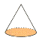
Congruent: Having the same size and shape.
- Congruent angles have the same measure.
- Congruent segments have the same length.

Cube: A rectangular solid having six congruent square faces.
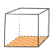

Cylinder: A three-dimensional figure with two circular bases, which are parallel and congruent.
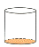

Edge: The line segment where two faces of a solid figure meet.

Equation: A statement that two mathematical expressions are equal.

Equivalent: Having the same value.

Expression: A variable, or any combination of numbers, variables, and symbols that represents a mathematical relationship (e.g., 24 x 2 + 5 or 4a – 9).

Face: A plane figure that serves as one side of a solid figure.

Fact family: A set of related addition and subtraction, or multiplication and division equations using the same numbers (e.g., 6+9=15, 15-9=6, 9+6=15, 15-6=9).

Factor: A whole number that divides evenly into another whole number (e.g., 1, 3, 5, and 15 are factors of 15).

Function: A relation in which every input value has a unique output value.

Hexagon: A polygon with 6 sides.

Inequality: A mathematical sentence that contains a symbol that shows the terms on either side of the symbol are unequal (e.g., 3+4>6).

Line: A straight path extending in both directions with no endpoints.

Line of symmetry: A line that divides a figure into two halves that are mirror images of each other.

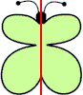

Line segment: A part of a line with two endpoints.
Mean (average): The number found by dividing the sum of a set of numbers by the number of addends.

Median: The middle number in an ordered set of data, or the average of the two middle numbers when the set has two middle numbers.

Mode: The number(s) that occurs most often in a set of data.

Multiples: The product of a given whole number and another whole number (e.g., multiples of 4 are 4, 8, 12, 16….).

Number sentence: An equation or inequality with numbers.

Obtuse angle: An angle with a measure more than 90º.

Octagon: A polygon with 8 sides.

Ordered pair: A pair of numbers used to locate a point on a coordinate grid. The first number tells how far to move horizontally, and the second number tells how far to move vertically.

Parallel lines: Lines that never intersect and are always the same distance apart.

Parallelogram: A quadrilateral whose opposite sides are parallel and congruent.



Pentagon: A polygon with 5 sides.
Perimeter: The distance around a figure.

Perpendicular lines: Two lines, segments or rays that intersect to form right angles.

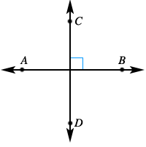

Pictograph: A graph that uses pictures to show and compare information.

Pyramid: A solid figure with a polygon base and triangular sides that meet at a single point (vertex).
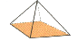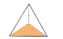
rectangular pyramid triangular pyramid

Quadrilateral: A polygon with 4 sides.

Ray: A part of a line that has one endpoint and continues without end in one direction.

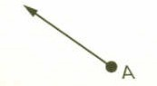

Rectangular prism: A solid figure in which all six faces are rectangles.
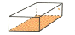

Reflection (flip): A transformation that produces the mirror image of a figure.

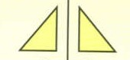

Rhombus: A parallelogram with four equal sides.
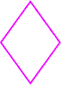

Right angle: An angle that measures exactly 90º.

Right triangle: A triangle that has a 90º angle.

Rotation (turn): A movement of a figure that turns that figure around a fixed point.

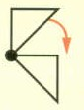

Sphere: A solid figure that has all points the same distance from the center.

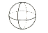

Tally chart: A table that uses tally marks to record data.

Favorite School Lunches
Hamburger
Pizza
Salad
Hotdog

Translation (slide): A movement of a figure to a new position without turning or flipping it.
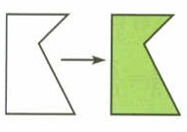
Trapezoid: A quadrilateral with exactly one pair of parallel sides.



Vertex: A point where lines, rays, sides of a polygon or edges of a polyhedron meet (corner).

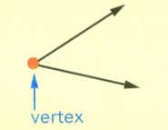 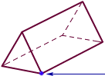vertex

Volume (capacity): The amount of space (in cubic units) that a solid figure can hold.

