
OFFICE OF CURRICULUM
Nicole Santora, Ed.D.
Assistant Superintendent of
Curriculum & Human Resources
nicolesantora@mersnj.us

Supervisors
Cindy Pope, Ed.D. Greg Schmidt
Language Arts/BSI/ELL Mathematics/BSI

Margaret Scuteri Rebecca Seery
Science/Technology Instruction

Peter M. Friedman Building
54 Main Street
Englishtown, N.J. 07726-1599
(732) 786-2531
Fax # (732) 786-2542

John J. Marciante, Jr., Ph.D. Superintendent
Serving With Pride the
Township of Manalapan
and the
Borough of Englishtown

September 2017

Dear Parent/Guardian of 5th Grade Student:

In sixth grade, students are placed in one of three levels of mathematics. In order to ensure accurate placement, a variety of data points that reflect students’ performance are examined.

Three benchmark assessments will be administered throughout fifth grade that align with the district curriculum. They will be administered at the end of Topics 4, 8, and 12. Students with at least a 90% average on the three benchmark assessments as well as all students in the Academically Talented and Enrichment math program will qualify to take the Pre-Algebra A placement test in May. Students who qualify will be notified in advance.

This year, PARCC scores will not be utilized for math placement.

Please see the accompanying flowchart on the next page that indicates all of our math courses, pathways, and placement details.

If you have any questions, please do not hesitate to contact me.

Sincerely,


Greg Schmidt
Supervisor of Mathematics

Mathematics Course Offerings for the 2017 - 2018 School Year
Red indicates a 2-year accelerated program
Green indicates a 1-year accelerated program
Blue indicates a grade level program
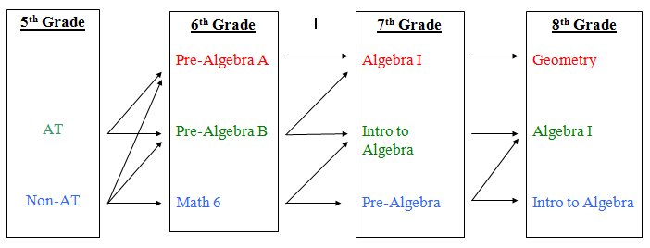

Notes:
Students need to average at least 90% on the first three Benchmark Assessments in order to qualify
for taking the Pre-Algebra A Placement Test. (All AT and Enrichment Math students also qualify to take the test.) Students who score at least 88% will be placed in Pre-Algebra A. Students who score below 88% will be placed in Pre-Algebra B.
For students who do not qualify to take the Pre-Algebra A placement test, five data points (three benchmarks assessments, Linkit! C, and teacher rubric score) will be entered into a placement formula that assigns weight to each criterion. Students will earn a percentage of the total possible points.
Students who do not qualify to take the Pre-Algebra A placement Test may enter Pre-Algebra B by earning 80% of the total possible points. Students who earn less than 80% will be placed in Math 6.
Some of the Learning Centers and Academies at Freehold Regional High School District require completion of Algebra I by the end of 8th grade with a minimum grade of B to gain admittance. Please visit http://www.frhsd.com/domain/38 for more information.
Important IEP/504 Note for Students Who Qualify for Taking the Pre-Algebra A Placement Test:

In order to ensure that students can successfully maintain the pace of this rigorous accelerated math course, the Pre-Algebra A Placement Test is timed. Students are given 40 minutes to complete 60 Multiple Choice items. If your child has an IEP or 504 with an accommodation that refers to extended or unlimited time, your child would not receive this accommodation when taking the Pre-Algebra A test. Providing a student with extended or unlimited time would invalidate the score since the district will not be able to accurately measure the student's ability to maintain the pace and rigor of this accelerated course.

