7th Grade Mathematics
Geometry - Unit 5a Curriculum Map, May 5th – June 6th

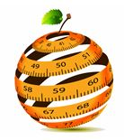

ORANGE PUBLIC SCHOOLS
OFFICE OF CURRICULUM AND INSTRUCTION
OFFICE OF MATHEMATICS
Table of Contents
- Unit Overview p. 2
- Common Core Standards p. 3
- CMP 3 Curriculum Guide p. 4
- Optional Review Curriculum Guide (CMP3) p. 5
- Teaching Multiple Representations p. 6-7
- Connections to Mathematical Practices p. 8
- Vocabulary p. 9-10
- Potential Misconceptions p. 11
VIII. Extensions and Sources p. 12
Unit Overview
In this unit, students will ….
- Extend knowledge of expressions and equations through solving problems about area, surface area, volume, and angle relationships
- Students will use estimation, basic computation, and assessing the reasonableness of solutions in real world geometric problems
Enduring Understandings
- Use a ruler and protractor to draw shapes
- Construct triangles given angle measures and sides
- Identify supplementary, complementary, vertical, adjacent, and the relationships in a transversal
- Solve mathematical and real world problems involving area, volume, and surface area
Common Core Standards
COMMON CORE STANDARDS
7.G.2 | Draw (freehand, with ruler and protractor, and with technology) geometric shapes with given conditions. Focus on constructing triangles from three measures of angles or sides, noticing when the conditions determine a unique triangle, more than one triangle, or no triangle.
7.G.3 | Describe the two-dimensional figures that result from slicing three-dimensional figures, as in plane sections of right rectangular prisms and right rectangular pyramids.
7.G.4 | Know the formulas for the area and circumference of a circle and use them to solve problems; give an informal derivation of the relationship between the circumference and area of a circle.
7.G.5 | Use facts about supplementary, complementary, vertical, and adjacent angles in a multi-step problem to write and solve simple equations for an unknown angle in a figure.
7.G.6 | Solve real-world and mathematical problems involving area, volume and surface area of two- and three-dimensional objects composed of triangles, quadrilaterals, polygons, cubes, and right prisms.

New Content Curriculum Guide – CMP3
Upon completion of the curriculum materials below, teachers should move onto the Unit 5b plan and student portfolio notebook.
Activity | Common Core Standards | Estimated Time
Shapes and Designs – Investigation 1  Problem 1.1 – Sorting and Sketching Polygons  Problem 1.2 – Angles and Rotations  Problem 1.3 – Estimating Measures of Rotations and Angles  Problem 1.4 – Measuring Angles | 7.G.2 | 3 days
Shapes and Designs – Investigation 2  Problem 2.1 – Angle Sums of Regular Polygons  Problem 2.2 – Angle Sums of Any Polygon  Problem 2.3 – Polygons in Nature  Problem 2.4 – The Ins and Outs of Polygons | 7.EE.2, 7.EE.4, 7.G.2 | 2 days
Shapes and Designs – Investigation 3  Problem 3.1 – Building Triangles  Problem 3.2 – Design Challenge II Drawing Triangles  Problem 3.3 – Building Quadrilaterals  Problem 3.4 – Parallel Lines and Transversals  Problem 3.5 – Design Challenge III The Quadrilateral Game | 7.G.2, 7.G.5 | 3 days
Filling and Wrapping – Investigation 1  Problem 1.1 – Finding Volume  Problem 1.2 – Finding Surface Area  Problem 1.3 – Finding the Least Surface Area  Problem 1.4 – Scaling Up Prisms | 7.RP.2, 7.EE.2, 7.G.1, 7.G.6 | 3 days
Filling and Wrapping – Investigation 2  Problem 2.1 – Surface Area and Volume of Prisms  Problem 2.2 – Calculating Volume of Prisms | 7.NS.3, 7.G.3, 7.G.6 | 2 days
Filling and Wrapping – Investigation 3  Problem 3.1 – Circumference  Problem 3.2 – Connecting Area, Diameter, and Radius  Problem 3.3 – Squaring a Circle to Find its Area  Problem 3.4 – Connecting Circumference and Area | 7.NS.3, 7.EE.1, 7.EE.2, 7.G.4, 7.G.6 | 2 days
Filling and Wrapping – Investigation 4  Problem 4.1 – Surface Area of Cylinders  Problem 4.2 – Volume of Cylinders  Problem 4.3 – Comparing Surface Areas  Problem 4.4 – Filling Cones and Spheres | 7.NS.3, 7.G.4, 7.G.6 | 3 days
Optional Mini-Unit Assessment | 7.G.1-7.G.6 | 1 day
Optional Review Content Curriculum Guide – CMP3
These problems are for students who need review to strengthen their number sense. Please refer to the Unit 1 plan for vocabulary, teaching to multiple representations, connections to the Mathematical Practices, and potential misconceptions.
Optional Activity | Common Core Standards | Estimated Time
Accentuate the Negative – Investigation 1  ACE Questions #56-64 | 7.NS.1, 7.NS.3, 7.EE.4 | TBD by Teacher
Accentuate the Negative – Investigation 2  ACE Questions #50-59 | 7.NS.1, 7.NS.3, 7.EE.3 | TBD by Teacher
Accentuate the Negative – Investigation 3  ACE Questions #37-48 | 7.NS.2, 7.NS.3, 7.EE.3 | TBD by Teacher
Accentuate the Negative – Investigation 4  ACE Questions #45-52 | 7.NS.1, 7.NS.2, 7.NS.3, 7.EE.3 | TBD by Teacher
Teaching to Multiple Representations
Concrete Representations
- Nets  - Solids  - Boxes  - Real life representations (eg: doors, windows, steps, corners)  - Angle ruler  - Projections and views | To be determined at the school level  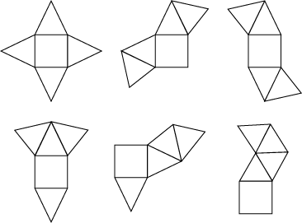  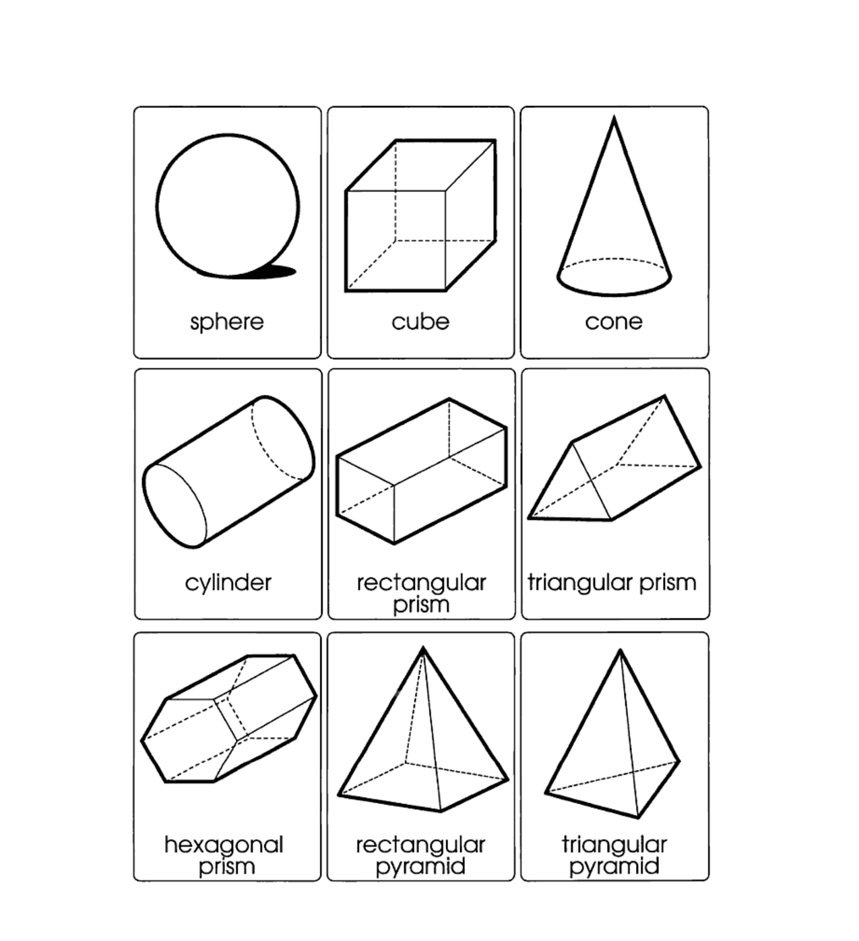  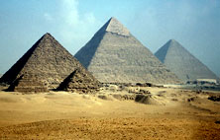  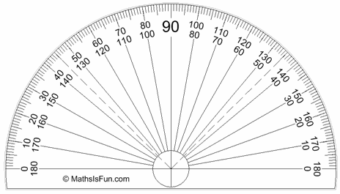  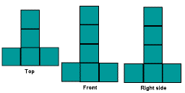
Pictorial Representations
- 3-Dimensional scale drawings of polygons  - Angles drawn to Measure (supplementary and complementary)  - Coordinate Graphs | 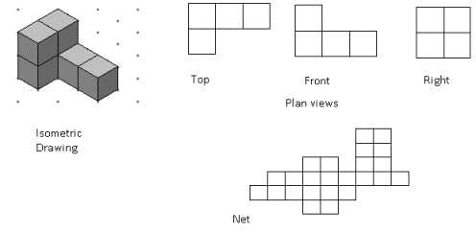  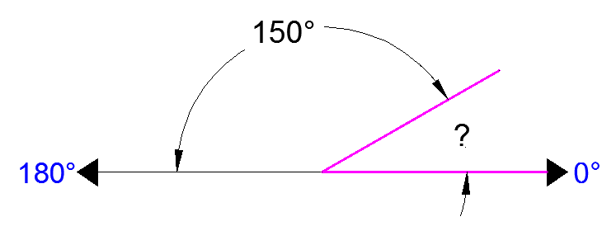  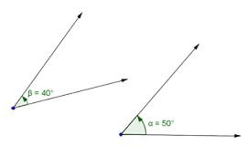  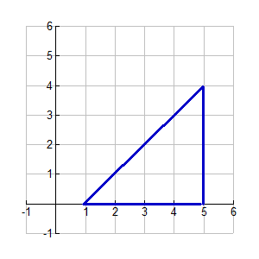
Abstract Representations
Refer to the 7th grade reference sheet for formulas for surface area and volume

Supplementary angles: pairs of angles that add up to 180 degrees.

Complementary angles: angles whose measures sum to 90°

Connections to the Mathematical Practices
1 | Make sense of problems and persevere in solving them
1 | - Students analyze givens, constraints, relationships, and goals  - Students might rely on using concrete objects or pictures to help conceptualize and solve a problem  - Students continually ask themselves, "Does this make sense?"
2 | Reason abstractly and quantitatively
2 | - Students decontextualize and conceptualize problems involving units and shapes
3 | Construct viable arguments and critique the reasoning of others
3 | - They justify their conclusions, communicate them to others, and respond to the arguments of others  - Students at all grades can listen or read the arguments of others, decide whether they make sense, and ask useful questions to clarify or improve the arguments
4 | Model with mathematics
4 | - Students will model an understanding of expressions, equations, inequalities, and graphs using tools such as algebra tiles/blocks, counters, protractors, compasses, and visuals to represent real world situations.  - Student might use geometry to solve a design problem or use a function to describe how one quantity of interest depends on another
5 | Use appropriate tools strategically
5 | - Students use tools that might include pencil and paper, concrete models, a ruler, a protractor, a calculator, a spreadsheet, a computer algebra system, a statistical package, or dynamic geometry software  - Students are able to use technological tools to explore and deepen their understanding of concepts
6 | Attend to precision
6 | - Students demonstrate precision by correctly using numbers, variables and symbols to represent expressions, equations and linear relationships, and correctly label units.  - Students use precision in calculation by checking the reasonableness of their answers and making adjustments accordingly.  - Students will use appropriate algebraic language to describe the steps in rewriting expressions and solving equations.
7 | Look for and make use of structure
7 | - Students recognize the significance of an existing line in a geometric figure and can use the strategy of drawing an auxiliary line for solving problems. They also can step back for an overview and shift perspective.
8 | Look for and express regularity in repeated reasoning
8 | - As they work to solve a problem, mathematically proficient students maintain oversight of the process, while attending to the details. They continually evaluate the reasonableness of their intermediate results.

Vocabulary – From CMP

Term | Definition
Circumference | The distance around (or perimeter of) a circle. It takes slightly more than three diameters to match the circumference of a circle. More formally, the circumference of a circle is pi (π) times the diameter of the circle.
Cylinder | A three-dimensional shape with two opposite faces that are parallel and congruent circles. The side (lateral surface) is a rectangle that is “wrapped around” the circular faces at the ends.
Diameter | A segment that goes from one point on a circle through the center of the circle to another point on the circle. Also, diameter is used to indicate the length of this segment. In this circle, segment AB is a diameter.
Pyramid | A three-dimensional shape with one polygonal base and lateral faces that are all triangles that meet at a vertex opposite the base.
Radius | A radius of a circle is the distance from the center of the circle to any point on the circle.
Rectangular Prism | A prism with a top and bottom (base) that are congruent rectangles.
Regular Prism | A prism whose bases are regular polygons.
Right Triangle | A prism whose vertical faces are rectangles. The bases are congruent polygons.
Angle Ruler | An angle ruler is a tool with two transparent arms, linked by a rivet that allows them to swing apart to form angles of various sizes. One arm is marked with a circular ruler showing degree measures from 0∘ to 360∘. A goniometer is one type of angle ruler.
Complementary Angles | Complementary angles are a pair of angles whose measures add to 90∘.
Degree | A unit of measure of angles is also equal to 1360 of a complete circle. The angle below measures about 1 degree (1∘); 360 of these would just fit around a point and fill in a complete circle; 90 of them make a right angle.
Exterior Angles | An angle at a vertex of a polygon where the sides of the angle are one side of the polygon and the extension of the other side meeting at the vertex. In the pentagons below, angles a, b, c, d, e, f, g, h, i, and j are exterior angles.
Interior Angles | The angle inside a polygon formed by two adjacent sides of the polygon. In the pentagon below, a, b, c, d, and e are interior angles.
Parallel Lines | Lines in a plane that never meet. The opposite sides of a regular hexagon are parallel.
Protractor | A protractor is a type of semi-circular ruler with scale measured in degrees. The degree measures on a protractor are listed both in ascending and descending order to measure angles regardless of their orientation.
Rectangle | A parallelogram with all right angles. Squares are a special type of rectangle.
Reflectional symmetry | A type of symmetry where one half is the reflection of the other half. You could fold the image and have both halves match exactly.
Polygon | A shape formed by three or more line segments, called sides. Each segment meets exactly two other segments, but only at their endpoints.
Regular Polygon | A polygon that has all of its sides equal and all of its angles equal. The hexagon below is regular, but the other hexagon is not regular, because its sides and its angles are not equal.
Right Angle | An angle that measures 90∘. A rectangle has four right angles.

Potential Student Misconceptions
- Students overgeneralize specific formulas and rules to apply to all shapes.

- Students simply apply a formula but do not understand concepts fully and cannot articulate. For example, the area of a triangle is ½ the area of a rectangle with height and width dimensions identical to the height and base dimensions of the triangle

Extensions and Sources
Online Resources

http://www.illustrativemathematics.org/standards/k8
- Performance tasks, scoring guides

https://www.khanacademy.org/math/
- Interactive, tracks student points, objective descriptive videos, allows for hints

http://www.doe.k12.de.us/assessment/files/Math_Grade_7.pdf
- Common Core aligned assessment questions, including Next Generation Assessment Prototypes

http://www.learnzillion.com
- Videos organized by Common Core Standard presented with visual representations and student friendly language

https://www.georgiastandards.org/Common-Core/Pages/Math-6-8.aspx
- Common Core assessment resources, tasks designed for students with special needs
http://www.parcconline.org/sites/parcc/files/PARCCMCFMathematicsGRADE8_Nov2012V3_FINAL.pdf
- PARCC Model Content Frameworks Grade 8

http://commoncoretools.files.wordpress.com/2011/04/ccss_progression_ee_2011_04_25.pdf
- Progressions of Expressions and Equations from grades 6-8

