

Peter Crump Elementary School Newsletter & Information

To help your child develop literacy skills
5 Easy Ways!!!
Talk : Have two way conversations with your children - children learn language by listening. » Respond to what they say and add words to stretch their vocabulary.
Sing: Sing nursery rhymes so children hear the different sounds in words. » Clap along to the rhythm so children hear the syllables.
Read: Read every day. » Make reading interactive. Look at the cover and try to guess what the book is about before you begin. Ask the child questions as you read and listen to the answers. » Use books to teach new words. As you read, talk about what these words mean. Also, encourage them to turn the page while reading to promote lifelong readers.
Write: Get magnetic letters for the refrigerator or make letters from cardboard for the children to play with. » Have them sign their drawings to develop hand-eye coordination and build up their writing muscles. Children also begin to understand that writing represents words. » Talk about what they draw. Have them make up stores or write captions for their drawings so they make the connection between written and spoken language. Use illustrations from magazines and books to encourage students to write a new story with a different ending.
Play: Encourage dramatic play with puppets or stuffed animals. Making up stories this way develops narrative skills so children understand that stories have a beginning, middle and end. » Have the child tell you a story based on the pictures in a book many times This develops vocabulary.

Writing Prompts:
- Finish this sentence in 10 different ways: This March I hope…
- Describe a dream your dog might have when he is sleeping.
- If you fell from the sky with a parachute, where would you hope to land? Why?
- What is something you did recently for the very first time? Write about it.
- Would you rather have to sit all day outside or stand all day inside? Explain.

Spring Break Activities
LIBRARIAN LIFT-UP FROM SUSAN ZANA, ALSDE EDUCATION SPECIALIST FOR LIBRARY MEDIA
Read aloud and read along at home or at school with Capstone Interactive Library eBooks from Alabama Virtual Library. This free library features 237 fiction and nonfiction books, including 25 Spanish or bilingual books. These browser-based, digital books feature easy navigation tools and enhanced content to support readers of all types and ages. Books are accessible via text and audio.
To access the books, visit Alabama Virtual Library at www.avl.lib.al.us, click the Green button for “Elementary School,” and click the purple and red “Capstone Interactive” logo.

Virtual Field Trips for Kids

Family Newsletter
ARI's Spring Break Literacy Fun | Smore Newsletters

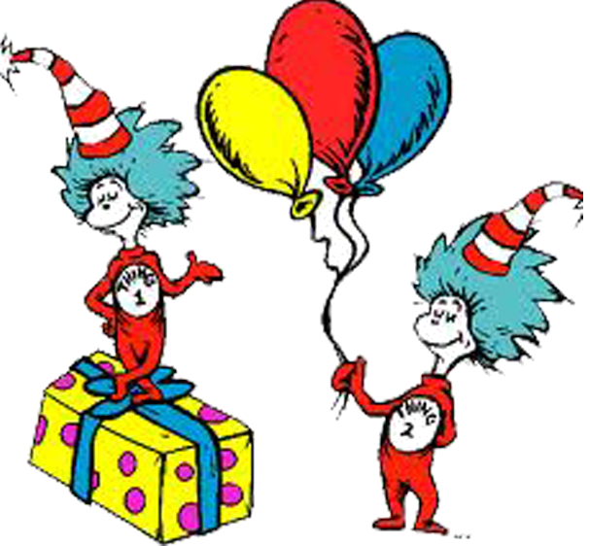



Kindergarten & Grade 1: 10-15 minutes per day.
Grade 2 & Grade 3: 20-30 minutes per day.
Grades 4 & 5: 30-40 minutes per day.
Of course, more is always better!
Have fun and read, read, read!

From Your Local Reading Coach’s Desk
The BIG 5+2=
Essential Components of reading

Comprehensive Activities
K & 1 Grade At Home:
- Using pictures and words to put ideas on paper
- Telling stories first to get ready to write
- Looking back at writing to add more to it
- Saying words slowly and write down the sounds that they hear
- Planning how the book will go, adding pages
Story Talk. Think aloud about a story. Talking about stories helps children develop their vocabularies, link stories to everyday life, and use what they know about the world to make sense out of stories. Connect your story to a similar story your child may have experienced.
Drawing Pictures of Real People, Objects, and Events. Encourage all efforts. Let your child tell you what he/she made. Hang your child’s art in their room or on the refrigerator.
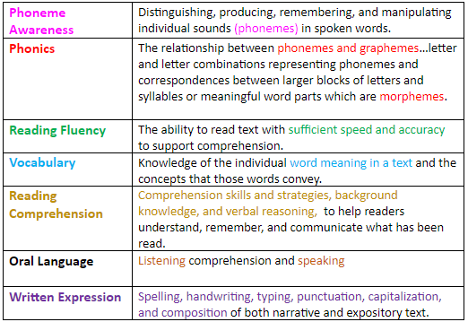

The Reading Challenge
2 &3 Grade At Home:
Make a list of multisyllabic Words: 1 syllable word- ten 2 syllable word- donkey 3 syllable word- computer 4 syllable word-caterpillar
Every day comprehension. Read a book to someone and summarize what you’ve just read aloud. Start a conversation about the book.
Reading Fiction:
Visualizing As you read a book, pay attention to any pictures that you make in your mind. Notice which words or phrases helped you make your mental images. Draw and write down the words or phrases before, during and after reading.
Reading Extension: Create a list of animals and then pick one. Write down as many things about the way the animal looks and what it does. Use your imagination to write your own poem about that animal. Keep the name of the animal a secret and have your family members try to figure out what animal you wrote about.

After reading. Ask your child to retell the story from the beginning, and ask for opinions, too. “What was your favorite part? Would you recommend this to a friend?”
Write a STORY that has a beginning, middle and end

Join the book(s) of the Month Challenge
The buzz in the classroom should be about what they are reading or what they are going to read next.
Accountability is Key!
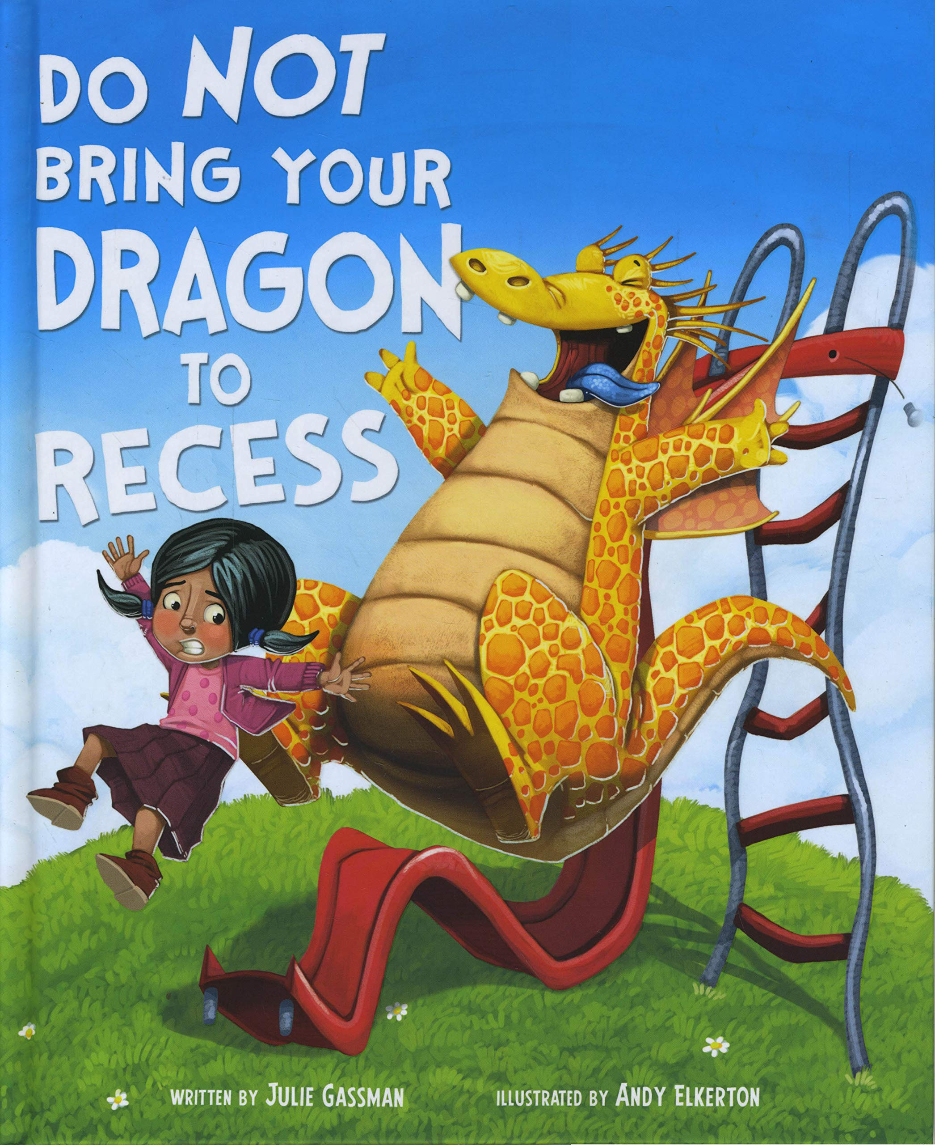

Click this link below to read now!
Do Not Bring Your Dragon to the Library!

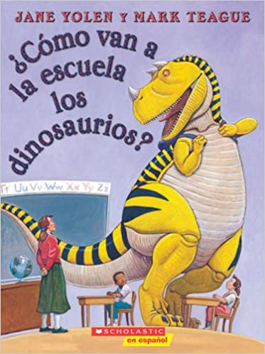

YouTube Link: https://youtu.be/l6Bh9d9DTb8

How Can Parents HELP?
Here are some suggestions for all parents who want to help their child read well:
• Read with your child every day.
• Listen to your child read.
• Echo read (You read a line, then they repeat).
• Choral read (Read together at the same time).
• Reread or retell favorite stories.
• Talk to your child about the stories you have read.



