Photosynthesis & Biomes Unit 2 “I CAN” Statements
Life Science Learning Target #1: I can identify the chemical formula of cellular respiration and photosynthesis.

Life Science Learning Target #2: I can distinguish between photosynthesis and cellular respiration and illustrate how the two processes are connected.

Life Science Learning Target #3: I can identify the cellular structures primarily responsible for photosynthesis and respiration.

Life Science Learning Target #4: I can draw/construct via computer software and label the process of photosynthesis.

Life Science Learning Target #5: I can create a chart/table that compares/contrasts the reactants and products of photosynthesis and cellular respiration.

Life Science Learning Target #6: Identify the biotic and abiotic factors/elements of the major biomes and describe how they are connected. (Jigsaw Activity or Inspiration Concept Map)

Look at portaportal.com for more resources.

http://plants.pppst.com/photosynthesis.html Power points on photosynthesis

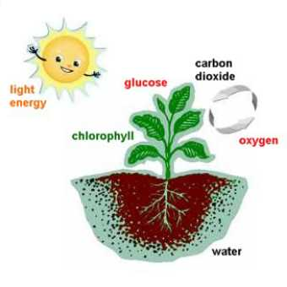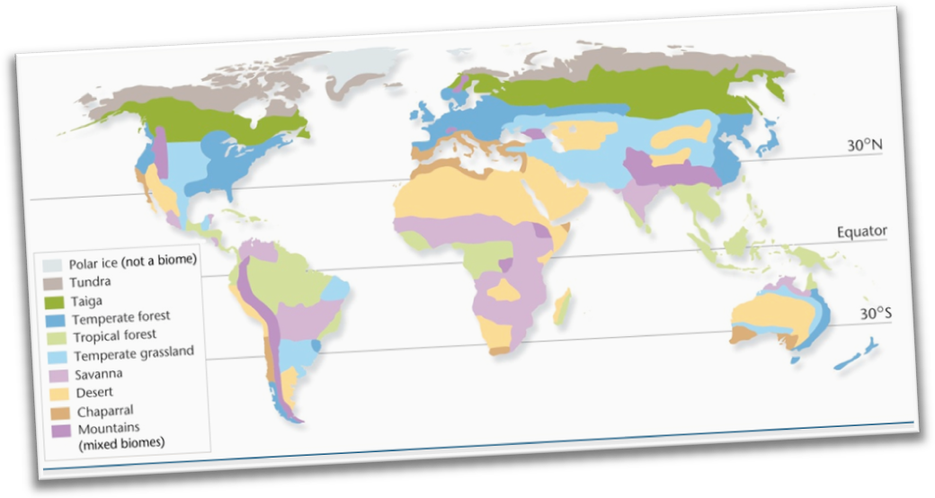

Shansgen2012

