Science OGT Study Guide
Life Science
Cell Organelles
Organelle | Function
Nucleus | Control center of cell & contains DNA
Ribosome | Makes proteins
Mitochondria | Site of cellular respiration- breakdown food to create energy
Endoplasmic Reticulum | Transports materials throughout cell
Golgi apparatus | Processes & packages proteins for shipment out of cell
Vacuole | Stores water, food & waste
Cytoplasm | Cell fluid that surrounds the organelles
Cilia/Flagella | Assist in movement
Lysosomes | Breakdown of food, bacteria, old organelles
Plasma Membrane | Allows certain materials to enter or leave cell

Cells
Prokaryotes: no nucleus
example: bacteria

Eukaryotes: have nucleus & membrane-bound organelles
example: plants, animals, protists, & fungi

Cellular Processes
Photosynthesis: process where plants take in water, carbon dioxide, and use light energy to make glucose (food).
6CO₂ + 6H₂O + ENERGY → C₆H₁₂O₆ + 6O₂
carbon + water + energy glucose + oxygen
dioxide from sun → FOOD

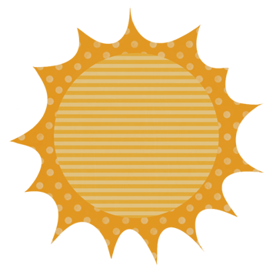 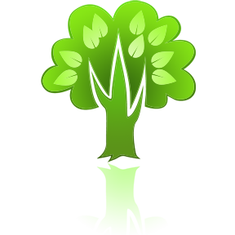 O₂
H₂0 Food
CO₂
Differences between Plants & Animal Cells
Plant Cells Have:
- Chloroplasts- contain chlorophyll; site of photosynthesis
- Cell Wall- gives plant cell support

Takes place in the Chloroplasts!
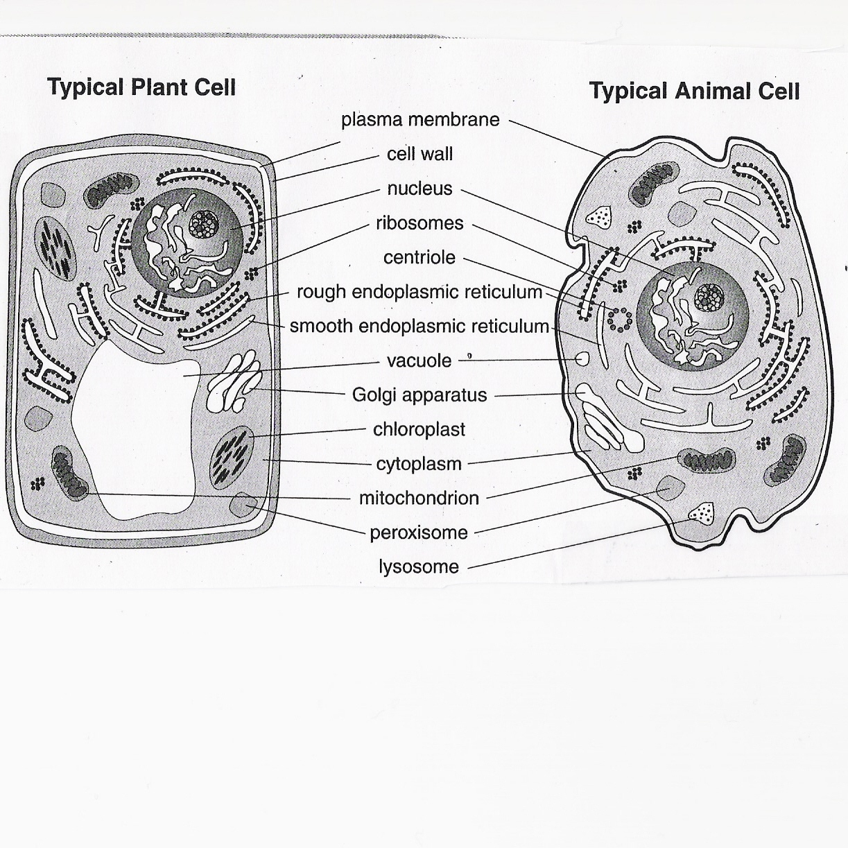
Examples of Eukaryotic Cells
Cellular Processes
Respiration: breaking down food to release energy.

C₆H₁₂O₆ + 6O₂ → 6CO₂ + 6H₂O + 36 ATP
glucose + oxygen → carbon + water + ENERGY
food dioxide

oxygen carbon dioxide

- End products of photosynthesis are the starting reactants for respiration & vice versa!

Takes place in the Mitochondria!
Genetics
Genes come in pairs of chromosomes (half from mom & half from dad)
Alleles: the different form of a gene
(ex. tall, short)
-can be dominant or recessive
dominant: will be expressed if any other alleles are present
- CAPITAL LETTER (T)
recessive: won’t be expressed when a dominant allele is present
- lowercase letter (t)

Homozygous: 2 of the same allele
ex. TT or tt
Heterozygous: one dominant and one recessive allele
ex. Tt
Genotype: the genetic make-up of an individual- letters!
ex. TT, Tt, tt
Phenotype: physical appearance (how they look)
ex. Tall or short
Punnett Squares
Punnett squares: express the possible combinations for a certain trait an offspring may inherit from the parents.

Example:
In pea plants, the trait for height has two alleles- tall or short. Tall is dominant over short.
Cross a heterozygous tall pea plant with a short.
Heterozygous tall: Tt
Short: tt

T t

t Tt tt

t Tt tt

Probability of offspring:

Genotypes:
Tt = 2 out of 4 or 50%
tt = 2 out of 4 or 50%

Phenotypes:
Tall (TT or Tt) = 50%
short (tt) = 50%
Biotic & Abiotic Factors
Abiotic: not living
ex. rock, water, sunlight

Biotic- living
ex. tree, dog, bacteria
DNA
Deoxyribonucleic acid
genetic material that is passed down from parents to offspring
- shape is a double helix

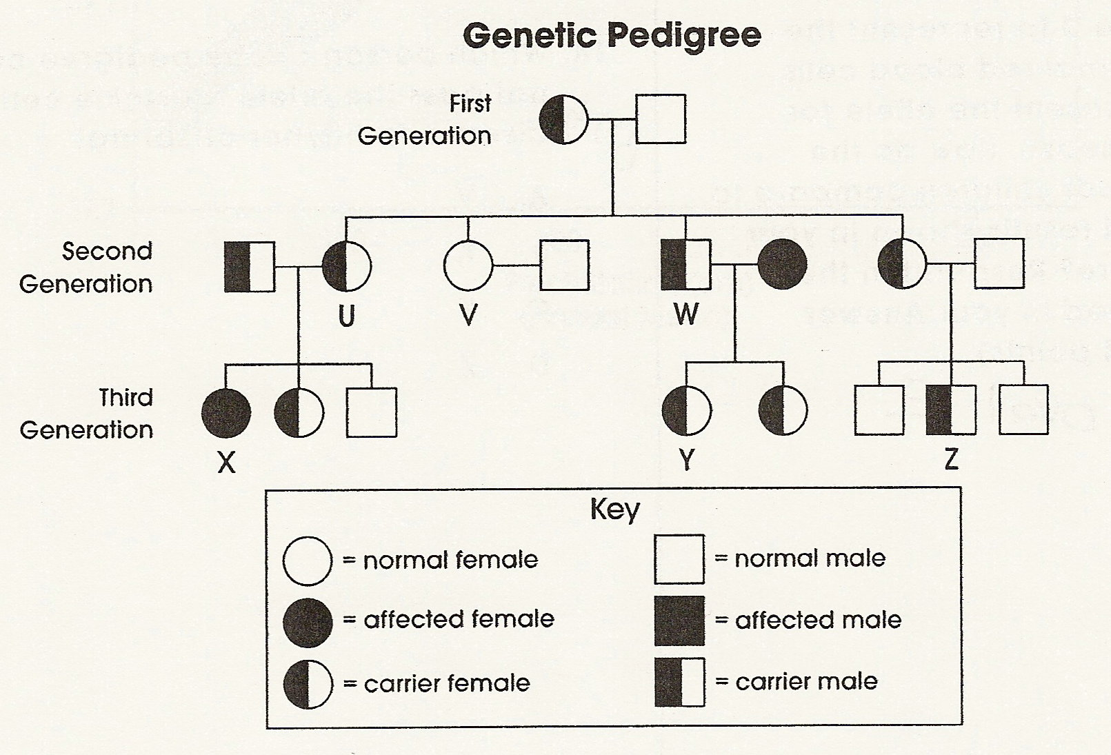
Pedigree
Shows the inheritance of a particular allele, usually an allele for a disease throughout generations of a family.

Carrier: someone who does NOT have the trait, but carries the allele & could pass it on to their offspring.
Energy Flow
Producers- make their own food. (Autotrophs) Examples: plants & algae
Consumers- depend on other organisms for their food (Heterotrophs)
- Herbivore- eat only plants
- Omnivore- eat both plants & animals
- Carnivore- eat only other animals
- Saprophyte- organisms that obtain food from dead organisms or waste products from living organisms (decomposers)

Community Interactions
Competition: occurs when organisms compete for a resource.
Predation: organisms (predator) that kill and eat other organisms (prey)
Symbiosis: relationship where one organism is living on or inside another.
Mutualism: a symbiosis where both organisms benefit
ex. Flower & Bee- Bee pollinates flower; the flower provides bee with nectar
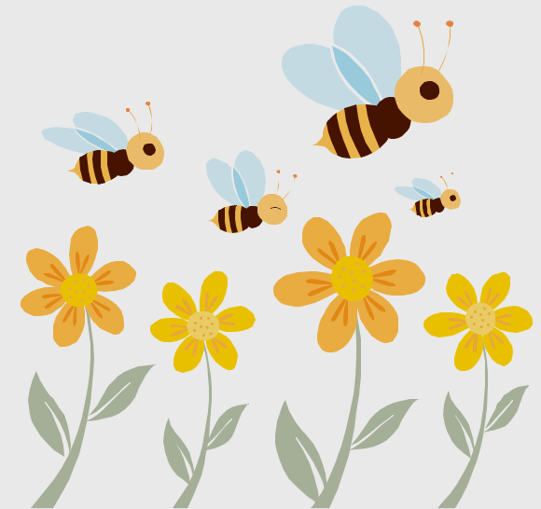
Commensalism: a symbiosis where one organism benefits & the other is unaffected
ex. A bird living in a tree- the tree gives bird protection; the tree is not helped or harmed.
Parasitism: a symbiosis where one organism benefits & the other is harmed
ex. Flea and dog- The flea benefits by biting the dog to get the blood as food; the dog is harmed by the flea
→ gives energy to
Example:
Tree → Deer
Tree gives energy to the Deer
Food Web
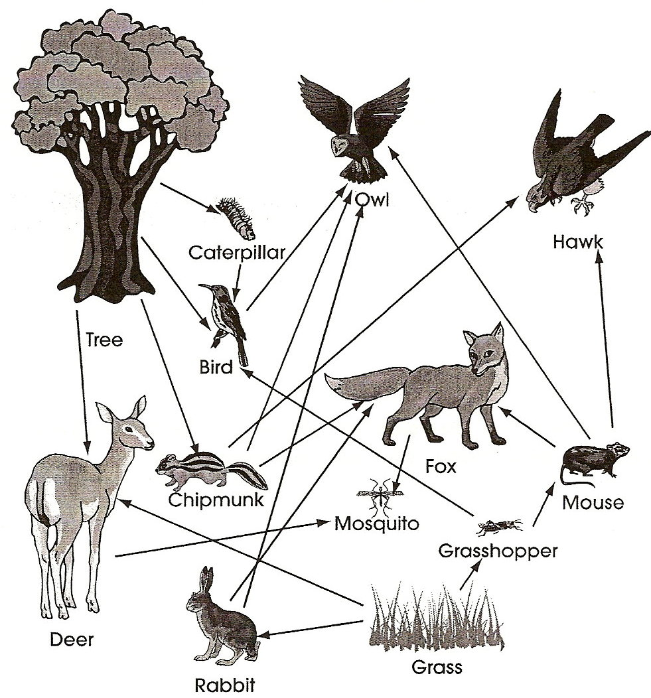
Examples of Human Impact on Environment
- Pollution
- Global Warming
- Cutting down forests
- Growth & land exploitation
- Introduction of chemicals into the environment (examples: pesticides like DDT).

Natural Selection
Natural Selection: favorable traits are better able to successfully reproduce than organisms that lack these traits.
- Survival of the fittest
- Driven by competition among individuals for resources necessary for survival
- One that survives can pass on those traits to future generations

Example:
Millions of years ago, some giraffes were born with short necks & others were born with long necks. When low grass and plants (food) became scarce, the giraffes with long necks were able to reach the leaves in high trees and survive. The short-neck giraffes could not reach the food, so they did not survive. Only the long-neck giraffes were able to pass their long-neck gene to future generations. Nature favored the long-neck trait.

