From: Raymond Lai MD, PhD
Department of Laboratory Medicine and Pathology
Cross Cancer Institute
11560 University Avenue
Edmonton, Alberta, Canada T6G 1Z2
Tel: (780) 432-8338
Fax: (780) 432-8214
rlai@ualberta.ca

July 6, 2010

To: Editor-in-Chief
International Journal of Clinical and Experimental Pathology

Dear Editor:

Re: Submission of Manuscript

We are submitting a manuscript entitled “STAT3 upregulates the protein expression and transcriptional activity of β-catenin in breast cancer” to be considered for publication in International Journal of Clinical and experimental Pathology. We believe this work is scientifically valid, and all authors have sufficiently contributed to data collection/analysis and manuscript preparation. We have no financial interest or conflict of interest in association with this work.

This manuscript has not been published previously and is not being considered for publication by another journal.

Dr. Lai will serve as the corresponding author.

Sincerely Yours,

Raymond Lai

STAT3 upregulates the protein expression and transcriptional activity of β-catenin in breast cancer

Hanan Armanious, Pascal Gelebart, John Mackey¹, Yupo Ma², Raymond Lai

Department of Laboratory Medicine and Pathology, and the ¹Department of Oncology, Cross Cancer Institute and University of Alberta, Edmonton, Alberta, Canada; the ²Department of Pathology, The State University of New York at Stony Brook, Stony brook, NY, USA

Correspondence: Raymond Lai, MD, PhD, Department of Laboratory Medicine and Pathology, Cross Cancer Institute and University of Alberta, 11560 University Avenue, Edmonton, Alberta, Canada T6G 1Z2. Tel: 780-432-8338; Fax: 780-432-8214, E-mail: rlai@ualberta.ca

Running title: STAT3 and β-catenin in breast cancer

Abstract word count: 202
Tables: 2
Color figures: 1
Black and white figures: 5

Acknowledgement: This work was partly supported by operating research grants from the Canadian Cancer Society and the Alberta Cancer Foundation awarded to RL.
Abstract

The expression of β-catenin detectable by immunohistochemistry has been reported to be prognostically important in breast cancer. In this study, we investigated the mechanism by which β-catenin is regulated in breast cancer cells. Our analysis of the gene promoter of β-catenin revealed multiple putative STAT3 binding sites. In support of the concept that STAT3 is a transcriptional regulator for β-catenin, results from our chromatin immunoprecipitation studies showed that STAT3 binds to two of the three potential STAT3-binding sites in the gene promoter of β-catenin (-856 and -938). Using our generated MCF-7 cell clones that carry an inducible STAT3C construct, we found that the expression levels of STAT3C significantly correlated with the transcriptional activity of β-catenin. Similar observations were made when we subjected two breast cancer cell lines (MCF-7 and BT-474) to STAT3 knock-down or transient gene transfection of STAT3C. Using immunohistochemistry, we found that pSTAT3 and β-catenin significantly correlated with each other (p=0.003, Fisher`s exact test) in a cohort of primary breast tumors (n=129). To conclude, our results support the concept that STAT3 upregulates the protein expression and transcriptional activity of β-catenin in breast cancer, and these two proteins may cooperate with each other in exerting their oncogenic effects in these tumors.

Keywords: STAT3, β-catenin, breast cancer
Introduction

β-catenin is known to function as an adhesion molecule that is associated with E-cadherin and actin filaments at the cell membrane [1]. In addition, it has been shown that β-catenin can act as a transcriptional factor involved in a number of cellular signaling pathways such as the Wnt canonical pathway (WCP) [2, 3]. In the WCP, β-catenin is normally sequestered by the so-called 'destruction complex', which consists of glycogen synthase kinase-3β (GSK3β), the adenomatous polyposis coli, axin and casein kinase 1 [4, 5]. Upon ligation of the soluble Wnt proteins to their receptors, the dishevelled proteins (Dvl's) will become phosphorylated, which is believed to result in inactivation and phosphorylation of GSK3β, leading to the dissociation of the destruction complex. Consequently, β-catenin is allowed to evade proteasome degradation, accumulate in the cytoplasm and translocate to the nucleus. Forming heterodimers with T-cell factor/lymphoid enhancer-binding factor (TCF/LEF) in the nucleus, β-catenin has been shown to regulate the expression of a wide range of important genes including c-myc and cyclin D1 [6-9].

β-catenin has been implicated in the pathogenesis of a wide range of human cancer [10]. There are also links between β-catenin and breast cancer. For instance, the expression of a β-catenin mutant with an abnormally high stability has been shown to induce breast adenocarcinomas in a transgenic mouse model [11]. By immunohistochemistry, the expression of β-catenin in breast cancer (reported to be up to 60% of the cases) has been reported to significantly correlate with a poor prognosis or relapse in breast cancer patients in previous studies [12-14]. A few previous studies have shed light to the mechanisms underlying the relatively high level of β-catenin expression in a subset of breast cancer. For instance, the WCP, which is known to regulate the expression and activity of β-catenin, is known to be constitutively active in a subset of breast cancer [15]. In another study, it has been shown that manipulation of the WCP can modulate β-catenin in breast cancer cells [16]. In addition to the WCP, other mechanisms also may be involved in regulating β-catenin in breast cancer. For instance, Pin1 was found to promote the dissociation of β-catenin from the destruction complex, and thus, increasing its stability [17]. Other studies showed that p53 downregulates β-catenin through ubiquitylation [18, 19]. Thus, the high level of β-catenin expression in a subset of breast cancer may be multi-factorial.

Signal transducer and activator of transcription-3 (STAT3) belongs to a family of latent transcription factors the STAT family [20]. In breast cancer, STAT3 is constitutively activated in approximately 50-60% of primary breast tumors; downregulation of STAT3 resulted in decrease in the tumorigenecity of breast cancer cells xenografted in nude mice [21, 22]. Blockade of STAT3 using a dominant negative construct has been recently shown to decrease the nuclear localization and transcriptional activity of β-catenin in colon cancer cell lines [23]. Given that both β-catenin and STAT3 are activated in a subset of breast tumors, we hypothesized that STAT3 may represent another mechanism by which β-catenin is regulated in breast cancer cells. In addition, we evaluated the biological and clinical significance of β-catenin in breast cancer.

Materials and methods

Cell lines and tissue culture

MCF-7 and BT-474 cell lines were obtained from American Type Culture Collection (Manassas, VA, USA). They were grown at 37⁰C and 5% CO₂ and maintained in Dulbecco’s modified Eagle’s medium (Sigma-Aldrich, St. Louis, MO, USA). The culture media were enriched with 10% fetal bovine serum (Life Technologies, Carlsbad, CA, USA). MCF-7 cells permanently transfected with the tetracycline-controlled transactivator and TRE-STAT3C plasmids (labeled STAT3C^{tet-off} MCF-7) have been described previously [22], this stable cell line was maintained by the addition of 800 μg/ml geneticin (Life Technologies, Inc.) to the culture media.

Subcellular protein fractionation, Western blot analysis and antibodies

For subcellular protein fractionation, we employed a kit purchased from Active
Motif (Carlsbad, CA, USA) and followed the manufacturer’s instructions. Preparation of cell lysates for Western blots was done as follows: cells were washed twice with cold phosphate-buffered saline (PBS, pH=7.0), and scraped in RIPA lysis buffer (150 mM NaCl, 1% NP-40, 0.5% deoxycholic acid, 0.1% SDS, 50mM Tris pH 8.0) supplemented with 40.0 μg/mL leupeptin, 1 μM pepstatin, 0.1 mM phenylmethylsulfonyl-fluoride and sodium orthovandate. Cell lysates were incubated on ice for 30 minutes and centrifuged for 15 minutes at 15000g at 4⁰C. Proteins in the supernatant were then extracted and quantified using the bicinchoninic acid protein assay (Pierce, Rockford, IL). Subsequently, cell lysates were then loaded with 4x loading dye (Tris-HCl pH 7.4, 1%SDS, glycerol, dithiothreitol, and bromophenol blue), electrophoresed on 8% or 10% SDS-polyacrylamide gels, and transferred onto nitrocellulose membranes (Bio-Rad, Richmond, CA, USA). After the membranes were blocked with 5% milk in Tris buffered saline (TBS) with Tween, they were incubated with primary antibodies. After washings with TBS supplemented with 0.001% Tween-20 for 30 minutes between steps, secondary antibody conjugated with the horseradish peroxidase (Jackson Immunoresearch Laboratories, West Grove, PA, USA) was added to the membrane. Proteins were detected using enhanced chemiluminescence detection kit (Pierce, Rockford, IL). Antibodies employed in this study included anti-β-catenin (1:4000, BD Biosciences Pharmingen, San Diego, CA, USA), anti-STAT3 and anti-pSTAT3 (1:500, Santa Cruz Biotechnology, Santa Cruz, CA, USA), anti-FLAG, anti-HDAC, anti-α-tubulin and anti-β-actin (1:3000, Sigma-Aldrich).

β-catenin transcriptional activity assessed by TOPFlash/FOPFlash

To assess the transcriptional activity of β-catenin in breast cancer cell lines, we employed the TOPFlash/FOPFlash luciferase system. This method has been previously described in details [24]. MCF-7 and BT-474 cells were transiently transfected with β-catenin responsive firefly luciferase reporter plasmids, TOPFlash (Millipore, Billerica, MA, USA) or the negative control, FOPFlash (Millipore). After 24 hours, cells were harvested and cell extracts were prepared using a lysis buffer purchased from Promega (Madison, WI, USA). The luciferase activity was assessed using 20 μL of cell lysate and 100 μL of luciferase assay reagent (Promega). The luciferase activity measured was normalized against the β-galactosidase activity, which was measured by incubating 20 μL of cell lysates in a 96 well plate with 20 μL of o-nitrophenyl-β-D galactopyranoside solution (0.8 mg/mL) and 80 μL H₂O, absorbance was measured at 415 nm at 37ºC. Data are reported as means ± standard deviations of three independent experiments, each of which was performed in triplicates.

Gene transfection

Transient gene transfection of cell lines with various expression vectors were performed using Lipofectamine 2000 transfection reagent (Invitrogen, Burlington, Ontario, Canada) according to the manufacture’s protocol. Briefly, cells were grown in 60 mm culture plates until they are ~90% confluence, culture medium was replaced with serum-free Opti-MEM (Life Technologies) and cells were transfected with the DNA-lipofectamine complex. For all in-vitro experiments, STAT3C^{tet-off} MCF-7 cells were transiently transfected with 3 μg TOPFlash or FOPFlash and 4 μg of β-galactosidase plasmid. To manipulate the expression level of STAT3C in these cells, various concentrations of tetracycline (Invitrogen) were added to the cell culture. For MCF-7 and BT-474, 2 μg of TOPFlash or FOPFlash, 3 μg of β-galactosidase plasmid and 2 μg of STAT3C (or an empty vector) were transfected.

Chromatin immunoprecipitation

Chromatin immunoprecipitation was performed using a commercially available kit according to the manufacturer’s protocol (Upstate, Charlottesville, VA, USA). Briefly, DNA-protein was cross-linked using 1% formaldehyde for 10 minutes at 37⁰C. Cells were lysed using the SDS buffer, followed by sonication. Immunoprecipitation was done using protein A/G agarose beads conjugated with either a rabbit anti-human STAT3 antibody or a rabbit IgG antibody overnight at 4⁰C. The DNA-protein-antibody complex was separated and eluted. DNA was extracted using Phenol/Chloroform/ethanol. Primer pairs were designed by Primer 3 Input 0.4 to detect the β-catenin gene promoter region containing putative STAT3 binding sites. The primer sequences are as follows: primer 1 forward: 5'-CCGAGCGGTACTCGAAGG-3' and reverse 5'-GTATCCTCCCCTGTCCCAAG-3'; primer 2 forward: 5'-CCAAAGAAAAATCCCCACAA-3' and reverse 5'-TCCTTAGGAGTACCTACTGTGAACAA-3'; and primer 3 forward 5'-AATTGGAGGCTGCTTAATCG-3' and reverse 5'-TTCCATTTTTATCTGGTTCCAC-3'.

Short interfering RNA (siRNA)

siRNA for β-catenin were purchased from Sigma-Aldrich. siRNA for STAT3 were purchased from Qiagen Science (Mississauga, ON, Canada) and used as described before [25]. Scrambled siRNA was purchased from Dharmacon (Lafayette, CO, USA). siRNA transfections were carried out using an electro square electroporator, BTX ECM 800 (225V, 8.5ms, 3 pulses)(Holliston, MA, USA) according to the manufacturer’s protocol, the dose of siRNA used was 100 picomole/1x10⁶ cells. Cells were harvested at 24 hours after transfection. The β-catenin or STAT3 protein levels were assessed by Western blot analysis to evaluate the efficiency of inhibition.

MTS assay

MCF-7 cells transfected with either β-catenin siRNA or scrambled siRNA were seeded at 3,000 cells/well in 96-well plates. MTS assay was conducted following the manufacturer’s instructions (Promega). The measurements were obtained at a wavelength of 450 nM using a Biorad Micro plate Reader (Bio-Rad Life Science Research Group, Hercules, CA, USA). The absorbance values were normalized to the wells with media only using the microplate Manager 5.2.1 software (Biorad). All experiments were performed in triplicates.

Immunohistochemistry and breast cancer specimens

A cohort of 129 consecutive, primary breast carcinoma specimens was retrieved from the centralized hormone receptor laboratory at the Cross Cancer Institute in Edmonton, Alberta, Canada. Morphologic features, including the histologic grade and the presence/absence of lymphatic invasion, were reviewed. The hormone receptor expression status was determined by immunohistochemistry at the time of initial diagnosis. The use of these human tissue samples has been reviewed and approval by our institutional ethics board. Immunohistochemistry was performed using standard techniques. Briefly, formalin-fixed, paraffin-embedded tissue sections of 4 μM thickness were deparafinized and hydrated. Heat-induced epitope retrieval was performed using citrate buffer (pH=6) and a microwave histoprocessor (RHS, Milestone, Bergamo, Italy). After antigen retrieval, tissue sections were incubated with 3% hydrogen peroxide for 10 minutes to block endogenous peroxidase activity. Tissue sections were then incubated with anti-β-catenin (1:50) and anti-pSTAT3 (1:50) overnight in a humidified chamber at 4°C. All of these primary antibodies were the same as those used for Western blots. Immunostaining was visualized with a labeled streptavidin-biotin (LSAB) method using 3,3'-diaminobenzidine as a chromogen (Dako Canada Inc., Mississauga, Ontario, Canada) and counter-stained with hematoxylin. For pSTAT3, the absence of nuclear staining or the presence of definitive nuclear staining in <10% of tumor cells was assessed negative; the presence of nuclear staining in ≥10% of tumor cells was assessed positive. ALK-positive anaplastic large cell lymphomas served as the positive control, whereas the lymphoid cells in benign tonsils served as the negative control. For β-catenin, only nuclear staining was scored. Moderate to strong nuclear β-catenin staining was assessed positive whereas the absence or weak (i.e. not definitive) nuclear staining was scored negative. Epithelial cells in benign tonsils served as the positive control whereas lymphoid cells in tonsils served as negative controls.

Statistical analysis

Data are expressed as mean +/- standard derivation. Unless stated otherwise, statistical significance was determined using Student's t-test and statistical significance was achieved when the p value is <0.05.

Results

STAT3 binds to β-catenin gene promoter

DNA sequence analysis of the -1000 bases of the β-catenin gene promoter region revealed 7 consensus sequences for the STAT family, characterized by TTN ₍₄₋₆₎ AA [26]. Three of these 7 sequences contained the specific STAT3 binding sequence, namely TTMXXXDAA (D: A,G, or T;M:A or C)(summarized in Table 1) [27]. These putative STAT3 binding sites are located at positions -314, -856 and -938, upstream of the ATG transcription initiation site. To provide direct evidence that STAT3 binds to these three sites, we performed chromatin immunoprecipitation using MCF-7 cells. As shown in Figure 1, both primer 2 (to detect STAT3 binding to the -856 site) and primer 3 (to detect STAT3 binding to the -938 site) showed amplifiable products. In contrast, no detectable amplification was observed for primer 1 (to detect STAT3 binding to the -314 site). The input lanes were included as a control for the PCR effectiveness. PCR without the addition of DNA templates was used as a negative control. The SALL4 primer served as the positive control, as published previously [28].

STAT3 regulates the transcriptional activity and protein levels of β-catenin

To determine if the expression of STAT3 affects the transcriptional activity and/or protein level of β-catenin, we subjected two breast cancer cell lines (MCF-7 and BT-474) to STAT3 knock-down using siRNA. As shown in Figure 2A, transfection of STAT3 siRNA resulted in a substantial downregulation in the STAT3 protein levels in both cell lines. In the same blots, the protein levels of β-catenin were also decreased. We also found evidence that STAT3 regulates the transcriptional activity of β-catenin. As shown in Figure 2B, downregulating STAT3 using siRNA in MCF-7 cells resulted in a significant downregulation of the β-catenin transcriptional activity, as assessed by the TOPFlash/FOPFlash system (p=0.0006)(Figure 2B). Furthermore, transient transfection of STAT3C (i.e. constitutively active STAT3) in MCF-7 and BT-474 cells led to a significant increase in the transcriptional activity of β-catenin, as compared to transfection of an empty vector (p=0.003 for both cell lines) (Figure 3A). Also, we performed subcellular fractionation after STAT3C transfection on MCF-7 but we did not see any change in β-catenin nuclear translocation (Figure 3B). Lastly, to further support that STAT3 regulates β-catenin, we employed our generated MCF-7 cell clone that has been stably transfected with an inducible (tetracycline-off) STAT3C expression vector (labeled as STAT3C^{tet-off} MCF-7), as previously described [22]. As shown in Figure 4A, increasing levels of tetracycline added to these cells resulted in a gradual downregulation of the total STAT3 level as well as the FLAG tag. Using the TOPFlash/FOPFlash system, the luciferase level from cells treated with 20 μg/ml and 60 μg/ml tetracycline were significantly lower than that of negative controls (p=0.04 and 0.03 respectively) (Figure 4B). These results are derived from triplicate experiments. Also, we performed subcellular fractionation after downregulation of STAT3C levels using tetracycline; however we did not see any change in β-catenin nuclear translocation (data not shown).

Nuclear expression of β-catenin significantly correlates with pSTAT3 expression in breast cancer samples

Using an anti-β-catenin antibody and immunohistochemistry, we surveyed the expression of nuclear β-catenin in a cohort of formalin-fixed, paraffin-embedded breast cancer samples (n=129). Nuclear β-catenin was detected in 24 (19%) cases. Similarly, we surveyed the expression of pSTAT3 using a monoclonal antibody and immunohistochemistry. pSTAT3 was detectable in 61 (47%) cases (Table 2). Importantly, the expression of these two markers significantly correlated with each other (p=0.003, Fisher exact test). However, the expression of these two markers did not significantly correlate with the overall survival. The staining results for pSTAT3 are illustrated in Figure 5A and 5B. The staining results for β-catenin are illustrated in Figure 5C-F. Cases scored negative for β-catenin showed no detectable nuclear staining, but some cases had staining on the cell membrane (Figure 5C) whereas other cases showed both membraneous and cytoplasmic staining (Figure 5D). Cases scored positive for β-catenin showed definitive nuclear staining, with some cases also showing staining in the cytoplasm (Figure 5E) whereas other cases showing only nuclear staining (Figure 5F).

β-catenin promotes cell growth in breast cancer

To investigate the biological importance of β-catenin on breast cancer, we downregulated β-catenin levels in MCF-7 using siRNA, and a significant downregulation of β-catenin was shown on Western blot (Figure 6A). An MTS assay was performed on day 1, 2, and 3 after β-catenin was downregulated. As shown in Figure 6B, there was a significant decrease in cell growth in cells treated with β-catenin siRNA, as compared to those treated with scrambled siRNA. Apoptosis, as detected by PARP and caspase 3 cleavages, was not detectable (not shown).

Discussion

Our presented data support the concept that STAT3 is a regulator of β-catenin in breast cancer. Specifically, we found that the gene promoter of β-catenin carries multiple STAT3 consensus sequences and our chromatin precipitation experiments provided direct evidence of STAT3 binding at two specific sites (-856 and -938) in the β-catenin gene promoter region. Furthermore, in two different breast cancer cell lines, we found evidence that the protein level and transcriptional activity of β-catenin can be modulated in response to a change in the expression and/or activity of STAT3, in both transient and stable transfection conditions. In further support that STAT3 regulates β-catenin in breast cancer, our immunohistochemical studies using a large cohort of breast tumors revealed a significant correlation between the expression of pSTAT3 and β-catenin. Our conclusion regarding β-catenin being a downstream target of STAT3 echoes the findings described in a recent study of colon cancer, which showed that STAT3 activity regulates the transcriptional activity of β-catenin in colon cancer cells [23]. In contrast with the same study, we did not detect any change in the nuclear translocation of β-catenin following STAT3 knockdown using nuclear/cytoplasmic fractionation. Based on our overall study results, the regulation of the transcriptional activity of β-catenin by STAT3 in breast cancer appears to be related to the observations that STAT3 controls the total protein level of β-catenin.

In the present study, we have presented evidence that STAT3 can directly regulate the gene transcription of β-catenin and its protein expression level. We are also aware of other mechanisms by which STAT3 can potentially regulate β-catenin through modulating the upstream of the WCP. Specifically, the gene promoter of Wnt3a has been shown to carry the consensus binding sequence for STAT3 [29]. STAT3 also has been shown to induce the expression of Wnt5a in rat cardiac myocytes [30, 31]. Taken together, it is possible that STAT3 regulates β-catenin via multiple mechanisms: 1) direct modulation of the gene transcription of β-catenin, and 2) modulate the secretion of different Wnt's, thereby regulating β-catenin via the WCP.

While we did not observe a prognostic significance for β-catenin in our cohort of breast cancer patients, we are aware of the results of a previously published study which showed that β-catenin is prognostically important in breast cancer [14]. In contrast with the study by Lin et al, who scored the β-catenin regardless of the staining pattern [14], we considered β-catenin positivity only when the staining was definitively nuclear. We also would like to point out that, one of the authors (JM) in a paper recently published that β-catenin is useful in predicting relapse in breast cancer patients [12]; however, no significant correlation between β-catenin nuclear staining and the overall survival was found (personal communication).

Although the focus of this manuscript is to document the functional interaction of STAT3 and β-catenin, we also examined whether β-catenin is biologically important in breast cancer cell lines. As shown in this study, downregulation of β-catenin using siRNA inhibited cell growth in MCF-7. Growth inhibition induced by a downregulation of β-catenin has been observed for esophageal cancer, colon cancer and glioma [32-34]. β-catenin was found to promote cell migration in a breast cell line [35], but we are not aware of any previous study in which the growth-promoting effect of β-catenin was examined in breast cancer. Thus, to our knowledge, these findings represent the first evidence that β-catenin promotes cell growth in breast cancer.

Both β-catenin and STAT3 have been shown to be oncogenic in various types of human cancer including breast cancer [11, 21]. Our findings described in this manuscript raise the possibility that the oncogenic effects of STAT3 may synergize with that of β-catenin. Of interest, it have been reported that β-catenin regulates the STAT3 transcriptional activity in esophageal cancer cell lines, thus potentially creating a positive a feedback loop between these two signaling proteins [36]. Since specific agents inhibiting STAT3 and β-catenin are available [37, 38], our data provide the rationale for combining these inhibitors in treating specific forms of cancer, such as in a subset of breast cancer in which both STAT3 and β-catenin are activated. In-vitro studies evaluating the potential synergistic effects of combining these agents will be of great interest.
References

[1] Huber AH, Weis WI. The structure of the beta-catenin/E-cadherin complex and the molecular basis of diverse ligand recognition by beta-catenin. Cell. 2001 May 4;105(3):391-402.
[2] Brennan KR, Brown AM. Wnt proteins in mammary development and cancer. J Mammary Gland Biol Neoplasia. 2004 Apr;9(2):119-31.
[3] Polakis P. Wnt signaling and cancer. Genes Dev. 2000 Aug 1;14(15):1837-51.
[4] Clevers H. Wnt/beta-catenin signaling in development and disease. Cell. 2006 Nov 3;127(3):469-80.
[5] Gordon MD, Nusse R. Wnt signaling: multiple pathways, multiple receptors, and multiple transcription factors. J Biol Chem. 2006 Aug 11;281(32):22429-33.
[6] He TC, Sparks AB, Rago C, Hermeking H, Zawel L, da Costa LT, Morin PJ, Vogelstein B, Kinzler KW. Identification of c-MYC as a target of the APC pathway. Science. 1998 Sep 4;281(5382):1509-12.
[7] Mikels AJ, Nusse R. Wnts as ligands: processing, secretion and reception. Oncogene. 2006 Dec 4;25(57):7461-8.
[8] Miller JR. The Wnts. Genome Biol. 2002;3(1):REVIEWS3001.
[9] Shtutman M, Zhurinsky J, Simcha I, Albanese C, D'Amico M, Pestell R, Ben-Ze'ev A. The cyclin D1 gene is a target of the beta-catenin/LEF-1 pathway. Proc Natl Acad Sci U S A. 1999 May 11;96(10):5522-7.
[10] Ewan KB, Dale TC. The potential for targeting oncogenic WNT/beta-catenin signaling in therapy. Curr Drug Targets. 2008 Jul;9(7):532-47.
[11] Imbert A, Eelkema R, Jordan S, Feiner H, Cowin P. Delta N89 beta-catenin induces precocious development, differentiation, and neoplasia in mammary gland. J Cell Biol. 2001 Apr 30;153(3):555-68.
[12] Asgarian N, Hu X, Aktary Z, Chapman KA, Lam L, Chibbar R, Mackey J, Greiner R, Pasdar M. Learning to predict relapse in invasive ductal carcinomas based on the subcellular localization of junctional proteins. Breast Cancer Res Treat. 2009 Sep 29.
[13] Lim SC, Lee MS. Significance of E-cadherin/beta-catenin complex and cyclin D1 in breast cancer. Oncol Rep. 2002 Sep-Oct;9(5):915-28.
[14] Lin SY, Xia W, Wang JC, Kwong KY, Spohn B, Wen Y, Pestell RG, Hung MC. Beta-catenin, a novel prognostic marker for breast cancer: its roles in cyclin D1 expression and cancer progression. Proc Natl Acad Sci U S A. 2000 Apr 11;97(8):4262-6.
[15] Benhaj K, Akcali KC, Ozturk M. Redundant expression of canonical Wnt ligands in human breast cancer cell lines. Oncol Rep. 2006 Mar;15(3):701-7.
[16] Schlange T, Matsuda Y, Lienhard S, Huber A, Hynes NE. Autocrine WNT signaling contributes to breast cancer cell proliferation via the canonical WNT pathway and EGFR transactivation. Breast Cancer Res. 2007;9(5):R63.
[17] Ryo A, Nakamura M, Wulf G, Liou YC, Lu KP. Pin1 regulates turnover and subcellular localization of beta-catenin by inhibiting its interaction with APC. Nat Cell Biol. 2001 Sep;3(9):793-801.
[18] Levina E, Oren M, Ben-Ze'ev A. Downregulation of beta-catenin by p53 involves changes in the rate of beta-catenin phosphorylation and Axin dynamics. Oncogene. 2004 May 27;23(25):4444-53.
[19] Liu J, Stevens J, Rote CA, Yost HJ, Hu Y, Neufeld KL, White RL, Matsunami N. Siah-1 mediates a novel beta-catenin degradation pathway linking p53 to the adenomatous polyposis coli protein. Mol Cell. 2001 May;7(5):927-36.
[20] Turkson J. STAT proteins as novel targets for cancer drug discovery. Expert Opin Ther Targets. 2004 Oct;8(5):409-22.
[21] Kunigal S, Lakka SS, Sodadasu PK, Estes N, Rao JS. Stat3-siRNA induces Fas-mediated apoptosis in vitro and in vivo in breast cancer. Int J Oncol. 2009 May;34(5):1209-20.
[22] Dien J, Amin HM, Chiu N, Wong W, Frantz C, Chiu B, Mackey JR, Lai R. Signal transducers and activators of transcription-3 up-regulates tissue inhibitor of metalloproteinase-1 expression and decreases invasiveness of breast cancer. Am J Pathol. 2006 Aug;169(2):633-42.
[23] Kawada M, Seno H, Uenoyama Y, Sawabu T, Kanda N, Fukui H, Shimahara Y, Chiba T. Signal transducers and activators of transcription 3 activation is involved in nuclear accumulation of beta-catenin in colorectal cancer. Cancer Res. 2006 Mar 15;66(6):2913-7.
[24] Staal FJ, Noort Mv M, Strous GJ, Clevers HC. Wnt signals are transmitted through N-terminally dephosphorylated beta-catenin. EMBO Rep. 2002 Jan;3(1):63-8.
[25] Sekikawa A, Fukui H, Fujii S, Ichikawa K, Tomita S, Imura J, Chiba T, Fujimori T. REG Ialpha protein mediates an anti-apoptotic effect of STAT3 signaling in gastric cancer cells. Carcinogenesis. 2008 Jan;29(1):76-83.
[26] Seidel HM, Milocco LH, Lamb P, Darnell JE, Jr., Stein RB, Rosen J. Spacing of palindromic half sites as a determinant of selective STAT (signal transducers and activators of transcription) DNA binding and transcriptional activity. Proc Natl Acad Sci U S A. 1995 Mar 28;92(7):3041-5.
[27] Ehret GB, Reichenbach P, Schindler U, Horvath CM, Fritz S, Nabholz M, Bucher P. DNA binding specificity of different STAT proteins. Comparison of in vitro specificity with natural target sites. J Biol Chem. 2001 Mar 2;276(9):6675-88.
[28] Bard JD, Gelebart P, Amin HM, Young LC, Ma Y, Lai R. Signal transducer and activator of transcription 3 is a transcriptional factor regulating the gene expression of SALL4. FASEB J. 2009 May;23(5):1405-14.
[29] Li X, Placencio V, Iturregui JM, Uwamariya C, Sharif-Afshar AR, Koyama T, Hayward SW, Bhowmick NA. Prostate tumor progression is mediated by a paracrine TGF-beta/Wnt3a signaling axis. Oncogene. 2008 Nov 27;27(56):7118-30.
[30] Fujio Y, Matsuda T, Oshima Y, Maeda M, Mohri T, Ito T, Takatani T, Hirata M, Nakaoka Y, Kimura R, Kishimoto T, Azuma J. Signals through gp130 upregulate Wnt5a and contribute to cell adhesion in cardiac myocytes. FEBS Lett. 2004 Aug 27;573(1-3):202-6.
[31] Miyagi C, Yamashita S, Ohba Y, Yoshizaki H, Matsuda M, Hirano T. STAT3 noncell-autonomously controls planar cell polarity during zebrafish convergence and extension. J Cell Biol. 2004 Sep 27;166(7):975-81.
[32] Pu P, Zhang Z, Kang C, Jiang R, Jia Z, Wang G, Jiang H. Downregulation of Wnt2 and beta-catenin by siRNA suppresses malignant glioma cell growth. Cancer Gene Ther. 2009 Apr;16(4):351-61.
[33] Wang JS, Zheng CL, Wang YJ, Wen JF, Ren HZ, Liu Y, Jiang HY. Gene silencing of beta-catenin by RNAi inhibits cell proliferation in human esophageal cancer cells in vitro and in nude mice. Dis Esophagus. 2009;22(2):151-62.
[34] Huang WS, Wang JP, Wang T, Fang JY, Lan P, Ma JP. ShRNA-mediated gene silencing of beta-catenin inhibits growth of human colon cancer cells. World J Gastroenterol. 2007 Dec 28;13(48):6581-7.
[35] Simpson KJ, Selfors LM, Bui J, Reynolds A, Leake D, Khvorova A, Brugge JS. Identification of genes that regulate epithelial cell migration using an siRNA screening approach. Nat Cell Biol. 2008 Sep;10(9):1027-38.
[36] Yan S, Zhou C, Zhang W, Zhang G, Zhao X, Yang S, Wang Y, Lu N, Zhu H, Xu N. beta-Catenin/TCF pathway upregulates STAT3 expression in human esophageal squamous cell carcinoma. Cancer Lett. 2008 Nov 18;271(1):85-97.
[37] Takemaru KI, Ohmitsu M, Li FQ. An oncogenic hub: beta-catenin as a molecular target for cancer therapeutics. Handb Exp Pharmacol. 2008(186):261-84.
[38] Yue P, Turkson J. Targeting STAT3 in cancer: how successful are we? Expert Opin Investig Drugs. 2009 Jan;18(1):45-56.

Table 1. Putative STAT binding sites on human β-catenin gene promoter

Site number | Location relative to ATG | Consensus sites TTN ₍₄₋₆₎AA
1 | -254 | TTCCCCAA
2 | -314 | TTCGGGAAA*
3 | -782 | TTGTTGAA
4 | -856 | TTAACCTAA*
5 | -938 | TTCTCCAAA*
6 | -970 | TTTCACAAA
7 | -1000 | TTCTCTATAA

*Specific STAT3 binding site

Table 2. Immunohistochemistry of pSTAT3 and β-catenin in breast cancer patients’ samples (p=0.003)

 | β-catenin positive | β-catenin negative | Total
pSTAT3 positive | 18 | 43 | 61
pSTAT3 negative | 6 | 62 | 68
Total | 24 | 105 | 129

Figure legends

Figure 1. (A) Schematic representation of the three primers sets specific for three putative STAT3 binding sites in the β-catenin gene promoter region. (B) Chromatin immunoprecipitation was performed using MCF-7 cells. A rabbit polyclonal antibody against STAT3 was used. Normal rabbit IgG antibody instead of anti-STAT3 served as a negative control. PCR with both primer 2 and primer 3 revealed amplicons. In contrast, no amplicons were detected with primer 1 and in the negative control. SALL4 gene promoter primer served as the positive control.

Figure 2. STAT3 regulates the protein levels and transcriptional activity of β-catenin. (A) Significant downregulation of the STAT3 protein level using siRNA in MCF-7 and BT-474 cells led to a substantial downregulation of β-catenin. Results are representative of four independent experiments. β-actin served as the loading control. (B) In MCF-7 cell line, in comparison to cells treated with scrambled siRNA, cells treated with STAT3 siRNA showed a significant decrease in the β-catenin transcriptional activity, as assessed by the TOPFlash/FOPFlash luciferase assay (p=0.0006).

Figure 3. (A) Transient transfection of STAT3C in MCF-7 and BT-474 led to a significant upregulation of the transcriptional activity of β-catenin, as assessed by the TOPFlash/FOPFlash luciferase assay (p=0.003 for both cell lines). (B) Subcellular fractionation after STAT3C transfection in MCF-7 showing no change in nuclear translocation of β-catenin.

Figure 4. (A) Downregulation of exogenous STAT3C using tetracycline in STAT3C^{tet-off} MCF-7 cells was revealed by western blot analysis, as the expression levels of the FLAG tag and total STAT3 were gradually decreased with increasing concentrations of tetracycline. Cell lysates were prepared 24 hours after tetracycline was added to the cell culture. B) STAT3C^{tet-off} MCF-7 cells treated with 20 μg/ml and 60 μg/ml tetracycline had a significant decrease in the transcriptional activity of β-catenin, as compared to cells without tetracycline (p=0.04 and 0.03 respectively). Results were derived from four independent experiments, each performed in triplicate.

Figure 5. An immunohistochemical study revealing the correlation between pSTAT3 and β-catenin expression in a cohort of paraffin-embedded breast tumors. A pSTAT3-negative case containing only rare positive cells (i.e. <10%) is shown in A, whereas a pSTAT3-positive case containing ≥10% stained cells is shown in B. pSTAT3 staining was largely nuclear. Staining for β-catenin is illustrated in Figure 5C-F. Figure 5C and 5D show two negative cases in which no definitive nuclear staining was detectable. The case shown in 5C had membranous staining whereas the case in Figure 5D had both membranous and cytoplasmic staining. Figure 5E and 5F show two positive cases, in which definitive nuclear staining was detectable. The case shown in Figure 5E also showed cytoplasmic staining, whereas the case in Figure 5F showed nuclear staining only.

Figure 6. The biologic importance of β-catenin in breast cancer. A, B) Downregulation of β-catenin using siRNA led to a significant decrease in cell growth compared to scrambled siRNA, as assessed by the MTS assay.

Figure 1

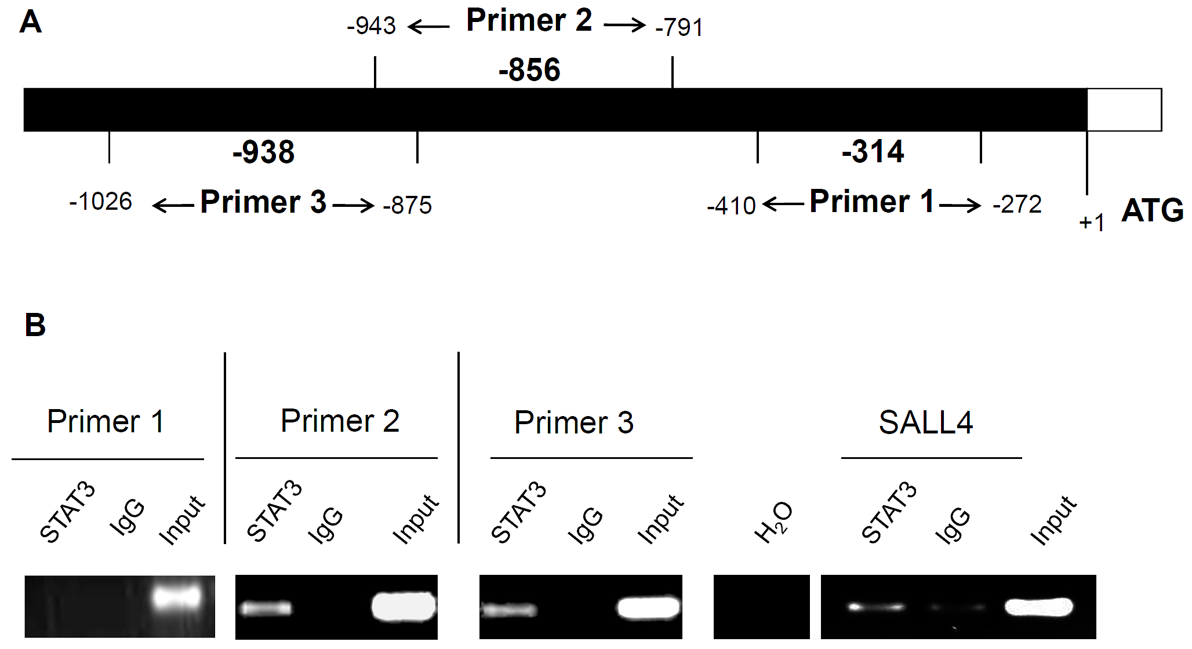

Figure 2

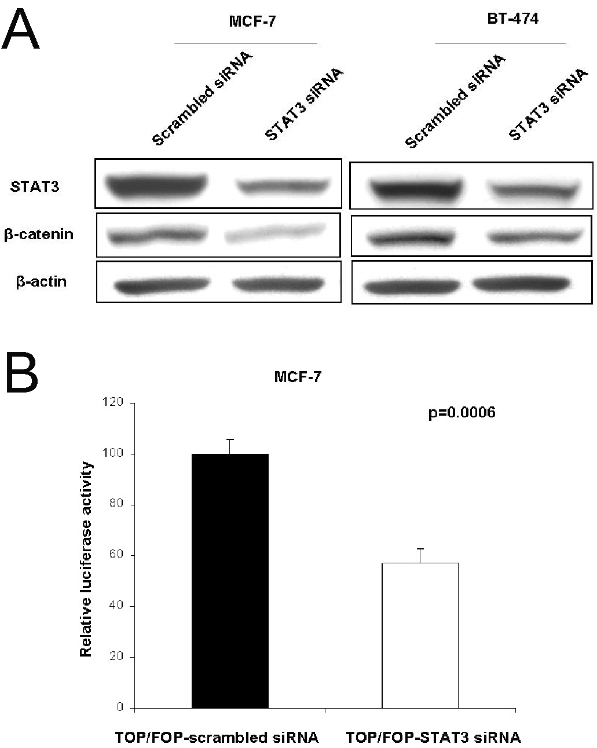

Figure 3

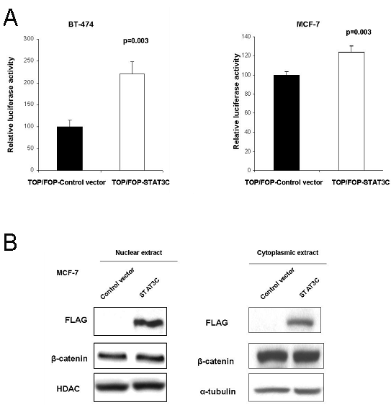

Figure 4

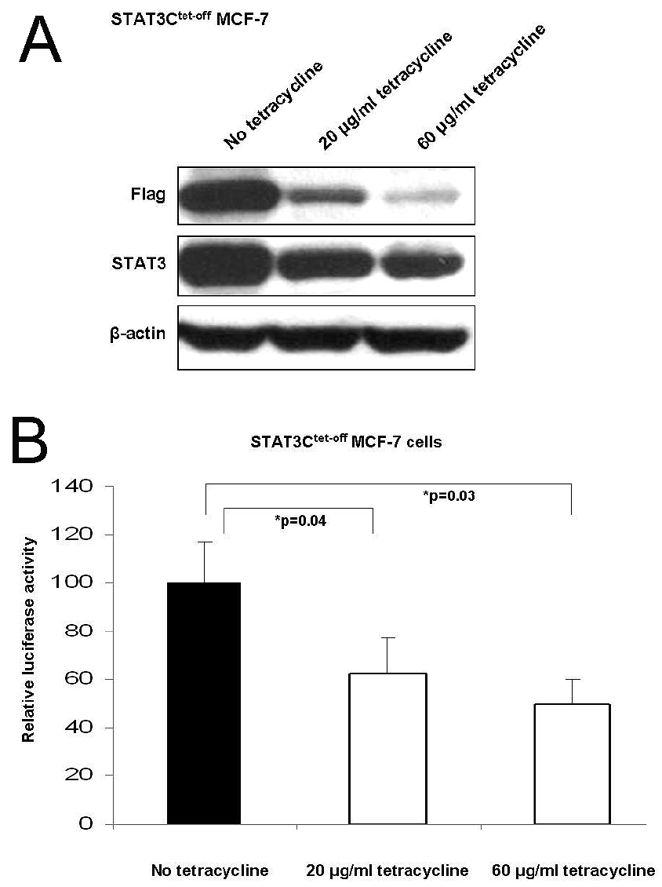

Figure 5

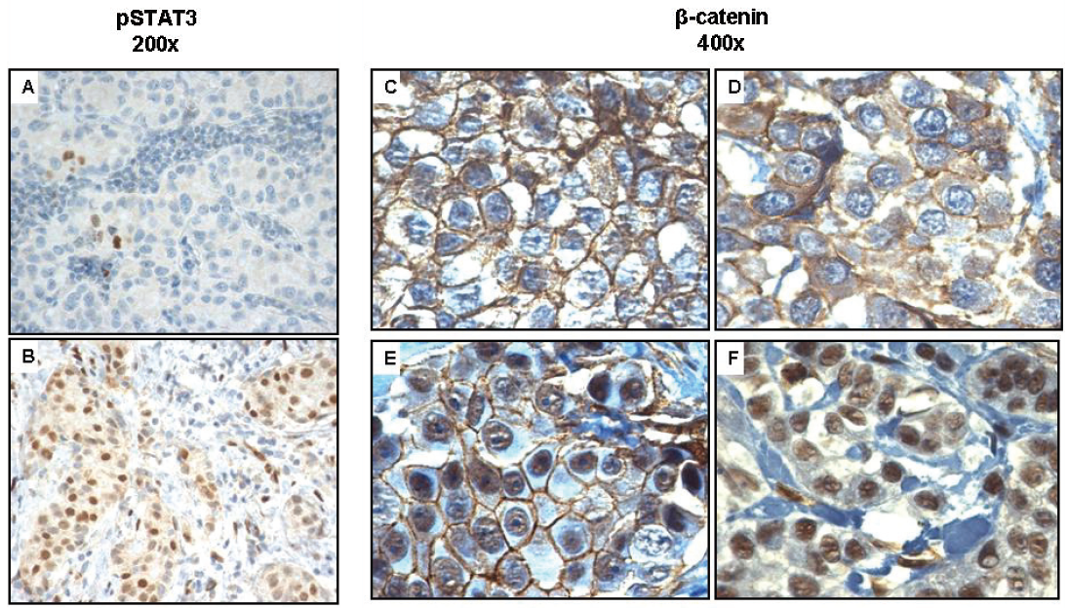

Figure 6

