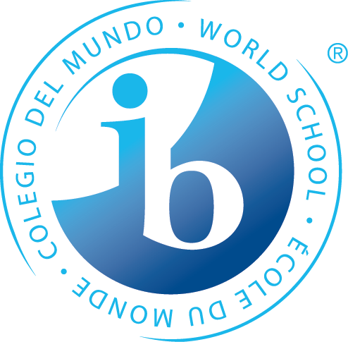

STUDENT SYLLABUS FOR
7TH GRADE LIFE SCIENCE!

Ms. Bell - Kaila.Bell@apsva.us
(703) 228-5900
Ms. Jenks – Elita.Jenks@apsva.us

Parent/Student Communication: Homework, projects, classroom notes or other science specific information will be posted on Google Classroom. Grades will be posted on StudentVUE/ParentVUE. Please check these sites regularly to keep up to date.

Course Description:
The 7th grade science curriculum centers on an exploration of life at both a microscopic and macroscopic level. This includes an examination of cells and DNA, the basic principles of genetics, a survey of the major groups of living organisms and finally how these organisms interact within their natural environment. Simultaneous with content learning, students will work to develop an awareness of the scientific method, experimental design, research, and analysis. The course requires students to collaborate effectively with others, practice good written and oral communication, think critically, and become active problem solvers.

IBMYP science units have been designed to add a global dimension to student learning, connect science to other curricular areas, and allow students to improve their communication skills. In keeping with the International Baccalaureate philosophy, a major aim of this course is to foster within students an understanding of the interdependence that connects them (and all humans) with their environment, and a sense of responsibility and stewardship toward the world around them.

Class Expectations:

1) Be on time and prepared for class
- Maintain an organized science section in their binder
- No food or drinks (except plain water)
- Emergency restroom requests will be granted once per grading period
- Orderly and respectful behavior will be expected at all times

Units:
1) Experimental Design
2) Cells
3) Genetics
4) Classification/Survey of living organisms
5) Ecology:

Textbook:
+ Concepts and Challenges in Life Science, Globe Fearon
+ McGraw Hill Digital Life Science resources
+ Newspapers, science magazines, videos, reference books, library research materials, and internet resources

Grading scale:
- Homework is intended as practice and will be graded for completion and effort
- Assignments are due at the beginning of class. After this time they are late
- Assignments are accepted up to one week late unless otherwise noted
- Grades will reflect student achievement and not student behavior
- Quarterly grades will round up when the percentage is .5 or higher.
Letter Grade | Percentage*
A | 100
B+ | 88
B | 85
C+ | 78
C | 75
D+ | 68
D | 65
E | 55
0 | 50
*IB assessments do not use percentages or points; products are assigned a score from 1 - 8.

IB Score | Science Assessment Criteria
8 | Criterion A: Knowledge and Understanding - Describe and apply scientific knowledge and understanding to solve problems set in familiar and unfamiliar situations and analyze information to make scientifically supported judgments.
8 | Criterion B: Inquiring and Designing - Describe a problem or question to be tested by a scientific investigation: outline and explain a testable hypothesis; describe how to manipulate the variables and now data will be collected; and design scientific investigations.
8 | Criterion C: Processing and Evaluating - Present and interpret collected and ransformed data; describe results using scientific reasoning; discuss the validity of a hypothesis and of the method used to conduct a scientific investigation; and describe improvements or extensions to the method.
8 | Criterion D: Reflecting on the Impacts of Science - Describe the ways which science is applied and used to address a specific problem or issue and analyze the various implication; apply scientific language effectively; and appropriately document the work of others and sources of information used.

 | Formative assessments  for “practice” | Summative assessments  to show mastery
Examples | 35 %  - Homework (10%)  - Class work (25%) | 65%  - Quizzes (15%)  - Projects  + Lab experiments (25%)  - IB Exams  + Unit Exams (25%)

Work Missed
If a student misses class for any reason they are responsible for making up assignments in a reasonable amount of time. A reasonable amount of time is to be determined by the length and difficulty of missed assignments and will be discussed with the student upon arrival back at Jefferson. Students should be aware that work for absent students is located in the blue bin and that any copies of lost assignments must be retrieved by checking the brown “Life Science Extras” folder or asking Ms. Bell for her “originals” binder.
Science Fair
All students are required to plan a Science Fair project and participate in the classroom Science Fair. A selected few will be chosen to participate in the TJMS Science Fair. All students are also encouraged to enter the Virginia Junior Academy of Science (VJAS).

