Name
Class
Date

1-4
Measuring Angles
Practice
Form K

A. Name the sides of the shaded angle. B. Name the vertex of the shaded angle. C. Name the shaded angle in three different ways.

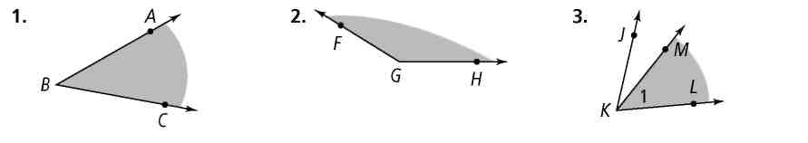
1. 2. 3.

Use the diagram below. Find the measure of each angle. Then classify the angle as acute, right, obtuse, or straight.
4. ∠AFB
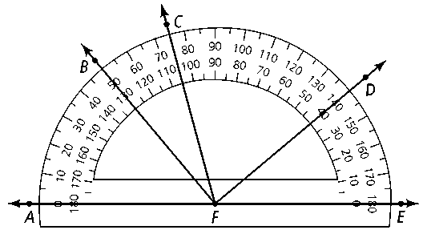
5. ∠AFD
6. ∠CFD
7. ∠BFD
8. ∠AFE
9. ∠BFE
10. ∠AFC

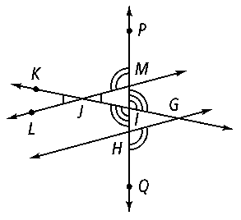
Use the diagram at the right. Complete each statement.
11. ∠MIG 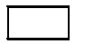
12. ∠PMJ 
13. If m∠KJL = 30, then m∠= 30.
14. If m∠LMP = 100, then m∠QHG = .

Prentice Hall Foundations Geometry • Teaching Resources
Copyright © by Pearson Education, Inc., or its affiliates. All Rights Reserved.
35

Name
Class
Date

1-4

Practice (continued)
Measuring Angles
Form K

15. If m∠FHI = 142, what are m∠FHG and m∠GHI?
16. ∠JKL is a right angle. What are m∠JKM and m∠MKL?

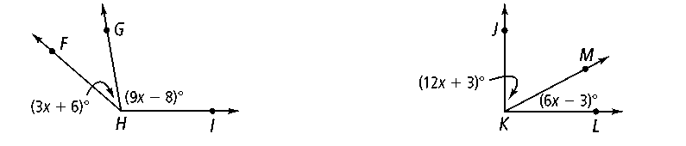

Use a protractor. Measure and classify each angle.

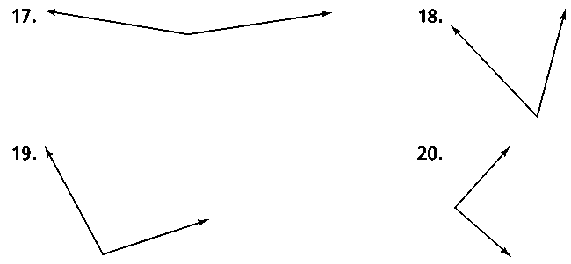
17. 18.

19. 20.

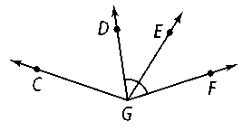
Algebra Use the diagram at the right for Exercises 21–23. Solve for x. Find the angle measures to check your work.
21. m∠CGD = 4x + 2, m∠DGE = 3x − 5, m∠EGF = 2x + 10

22. m∠CGD = 2x − 2, m∠EGF = 37, m∠CGF = 7x + 2

23. If m∠DGF = 72, what equation can you use to find m∠EGF?

Prentice Hall Foundations Geometry • Teaching Resources
Copyright © by Pearson Education, Inc., or its affiliates. All Rights Reserved.
36

