Name: _______________________________ Date: ________________________

Opinionaire: Peer Relationships

Part A: 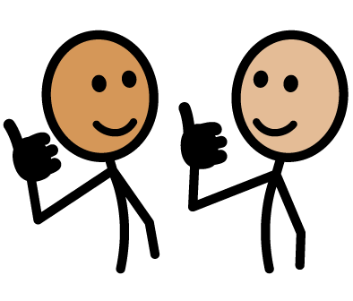 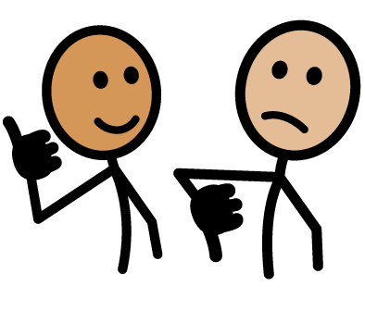
Directions: Identify whether you agree or disagree with each statement by circling the symbol.

- Other people define you by the people you hang out with.

Agree Disagree
- Physical appearance doesn’t matter among friends.

Agree Disagree
- I have many friends who are nothing like me.

Agree Disagree

- Kids who act “weird” deserve the treatment they get from their peers.

Agree Disagree
- A person’s parents are his/her best friends.

Agree Disagree

- It’s better to have a large group of friends than just one or two.

Agree Disagree
- Your status in your peer group affects how you feel about yourself.

Agree Disagree
- It’s okay to change how you act in front of different groups of peers.

Agree Disagree
- There are people in my close peer group whom I do not like.

Agree Disagree
- The people that you’ll be friends with in the future will probably be similar to the people you’re friends with now.

Agree Disagree

Part B:
Directions: Circle the character that you identify with the most.

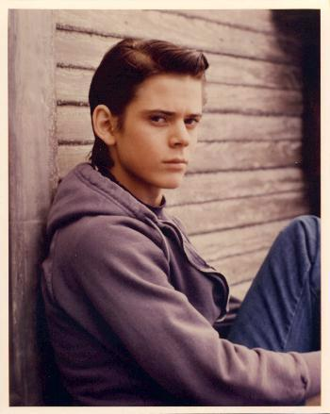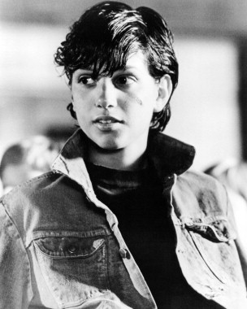
Ponyboy Bob Johnny Cherry

