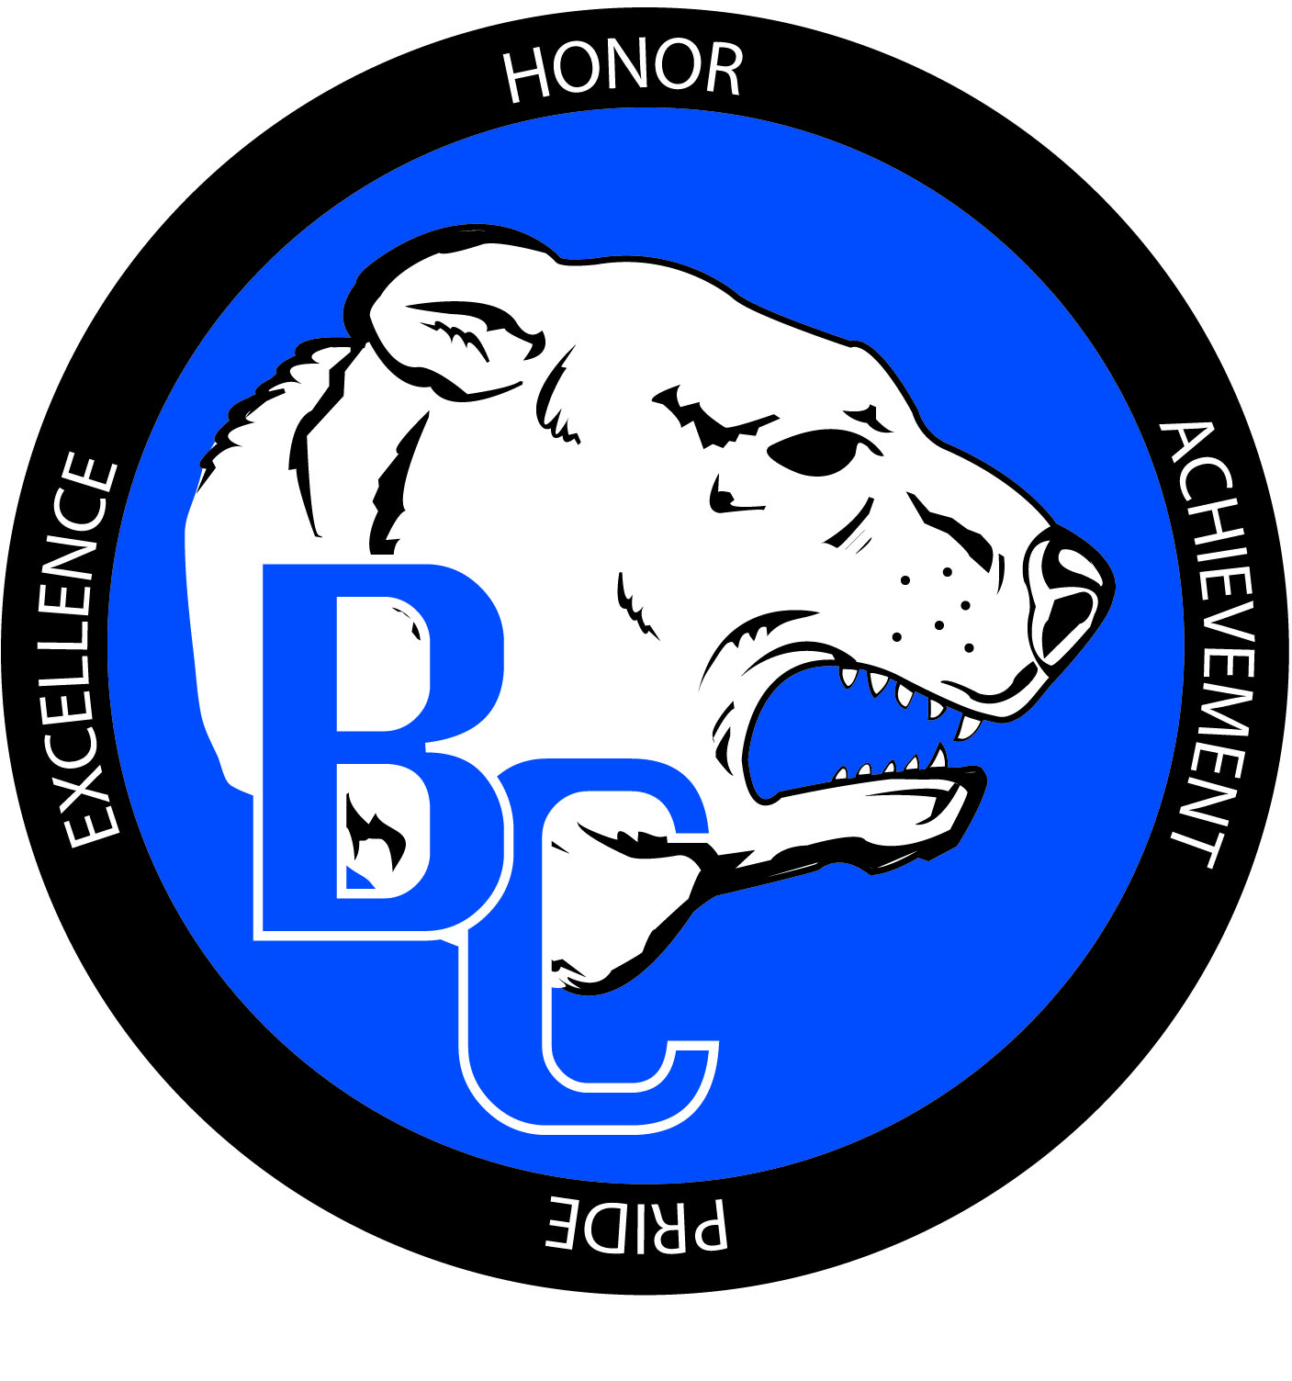
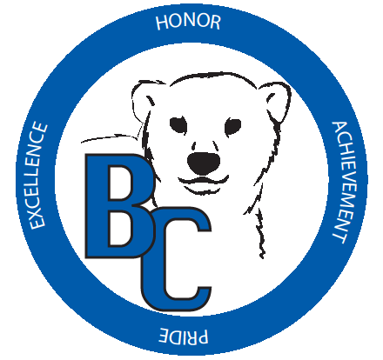
Bracken County Schools
348 West Miami Street

Brooksville, KY 41004
606-735-2523- phone 606-735-3640- fax
“Changing the world, one student at a time.”

Bracken County Schools
Gifted and Talented Student Service (GSSP)Plan

Student: _______________________ Grade: _____ Plan Date: ____________

Dear Parent/Guardian:

The Bracken County School District has developed guidelines for the identification of gifted/talented students. (These guidelines are provided in our online Gifted & Talented Handbook or by request through your child’s staff developer.) Through this process, your child has been identified as having demonstrated or potential ability in the following areas:

- Creative and Divergent Thinking
- General Intelligence
- Leadership
- Specific Academic Area: Language Arts
- Specific Academic Area: Mathematics
- Specific Academic Area: Science
- Specific Academic Area: Social Studies
- Visual and Performing Arts: Art
- Visual and Performing Arts: Music
- Visual and Performing Arts: Dance
- Visual and Performing Arts: Drama

The services your child will receive are checked below:

Check if Provided | Service Delivery Options: | Teacher Providing Service(s)
Various Acceleration Options (Check all that apply.)
___ Early Exit from Primary ___ Grade Skipping
___ Subject Area Higher Gr. Level ___ Dual Credit Courses
___ Dual Enrollment Courses ___ Early Exit from HS

 | Advanced Placement and Honors Courses
 | Collaborative Teaching and Consultation Services
 | Special Counseling Services
Differentiated Study Experiences in the Classroom (Check all that apply.)
___ Individual ___ Cluster Groups
Distance Learning (Check all that apply.)
___ KVHS Course ___ Video Course ___ Other Online Course
 | Enrichment Services (school day)
 | Independent Study
 | Mentorships
Resource Services (Check all that apply.)
___ Pull-out Setting ___ Appropriate Instructional ___ Setting Consortium
 | Seminars
 | Travel Study Options
 | Special Schools (4-12)
 | Self-contained Classrooms (4-12)

