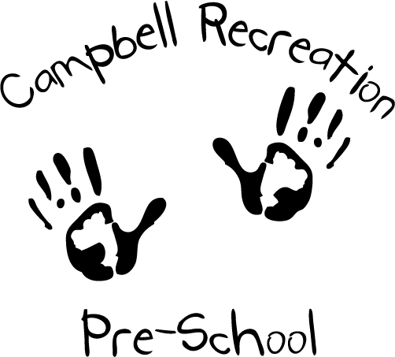

Super Kinders
Daily Schedule

12:30 – Students arrive and choose from free choice
activities such as: table top puzzles, art cart,
cars & roads, building blocks, legos, stories,
group games, etc.
1:00 – All students help to clean up toys and then join
together at the rug for circle time.
1:10 - Circle time consists of counting students,
calendar, daily weather chart, songs, finger
plays, flannel board games & stories, group
games, science experiments, etc.
1:30 - All students wash hands & use the bathroom if
needed, then enjoy a snack together.
1:45 - All students join together again on the rug to
hear about the daily center choices. (Art, science writing activity, math activity, computer, etc)
2:30 - All students help to clean up, then enjoy a snack.
2:50 - All students go outdoors to play.
3:20 - All students help to put outdoor toys away, then
enjoy a story and a short game to end the day!

