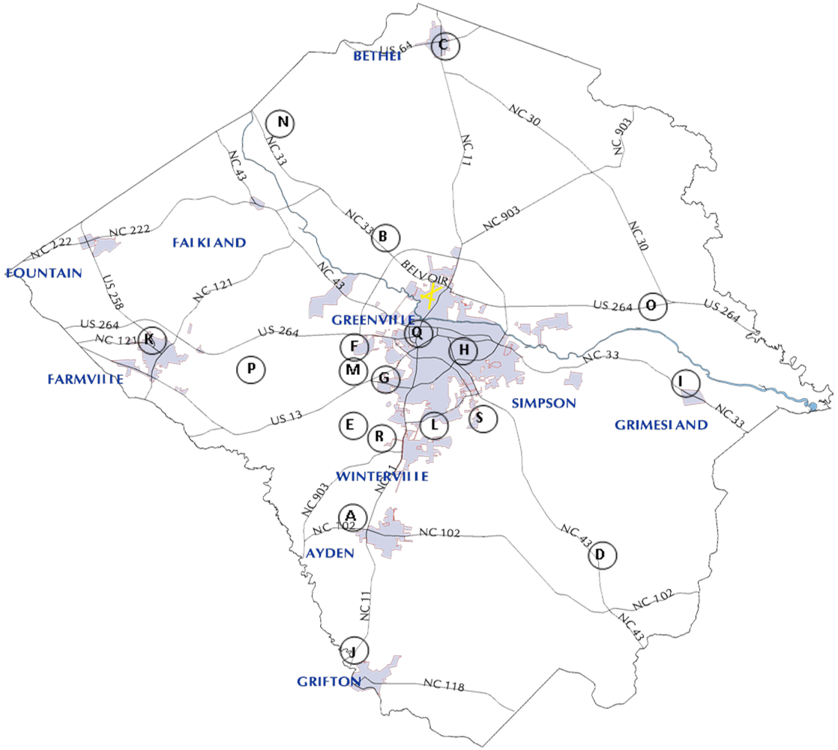

- Ayden Elementary School
187 3rd Street
Ayden, NC 28513

- Belvoir Elementary School
2568 NC 33 West Greenville, NC 27834

- Bethel Elementary School
210 E. Washington Street
Bethel, NC 27812

- Chicod Elementary School
7557 NC Hwy 43 South
Greenville, NC 27858

- Creekside Elementary School
431 Forlines Rd
Winterville, NC 28590

- Children’s World Aspiring Minds
804 John Hopkins Dr.
Greenville, NC 27834

- Children’s World Learning Center
1360 Greenville Blvd SW
Greenville, NC 27834

- Nancy W. Darden Child
Development Center at ECU
169 Rivers Building College of Human Ecology
Greenville, NC 27858

- G.R. Whitfield Elementary School
4839 School Rd
Grimesland, NC 27837

- Grifton Elementary School
513 E. MeCrae Street
Grifton, NC 28530

- HB Sugg Elementary School
3992 Grimmersburg St.
Farmville, NC 27828

- East Carolina Kiddie College
4024 B. Old Tar Rd
Winterville, NC 28590

- Lakeforest Elementary School
3300 Briarcliff Drive
Greenville, NC 27834

- Northwest Elementary School
1471 Holland Road
Greenville, NC 27834

- Pactolus Elementary School
3405 Yankee Hall Road
Greenville, NC 27834

- Possessing Keys to the Kingdom
2659 Railroad Street
Bell Arthur, NC 27811

- Sadie Saulter Educational Center
400 Spruce Street
Greenville, NC 27834

- W.H. Robinson Elementary School
2439 Railroad Street
Winterville, NC 28590

- Wintergreen Primary
4710 County Home Road
Greenville, NC 27858

