Clare F. Ostrander Elementary School
137 Viola Street, PO Box 310

Wallkill, New York 12589
Office: 845-895-7225 Fax: 845-895-8043

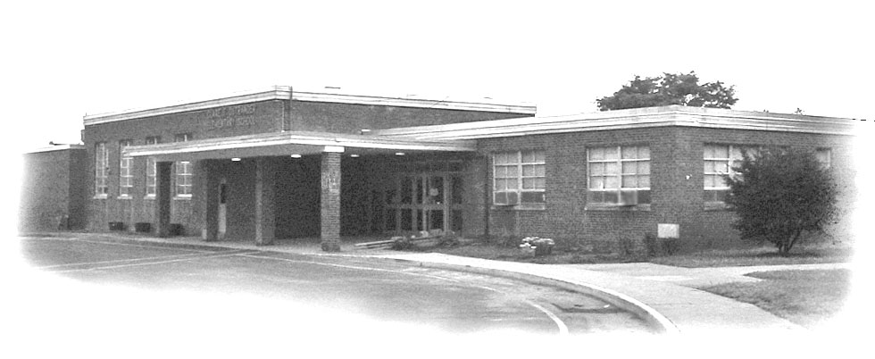
“Ostrander Elementary – A Proud Past and a Promising Future”

Mrs. Natalie Harjes
Principal
Mrs. Kristine Boyle
Intervention Specialist

Kindergarten Readiness

What does my child need to know to be “ready” for kindergarten?

Kindergarten is not the same as it used to be when you were in school. Today the focus is much more academic. Your child will be playing less and required to sit for a longer period of time. They will also learn to read, write simple sentences, and add and subtract numbers to five. Due to this, your child needs to acquire many skills prior to starting kindergarten in order to keep up with the New York State Standards.

How is Kindergarten different from Preschool?

Kindergarten follows a more rigorous daily schedule. Kindergarten students are required to follow our school's Code of Conduct. As a result, a kindergarten child must be more self-disciplined than a preschooler.

A Kindergarten Readiness Checklist

□ I can say my first and last name.

□ I know my address and phone number.

□ I know my parent’s first and last names.

□ I can recognize my own printed name.

□ I know how to use a zipper, shoelaces, snaps, and buttons.

□ I can independently take clothing on and off for restroom and outdoor recess times.

□ I know how to use a tissue and can ask for one.

□ I can let an adult know when I need to use the bathroom.

□ I can use the toilet, including raising the seat for boys, and the flusher.

□ I can wipe myself after using the toilet.

□ I can listen and sit quietly while others are talking.

□ I know my colors.

□ I can write my first name.

□ I can follow two-step directions.

Ostrander Kindergarten Teachers

Mrs. Busse Ms. Ellison Mrs. Kreuscher Mrs. Palen

