What will my child learn in Kindergarten?
Reading Readiness 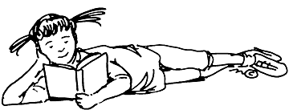 Kindergarten is a critical time to lay the foundation for becoming a successful reader.
Your child will learn to:
- Recite the alphabet.
- Recognize both upper and lower case letters.
- Correctly say each letter’s sound.
- Learn basic concepts of print:
  - holding a book correctly;
  - tracking words left to right;
  - reading from the top to the bottom of the page;
  - identifying the front and back cover and title page;
  - understanding the correlation between spoken and printed words.
- Identify initial and final sounds in spoken words.
- Identify rhyming and non-rhyming words (sun/run vs. sun/man)
- Determine word meanings from the way they’re used in a sentence.
- Identify characters, setting, and key events in a story.
- Retell stories in correct sequence.
- Follow two and three-step directions using picture clues.
Writing 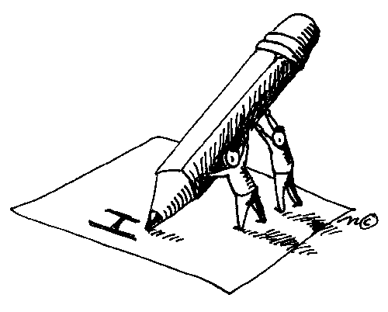
Early writing skills are reported using one of five stages, showing continual growth from kindergarten through the primary grades.
- Stage 1 involves pictures and scribbling.
- Stage 2 moves your child to the use of random letters, sometimes with correct initial sounds.
- Stage 3 involves the use of initial sounds or both the initial and final sounds-mostly consonants (i.e., lk for like).
- Stage 4 increases the use of vowels (lk becomes lik). As the words become longer, students begin to show an understanding of multiple-syllable words.
- Stage 5 uses many correctly-spelled words in multiple, related sentences.
  - Kindergarten writing objectives involve:
  - Generating story ideas as a class and drawing pictures to match.
  - Working as a group to draft a story.
  - Writing from left to right and showing space between words.
  - Writing the alphabet in both upper and lower case letters.
  - Writing first and last name on school/homework papers.

Mathematics 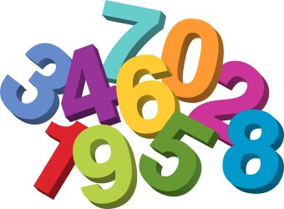

- Count to 30
- Identify and write numbers 0-30 (in and out of order).
- Identify the symbols +,-, = and learn simple addition and subtraction through number 10.
- Identify penny, nickel, dime and quarter.
- Understand the concepts of above/below/ between, smaller/larger/shorter.
- Identify copy and create models of various shapes (circle, square, rectangle, triangle, sphere, cube and diamond).
- Sort objects by size, color and shape.
- Create a variety of simple patterns.
Science 
- Introduction to…
  - Senses
  - Earth
  - Weather
  - Physical Science
  - Environmental Science
Social Studies 
- Understanding…
- Community Helpers
- Holidays and Seasons
- Customs
- Maps and Globes
Oral Language
- Strengthening oral skills by…
- Increasing vocabulary
- Speaking in complete sentences in front of groups
- Class discussions in small and large groups

Kindergarten Expectations

During his or her kindergarten experience, your child will experience many activities in all areas of development.
Social:
- Develop positive self-esteem.
- Learn to work and play with others.
- Learn to work independently.
- Learn to follow directions and classroom expectations.
- Demonstrate respectful and responsible behaviors.
- Be polite and kind.
Physical:
- Learn to use classroom equipment and supplies appropriately.
- Develop large motor skills involving body movement and coordination through running, skipping, and rhythmic activities.
- Develop small motor skills by cutting and tracing activities.

