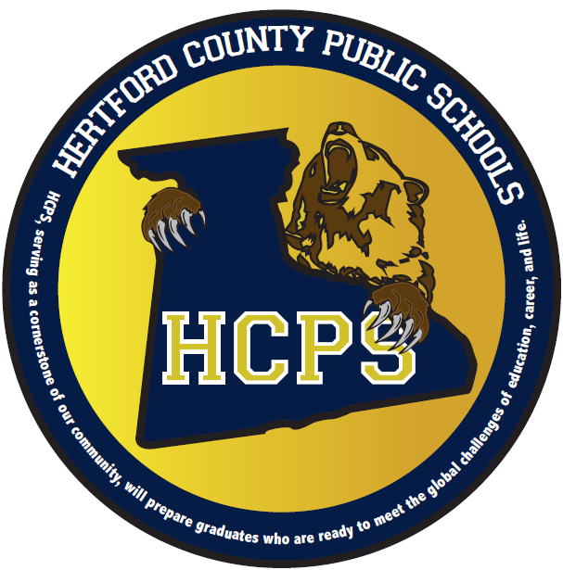
Hertford County Public Schools
2014 Graduation and Promotion Dates and Times

Roanoke Chowan Community College
Friday, May 09 @ 6:30 PM on RCCC Courtyard behind New Student Center (Some ECHS Students)

Early College High School Friday, May 23 @ 6:00 PM in RCCC Student Services Building

Riverview Elementary School Friday, June 6 @ 2:00 PM in Cafeteria * 6th Grade
Tuesday, June 10 @ 9:00 AM in Cafeteria * Pre-Kindergarten
Tuesday, June 10 @ 6:00 PM in Cafeteria * Kindergarten

Ahoskie Elementary School Thursday, June 12 @ 8:30 and 9:30 AM in Gymnasium * 6th Grade

Bearfield Primary School Wednesday, June 11 @ 9:00 & 11:00 AM in BPS Café * Kindergarten
Thursday, June 12 @ 11:00 AM in BPS Café * 3rd Grade

Hertford County Middle School Thursday, June 12 @ 1:00 PM in Gymnasium * 8th Grade

C.S. Brown High School Friday, June 13 @ 6:00 PM at CS Brown Cultural Arts Center * 12th Grade

Hertford County High School Saturday, June 14 @ 10:00 AM in HCHS Gymnasium * 12th Grade

