

March/April
18 | 19 | 20 | 21  Early Release @1:55 pm  AM Kinders attend all day | 22 | 23 | 24
25 | 26  No School  Spring Break | 27  No School  Spring Break | 28  No School  Spring Break | 29  No School  Spring Break | 30  No School  Spring Break | 31
April 1st | 2 Site Council @ 5:00 pm  PTO at 6:15 pm | 3 | 4 | 5 | 6  No School  Teacher Work Day | 7

The next meeting is Wednesday, April 11th @ 7:00 pm in Council Chambers at Fairview City Hall. Located at 1300 NE Village St. in Fairview. Call 503:661-7200 for more information.
District News
Woodland Elementary School • 21607 NE Glisan • Fairview, OR 97024
Chris Greenhalgh, Principal • (503) 674-8188 • www.reynolds.k12.or.us/~woodland

March 16, 2012
Spring Picture Day
Tuesday, March 20th
Class group pictures will be taken the cost is $8.00. Scenic back -ground individual pictures will be taken if students return the order form. Call the office if you did not receive an order form.

Box Top Winners
The Parent Group received over $538.00 in box tops. Thanks for sending in your box tops. Ms. Dugan’s AM class won top honors for Kindergarten with $50.10. Other class winners were Mrs. Forwood’s first grade class with $82.50 and Ms. Macdonald’s fourth grade class with $48.70. These three classes were provided a healthy snack party from the Parent Group. Keep saving box tops!
Spirit Winners
Ms. Macdonald’s fourth grade class won the Woodland Wolf Spirit Award on Wednesday, March 7th with 100% of the class wearing school colors. Ms. Krell’s fourth/fifth grade class won with 98% on March 14th.

The Bird Who Ate Too Much
Ms. Kennedy’s ELD class put on a reader’s theater production of The Bird Who Ate Too Much. The children had two performances, one for Ms. Campbell’s PM kindergarten and one for parents. Students Norma Ceniceros, Jasmin Crisostomo-Damian, Jason Diaz, Rosa Magana-Farias, Saul Zamorano, Adalberto Hernandez-Hernandez, Santiago Felipe-Francisco, Evelina Gutsul and Janett Arredondo-Zavala created their own costumes, practiced their lines and did a wonderful job!
Ms. Kennedy, Third Grade Teacher
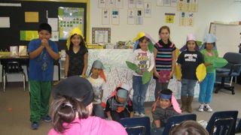

Spring Break

March 26th to March 30th

School Resumes
Monday, April 2nd

April 8th Parent Group Meeting @ 4:30 pm

April 15th Wolf Council @ 1:50 pm

April 23rd Spring
Pictures

May 14th Kindergarten
Round-Up @ 4:00 pm

Upcoming Events
Woodland Parent/Teacher
Organization (PTO)

Our next meeting is Monday, December 5th at 6:15 pm. Please join us and help plan our December movie night.

Penny Drive For
Special Olympics
Room 106 (Life Skills) is sponsoring a penny drive for the Special Olympics. Bring in your pennies, nickels, dimes and quarters between Jan. 17th—Feb. 8th. This is a fundraiser for the Polar Plunge where participants jump into the Columbia River on Saturday, Feb. 11th. Several of our staff members will be doing the “plunge”. Support the cause and bring in your spare change!

Penny Drive For
Special Olympics
Room 106 (Life Skills) is sponsoring a penny drive for the Special Olympics. Bring in your pennies, nickels, dimes and quarters between Jan. 17th—Feb. 8th. This is a fundraiser for the Polar Plunge where participants jump into the Columbia River on Saturday, Feb. 11th. Several of our staff members will be doing the “plunge”. Support the cause and bring in your spare change!

If your student(s) are going to be absent please call the school @ 503:674-8188. You may call the night before or early in the morning and leave a message. Please call by 9:00 am!

Early Release
The next early release date is Wednesday, March 21st. Students will be dismissed at 1:55 PM.
AM Kindergartners will attend all day.

PM Kinders will stay home.

Frogs and First Graders
Spring is almost here. Have you heard the frogs croaking near where you live? If you have, it’s the song of the Pacific Tree Frog. They are the only native croaking frogs in our area. And, now the first graders at Woodland are going to be studying their life cycle or metamorphosis. This week Laura from Gresham Watershed Restoration delivered our frog eggs (called spawn). In about 2 weeks, the tadpoles will hatch and by the end of the year, we will have a tank full of baby frogs in each first grade classroom.
We are excited to watch for changes as they go through the stages of development. Feel free stop by and see their growth before or after school, if you are interested. We’d love to share our first grade learning with you!
By: Heidi Schneider, First Grade Teacher

African Storytelling With Habiba
On Saturday, March 17th at 3:00 pm, join Habiba, a native of Ghana, in learning stories about African history. Habiba offers an interactive, multicultural performance with authentic West African costume, spiced with singing and movement. These stories help us explore our own world as well as those far, far away. This will take place at the Columbia Regional Library in Fairview Village.
Woodland Wanderings

Call In Absences
503:674-8188

Woodland Parent/Teacher
Organization (PTO)
We want to thank everyone who donated items for our Bingo Night raffle baskets. Also, a big thank you to all the volunteers who helped with the planning and preparation for our Bingo event.
Our next meeting is Monday, April 2nd at 6:15 pm.

Health Room
Clothing Supply
We keep extra sweat pants and tops in our health room for students who need a change of clothes. Please return items if your student has borrowed clothing. Our supply is low on sweat pants. If you can donate sweat pants it would be helpful.

Half Moon Celebration
Students were awarded one-half hour of free time with their classmates on Friday, March 9th. The time was earned because students achieved the half-moon phase on the Wolf Wall, which is located in our school’s cafeteria. Students who demonstrated respectful, and safe behaviors earn Pack Power Tickets and Wolf Paws. These rewards
can be used to purchase wolves for the Wolf Wall. By purchasing wolves, students help the whole school achieve phases of the moon. At each phase of the moon, the school celebrates together. The quarter moon celebration was Hat Day. This half- moon celebration was one-half hour of free time filled with fun activities. Thank you students for making responsible choices. By: Mrs. Larsen, School Counselor

Pictured below are students playing with Legos for their fun free time!
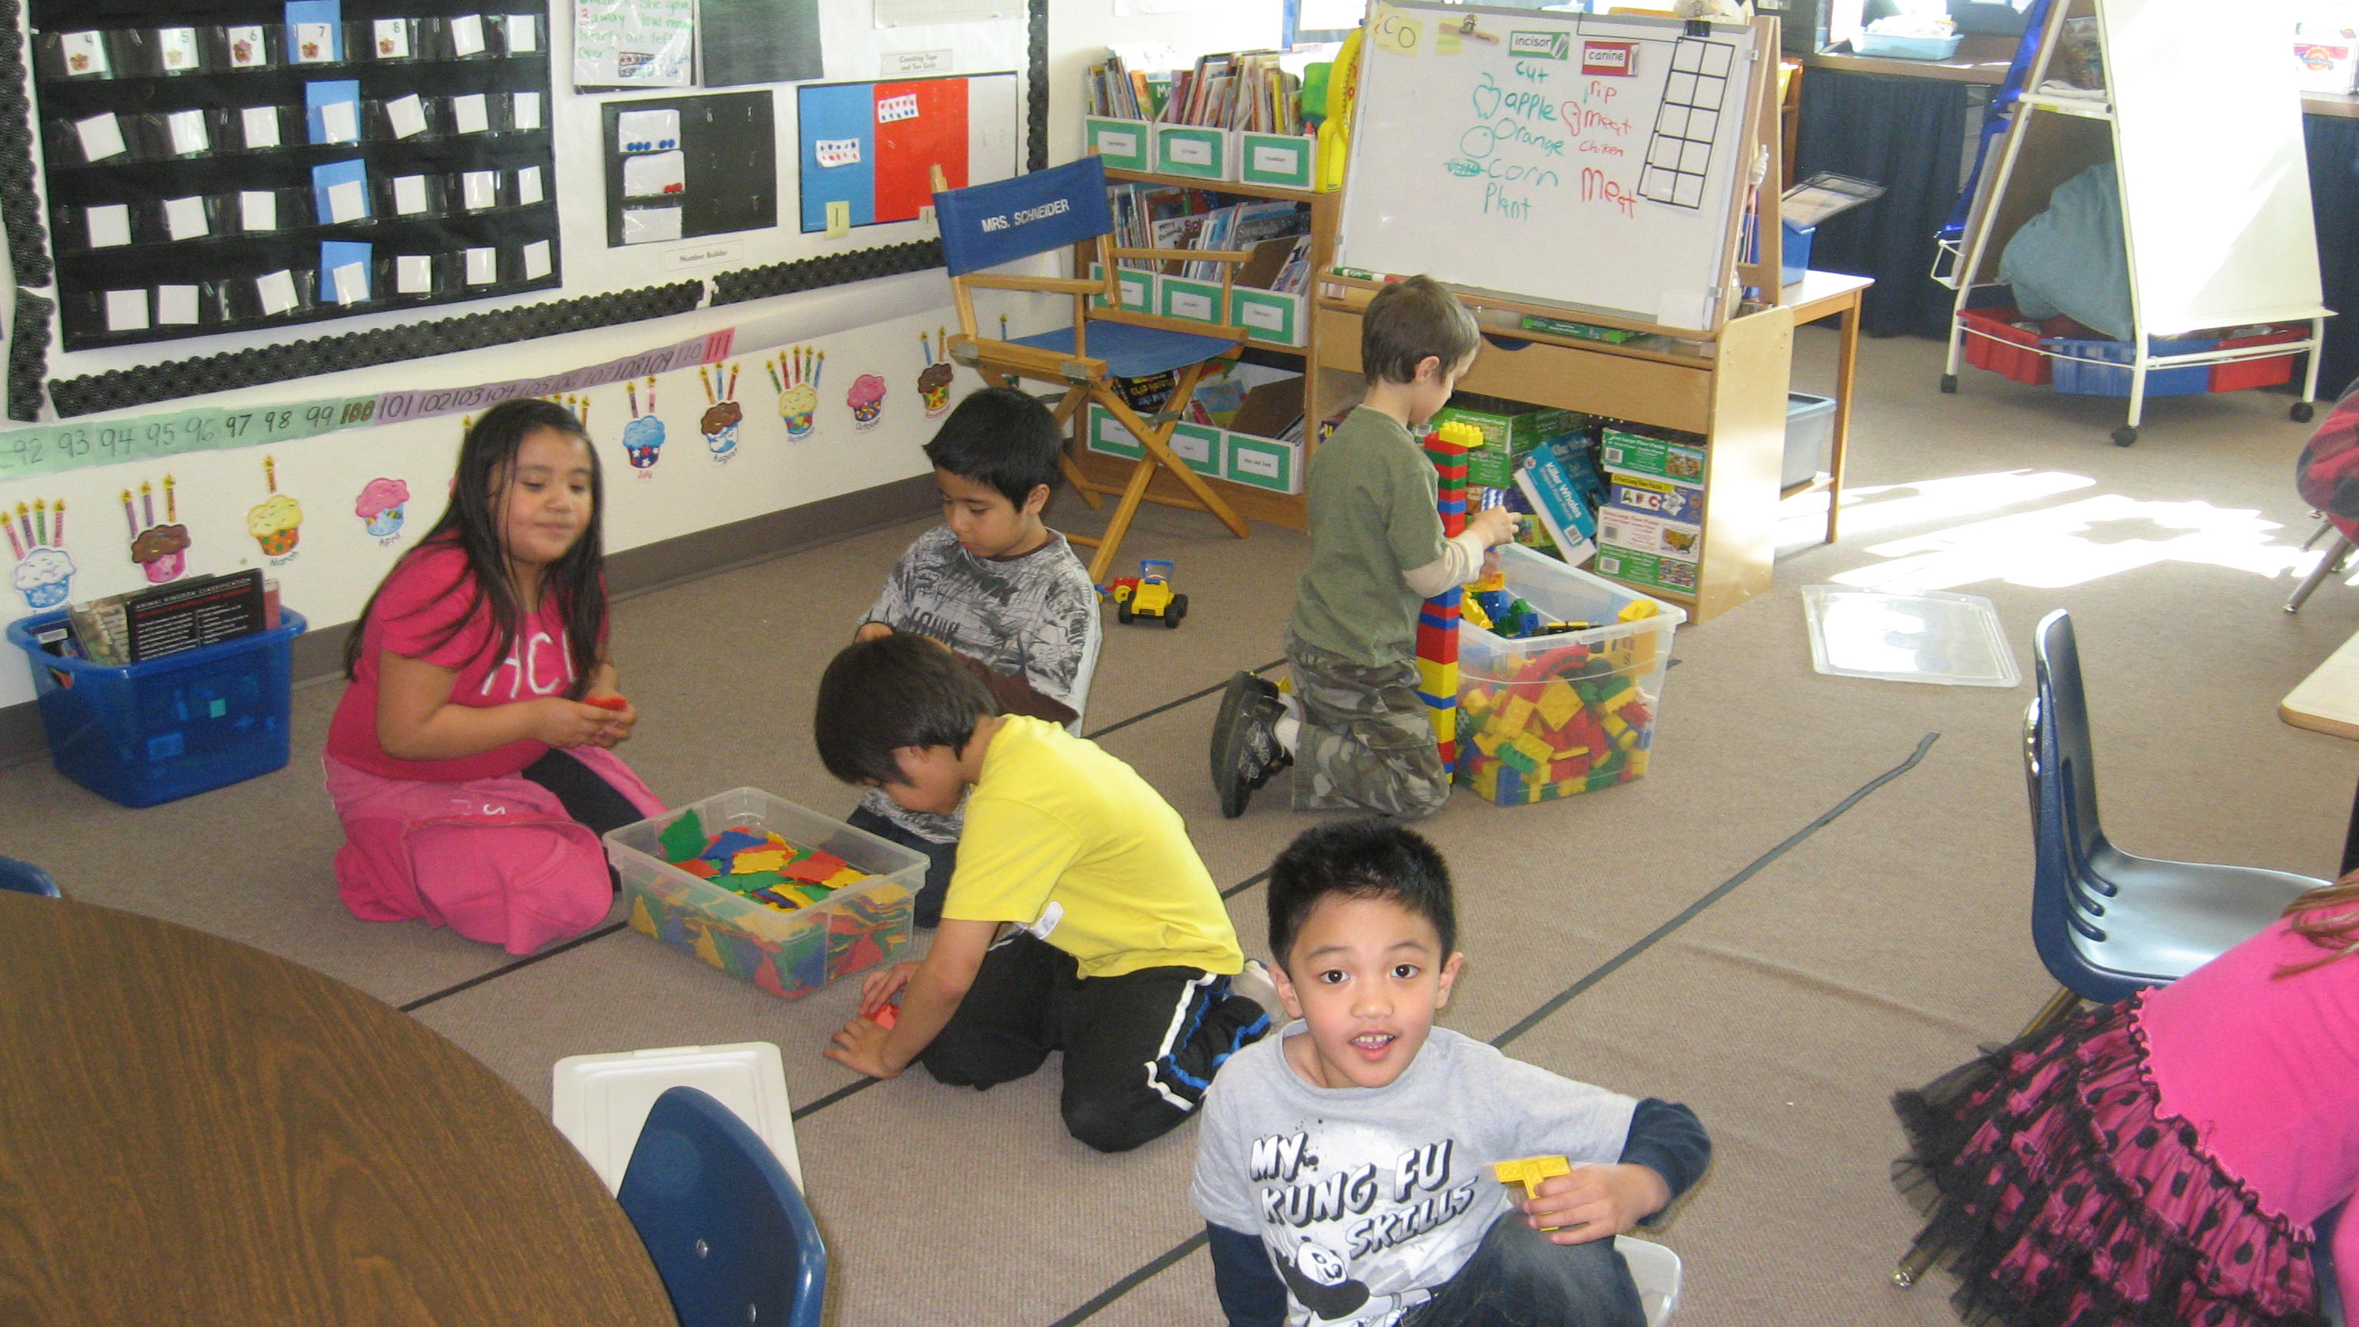

Volunteer Update

