________________________________________________________

Masterpiece: Four Ice Cream Cones, 1964 by

Wayne Thiebaud
_____________________________________

Pronounced: TEE-bo

Keywords: Texture, Shape, Repetition
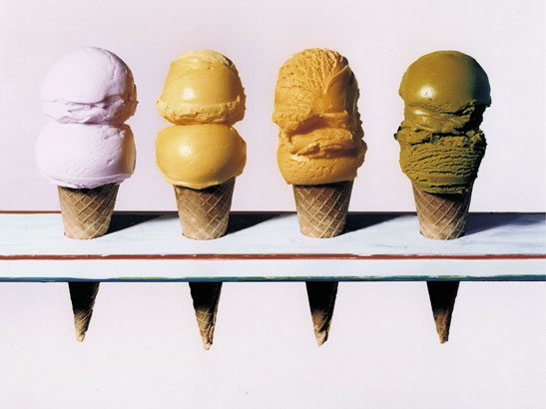
Grade: Kindergarten
Month: September
Activity: Stamping with Sponges

Meet the Artist
- He was born in Mesa, Arizona in 1920. Currently he lives in California and is an art professor at a university.
- As a young man, he worked in an ice cream and hot dog café. These items gave him inspiration for his future paintings.
- He drew comic strips and was once an animator for the Walt Disney Studios.
- He considered himself a painter, not an artist.

Possible Questions:

- What shapes do you see?
- What do you think the ice cream cones would feel like if you could touch them?
- How does this make you feel? Hungry? Thirsty? Happy? Cold?
- How are these ice creams different from real ice cream cones? How are they the same?

**DO NOT LET CHILDREN TAKE THIS PROJECT HOME IT WILL BE DISPLAYED IN OUR MARCH ART WALK!

Activity: Stamping With Sponges

Materials Needed: paints of red, yellow, orange, green, brown and white,
Circle, triangle sponges, 9”x12” white construction paper, paper plates (enough for each pastel color and brown), bowls of water, stir sticks to mix paint, Paper towels for blotting and clean-up, newspaper to cover the desks. Optional: puffy paint, glitter, sand or shaving cream.

Process:
- Cover the Desks with newspaper.
- Pass out the 9”x12” white construction paper to each student. Place name labels on back of paper.
- Pour white paint onto four paper plates. Add small amounts of other paints to each plate to create light pastel colors (pink, peach, mint and lemon) to be used for the ice cream. Use a separate plate for the brown cones.
- Have children come to the worktable or tables 4 or 5 at a time. Show them how to dip the sponge in the paint then blot off the excess on the paper towel before stamping their sponge on the paper.
- Before they start, ask the students to think how they are going to place the shapes on the paper. How will they make them look like ice cream cones? (i.e. Do the circles go on top of the triangles or underneath?) Lay the artwork flat to dry.
*Be sure to wash off the sponges and trays well. The sponges will mold if not dried off properly.

Variation: Walk around the classroom with brown “fabric or puffy paint” and create a diagonal crisscross pattern on the cone area of their paper. Also, add something like sand, glitter or shaving cream to the “ice cream” paint to add texture. When the artwork dries, it will have a definite texture that they can feel.

Art Masterpiece - 4 Ice Cream Cones - September - Kindergarten

Artist- Wayne Thiebaud (Tee-Bow) b. 1920

Today we studied Four Ice Cream Cones, a still-life of four large, luscious ice cream cones lined up on the counter of an ice cream parlor. Thiebaud manipulates the oil paint with rapid brush strokes, resulting in a thick impasto. This technique simulates the creamy texture of the ice cream and reflects the artist’s interest in depicting real objects as they appear in nature (realism). We painted soft, pastel colored ice cream cones today using triangle and circle shaped sponges. This will be your child’s Art Masterpiece art walk project. They are excited to share it with you during their Spring conference!

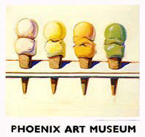

Art Masterpiece - 4 Ice Cream Cones - September - Kindergarten

Artist- Wayne Thiebaud (Tee-Bow) b. 1920

Today we studied Four Ice Cream Cones, a still-life of four large, luscious ice cream cones lined up on the counter of an ice cream parlor. Thiebaud manipulates the oil paint with rapid brush strokes, resulting in a thick impasto. This technique simulates the creamy texture of the ice cream and reflects the artist’s interest in depicting real objects as they appear in nature (realism). We painted soft, pastel colored ice cream cones today using triangle and circle shaped sponges. This will be your child’s Art Masterpiece art walk project. They are excited to share it with you during their Spring conference!

Photographs and other paintings by Wayne Thiebaud

