gina m. picard
Superintendent of Schools

MICHAEL COMELLA, Ed.D.
Assistant Superintendent of Schools
Chariho Regional School District
Office of the Superintendent

455A Switch Road
Wood River Junction, Rhode Island 02894

All Kids. All of the Time.
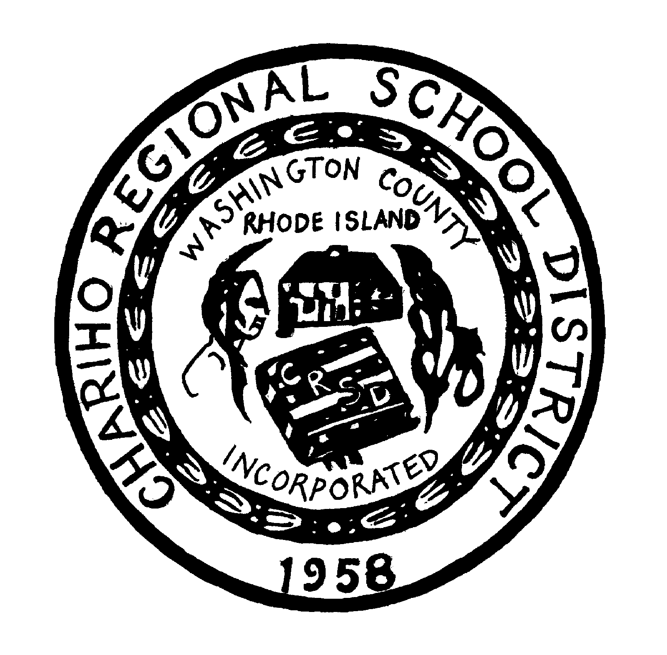


catherine m. giusti
School Committee Chairperson
CHARIHO REGIONAL SCHOOL DISTRICT
School Committee Special Meeting/Budget Workshop

A vote may be taken on any item on this agenda.

Note: The public is welcome to any meeting of the School Committee or its subcommittees. If communication assistance (readers/interpreters/captions) or any other accommodations are needed to ensure equal participation, please contact the Superintendent’s office at least two (2) business days prior to the meeting.

Any changes in this agenda will be posted on the school district's website (www.chariho.k12.ri.us) as well as in the Chariho Administration Building at least forty-eight (48) hours in advance of the meeting. Individuals requesting special notice of the revised agenda must call (401) 364-7575 to make arrangements for same.

DATE: Tuesday, January 3, 2023
TIME: 6:00 PM
PLACE: Chariho High School Library, 453 Switch Rd, Wood River, Jct, RI

AGENDA

- Meeting Call to Order/Pledge of Allegiance/Silent Meditation

- Budget Workshop

III. Adjournment

Posted December 21, 2022
Office of Secretary of State, Chariho Website, Chariho Superintendent’s Office, Chariho High School, Charlestown, Richmond, Hopkinton Town Halls

