Hart Park Senior Center Wauwatosa Senior Club
7300 Chestnut Street 7725 W. North Ave
Wauwatosa, WI 53213 Wauwatosa, WI 53213
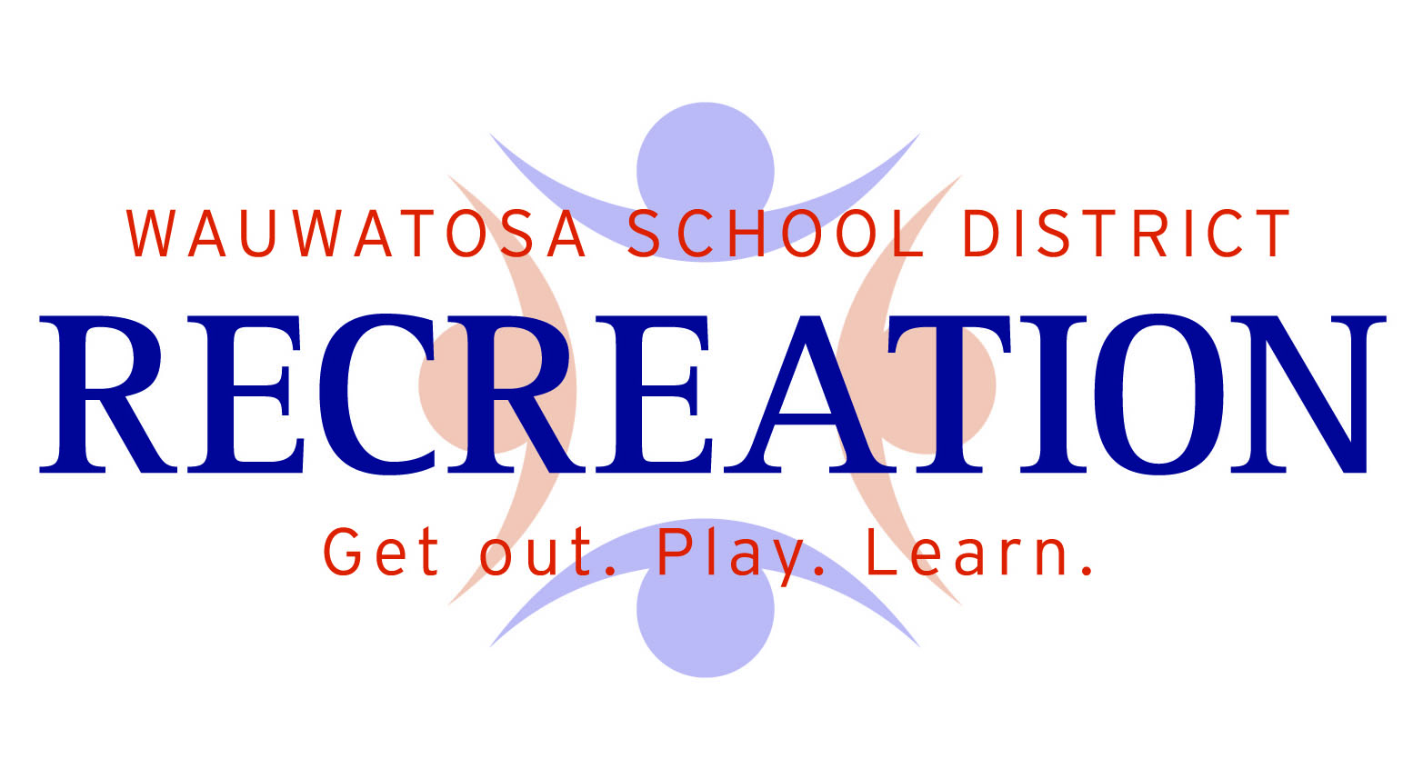

Wauwatosa Active Older Adults Membership
2023

Registration Form (Activity #663000-23)

$15 Resident $20 Non-Resident (Make checks payable to: Wauwatosa Recreation Dept.)

Name: __________________________________________________________________________

Address: _____________________________________ City: _______________ Zip: ________

Phone: ______________________________ Birthday (Month/Day/Year): _____________________

Cell Phone: __________________________ Email Address: ____________________________

Are you interested in having your name/address/phone posted in a directory? Yes No

I, the undersigned, do hereby understand that I have registered the individuals named herein to participate in the aforementioned activity (ies) and I further agree to indemnify and hold harmless the Wauwatosa Recreation Department and its employees, officers and agents from and against any and all liability. In addition, I understand that this requested program, like all activity has some inherent risk involved. Furthermore, the individuals named herein are in good physical condition appropriate for the slated activity (ies) and that participants must assume full responsibility for injuries incurred while taking part in an activity. No accident insurance is provided by the Wauwatosa Recreation Department. I/We have read and agree to the registration and program policies.

Signature: _______________________________________ Date: ___________________________

Medical Information

Emergency Contact Person: ___________________________________________________________

Emergency Contact Phone: ____________________________________________________________

Medications: ________________________________________________________________________

Allergies: ___________________________________________________________________________

