BENEFIT ELIGIBLE EMPLOYEES
OPEN ENROLLMENT IS HERE, THE TIME YOU MAY MAKE CHANGES TO


YOUR BENEFITS PACKAGE!!!

May 3, 2021 – May 31, 2021

The Human Resource Departments will be available to assist employees making changes to the following benefits:

- Blue Cross Blue Shield of MA - Health and Dental
- Boston Mutual – Life Insurance and Long-Term Disability
- 403B
- AFLAC -Voluntary Accident, Short-Term Disability, and Cancer Insurance
- MassMutual – Voluntary Life Insurance
- MIIA Employee Assistance Program
- Town of Plymouth Retirement Board
- BJ’s Wholesale Club

Benefits information, rates, enrollment/change forms, and representative contact information will be available on the Plymouth Public School website from May 3, 2021 – May 31, 2021 at www.plymouth.k12.ma.us
YOU DO NOT HAVE TO NOTIFY THIS OFFICE IF YOU DO NOT WANT TO MAKE ANY CHANGES.

PLEASE REMEMBER:
- The deadline to submit changes to your Human Resource Department is May 31, 2021.
- New deductions will appear on the first paycheck in June 2021. Changes are effective July 1, 2021.
- Dental and Long-Term Disability is available only to subscribers of Blue Choice, Access Blue NE Saver, or those not enrolled in health insurance through the Town of Plymouth.

Questions? Please contact Jackie Gurney, Human Resources-Town (508) 747-1620 x10103 – jgurney@townhall.plymouth.ma.us , or Theresa Sears, Human Resources-School (508) 224-5061 – tsears@plymouth.k12.ma.us

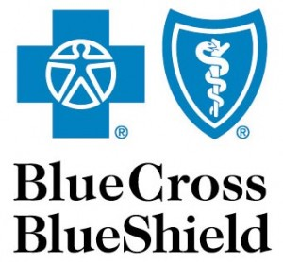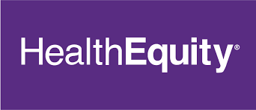

Questions about the Access Blue NE Saver plan (HDHP) with HSA?
Live informational webinars will be presented by Blue Cross Blue Shield and Health Equity on the followings dates, please use the links provided below to register:

May 3, 2021 – 10:00 am - https://well-b.zoom.us/webinar/register/WN_p0JxJqLKTKmLCrAFv9Pp-w
May 11, 2021 – 5:00 pm - https://well-b.zoom.us/webinar/register/WN_KESHE-qKRHCD_mx6zskfTw
May 19, 2021 – 12:30 pm - https://well-b.zoom.us/webinar/register/WN_NUi91qfoSjaA9ZyNNY5G8g
May 27, 2021 – 10:00 am - https://well-b.zoom.us/webinar/register/WN_JMCHkrndTgmEgy-Gh6YmQQ

- Links to register for the Webinars will also be available on the Town of Plymouth website: www.plymouth.k12.ma.us

- A pre-recorded presentation on the Access Blue NE Saver High Deductible Health Insurance Plan with HSA is now available on the Town of Plymouth website or using the following link: https://www.brainshark.com/bcbsma/vu?pi=zH6zZmY3azUK5fz0&intk=976685610

CHANGES TO LIFE INSURANCE!

- Effective July 1, 2021 the value of the Basic Life insurance program offered by the Town of Plymouth to active employees will increase from $2,000 to $15,000. The employee contribution percentage will increase from 10% to 25%. The new monthly premium will increase from $0.07 to $0.69 (26 payrolls) or 0.82 (22 payrolls) per pay period.

- Employees already enrolled in the Basic Life Insurance Plan with Boston Mutual will not need to make any changes.

- If you wish to enroll in Boston Mutual Life Insurance this year, you will not be subject to a medical review - it will be guaranteed issue.

CHANGES TO LONG TERM DISABILITY INSURANCE!
- Effective July 1, 2021 the employee contribution percentage for Long Term Disability Insurance will increase from 10% to 25%.

- Employees already enrolled in LTD with Boston Mutual will not need to make any changes. If you wish to enroll in LTD with Boston Mutual this year, you will be subject to a medical review - it will NOT be guaranteed issue.

