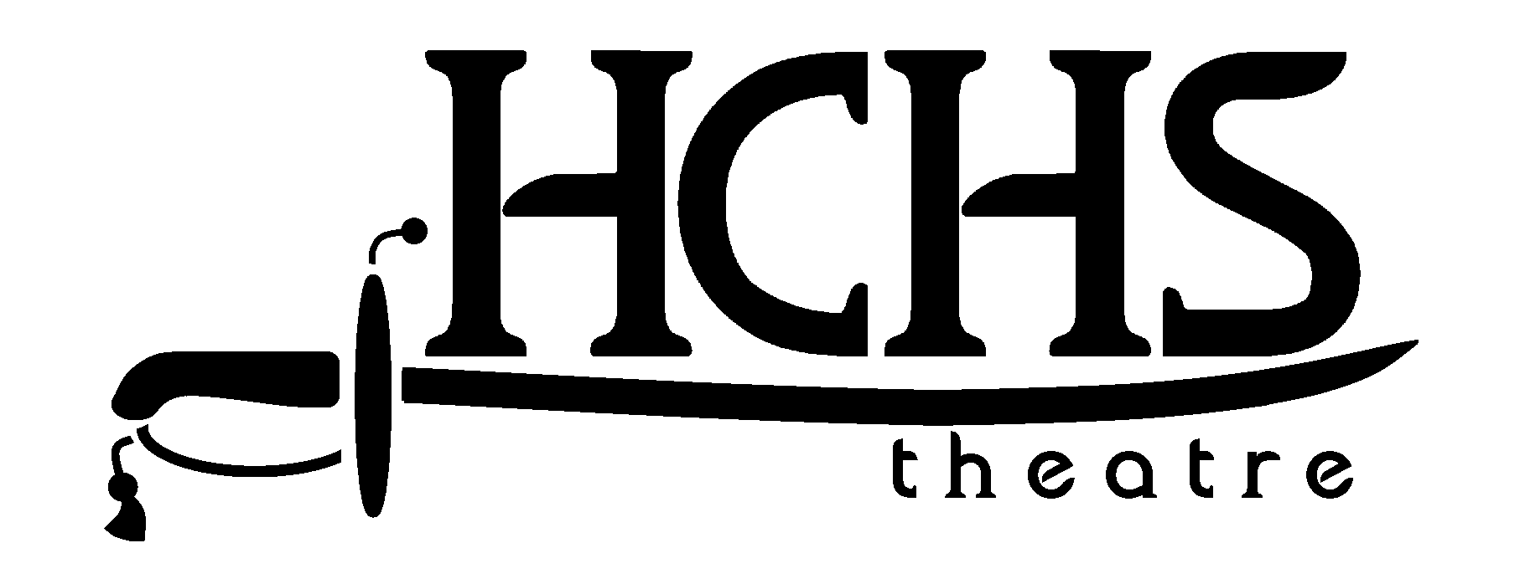
Contact: Mark Stich  (770) 574-7647  (478) 494-2435 cell  mark.stich@haralson.k12.ga.us | FOR IMMEDIATE RELEASE

ZOMBIES INVADE HCHS IN “NIGHT OF THE LIVING DEAD”
Theatre Department Tackles Classic Horror Movie
Haralson County High School Theatre launches its new season with a stage adaptation of the George Romero film, Night of the Living Dead. The stage production follows the story of the film closely as a group of strangers finds themselves stranded in a Maryland farmhouse during a zombie event. Opening night is October 21st, with performances to follow on the 28th and 30th of October. All performances are at 7:30 p.m. at the HCHS Fine Arts Building, and all tickets are $5. Tickets can be purchased at the door, and doors open thirty minutes prior to curtain. This show does contain some zombie violence. For more information, find HCHS Theatre on Facebook at Haralson County High School Theatre.
-xxx-
If you would like more information on HCHS Theatre or “Night of the Living Dead”, contact Mark Stich at mark.stich@haralson.k12.ga.us

