Ralph J. Bunche Middle School
Virtual Learning Plan
2021-2022

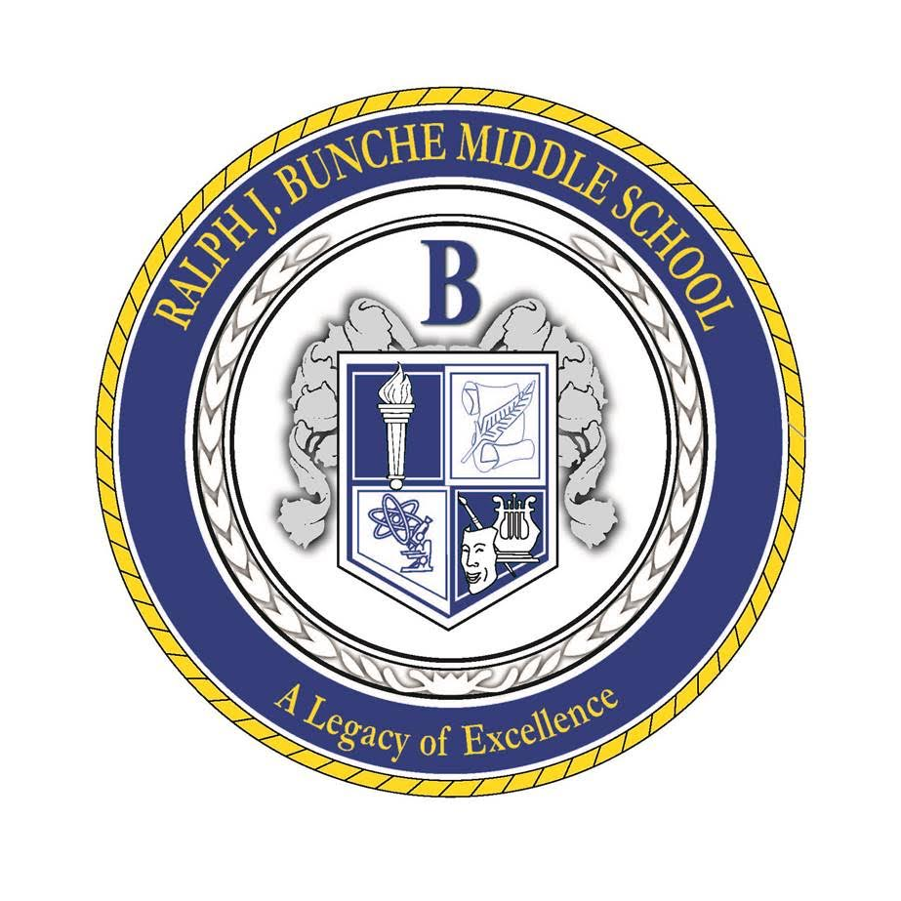

Mrs. Kimberly Whitfield, Principal

Communication Plan

Ralph. J. Middle School is committed to keeping families informed and in ensuring all families and staff receive important information as it relates to virtual learning.

Bunche Middle School will continue to follow district established protocols regarding case investigation and contact tracing. In addition, students or staff who are ill or presenting with any symptom of COVID-19 should always remain home. Additionally, if a student tests positive with COVID-19 or is determined to be a close contact of someone who has tested positive, parents should continue to use our self-report form to properly notify school officials. Employees should report positive cases or close contacts using the staff self-report link as well.

In the face-to-face setting, once a case has been identified, parents of positive students, close contacts and non-close contacts are contacted within 24 hours via phone communication or email notifications. This communication is sent with procedures for notification that include the date of exposure, length of isolation or quarantine if required, and public health guidance.

HealthCheck Screener

Parents are asked to respond to the five daily health screening questions quickly and easily before your student reports to school. These questions will help you assess if the student has had exposure to COVID-19, has experienced any potential symptoms or illnesses, and if they have been advised to quarantine. The answers of this questionnaire will determine if the child should attend school or not. Learn more about the HealthCheck Screener on our webpage here: https://www.atlantapublicschools.us/Page/65256

Communication Updates
Routine communication, as well as updates will be sent via Parent Square and infinite campus messenger ad the Bunche Middle School website. It is imperative that your contact information is up to date in Infinite Campus.

Student Absences
Parents should continue to inform their child’s teachers and the attendance clerk, Ms. C. Ross, of all absences. Ms. Ross can be contacted at cyross@atlanta.k12.ga.us.

Quarantine and/or Positive Covid-19 Cases
APS’ Comprehensive Health Services department also monitors and maintains self-reported Covid-19 cases. If a student tests positive with Covid-19 or is determined to be a close contact of someone who has tested positive, parents should continue to use the self-report forms to properly notify school officials.

The principal and principal’s designee along with the school nurse will continue to follow district established protocols regarding case investigation and contact tracing. In addition, students or staff who are ill or presenting with any symptom of COVID-19 should always remain home.

The links for self-reporting are below:
- Staff self-report form: http://tinyAPS.com/?CovidStaffForm
- Student self-report form: http://tinyAPS.com/?CovidStudentForm

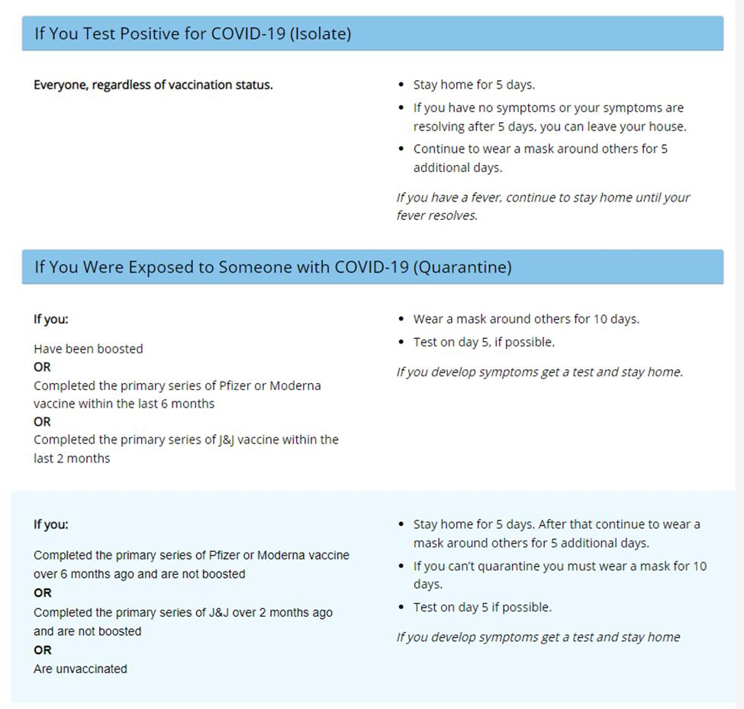
For the safety of all, the following guidelines should be followed in all settings:

Student Surveillance Testing

- Bunche MS students are eligible for COVID-19 two times per week while at school. While we do not require testing for students, we strongly encourage all parents to provide consent for their child or children to be tested. With the surge of COVID-19 cases due to the omicron variant and high community spread, it is likely that some students have been exposed to the virus. When students are tested, it helps everyone in our learning environment to be protected together.

- This rapid test detects the presence of COVID-19 even in individuals who may be asymptomatic.

- The benefits of surveillance testing include allowing APS to test, receive test results (within 24 hours), and notify individuals of a clinically significant reading before coming to school or work.

- APS and Viral Solutions have designed the COVID Surveillance Testing Healthier Schools Program to help keep kids, families, and teachers safer from COVID outbreaks. The e-consent form is now available and only needs to be completed once to allow testing for the school year. Access the consent form here: http://tinyURL.com/HealthyAPS.

Virtual School Schedule

Our virtual schedule closely aligns with our daily face-to-face schedule as noted below. Brain breaks are embedded within instructional times and will be facilitated by our staff.
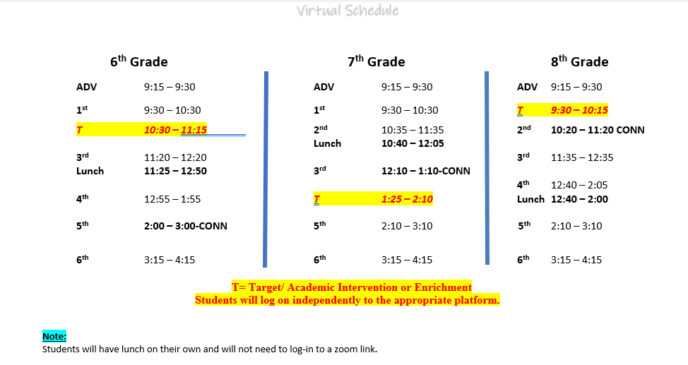

Accessing Classes
Students will attend classes daily through Zoom. Students may access Zoom links through their Google Classrooms. If your child has a new class (especially for Connections), then they will receive a Google Classroom invitation from their teacher to be added to the class. Students should regularly check their Google Classroom for any notifications. Each student should have a Google Classroom for homeroom or advisory, four core classes, and two connection classes. If there are problems entering the Zoom, your child may need to authenticate to enter the Zoom. If he or she is not able to get in after authenticating, you or your child should contact the main office line at 404-802-6700 for assistance.

Devices & Zoom
All students have been issued a school device. New students, or students who have a damaged device, should notify the school directly for an appointment time to retrieve a device. They should use their district authenticated zoom accounts to access classes. Please see the instructions below to authenticate zoom accounts.

Authenticating on Chromebooks:

https://sites.google.com/apsk12.org/zoom/aps-zoom-for-students/chromebook?authuser=0

Authenticating on Cell Phones or iPads:

https://sites.google.com/apsk12.org/zoom/aps-zoom-for-students/cell-phone-or-ipad?authuser=0

Authenticating on Windows Devices:

https://sites.google.com/apsk12.org/zoom/aps-zoom-for-students/digital-bridgewindows-device?aut

huser=0

Special Education Considerations
All entire group instruction should continue to be taught in the manner currently being utilized during remote learning. This means…

- GE (General Ed) teacher and SE (Special Ed) teacher should be on the computer addressing all students via ZOOM while implementing various co-teaching models (i.e. parallel teaching, team teaching, or alternative teaching),
- Students in the classroom, as well as those who are virtual should participate through a blended approach through the use of technology and classroom tools.
- All teachers will use digital tools (i.e. APEX, Amplify, Reading Plus, Nearpod, etc.) OR other classroom tools that can be seen by students via the computer camera or document camera, that give students the ability to see and hear the discussion/instruction regardless of the location.
- Digital tools in use could/should be projected in the classroom to allow students to participate in instruction via Zoom, but also be able to see on display in the classroom.
- GE and SE teachers will continue to collaborate to ensure all students’ accommodations are implemented during this time.

Virtual Expectations for Students

Students are reminded to remain in compliance with Bunche Middle School guidelines in the virtual setting. Below are the guidelines that all BUNCHE SCHOLARS are expected to exhibit during virtual instruction.

BMS Expectations
Prepared | ∙ Organize Your materials  ∙ Create a schedule/space to complete  assignments  ∙ Complete preparation work
Responsible | ∙ Login on time  ∙ Reach out to teacher for help  ∙ Use equipment correctly  ∙ Access only appropriate websites  ∙ Mute microphone
Independent Thinkers | ∙ Know your login information  ∙ Set daily goals  ∙ Write in complete sentences  ∙ Share and collaborate
Disciplined | ∙ Enter & exit in orderly fashion  ∙ Complete tasks on time/Stay on top of  assignments  ∙ Follow instructions  ∙ Minimize distractions  ∙ Wait for your turn to speak or contribute
Engaged | ∙ Make yourself visible  ∙ Be Present and active  ∙ Have a backup plan if you get disconnected ∙ Use the raise your hand  Utilize chat features appropriately

Academic, Technical, & Counseling Support

Email addresses for our support staff are listed below for assistance. Additionally, the main office line will be monitored during school hours. Therefore, should you require immediate assistance, you may call 404-802-6700 to speak with a staff member.

Name | Role | Email
Kimberly Whitfield | Principal | Kimberly.whitfiel@atlanta.k12.ga.us
Cassandra Bolding | Business Manager | cbolding@atlanta.k12.ga.us
Zakia Gordon | 6th Grade Assistant Principal | zgordon@atlanta.k12.ga.us
Lovetta Durham-Martin | 7th Grade Assistant Principal | ldurham@atlanta.k12.ga.us
Cephia Blassingame | 8th Grade Assistant Principal | cblassingame@atlanta.k12.ga.us
Cynteria Ross | Attendance Clerk | cyross@atlanta.k12.ga.us
Debriel Amos | Registrar | debriel.amos@atlanta.k12.ga.us
Shayla Snipes | School Social Worker | shayla.snipes@atlanta.k12.ga.us
Amber Britman | Instructional Technology Specialist | amber.britman@atlanta.k12.ga.us
Ashley Ewart | Parent Liaison | ashley.ewart@atlanta.k12.ga.us
Tracey Fisher | School Counselor | tfisher@atlanta.k12.ga.us
Ali Brinson | School Counselor | ali.brinson@atlanta.k12.ga.us
As always, the health and safety, as well as the educational success of our students, remain our focus. We ask that you continue to partner with us to ensure our scholars are supported and able to transition between the face to face and virtual settings with as little disruption as possible. As we partner, we also ask that you continue to let the Bunche team know how WE can best support you and your family.

Let’s continue to make it a GREAT year!

