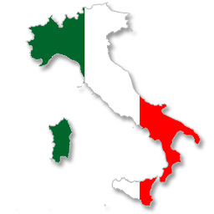
11/21/13
Dear Parents,
Hello my name is Mrs. Neary, the Italian teacher for Logan Elementary School. Now that the first marking period has come to a close and the students have established a daily routine, I would like to inform you of what the students have been learning about, what the students will be learning about in the upcoming months, and how you can support them in achieving their learning goals.
Second grade students have been diligently working on learning about the Italian culture and language. Students have located Italy on the map and can recognize it because of its boot shape. The following I can statements have been satisfied:
- I can do what my teacher tells me to do in Italian.
- I can say hello and good-bye in Italian.
- I can say my name in Italian.
- I can say how I feel in Italian.
- I can sing a song in Italian.
In the next few months students will continue working in the “All About Me” unit. We will be concentrating on the following “I can” statements:
- I know my colors in Italian.
- I can count from 0- 30 in Italian.
- I can name common pets in Italian.
- I can describe animals by size.
- I can say how old I am in Italian.
- I can say what I like and dislike.
- I can sing a song in Italian.
The first set of “I can” statements will be continually reinforced as we progress forward with our new “I can” statements.
In order to support your children with their learning, I encourage you to review any of the “I can” statements mentioned previously. This is not mandatory, but can be helpful in the language acquisition process. At this point in time there is not a need for perfect pronunciation. Instead students are focusing on vocabulary building. Learning a second language at a young age should be fun and not stressful. Through games, songs, and educational play students stay interested and want to learn more.
The following is the link to my web page where you can find vocabulary and songs that we are currently working on in class:
- http://www.logan.k12.nj.us/Page/2168
These are two websites that students can explore and learn additional Italian vocabulary:
- http://www.chillola.com/at/italian%20starter%20page.html
- http://www.learnalanguage.com/learn-italian/italian-words/travel.php

It is a pleasure teaching your children Italian. I am so impressed with how much Italian they know already! I am looking forward to many more fun filled lessons. I thank you for your support and feel free to contact me at any time. It is best if you email me since I travel between schools.

Sincerely,
Mrs. Cinzia Neary
Mrs. Cinzia Neary
Logan Township School District
856-467-5133 Ext. 216
cneary@logan.k12.nj.us

