DEPARTMENT OF INFORMATION TECHNOLOGY

The department of Information Technology is responsible for all information technology policy and management. These duties include providing administrative overview, guidance, and foundation in the areas of planning, recommending, installing and supporting all computing and telecommunication technology resources utilized in City of Rio Rancho municipal functions.
The Information Technology Department provides:
- Administration & Management – Manage all operations of voice and data networks to ensure a high level of data integrity and systems availability.
- Support Services – Support all aspects of departmental business functions throughout the city, while maintaining a high level of customer service.
- Applications – Implement, deploy and maintain network enabled information applications to maximize external communications and streamline core internal business processes.
- Implementation/Deployment – Perform technical assignments related to network and telecommunications systems citywide to include installation and support of all resources and activities.

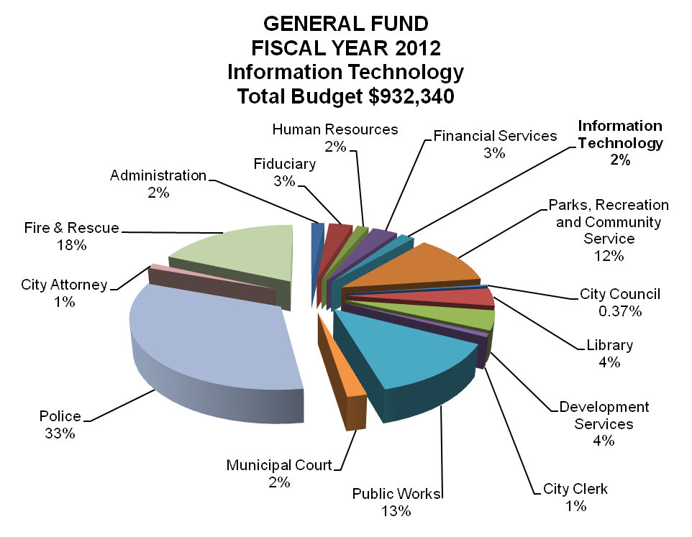

Operational Performance Indicators:

