DCIPS Performance
Management
Job Aids



19 June 2009

Table of Contents

Introduction 3
Performance Appraisal Application (PAA) Steps for the DCIPS Performance Management Cycle 4
Writing SMART Performance Objectives Using a New Sequence 7
How to Transform Work Activities into SMART Performance Objectives 8
Examples of SMART Performance Objectives 10
STAR Framework for Documenting Your Accomplishments 20
Additional Reminders 21

Introduction
The HQDA-ODCS, G-2 Intelligence Personnel Management Office (IPMO) Transition Team developed the specific job aids in this document to address challenges identified by the majority of the DCIPS employees and supervisors within Army Intelligence and across the Intelligence Community. The job aids in this document are designed to help employees and supervisors navigate through the DCIPS performance management process.

Before using these job aids, it is important for employees to review the DCIPS Performance Management (PM) Handbook which can be found on the Army DCIPS website. The PM Handbook contains information on the importance of the DCIPS performance management process. The PM Handbook also provides detailed information on how to develop SMART performance objectives and the employee self-report of accomplishments. The job aids described in this document are complementary to the PM Handbook.

Some of these job aids are just simple reminders of acronyms. You are encouraged to post these job aids on your wall/cube or put them in a location for easy access.

Additional performance management information can be found on the IPMO DCIPS website which is accessible on all three networks.

NIPRnet
http://www.dami.army.pentagon.mil/site/dcips/
SIPRnet
http://www.dami.army.smil.mil/site/dcips
JWICS
http://www.dami.ic.gov/site/dcips

Performance Appraisal Application (PAA) Steps for the DCIPS Performance Management Cycle
The sections below describe the steps that must be taken within the Performance Appraisal Application (PAA) Tool during each phase of the DCIPS performance management cycle. Employees and their Rating Officials should understand the phases and actions to be taken during the cycle so they know when they need to be involved.
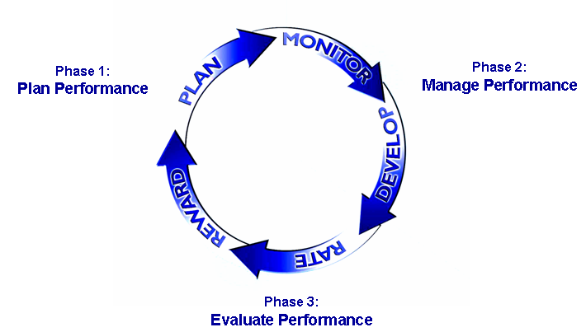

Phase 1: Plan Performance
In the planning phase, you collaborate with your supervisor to develop three to six SMART performance objectives within the PAA. You and your supervisor should also discuss the six performance elements and how they relate to your overall performance. Remember performance objectives represent “what” you do and performance elements show “how” you do it. The following process flow identifies the steps to follow within the PAA to develop your performance objectives.
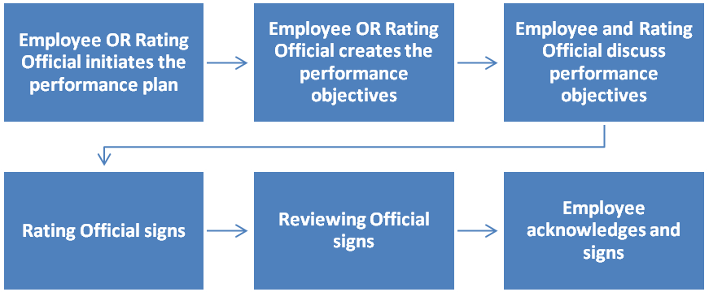
Phase 2: Manage Performance*
The managing phase consists of monitoring and developing your performance. During this phase, you should engage in frequent performance discussions with your supervisor and complete a self-assessment of your performance within the PAA tool at the midpoint appraisal period. Your supervisor will provide you with a formal midpoint review. The following process flow identifies the steps to follow within the PAA to develop your midpoint review.
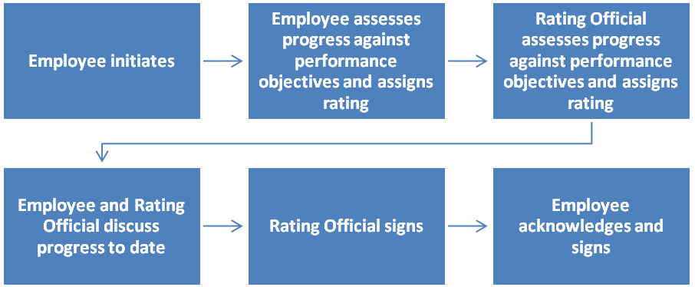
*The midpoint review process is not applicable to the BETA participants.

Phase 3: Evaluate Performance
During the evaluating phase, you complete a Self-Report of Accomplishments and receive your Rating of Record. The following process flow identifies the steps to follow within the PAA to develop your self-report of accomplishments.

The following process flow identifies the steps within the PAA to develop your Rating of Record.
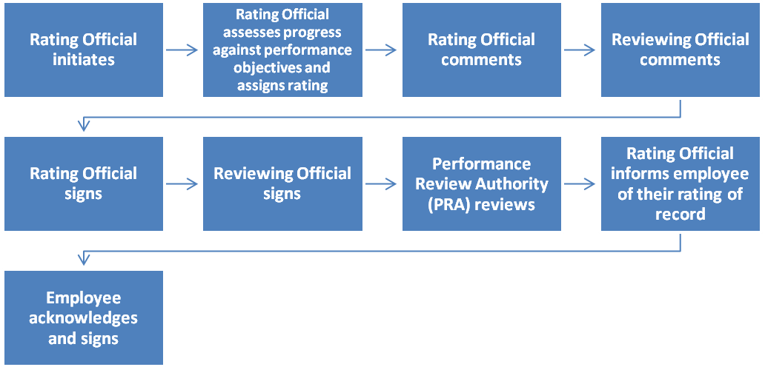

Writing SMART Performance Objectives Using a New Sequence
The SMART methodology works well for many people. For those of you who are struggling with following the order of SMART (with S being first), try this sequence when writing objectives. First decide what performance objective you are going to measure and then how you will measure it. This approach helps you to avoid writing other parts of an objective and then have to start over because it is not measurable. Do not rush through identifying the measurement. Once you are done identifying the measurement, follow the rest of the sequence as shown below.
M | A | R | S | T
MEASURABLE  Describes the quantifiable outcome.  Ask Yourself  - What is the evidence for this change?  - What ways can I measure performance (i.e, quantity, quality, time resources, etc.)?  Sentence Starter  - These results will be measured in terms of _______, _______ and _______.  - Metrics that will be used to evaluate this outcome include _______. | ACHIEVABLE  Confirms the objective is capable of being reached.  Ask Yourself  - Is the objective appropriate for my experience, skill and work level?  - Do I have the resources to accomplish this goal?  Sentence Starter  - This is consistent with expectations for other Band ___ employees.  - As a Band ___ employee, I have the knowledge/skills/ authority to meet these objectives. | RELEVANT  Determines if the objective links to agency, command or work unit goals.  Ask Yourself  - Does this objective support the goals of my work unit?  - Does this objective support the goals of my organization? Which one(s)?  Sentence Starter  - This objective links to _______.  - This objective is in line with Army Intelligence’s goal of ______. | SPECIFIC  Identifies the desired outcome or results.  Ask Yourself  - What is important?  - As a supervisor, what do I really care about?  - Is it clear who is involved?  - Is the outcome clear?  - How would I know if this was done successfully?  Sentence Starter  - The expected result is _______. | TIME-BOUND  Establishes the point in time when the objective starts and/or ends.  Ask Yourself  - When must this objective be accomplished?  - What are the milestones?  - Do I have to check in at regular intervals?  - Is the timeframe within the current rating period?  Sentence Starter  - The anticipated completion date is _______.  - This objective should be achieved no later than _______.  - Milestones for completing this objective are ______, _______ and _______.

How to Transform Work Activities into SMART Performance Objectives
As stated in the DCIPS Performance Management Handbook, employees should use position descriptions, performance management plans and office strategic plans/work plans as a starting point for developing their performance objectives. These documents are excellent resources but they only list work activities or job duties and NOT the actual performance objectives. Work activities do not focus on end results, include a way to measure the objective, or provide timeframes in which the work is to be completed. Refer to the tables below to see the difference between work activities/job duties and performance objectives.

General Work Activities or Job Duties
- Conduct market research and develop contract plans to meet project needs
- Read materials in foreign language and accurately evaluate them
- Work in concert with core collectors, providing guidance for operational testing and asset validation
- Produce highly sophisticated tactical, strategic, and multi-disciplinary analysis that supports the mission

Performance Objectives
- Generate two operational leads per quarter
- Maintain weekly contact with assets by establishing a regular communication system via appropriate channels
- Write one asset validation report per quarter for guiding collectors in the field
- Debrief liaison services personnel monthly
- Participate in one operational task group in the next fiscal year
- Produce operational task group update reports for manager on a quarterly basis

To transform work activities into SMART performance objectives, follow the two steps listed below and refer to the table for examples.
Step 1: Identify the important/relevant work activities for your position using position descriptions, performance management plans and office strategic plans/work plans.
Step 2: Determine the end result from each work activity
- Focus on the products, services, and accomplishments resulting from the work activity.

Going from Work Activities to Performance Objectives

Work Activities |  | Performance Objectives
Identify new and existing products and technologies to solve design, development, and operational problems. |  | By the end of the fiscal year, present to management, one alternative technology-based solution for improving efficiency in program development by at least 10%.
Develop a budget or financial plan for an organization, organizational unit, program, or expenditure/cost center. |  | Submit a budget for the new computer system implementation process that accounts for all known requirements and costs by 31 March.
Define acquisition strategies. |  | Present two acquisition plans for new computer systems based on a thorough analysis of customer needs, capabilities, and costs/benefits by the end of the performance year.
Create funding profiles for programs, projects or contracts. |  | Author one funding profile for how the organization will allocate money for contracts placed on the development of new SIGINT collection applications.
Identify and select IT products, tools, services, and infrastructure components. |  | Acquire two new IT tools for implementation into client architecture systems that increase system efficiency or client capabilities.
Apply analytic knowledge and skills to perform collection strategy related tasks. |  | Develop one data repository by the end of the fiscal year that facilitates the evaluation of counter proliferation collection initiatives and capabilities.
* This table and more detailed information on writing performance objectives can be found in the course titled “Supplementary Online Training for Supervisors - Writing Performance Objectives.” The information in this course is useful for both employees and supervisors. Here is a link to the course: http://odni.touch-point.net/

Examples of SMART Performance Objectives
Employees and supervisors should use the SMART performance objective examples in this document as a starting point for developing performance objectives.
The first two examples illustrate which parts of the performance objective demonstrate each aspect of the SMART framework.

Specific
1. Provide relevant, timely, all-source intelligence reporting
Complete analysis of effects of UN-imposed sanctions on Iraqi industrial sector and present results in appropriately coordinated intelligence report for release to policy-making community by 31 August. Product will reflect engagement with other analysts and stakeholders and incorporate their coordinated views. The completed product will make use of available intelligence from at least 90% of relevant sources as dictated by ICD 203.2 and reflect engagement with other stakeholders in the subject of the analysis.

Time-Bound
Relevant
Achievable
Measurable
Relevant
Specific
2. Provide accurate, timely customer service
Upon receipt of requests, provide accurate responses in the agreed-upon timeframes, as defined by ICD 24.8, using the appropriate format identified in SOP25 during the evaluation period ending September 30, 2009. This supports the organization’s commitment to be responsive to customers and clients. Meet suspenses 90% of the time. Provide accurate responses with no more than 2 errors per request.

Time-Bound
Relevant
Achievable
Measurable

Achievable
Measurable

These examples should NOT be copied word for word. It is critical that employees and supervisors develop individualized performance objectives to accurately represent the work accomplished during the performance appraisal cycle.
The performance objective samples are organized by the three DCIPS work categories:
- Technician/Administrative Support
- Professional
- Supervision/Management

SMART Performance Objective Examples
Work Category: Technician/Administrative Support

Position Series and Job Title | Work Level | Performance Objective Example
303  Administrative Support Assistant | Full Performance | Effectively accomplish office administration responsibilities such as keeping office calendar, administering time and attendance, and screening visitors and phone calls. Complete review of office correspondence assuring formats and packages are in compliance with the Army correspondence manual and other applicable standards (e.g., [fill in] memorandum, signature block). Accomplish staff support responsibilities such as managing office suspense’s (Tracker System), compiling status reports, and coordinating travel. Work products will be accurate and complete within the timeline established by supervisor. Accomplish work with good judgment (e.g., screening phone calls) and demonstrate professionalism (e.g., tactful and courteous).
0561  Budget Assistant | Full Performance | With significant supervision effectively conduct timely trend analysis. Monitor current and prior year execution levels for assigned areas of responsibilities. Monitor and accurately document current and historical program execution using established generally accepted principles and methodologies and accomplish tasks in accordance with assigned timelines.

Work Category: Professional

Position Series and Job Title | Work Level | Performance Objective Example
0201  Human Resources Specialist | Full Performance | Effectively develop and revise Army-wide HR policy guidance and instructions in accordance with prescribed objectives and implementation timeline. Work products may include (fill in functional area examples). Work is reviewed to ensure products are well researched, technically sound, thorough (e.g., considered scenarios), properly staffed, clear, aligned with legislative and regulatory authorities, timeliness, and impact on achieving organizational goals.
0201  Human Resources Specialist | Senior | Effectively plan and execute implementation tasks/actions on a continuing basis to achieve timely and successful conversion/implementation of (name the program) within Army in accordance with established DoD and Army timelines. Contributions include actions to develop and field a variety of communication tools to inform the workforce and leadership on (name of program), answer program related questions; briefings, on-site subject matter expert staff support, and leading (DA/Command headquarters) level work groups. Proactively and timely issue quality implementation guides and resolve problems that contribute to successful implementation of Army (name of program) program.
0343  Management Analyst | Full Performance | Complete analysis of civilian manpower program, for all structure and budget sensitive elements of assigned commands, programs, or projects. Independently utilize common-use analytic tools, such as web-based applications, and other analytical software to generate data and analysis within established timelines. Organize and present results/reports in established format to senior analysts for incorporation into strategic Army objectives. As directed and with senior analyst supervision, apply principles of manpower program management to novel or special circumstances that require such evaluation.

Work Category: Professional

Position Series and Job Title | Work Level | Performance Objective Example
0343  Management Analyst | Senior | Accomplish independent, collaborative, and cross-functional analyses for assigned programs. Initiate timely action during fiscal cycle to schedule briefings and present recommendations to (XYZ committee), identifying and verifying key resourcing challenges and providing meaningful recommended solutions in accordance with established Army resources strategy.
0346  Logistics Management Specialist | Full Performance | Accomplish the review, analysis and evaluation of current or projected logistics programs in accordance with established timelines and applicable laws, regulations, agreements and policies (as it relates to specific program). Coordinate with representatives of the Army, other services, and DoD components in developing, monitoring and evaluating joint logistics programs. Based on these reviews and analysis, complete program enhancements in a timely manner per published DA Guidance.
0510  Staff Accountant | Full Performance | Effectively deliver [provide] accurate and timely advice and guidance on an "as needed basis" to headquarters staff and managerial accountants in the field - resolving normal issues/inquiries in 3-4 business days, for more complex situations an initial response should be given in 3-4 business days and updated until resolved. Complete responses to inquiries that require the correct application of accounting principles, theories, concepts and practices to financial processes to produce accurate results and meet legal requirements.

Work Category: Professional

Position Series and Job Title | Work Level | Performance Objective Example
0560  Budget Analyst | Full Performance | Accomplish resource management support and budget analysis functions on a daily basis or as needed, for the G-3/5/7 staff, in order to keep the G-3/5/7 staff aware of execution that is in accordance with phased obligation plan. Support/analysis is given on the day it was sought for most situations, and within 5-7 days for more complex situations (as determined by supervisor), based on an accurate, timely and thorough analysis in accordance with generally accepted principles and practices.
1035  Public Affairs Specialist | Full Performance | On an as needed basis, provide accurate & timely public affairs advice to organization leadership in accordance with regulations and mission. Complete initial advice/guidance in 3-4 days, coordinate with appropriate organizations as necessary,
1712  Training Instructor | Full Performance | Complete updates and development of course material for the assigned training program in accordance with established standards and timelines, and course material is consistent with applicable manuals and regulations. The course materials include lesson plans, practical exercises, and competency tests. This standard requires that 25% to 30% of all training material must be updated within the performance rating cycle.
2210  Information Technology Specialist | Full Performance | Accomplish assigned projects in accordance with established project objectives, achieve expected results, and meet stated milestones/timelines. Results must be technically sound (e.g., in compliance with applicable legal and regulatory provisions), accurate (e.g., validated data, cited references), and in accordance with applicable policies, procedures, and guideline.

Work Category: Professional

Position Series and Job Title | Work Level | Performance Objective Example
2210  Information Technology Specialist | Senior | Effectively identify, justify, and defend automation funding requirements, which include capturing, tracking, and reporting costs for automation requirements. Funding requirements should be thoroughly and accurately documented, and available to meet internal and external suspenses for Program Objective Memorandum (POM) submissions, weekly budget status meetings, occasional budget reviews by the Resource Management Office, and adhoc request. Critical thinking should be applied to the analysis of funding impacts and justifications in defense of civilian HR automation funding. Comprehensive impact statements will be developed and provided in time to meet internal and external suspenses.

Work Category: Supervision/Management

Position Series and Job Title | Work Level | Performance Objective Example
Budget Officer | Entry/Developmental, Full Performance, Senior | On an ongoing basis, oversees, directs, and monitors the execution of the annual budget. Manages and distributes dollar resources to assigned garrisons, centrally Managed Account and Region Headquarters equitably. Meets mid-year and year end Army targets for budget execution in coordination with Resource Management Personnel.  Measurements:  • Conforms to XXX strategic mission and objectives  • Ensures all financial actions are within current fiscal year budget  • Compliance with XXX and other funding policy  • Close fiscal year to the Army standard  • Execution and Spend Plan Reports  • XXX operating requirements and budget submission
Budget Officer | Entry/Developmental, Full Performance, Senior | Provides advice, policy guidance and technical assistance to the XXX Financial Manager, region staff and assigned garrisons on equitable, effective and efficient management of financial resources on an ongoing basis. Guidance is provided to ensure resources are protected, accounted for and are expended in compliance with statutory, regulatory and policy requirements.  Measurements:  • Develops Europe Funding Letter Narrative  • Routinely distributes to staff and assigned garrisons HQ guidance on the budget, future funding, spend plans, PBACs, execution of current year dollars, prior year funds midyear and year end close, mission policy changes, etc.

Work Category: Supervision/Management

Position Series and Job Title | Work Level | Performance Objective Example
Budget Officer | Entry/Developmental, Full Performance, Senior | As required, provides accurate budget requirements and budget estimates (Program Objective Memorandum) to higher headquarters. Consults with other budget officers and Program Directors in determining mission priorities. Considers overall Region requirements in connection with program plans, prior obligation, known and anticipated requirements, changes in assigned missions and responsibilities, available resources, overall fund inventory changes and use of prior year funds. Determines course of action, as it pertains to funds, to accomplish programmed activities.  Measurements:  • Conforms to XXX Strategic Plan (Europe’s Transformation Plans)  • Budget estimates are in accordance with budget program financial structure
Generic | Entry/Developmental, Full Performance, Senior | Execute the full range of human resources (including performance management as outlined in DoD 1400.25-M, SC1940.5.7.4.) and fiscal responsibilities within established timelines and in accordance with applicable regulations. Adhere to merit principles. Develop a vision for the work unit; align performance expectations with organizational goals. Maintain a safe work environment and promptly address allegations of noncompliance. Ensure EEO/EO principles are adhered to throughout the organization. Ensure continuing application of, and compliance with, applicable laws, regulations and policies governing prohibited personnel practices; promptly address allegations of prohibited discrimination, harassment, and retaliation.

Work Category: Supervision/Management

Position Series and Job Title | Work Level | Performance Objective Example
Generic | Full Performance, Senior | Develop, maintain and operate a streamlined agile organization that is customer-focused and results-driven in support of current and future missions. Deliver Service Support Programs to Performance Management Review and Installation Status Report Standards. Leads or directly supports special programs and initiatives, including NSPS, PSDR, and transformation to established requirements and standards. Perform these functions with a particular emphasis on high quality customer service practices and technical proficiency.  Measurements:  - Performance Management Review results  - Installation Status Report  - Plan to correct critical deficiencies identified through SAV’s and SAI’s approved within 45 days  - Response to customer feedback within 5 working days
Generic | Full Performance, Senior | Optimize resources and employ innovative means to provide high quality services and optimal facilities within funding availability. Implement sound business practices to ensure the Human Resources Directorate operates within budget constraints as outlined in the applicable funding guidance and the directorate spend plan. Ensure personnel, travel, training, supplies and operational costs align with mission requirements and fiscal responsibility. Perform these functions with a particular emphasis on cooperation and teamwork.  Measurements:  - Quarterly tracking of resource and service quality levels (i.e. SAV’s ISR)  - Complies with funding guidance  - Develops, executes and adjusts spend plan not to exceed budget

Work Category: Supervision/Management

Position Series and Job Title | Work Level | Performance Objective Example
Generic | Full Performance, Senior | Coordinate effectively with XXXX staff, garrison leadership and staff, and partner organizations ensuring all human resource functions and regulatory requirements are incorporated in all installation plans, policies, procedures, and operations. Establish internal business practices to ensure all requests for information, data calls, and recurring suspenses are completed on time. Communicate effectively within functional channels at the Region ensuring guidance and requirements are properly evaluated and disseminated to the Garrison work force.  Measurements:  - Taskings completed to standard  - HR issues are comprehensively addressed in all Garrison plans, policies, procedures, and operations  - Application and use of at least 3 communication and marketing instruments. (i.e. surveys, town hall meetings, VTC’s, DL’s, newsletters, SAV’s, weekly staff meetings, marketing plans, web sites, etc.)

STAR Framework for Documenting Your Accomplishments

You should use the STAR framework to document your accomplishments throughout the performance cycle. It is recommended that you document this information in your DCIPS Employee Performance Journal which is posted on the Army DCIPS website. This will help you to track all of your accomplishments, as well as write your Self-Report of Accomplishments at the end of the performance cycle.

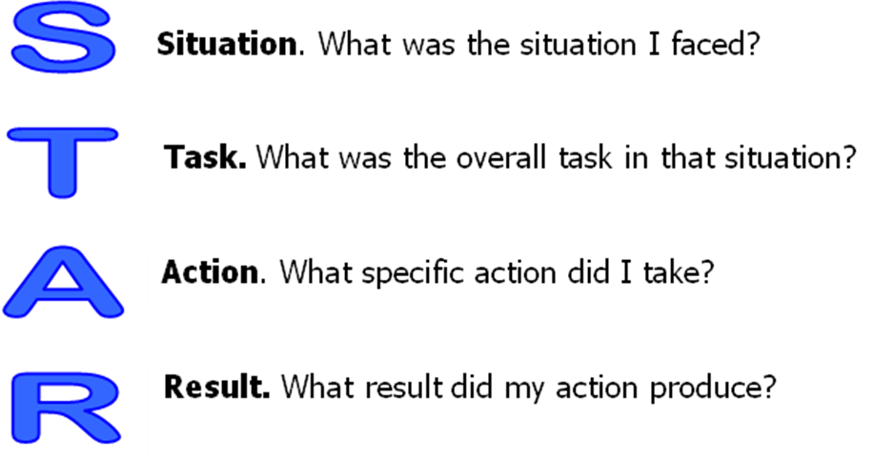

Additional Reminders
Here are some additional items to keep in mind:

- Throughout the performance management process, employees and supervisors should work together to:
  - Allow employees and supervisors to identify if it is appropriate to change an employee’s performance objective
  - Ensure there are no major surprises for the employee when he/she receives the final rating of record

- Be fully committed to accomplishing your objectives

- Additional tips for writing performance objectives
  - Write out acronyms
  - Proofread your objectives to ensure there are no spelling or grammar mistakes
  - Ensure your performance objectives are clear and concise
  - Refer to the DCIPS Performance Management Handbook for additional tips such as wording suggestions for performance objectives

- Open your MyBiz and MyWorkplace accounts at the following website: http://cpol.army.mil
  - For more information on how to perform this action, refer to the document titled “My Biz/Workplace Login Instructions” which can be found on the Army DCIPS website.

- Access the PAA Tool and ensure your rating hierarchy is accurate.

