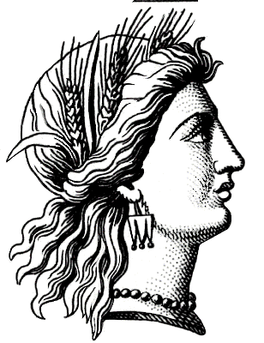
Mythology game project

Directions: With your groups (to be determined by instructor), your task is to create a game that will help your classmates review their reading of the summer reading assignment, Edith Hamilton’s Mythology.

Here are the rules:
- Your game must have a clear goal to determine the winner
- You must pick an approved area from the list of myths
- You must have your game approved by me
- Your game must be appropriate for the entire classroom audience
- You will conduct the game in class and must involve at least four players
- You must provide all materials for the game
- Your game cannot exceed 20 minutes
- You must have different moderator/time-keeper for each rotation
- Your game cannot be on the computer
- Your game must be safe for student participation
- Please type the rules/directions to your game including the correct MLA format heading with all names of your group members

Some types of games that have been used in the past include: (THESE MUST ALL BE QUESTION BASED GAMES)
- Board games (i.e. Monopoly, Candy Land)
- Twister (i.e. physical movement type) games
- Poster board games (i.e. Jeopardy)
- Any other ideas? Please have them approved by me.

In addition to meeting the above requirements, your board game must also include specific content from your myth(s). Your game must include questions on the following:
- The plot of the myth
- Modern day allusions to the myth
- Information on the gods/goddesses from the myth (background, symbols, domains)
- Themes contained within the myth
- Literary devices within in the myth (i.e. similes, extended metaphors)
- Common archetypes contained within the myth (i.e. temptress, quests)

Grading Rubric:

Content – 50 points
- Did you include plot, allusion, theme, archetypes, and literary devices?
- Did you type up clear instructions with MLA format heading?

Presentation – 25 points
- Is your game neat, creative, and clear?
- Does your game follow the requirements?

Participation – 25 points
- Did you contribute to the group?
- Did you use class time wisely?

MYTHS:
The Earliest Heroes
The Flower Myths
Cupid and Psyche
Eight Brief Tales of Lovers
The Quest of the Golden Fleece
Four Great Adventures
Perseus and Theseus
Hercules
Atalanta
The Trojan War
The Fall of Troy
The Adventures of Aeneas
The House of Atreus
The Royal House of Thebes

