World History II

Instructor: Mr. Brent Deel bdeel@dcps.k12.va.us


Course Description: World History II is designed to provide an overview of world history from A.D. 1500 to the present, with a particular emphasis on Western Europe.Throughout the year the focus will be on those civilizations and eras that have had & continue to have a profound impact upon the present through their political institutions, philosophical contributions, economic activities, social structures, religious beliefs & practices, cultural achievements, technological innovations, & geographical influences. This is predominantly a lecture & note-taking class. Students are expected to be present for classes, be attentive to the lectures, & where appropriate participate in discussions. This class requires an End of Year SOL Test.

World History II Pacing Guide:

 | Topics Studied
Unit 1 | 5 Major World Religions: Judaism, Christianity, Islam, Hinduism, & Buddhism
Unit 2 | Development of Major States, Regional Empires, & Trade Routes
Unit 3 | The Italian Renaissance & Reformation Era
Unit 4 | The European Age of Exploration & Conquest - including Slavery
Unit 5 | Age of Absolutism, English Civil War, Glorious Revolution, & Thirty Years War
Unit 6 | The Scientific Revolution, the Enlightenment, & the American Revolution
Unit 7 | The French Revolution, Napoleon, Congress of Vienna, Nationalism, Revolutions of 1848, & Latin American Revolutions
Unit 8 | The Industrial Revolution, Capitalism & Communism, & Unification of Italy & Germany
Unit 9 | Imperialism in Africa, Asia, India, & Latin America, WW I, & Russian Revolution
Unit 10 | The Worldwide Great Depression, Totalitarianism & Aggression, WW II, & the Holocaust
Unit 11 | Outcomes of WW II & Rebuilding of Europe, the Cold War, Chinese Communist Revolution, & Mandate System in the Middle East
Unit 12 | Independence Movements in India & Africa, Modern Conflicts & Migration Patterns, Global Trade & Interdependence, & Characteristics of Developed & Developing Nations
SOL  REVIEW | Overall Review of World History II Topics

Required Materials:
RHS Grading Scale:

A = 93-100
B = 86-92
C = 78-85
D = 70-77
F = below 70

History is who we are and why we are the way we are.

~David McCullough

- 3-Ring Binder/ Notebook
- Textbook: Glencoe World History Modern Times
- Paper & Writing Materials

Grading Procedures:

- Unit Test 60%
- Unit notes 10%
- SOL Reinforcers 30%

Tests & Benchmark Exams:

Tests will be given on each unit of study. The tests will be of a multiple-choice type format. In the week following the close of each nine weeks, Dickenson County mandates the administration of benchmark exams. The primary purpose of the benchmark exams is to further prepare for the World History II SOL Test.

Basic Classroom Expectations:

Students are expected to come to class on time and be prepared for the day’s activities. Regular attendance is essential to a good grade. All necessary materials should be brought to class every day unless the teacher has instructed otherwise. Students should be respectful of the teacher and their fellow classmates. The teacher will enforce and emphasize the School System’s policy addressed in the Student Handbook.

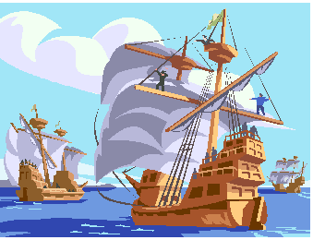

Following the light of the sun, we left the Old World behind.
Christopher Columbus

2018-2019 Syllabus

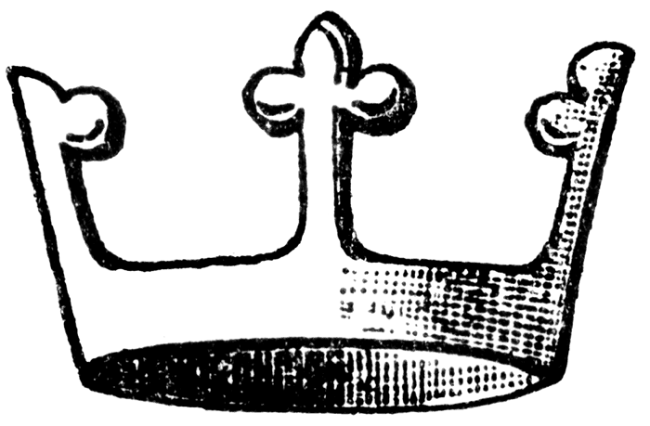
Rules & Expectations for World History II

- Follow all school rules, regulations, & policies. Think of it as a privilege to be in school & this class. Both privileges can be taken from you.
- Treat each other & the teacher with respect.
- Demonstrate good manners – don’t talk when I’m talking – be courteous – it is a learned behavior. There will be time for you to talk in class discussions & time to be quiet & listen.
- Respect each other’s property & opinions – when discussing things in class, take turns & listen. You can learn a lot this way. Respect each other’s right to learn.
- Stay in your seats. Don’t be up moving around. At the end of the period, wait in your seat till the bell rings or I dismiss you.
- Attendance – Good Attendance is very important to class success – most class activities & discussions cannot be duplicated just by copying the notes you missed. You will miss extra details & explanations.
- Tardiness: 3 count as an absence – get here on time. It is important for us to get going on time so we can accomplish our goals for the day.
- It’s your responsibility to obtain missed assignments or schedule a time to do make up tests – and they must be scheduled around class activities so you will not get even further behind.
- There is Zero Tolerance for cheating or disruptive behavior. Do your own work.
- Food & drinks will not be a distraction
- Keep the room & desks clean.
- No to all this: caps, tobacco, sunglasses or sleeping in class.
- Cell phones correctly stored. Cell phones will be confiscated if they are not properly put away.
- It is your responsibility to bring your own materials
- Bathroom Policy: 5 minute break - straight there & back. If you don’t follow this process correctly then you will lose that privilege. Time is of the essence.
- Nobody on my computer.
- Remember to come in with a good attitude & be willing to follow directions.
- Take good notes & don’t complain – We will work every day in here. There will be NO free days until after the SOL. Study your notes each night – that is an important part of your homework.
- Overall, remember to follow instructions & pay attention & allow me to teach. I know where we need to be in order for you to be successful on the SOL Test.
- Remember that your parents will be contacted – give your best effort & behave.

NOTE on class rules: We can have fun & academic success when these simple rules are followed by everyone. Don’t be offended if I have to remind you about this from time to time. The rules are designed to protect each student & to ensure that everyone has an equal right to a free, public education without disruption. These rules are not designed to get people in trouble. They are designed to allow everyone to learn & have a chance to be successful.

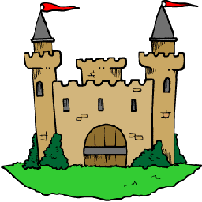
REASONS for Studying WORLD HISTORY

1) We study World History to examine the root causes of our own current civilization. In other words, we trace past civilizations to explain why cultures and people are the way they are. 2) We study history to learn from the successes and failures of the past so that we can better shape our own future. 3) As Americans we study World History to get a better idea of how our founding fathers and other Americans took ideas from the past to create the United States. 4) We study history to become better evaluators and organizers of information. We need to think critically about the past so we may better understand the present. 5) We study World History for Inspiration. We may look back on the lives of people from the past and use them as a model to better our own lives or the lives of others. Important historical figures aren’t always famous or wealthy people – more often than not, they were ordinary people who had the courage and leadership to take action and change their circumstances. They experienced the same emotions we do and had many of the same issues to deal with that we have today 6) History can be Exciting. History isn't just names and dates. Well-written, well-told history is an interesting & exciting story to hear.

Cut along lines
------------------------------------------------------------------------------------------------------------

2018-2019 Syllabus

I have read the syllabus and understand each part of it. I will take this home and have my parent/guardian read it and sign it. I will return a signed copy to Mr. Deel, which will be copied and kept on file while the original signed copy is kept in the student's notebook.

Student Name _________________________ Student Signature __________________________

Parent/ Guardian Name: __________________ Parent/Guardian Signature __________________

Phone Numbers work: ___________________________ home: ___________________________

Parent's e-mail address: ___________________________________________________________

