Expanded PVC Snow Board Test
Winter 2001-2002 Maplewood, MN
Peter J Boulay
State Climatology Office DNR Waters

651-296-4214(Work)

I’ll try to do the best I can to describe the test I performed on the expanded PVC snowboard during the winter of 2001-2002. First I will give some background on the site and then some information on the use of the snowboard during the season.
My station was established as part of the Minnesota State Climatologist Backyard Network on January 1, 1999 at my home in Maplewood, MN. Site is in a low-density neighborhood in a first ring suburb of the Minneapolis/St. Paul Metropolitan Area. Surrounding terrain is open with trees 100 feet away in the back yard (south of house). Large field and woods on 10 acres to south, Kohlman Lake is 500 feet to the north. It is sheltered by the north winds due to the house and garage to the north.
My instruments are a 4-inch diameter plastic rain gauge that is used for rain and snow equivalent. There is an inner cylinder with accuracy to .01. The 4-inch gauge seems to capture snow well with the funnel and inner cylinder removed. If the gauge does not look like the storm was captured well due to high winds, a cookie cutter technique would be taken with the snowboard. An 8-inch standard NWS gauge is at the site, but is only used for snow depth water equivalent and occasionally some comparisons to the 4-inch gage with heavy rain events. A frost tube was installed at the site in November 2000 and continues to function well. My observe time is 7:30am each day.
I had been using a ¼ thick piece of hardboard about 1 foot by 3 feet spray painted white for a snowboard. The paint did not adhere well to the board and was quite weathered. In the fall of 2001 I began using the ¼ inch thick 16X24 inch expanded PVC board. It weighs 2 pounds 4 oz. The board has a matte white finish on both sides and has a slight texture to it. I continued to use the old wooden snowboard for snow depth measurements only and I did not clear the snow from that board for the duration of the winter. You can see both snowboards in the photographs.
The winter of 2001-2002 was far from an “average” winter in Minnesota. There were very few arctic outbreaks, and very few Canadian source snowfalls. The coldest temperature measured at the Minneapolis/St. Paul airport was –3 on March 3, 2002 and there were only two nights that the temperature dipped below zero the whole season. Snow did still fall however and here are the monthly totals measured with the snowboard.

Snow Measured in the 2001-2002 Season With Expanded PVC board.
Oct 2001 .2
Nov 2001 7.9
Dec 2001 2.6
Jan 2002 5.9
Feb 2002 5.2
Mar 2002 13.5
Apr 2002 14.1*
Season total: 49.4

*A very heavy wet snow that fell on 4-21-2002 was very difficult to measure and melted on ground and board to an inch or two of slush. In this storm 4.0 was measured on a picnic table and is included in this total for the month.
The expanded PVC snowboard performed quite well. The board is quite rigid, but will flex slightly if a person bends it. I used a wooden or plastic ruler to measure snowfall. Sometimes with larger storms I would take a measurement every six or twelve hours to avoid settling of snow. I can recall one severe blowing and drifting day with a stiff east wind where the snow had difficulty adhering to the board. This was similar to my experience with a smooth wooden board too in the past. The board held up well to some abuse with myself hitting the edges on the ground to remove the snow. I did manage to chip a 1/3rd of an inch from a corner of the board after repeatedly hitting it on the frozen ground to remove snow. There wasn’t any warping typical of wooden snowboards, nor any noticeable fading. The board can be slippery when covered by snow so a small marking flag may be useful, especially with deeper snowfalls. The winds experienced in the past winter did not blow or flip the board. There weren’t any real extreme cold days to test cracking of board.
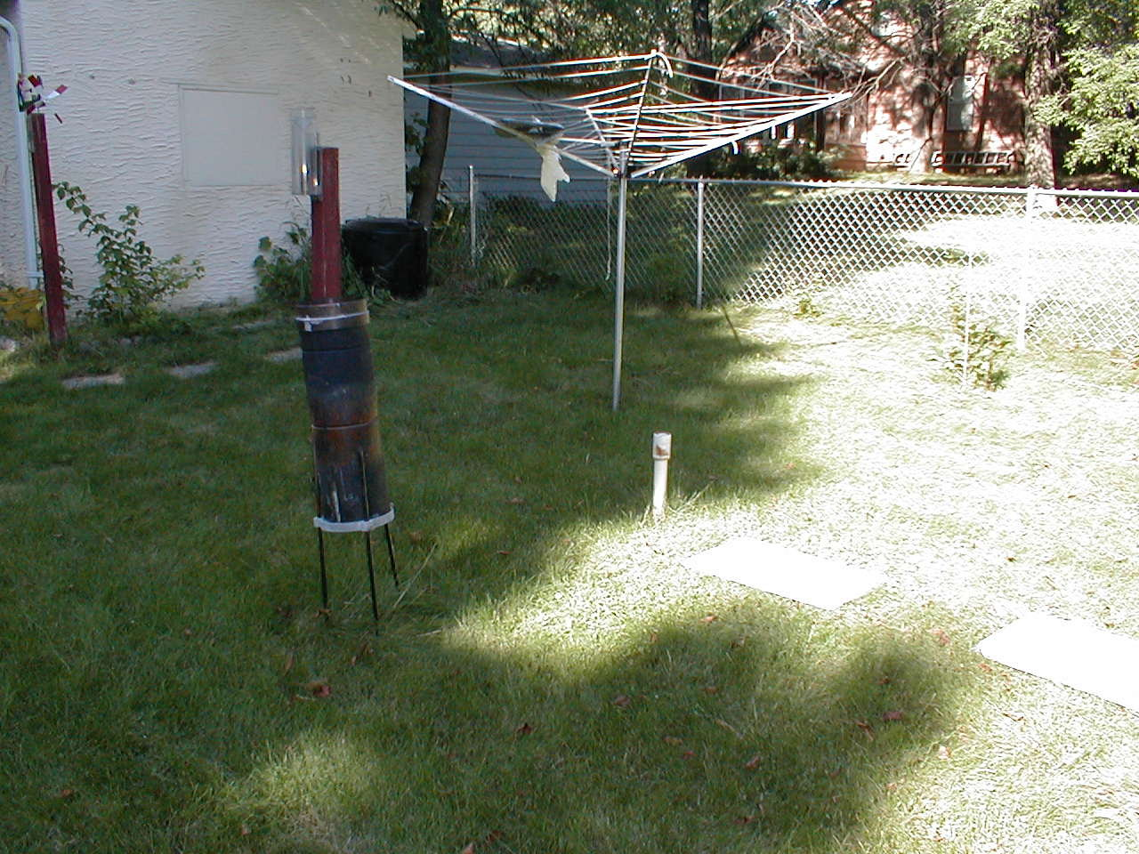

Here is my weather station where I tested the board. The optics weren’t the greatest this day, but here is a description. This was taken with a digital camera looking northeast. The clothesline is in storage during the winter. My 4-inch gauge is on the left on the 4X4 pole, the 8-inch gauge is in the foreground. The frost tube is the small white PVC pipe next to the snow board. The board next to the frost tube is the Expanded 16X24 PVC board. The other board to the right of the PVC board was a piece hardboard that I had used in the previous year.

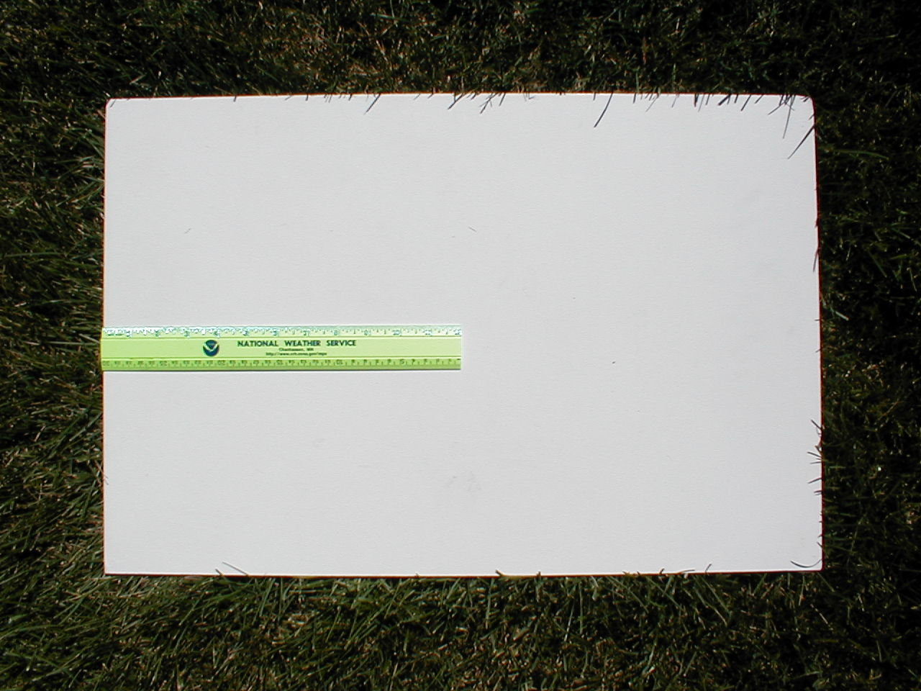

Here is a close-up of the PVC snowboard. I did not wipe the snowboard clean of dirt at all during the season and it seemed to repel dirt quite well.

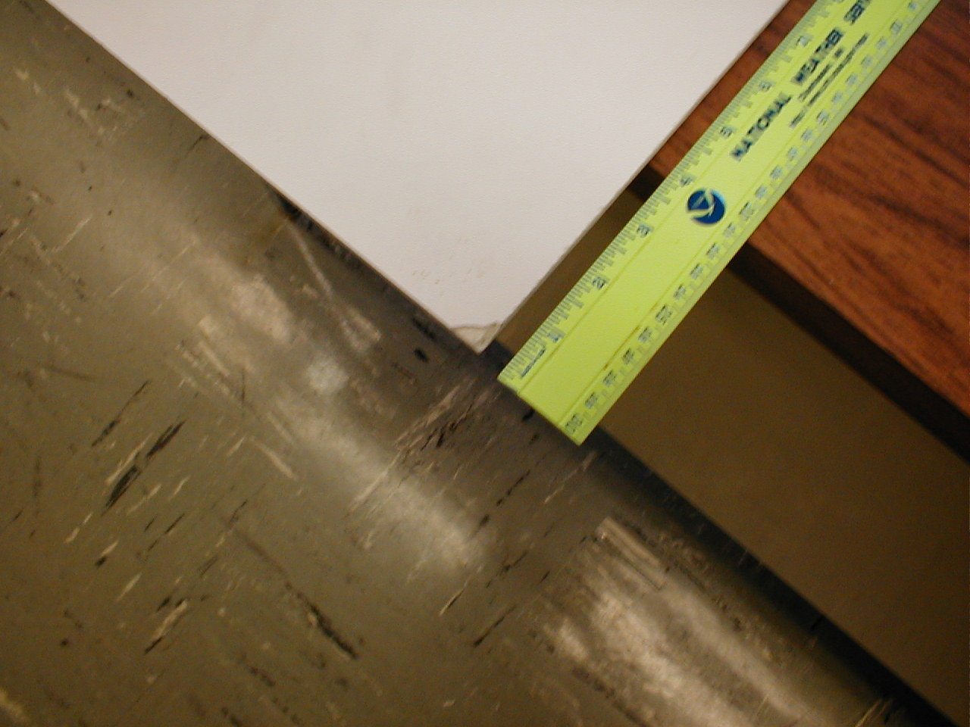

Here is a close-up of the tiny amount of damage I did to the board hitting it on the ground to knock off ice.

