Flowers for Algernon Web Search Name ________________________

Directions: Use the links to answer questions to prepare you for reading the story Flowers for Algernon. Each link will take you to a website where you will locate the answers.

History behind Daniel Keys’ Story, Flowers for Algernon

- How did Daniel Keys form the idea for the novel?___________________________________
____________________________________________________________________________
- Is the main character, Charlie Gordon, an actual person?____________________________
- When and where was the original short story published? ____________________________
- When was the novel version published? _________________________________________
- What is the title of the 1968 movie version of the story? _____________________________

The Brain

- What are the three main parts of the brain?

2. What are the four lobes of the brain?

3. Which lobe deals with thinking, conceptualizing, and planning?

Brain Surgery
- Summarize how the surgery is performed:

2. Name 3 reasons someone may need brain surgery.

3. Name 3 risks of brain surgery.

(turn over!)
4. On the day of surgery, what are 3 patient instructions?

IQ
- What does IQ stand for?
- Who first introduced the concept of IQ?
- How is the “quotient” calculated? (fill in the blanks)
_____________ divided by _____________ and this answer is then multiplied by ______
- What score classifies a person as a genius?
- What score is considered average?
- What score is considered borderline mental retardation?___________________________
7. What are the subtests of an IQ test? Name and describe 3 per category:
Verbal

Performance

FOR FUN AT HOME: What’s your IQ?
These sites require you to provide an e-mail address in order to receive your results. They are free, but do not necessarily provide an accurate assessment of your IQ. This activity is NOT required, and should be done with a parent’s permission only.
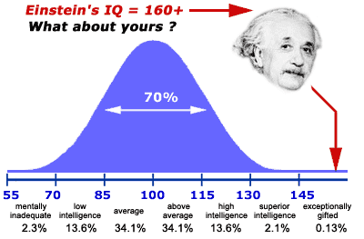
http://www.iqtest.com/
http://www.intelligencetest.com/

Write down any of these sites you may wish to access
at home.

