CT_CORE_FIN_VENDOR_PYMNT_HSTRY

Purpose of Query

Vendor Payment History Query - Query will return payment information for the Business Unit, Accounting Date range and Vendor Id the user prompts on.

Note: Works best when Scheduled.

Folder

AP

Tables

A CTW_VCHR_TRANS - Voucher Transactions Rpt Tbl
Join B CTW_PAYVC_XREF - Pay Voucher XRef Reporting Tbl
Join C CTW_PAYMNT_TRN - Payment Transactions Rpt Tbl

Note: A JOIN is an SQL command that is used to relate two or more data tables (Records in PeopleSoft) based on the use of related (key) fields from one table to the next. Once joined, data can be retrieved without repeating all of the data in every table.

Prompts

BUSINESS_UNIT - AP Business Unit – (Equal To)
ACCOUNTING_DT - Begin Date / ACCOUNTING_DT - End Date – (Between condition)
VENDOR_ID - Vendor ID – (Equal To)

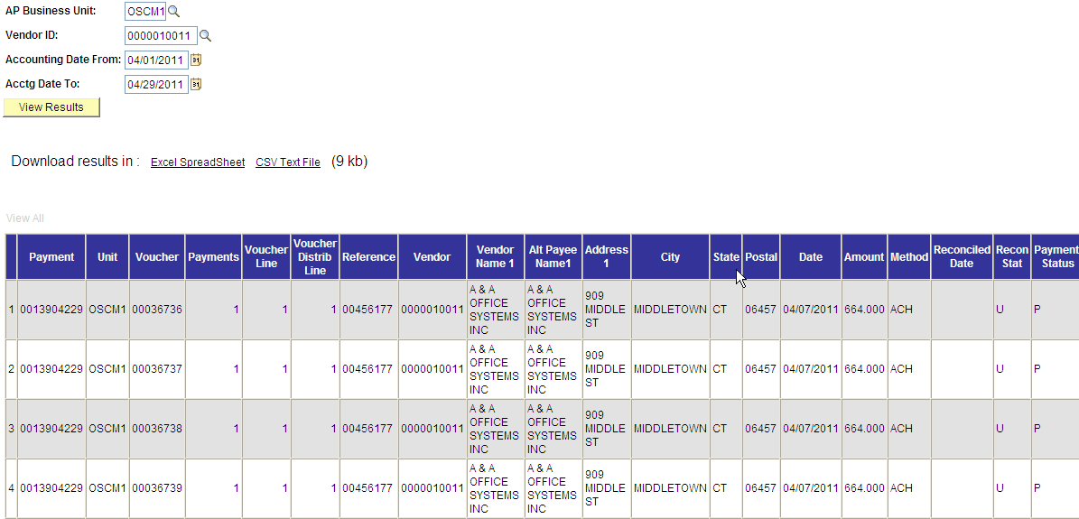

Criteria

B.PYMNT_SELCT_STATUS - Payment Selection Status in list ('E','P','S') – (Externally Paid, Paid, Settlement Payment)
A.VENDOR_SETID - Vendor SetID equal to STATE

Note: Runtime prompts are included as criteria.

Fields

Col | Record.Fieldname | Format | Ord | XLAT | Agg | Heading Text
1 | C.PYMNT_ID - Payment Number | Char10 | 1 |  |  | Payment
2 | A.BUSINESS_UNIT - Business Unit | Char5 | 2 |  |  | Unit
3 | A.VOUCHER_ID - Voucher ID | Char8 | 3 |  |  | Voucher
4 | B.PYMNT_CNT - Payments | Num5.0 | 4 |  |  | Payments
5 | A.VOUCHER_LINE_NUM - Voucher Line Number | Num5.0 |  |  |  | Voucher Line
6 | A.DISTRIB_LINE_NUM - Distribution Line Number | Num5.0 |  |  |  | Voucher Distrib Line
7 | C.PYMNT_ID_REF - Payment Reference | Char20 |  |  |  | Reference
8 | C.REMIT_VENDOR - Remit Vendor | Char10 |  |  |  | Vendor
9 | A.CT_VNDR_NAME1 - Vendor Name 1 | Char40 |  |  |  | Vendor Name 1
10 | C.CT_VNDR_ADD_NAME1 - Alternate Payee Name 1 | Char40 |  |  |  | Alt Payee Name1
11 | C.ADDRESS1 - Address Line 1 | Char55 |  |  |  | Address 1
12 | C.CITY - City | Char30 |  |  |  | City
13 | C.STATE - State | Char6 |  |  |  | State
14 | C.POSTAL - Postal Code | Char12 |  |  |  | Postal
15 | C.PYMNT_DT - Payment Date | Date |  |  |  | Date
16 | C.PYMNT_AMT - Payment Amount | SNm25.3 |  |  |  | Amount
17 | C.PYMNT_METHOD - Payment Method | Char3 |  | N |  | Method
18 | C.PYMNT_RECONCILE_DT - Date Reconciled | Date |  |  |  | Reconciled Date
19 | C.RECON_TYPE - Reconciliation Type | Char1 |  | N |  | Recon Stat
20 | C.PYMNT_STATUS - Payment Status | Char1 |  | N |  | Payment Status
21 | C.POST_STATUS_AP - Post Status | Char1 |  | N |  | Voucher Status
22 | C.RECON_STATUS - Recon Status | Char3 |  | N |  | Recon Status
23 | B.DUE_DT - Due Date | Date |  |  |  | Due Date
24 | A.CT_VCHR_LN_DESCR - Voucher Line Description | Char30 |  |  |  | Vchr Ln Descr
25 | A.QTY_VCHR - Quantity Vouchered | SNm13.4 |  |  |  | Quantity
26 | A.MONETARY_AMOUNT - Monetary Amount | SNm25.3 |  |  |  | Voucher Amount
27 | A.ACCOUNT - Account | Char10 |  |  |  | Acct
28 | A.CT_GL_ACC_DESCR - GL Account Description | Char30 |  |  |  | GL Acct Descr
29 | A.DEPTID - Department | Char10 |  |  |  | DeptID
30 | A.CT_DEPT_DESCR - Department Description | Char30 |  |  |  | Deptid Descr
31 | A.FUND_CODE - Fund Code | Char5 |  |  |  | Fund
32 | A.CT_FUND_DESCR - Fund Code Description | Char30 |  |  |  | Fund Descr
33 | A.CT_SID - SID | Char5 |  |  |  | SID
34 | A.CT_SID_DESCR - SID Description | Char30 |  |  |  | SID Description
35 | A.PROGRAM_CODE - Program Code | Char5 |  |  |  | Program
36 | A.CT_PRGRM_DESCR - Program Code Description | Char30 |  |  |  | Program Descr
37 | A.BUDGET_REF - Budget Reference | Char8 |  |  |  | Bud Ref
38 | A.PROJECT_ID - Project | Char15 |  |  |  | Project
39 | A.CT_PROJCT_DESCR - Project ID Description | Char30 |  |  |  | Project Descr
40 | A.CHARTFIELD1 - Chartfield 1 | Char10 |  |  |  | Chartfield 1
41 | A.CT_CHRTF1_DESCR - Chartfield One Description | Char30 |  |  |  | Chrtfld1 Descr
42 | A.CHARTFIELD2 - Chartfield 2 | Char10 |  |  |  | ChartField 2
43 | A.CT_CHRTF2_DESCR - Chartfield Two Description | Char30 |  |  |  | ChrtFld2 Descr
44 | A.PO_ID - Purchase Order | Char10 |  |  |  | PO
45 | A.LINE_NBR - Line Number | Num5.0 |  |  |  | Line
46 | A.SCHED_NBR - Schedule Number | Num3.0 |  |  |  | Sched Num
47 | A.PO_DIST_LINE_NUM - PO Distribution Line Number | Num5.0 |  |  |  | PO Distrib Line
48 | A.CNTRCT_ID - Contract Id | Char25 |  |  |  | Contract
49 | A.VERSION_NBR - Contract Version | Num5.0 |  |  |  | Contract Version

