AP History Ch 24 (13th) Industrialization

The Railroads (Iron Horse)

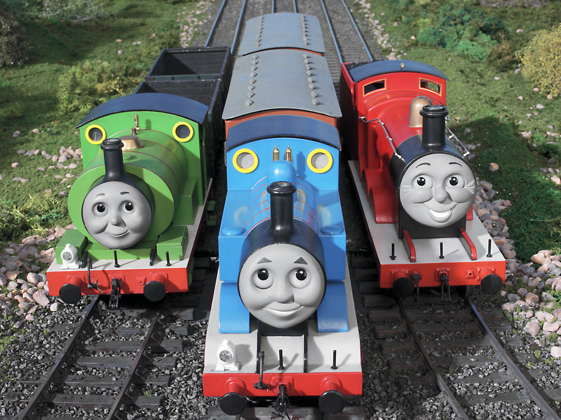

- Transcontinental RR

-Congressional Act 1862/Finished 1869
Loans + Land Subsidies (Laissez-faire?)
-Irish (Going west) + Chinese (Going east) Labor
-By 1890’s 5 Transcontinental Lines completed
-Opens west to development + Increases trade with Asia

- Consolidation + Growth 1860-1900

-Standard Gauge…width between rails
-Corporate innovation by Vanderbilts
-“Trunk” lines created w/ mergers + buyouts
-Railroad Time… 4 Time Zones
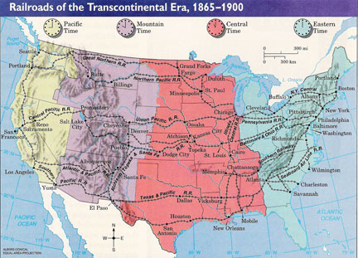
-Big customer of Steel + Other Raw materials
-Ships Finished Goods
-Creates jobs
-Stimulates immigration

- Corruption

- “Stock Watering” Inflated value of Company
- Combinations of companies formed to minimize Competition
- Pools (informal/ “handshake”) then Trusts (formal)
- RR’s have Tremendous Influence on gov ($)
- Farmers pay exploitive rates

- Gov Steps In

- Grange Laws (passed by agricultural states’s)
- Munn v Ill , But then Wabash v Ill.(1886)
- 1887 Interstate Commerce Act RR
- First Regulation of Private Industry by Fed Gov
- Precedent for leaving Laissez -faire

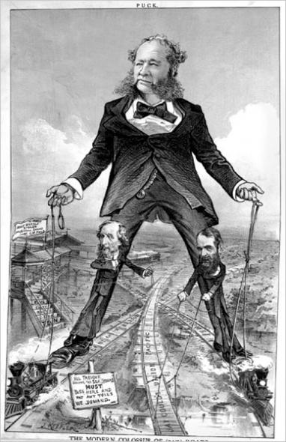
Vanderbilt

Captains of Industry

- Carnegie
-Vertical Integration… Control all aspects of production
-Mining to end product… Goal was efficiency(lower costs)
-25% US steel production is Carnegie by 1900

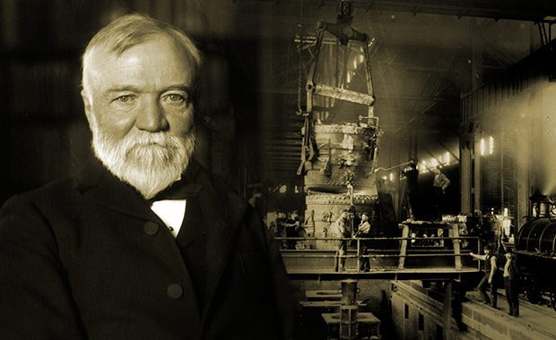

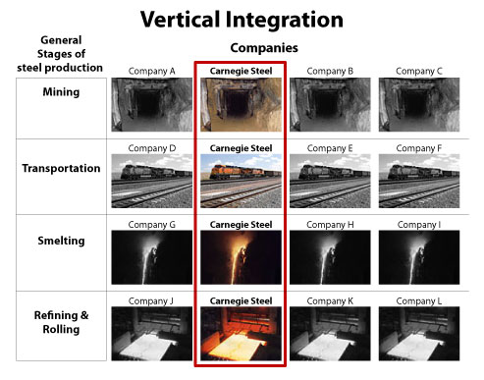

- Rockefeller

- Horizontal Integration…Combinations to Control + Dominate Markets. ie. Trusts

- By 1880’s Standard Oil controls 95%

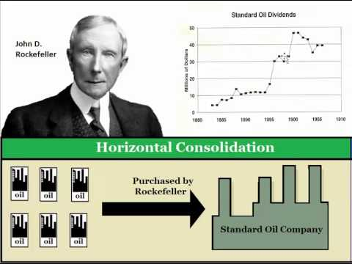

- Morgan
- Wall Street Banker
- RR’s, Ins., Banks
- “Holding” Co., Interlocking Directorate
- Made Bailout loan to Nat’l Gov’t 1907

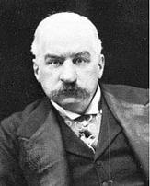

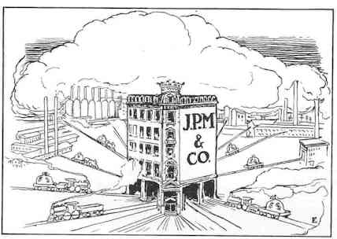

- “Captains of Industry” (positive)
Men of Vision, Ambition, Drive.. The Builders of America?
Raised the Standard of Living/Created jobs/Econ growth
Philanthropy… “Gospel of Wealth”
Supported by ideas of
-Plutocracy
-Natural Selection
-Social Darwinism

- Robber Barron (negative)
-Exploited Workers, Consumers, Corrupted Gov
-Ruthless competitors
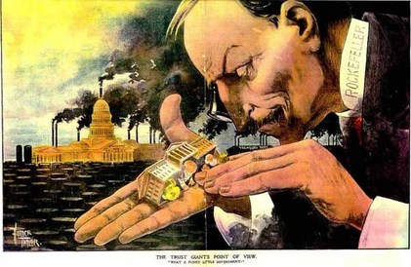
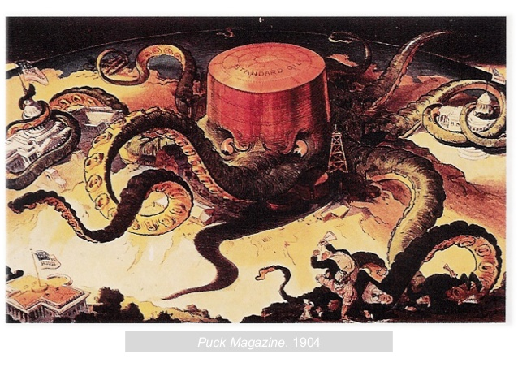
- Sherman Anti-Trust 1890 “Democratic” Fairness to Markets
- Clayton Anti-Trust 1912
Labor

- Wage-Earners displace Farm labor
-Long hours 12/14 hr days 6 day work week
-Low wages … Subsistence
-Unsafe

- Unions
-Collective Bargaining: Owners Oppose
-Knights of Labor (originally secret)
Terence Powderly
Pushed Econ + Social reform
Membership inclusive
Haymarket Affair 1886 dooms the Union
-The American Fed of Labor (AF of L) 1886
“Federation” of separate unions
Samuel Gompers
“Skilled workers” only
Higher Wages, Shorter Hrs, Work conditions
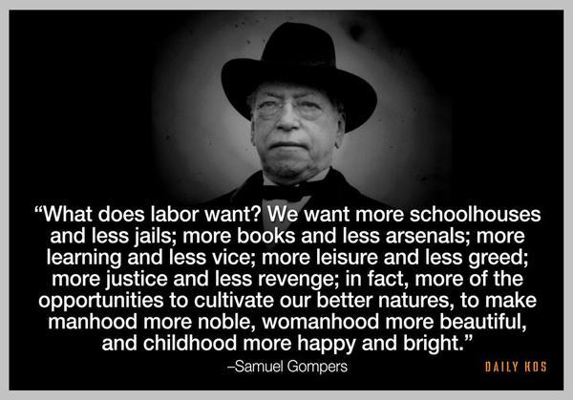

First Labor Day 1894

- Women
-Inventions create job opportunity
“womens” work
-Typewriter, Sewing machine

- Children
- Cheap labor (10-12 yrs old)
- Textiles, Mines

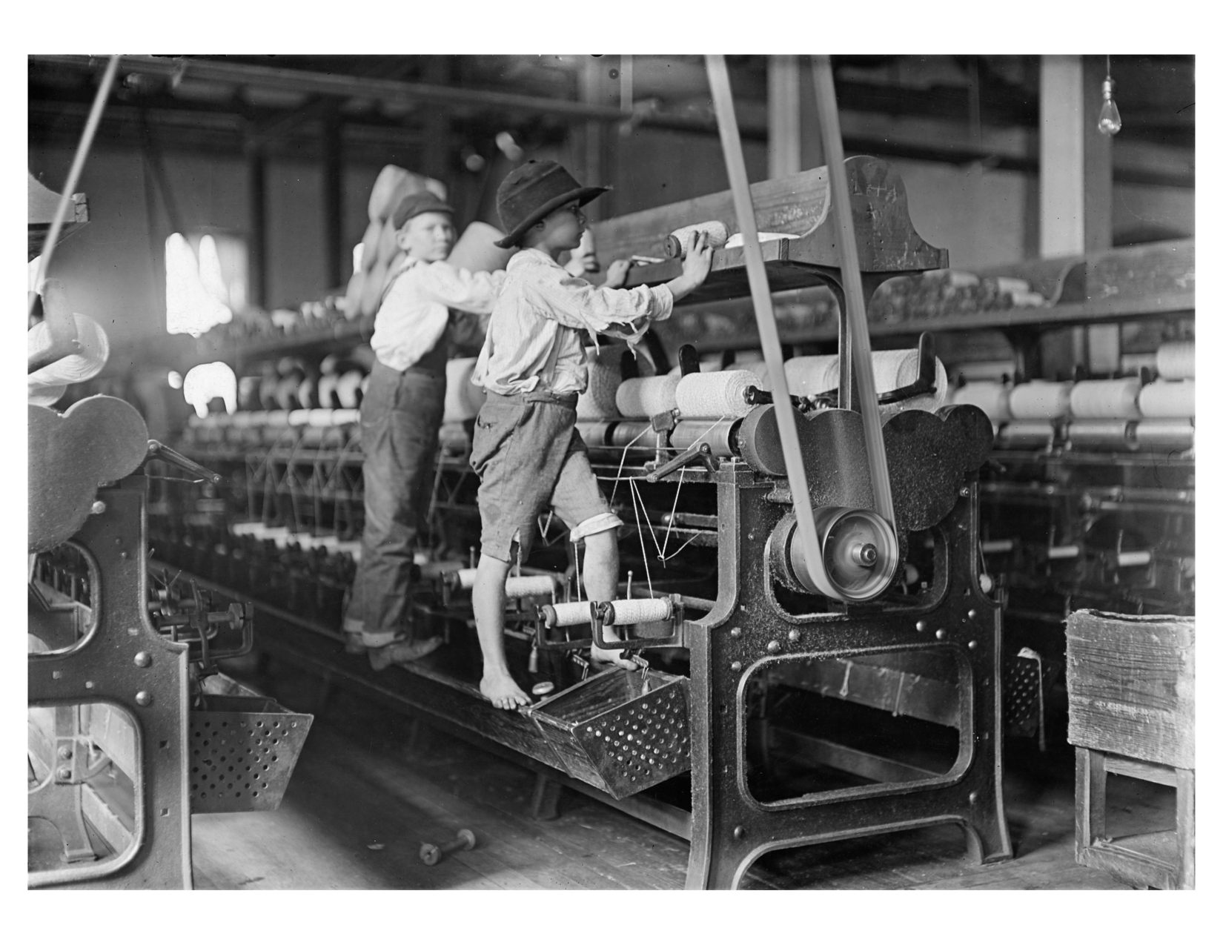
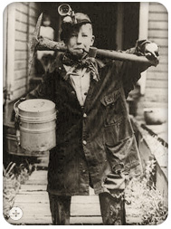

Congress passes 2 child labor laws 1918 + 1922

-Supreme Court Declares each Unconstitutional

1938 Fair Labor Standards Act (New Deal)

-First Nat’l law regulating child labor

