Background Information
http://www.onr.navy.mil/focus/ocean/water/salinity1.htm
Molecules are in constant motion, and tend to move from areas of higher concentrations to lesser concentrations until equilibrium has been met. Once at equilibrium, molecules will continue to pass throughout a solution or a semi-permeable membrane to maintain that equilibrium.
Most of the salt in the oceans came from land. Over millions of years, rain, rivers, and streams have washed over rocks containing the compound sodium chloride (NaCl), and carried it into the sea. You may know sodium chloride by its common name: table salt! Some of the salt in the oceans comes from undersea volcanoes and hydrothermal vents. When water evaporates from the surface of the ocean, the salt is left behind. After millions of years, the oceans have developed a noticeably salty taste. Most marine creatures keep the salinity inside their bodies at about the same concentration as the water outside their bodies because water likes a balance. If an animal that usually lives in salt water were placed in fresh water, the fresh water would flow into the animal through its skin. If a fresh water animal found itself in the salty ocean, the water inside of it would rush out. The process by which water flows through a semi-permeable membrane (a material that lets only some things pass through it) such as the animal's skin from an area of high concentration (lots of water, little salt) to an area of low concentration (little water, lots of salt) is called osmosis.
This is also why humans (and nearly all mammals) cannot drink salt water. When you take in those extra salts, your body will need to expel them as quickly as possible. Your kidneys will try to flush the salts out of your body in urine, and in the process pump out more water than you are taking in. Soon you'll be dehydrated and your cells and organs will not be able to function properly.
Osmotic vocabulary:
  - Diffusion – the movement of molecules from an area of high concentration to low concentration
  - Osmosis – the diffusion of water molecules through a selectively permeable membrane
  - Selectively permeable – means that some molecules can move through the membrane while others cannot
  - Hypotonic- Lower solute concentration in the solution than inside a cell / membrane
  - Hypertonic- Higher solute concentration in the solution than inside a cell / membrane
  - Isotonic- Equal amounts of solute both in the solution and inside the cell / membrane

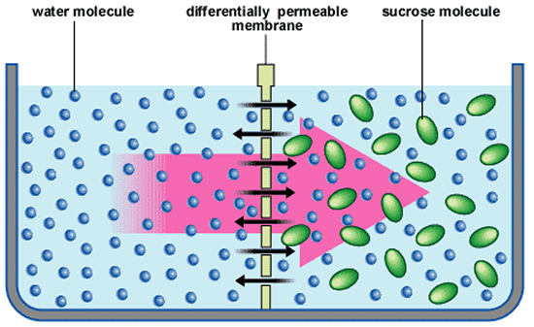
- The diagram shows the movement of water (small dots) across a selectively permeable membrane. The water moves from where there is more water (high concentration) to where there is less water (low concentration).

Question
- How will soaking the Gummy Bear candies in tap water or salt water affect the size of the candy?

Prediction
- What to you think will happen to the size of the gummy bears in tap water VS salt water

Materials

2 small beakers
1 Ruler
2 gummy bears
Water
Salt water
Masking tape
Triple Beam Balance
Writing utensil

Procedure
- Day 1
- Use the masking tape, label one beaker “Tap water” and the other, “Salt water”. Write your names on the tape.
- Measure the height, width and mass of each gummy bear. Record this information in your data table.
- Observe and describe in your data table the color (dark, light) of each gummy bear.
- Fill one beaker about ¼ full with tap water and place one gummy bear, facing up, at the bottom. The gummy bear should be completely submerged.
- Fill the other beaker about ¼ full with salt water and place the other gummy bear, facing up, at the bottom. The gummy bear should be completely submerged in the salt water.
- Set the beakers in the cabinet, under the proper period number. DOUBLE CHECK YOUR NAMES & SOLUTIONS ARE LABELED!

- Day 2 (24 hours)
- Carefully remove the gummy bear from the “Tap water” beaker, place it on a paper towel to help absorb any extra water.
- Measure the new height, width and mass of the gummy bear. Record the information in the data table.
- Observe the color (dark, light) of the gummy bear and describe any changes in your data table.
- Repeat steps 1-3 for the gummy bear from the “Salt water” beaker.

Data Table
Measurements | Tap water beaker |  |  | Measurements | Salt water beaker
 | Before Soaking | After Soaking (24 hours) |  |  | Before Soaking | After Soaking (24 hours)
Height (mm) |  |  |  | Height (mm)
Width (mm) |  |  |  | Width (mm)
Mass (grams) |  |  |  | Mass (grams)
Color |  |  |  | Color
Analysis Questions
- Calculate the percent change in the size of the candy from the Tap water beaker.
  - % Height = ((After soaking – Before soaking) / (Before Soaking)) x 100%

  - % Width = ((After soaking – Before soaking) / (Before Soaking)) x 100%

  - % Mass = ((After soaking – Before soaking) / (Before Soaking)) x 100%

- What happened to the gummy bear that soaked in the tap water? Explain clearly why this happened.

- What happened to the gummy bear that soaked in the salt water? Explain clearly why this happened.

- After the experiment, you decided to place the salt water gummy bear into the tap water overnight. What do you think will happen to the gummy bear? Explain your answer clearly.

