SIS MADE E-Z

- Icon Locations 2
- Marking attendance 3
- Check individual student’s attendance 4
- Setting up the grade book, entering grades 4
- Formulas for grades 5
- Weighting your grades 5
- Copying the MUST HAVE columns to other classes 6
- Create a new assignment 6
- Deleting an assignment 7
- Copy assignments to other classes 7
- To move a student’s grades from one block to another 7
- Printing an individual student’s progress report 7
- Print grade book page for entire class 7
- Entering in Ac Lab (Purple/Gold) Grades 7
- Print out missing assignments only for a class 8
- Print grade book page for deficient students only 8
- End of semester grades – importing from SIS 8
- Quick way to find out if your students have an IEP 10
- Modifications for IEP students 10
- Checking Entire Class for IEP 10
- Checking individual student for 504 Plan or Medical Alert 11
- Checking OTHER teacher grade books for student grades 12
- Check to see if the student meets the prerequisite 12
- Print Transcript 13
- Create a quick roster of my students 13
- Create a list of all my students 13
- Send Email to Entire Class 14
- Create a list of ALL STUDENTS I N BUILDING 14
- Delete student(s) from a list 15
- Print Student Update Form 16
- Trouble shooting
  - I entered an assignment and it doesn’t show up 12
  - My semester grades are figuring incorrectly 12
  - My quarter grades are figuring incorrectly 12

As you need help with more items regarding SIS, please contact Lisa Hoffmann at TBHS (313) and she can add things to this training guide.

ICON LOCATIONS
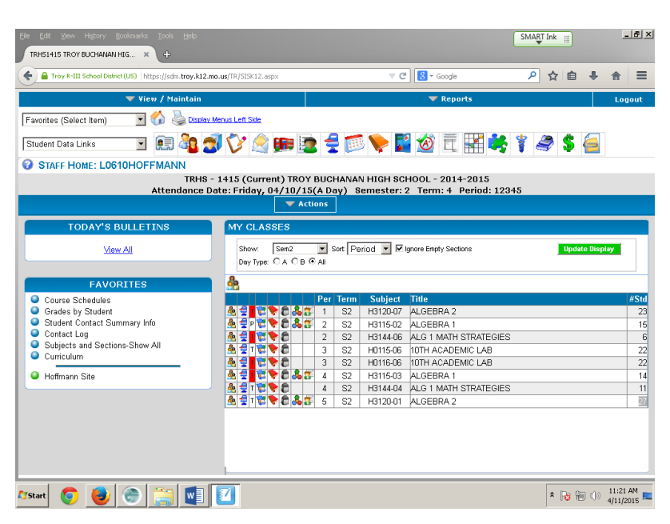
1
2
3
4
5
601
7
8
9
10
11
12
13
14
15
166
17
18
19
20

- Home
- Contact Information
- Student Data
- Contact Log
- Email
- Schedule
- Today’s Attendance
- Attendance History
- Gradebook Summary
- Term Grades (not current)
- Transcript
- Assessments
- Medical Alert
- SpEd Services
- Roster All Students
- Attendance
- Gradebook
- Curriculum Marks
- Roster One Class
- Major Learning Objectives for Course

After logging into your computer with your NETWORK ID (hoffmanl) and password, you can log into the SIS grade book program by using your SIS LOGIN (L0610HOFFMANN) and password. You’ll find the SIS program by clicking Start, Novel Zenworks Applications, Application Window. When the window opens, double click on the Student Information System icon.

To mark your attendance:

Log in to SIS, then click on the Blue Desk Icon, for any class. You may choose to view Today’s Only, Sem 1 or 2, Term 1, 2, 3, or 4, or View All. You can Sort by Period, Subject, or Title. If you change the SHOW or SORT BY categories, you must click “UPDATE DISPLAY” in green from the right side of your screen for changes to occur.
Once you’ve marked absences, the Blue Desk Icon will be replaced with a “T” for teacher marked attendance, or a “P” for perfect attendance.

To check an individual student’s attendance for the current day: click on the LARGE BLUE DESK ICON (7) at the top center of the screen. Type in the student’s last name, and press enter. To check on another student – click the magnifying glass to the left of “Actions”, Type in the student’s name and press enter.

To check an individual student’s attendance history: click on the LARGE CALENDAR ICON (8) at the top center of the screen. Type in the student’s last name, and press enter. To check on another student – click the magnifying glass to the left of “Actions”, Type in the student’s name and press enter.

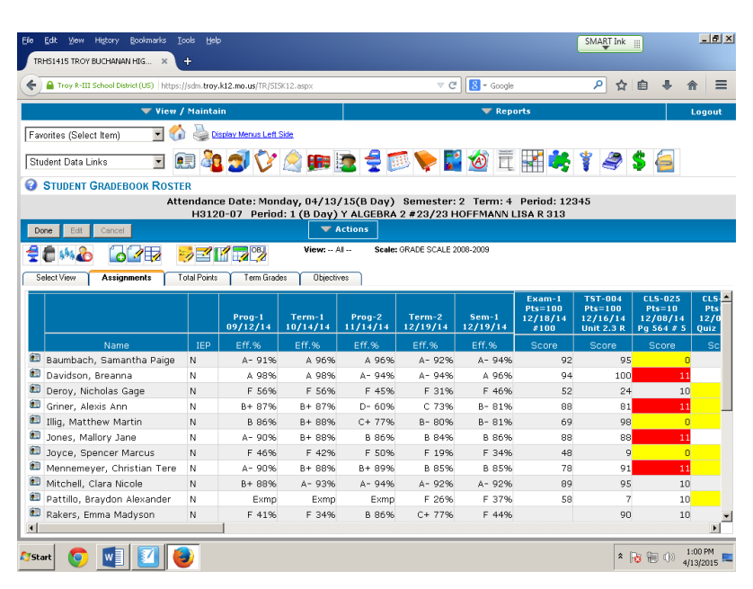
There are 6 MUST HAVE columns for each semester for each class.
Prog- 1 – student grade progress report quarter one
Term- 1 – student grade term quarter one
Prog- 2 - student grade progress report quarter one
Term- 2 - student grade term quarter two
Exam-1 – final exam first semester (to be added when finals are given)
Sem- 1 – student grade first semester

If one of the above columns does not appear in the grade book, you can create them. IF YOU HAVE SEMESTER CLASSES, the MUST HAVE columns might not appear automatically for 2nd semester. Simply click on ASSIGNMENT, create new assignment and choose the type that you need.
All of the previous columns will have some type of formula. You may choose to adjust them now or go back later when you have more time.
If you are going to average ALL GRADES EQUALLY:
You do not need a special formula, the computer will “Average All Assignments”. Please be aware that this means your 12 point test is not going to be weighted any differently than your 12 point assignment.

If you weight your grades, you may want to start off the quarter with them weighted. To change what they are worth, you need to have a formula in both your Progress column and your Term column
.
To weight your grades:
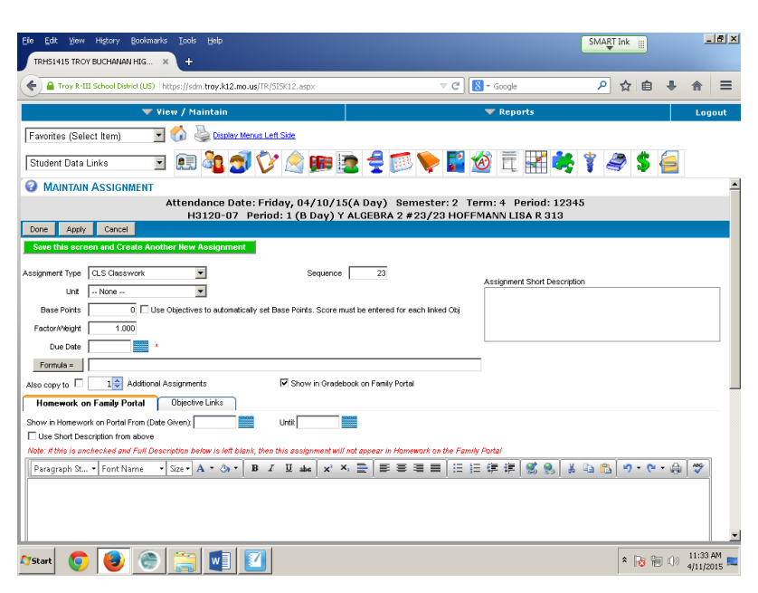
Open the gradebook for the class you wish to weight, Red Book Icon (18)
Click on the first cell in the column you’d like to change (Prog-1)
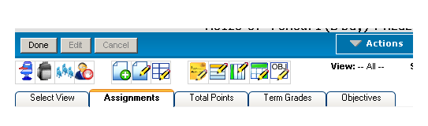
21

22

Click on the Edit Properties Icon, Paper with Pencil Icon (21)
Click on Formula Button on left side of screen
Choose what you’d like to use to determine the grade (CLS and TST is what I most often)
Click Done
Enter the percent you’d like to use (75% CLS and 25% TST)
Click Done – you can verify that the formula is correct
Click Done (you may have to enter a date)

To copy this formula to Term 1, Prog 2, and Term 2
- Enter the gradebook that already has the formulas entered
- Click on Actions in the center of the screen
- Click on Manage Assignments
- Click on One Specific Assignment (SGP-1) on the left side of the screen and My Other SG? Columns in this section
- Click Start Copy Process (should get a red confirmation statement at the top)
- Click Done

To copy formulas from one class to the rest of your classes
- Enter the gradebook that already has the formulas entered
- Click on Actions in the center of the screen
- Click on Manage Assignments
- Click on Copy Formulas
- Choose All system SG? Columns in this section from left of screen
- Choose All my sections for this subject
- Click Start Copy Process from left of screen (should get a red confirmation statement at the top)
- Click Done

To create a new assignment, click on: Page + Icon (22), use the dropdown menu to label as: classwork, homework, project, quiz, test, or lab. Put in the # of points it is worth under base points (extra credit would be 0). Factor/Weight should be 1.000. Under Assignment Short Description you can describe the assignment or page number. To enter another assignment, click the Green Save this Screen and Create Another Assignment Button. Once all assignments are entered, Click done.

TO DELETE AN ASSIGNMENT:
Once you’ve logged in click the Red Grade book for the class you want, then click on the first cell of the column you want erased, click on Actions, Manage Assignments, Delete Current Assignment. It will ask you to verify before it deletes the assignment.

To copy a single assignment or a few assignments to all of your other classes, follow these steps:
- From the gradebook that already has the assignment entered
- Click on Actions, Manage Assignments
- Choose the assignments you want to copy to other classes from the left side of the screen
- Choose the classes you want to copy to from the right side of the screen
- Click on Start Copy Process
- You should get a verification message when the copy process is complete.

To move a student’s grades from one block to another (transferred classes),
To view the previous grade:
- Open the gradebook from the original hour
- Click on the Select View Tab at the top
- Scroll down to the boldface type: Student names in Roster
- Click the checkbox next to Dropped/Withdrawn Students
- Go back up to the top and click on Update Display
- You should now be able to see the transferred student’s name in RED
- You can write down individual grades for the student if you use straight points, OR you can write down the percentage for the student if you use weighted grades.
To enter the grade:
- Open the gradebook for the new hour
- Enter the individual grades for the student if you use total points to calculate the grade OR create a new assignment worth 100 points titled transfer grade then enter their percentage if you use weighted grades. Everyone else will be EXEMPT from this “assignment”

PURPLE/GOLD DAYAC LAB GRADES
To make things as simple as possible. I keep grades for my ac lab in my PURPLE DAY grade book. At grade reporting time (progress reports, term grades, semester grades), I write down (or print) the students current ac lab grade. I open my Gold Day Gradebook and create 1 new assignment titled “Duplicate of purple day grades” I make this assignment worth 100 points and I enter the students’ grades from the purple day gradebook.

To print progress report:
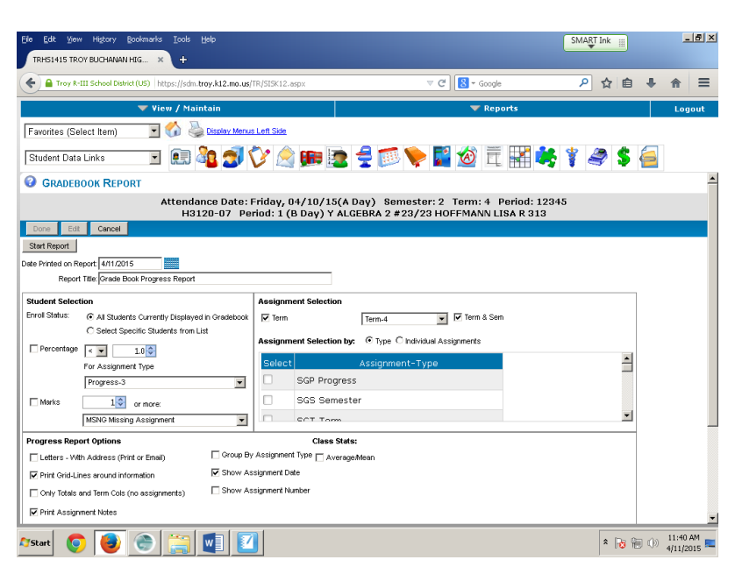

Inside the grade book page Click on Actions, Reports, Progress Reports, Choose Specific Student (to print off one student’s report) or Choose All from List (to print off entire class). Double check that the TERM/SEMESTER that you’d like to print for is checked and that the Percentage and Marks boxes are NOT checked. Make sure that the Progress Report Options that you want are checked on the bottom, then click Start Report at the top of the page.

To print out a list of students with missing assignments ONLY, inside the gradebook page Click on Actions, Reports, Progress Reports, Choose Specific Student (to print off one student’s report) or Choose All from List (to print off entire class). Double check that the TERM/SEMESTER that you’d like to print for is checked and that the Percentage box is NOT checked. This time you want to check the Marks box. You will want to use the drop down menu to list 1 or more: MSNG ASSIGNMENTS. Make sure that the Progress Report Options that you want are checked on the bottom, then click Start Report at the top of the page. This also works for ISS, ABS, ABSX, but not for multiple codes at once.
*This will only work if you use the MSNG code when you enter grades*

To print the grade book page for deficient students only:
Inside the grade book page Click on Actions, Reports, Progress Reports, Choose Specific Student (to print off one student’s report) or Choose All from List (to print off entire class). Double check that the TERM/SEMESTER that you’d like to print for is checked and that Marks box is NOT checked. This time you will want to Check the PERCENTAGE box and use the drop down menu to choose < 70 for Assignment Type choose the current term (Term 1). Double check that the other options for the report are what you would like, then click on Start Report.

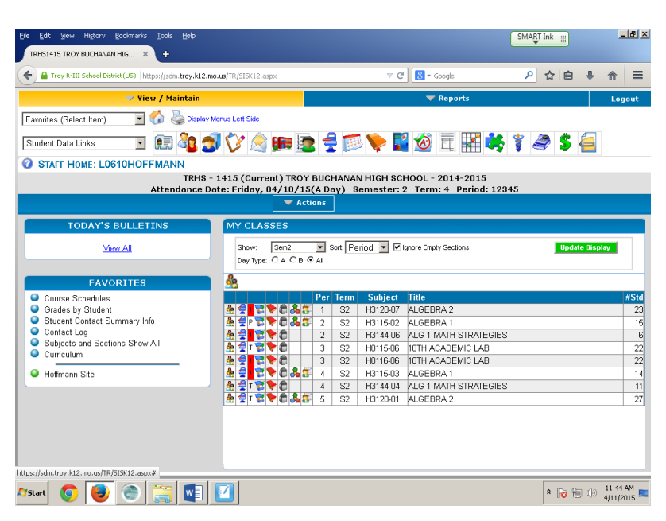
End of semester – importing from SIS
- Open SIS
- Click on View Maintain at the Top Left of the Screen
- Click on End of Term Grading Rosters
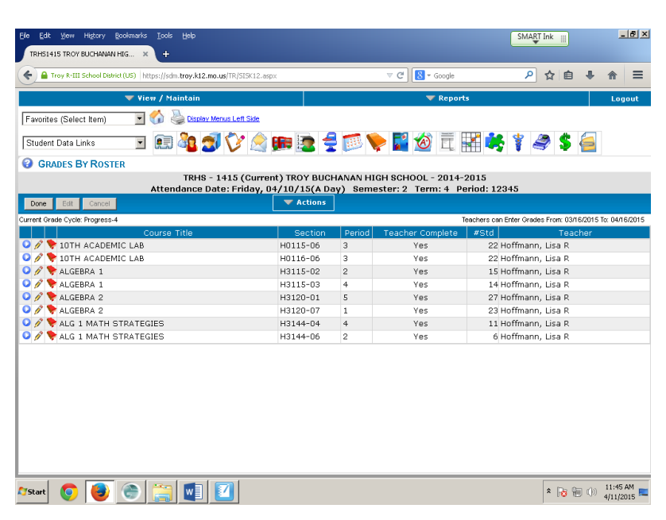
- Clicking on the RED Gradebook Icon will IMPORT grades from the system
- Clicking on the PENCIL Icon will allow you to EDIT grades already imported.
- To IMPORT select a class and click on the Red Gradebook Icon
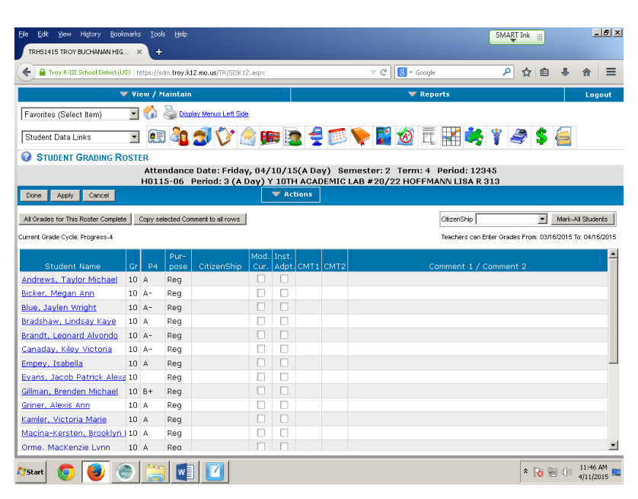
- The program will import the letter grade only for each student.
- Add a Citizenship score. You can give everyone the same citizenship score by choosing that option in the upper right corner.
- Enter Comment Code for individual students
- Click Done
- Class will show up as “YES” on the main screen under Teacher Complete.
If you wish to change a grade after a class has been marked, go through Steps 1 – 3 then choose the PENCIL Icon next to the class you wish to edit. DO NOT IMPORT AGAIN, this will erase any comments or citizenship grades you have enetered.

QUICK WAY TO FIND OUT IF YOUR STUDENTS HAVE AN IEP
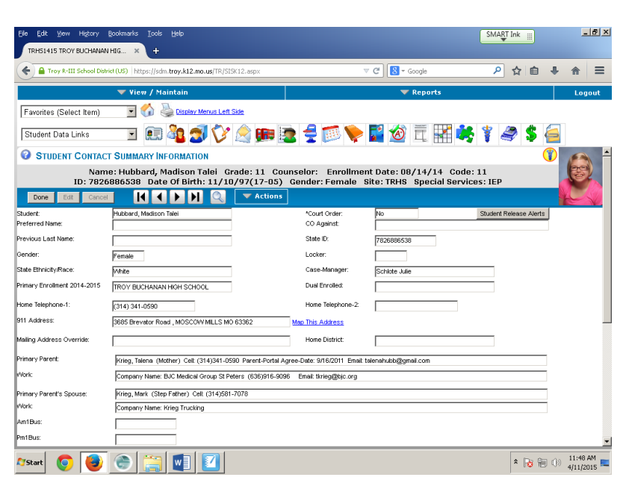
- Log in to SIS
- Choose ANY of the Large Icons across the top of the page except the Family Data Screen. Once you have entered a student’s name, if they have an IEP, there will be a Special Services: IEP message on the right side of the screen.

MODIFICATIONS FOR IEP STUDENTS
- Log in to SIS
- Choose the Paper with a Paper Clip Icon (14) on the far right at the top of the screen.
- Type in the student’s name.

Entire Class – Do they have an IEP?
- Log in to SIS
- Click on the Red Grade book Icon (18)
- Click Select View
- Scroll Down to Display Student Columns
- Select the Check Box for SpEd Status
- Click Update Display.
Your Gradebook will now have a column that displays a Y or N for IEP Status

Quick Way to Find Out if your Students have a 504 Plan or Medical Alert
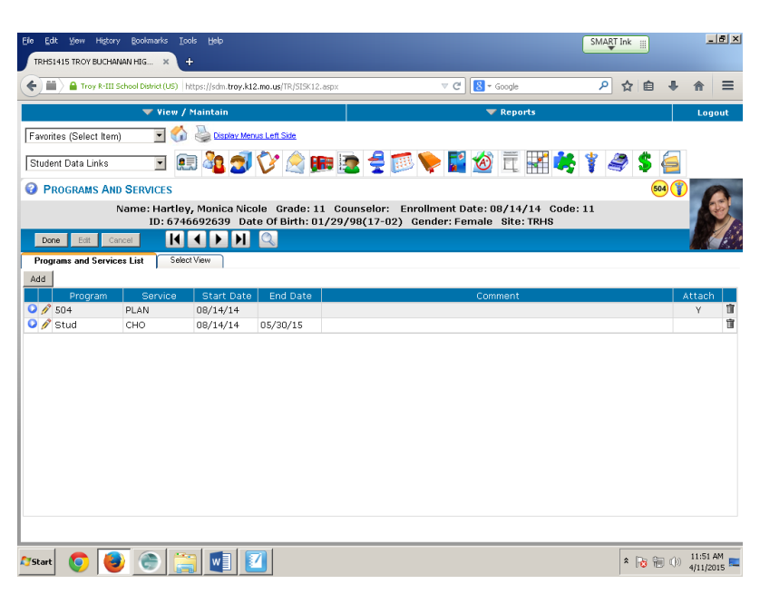
From any of the screens, you should be able to see the yellow 504 or Medical Alert Icon next to the student’s picture.

Academic Lab Teachers, Resource Teachers, Coaches ~
To check a student’s grade in all their classes (the teacher’s gradebook)
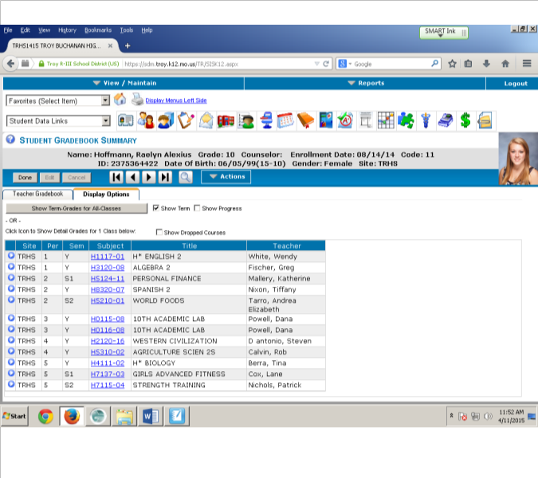
- Login to SIS
- Click on the Brown Gradebook Icon (9) with the Red Tab at the top center of the screen
- Enter the student’s name
- Click on Show Term Grades to see All of their Class Grades
- Click on Individual Gradebook for the course (course number in blue) to see assignments for an individual class.

Check to see if they have the prerequisite for your class:
- Log in to SIS
- Click on the Transcript Icon (11) at the top center of the screen.
- Enter the student’s name
- Scroll down to see if they have the prerequisite course needed.

Print Transcript for Individual Student:
- Log in to SIS
- Click on the Transcript Icon (11) at the top center of the screen
- Enter the student’s name
- Click on Actions, Print High School Transcript
- Choose the Options that you’d like to see on the transcript
- Click Start Report
- Click on the Printer Icon top right corner of the transcript screen

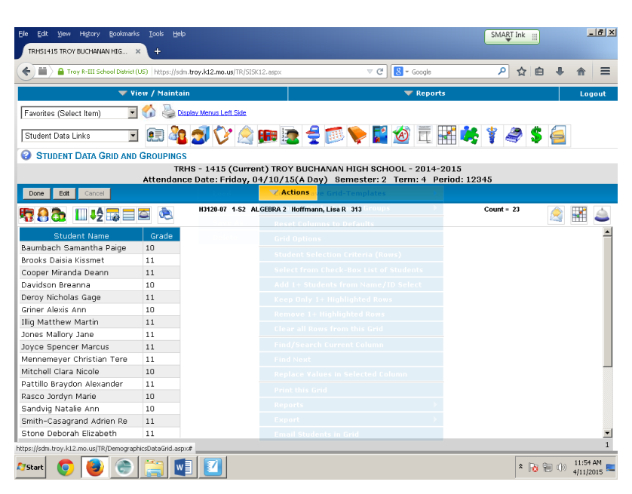
Create a quick roster of my classes:
- Log in to SIS
- Click on the Three People Icon (15) next to the class you’d like a roster for
- Click Actions, Print this Grid
- Click on Start Report

List of all my students:
- Log in to SIS
- Click on the LARGE Three People Icon (16) above the individual class lists.
- Click on Actions, Print this Grid
- Click on Start Report

To Send an Email to an ENTIRE CLASS:
- Log in to SIS
- Click on the Three People Icon (15) next to the class you’d like to email
- Click on Actions, Email Students in this Grid
- Fill in the subject, type your message, Click on the Green Send Emails Tab

When you are done, it will kick you out to a report screen. It should say that the report has been submitted, give it a second and then click on the blue button on the left. You can print the report. It will print a list of all the email addresses sent. If the email that SIS has does not work, you will get an error email form the helpdesk that says the email did not go through. To determine which parents did not receive the email see page 16 under Troubleshooting.

Create and Sort a List of ALL STUDENTS in the Building:
The math department does this when we are completing schedules for students. The guidance office provides us a list of students enrolled in each class for the following year and we highlight the students on our list to make sure that every student is placed in the correct math class before we leave for the summer.
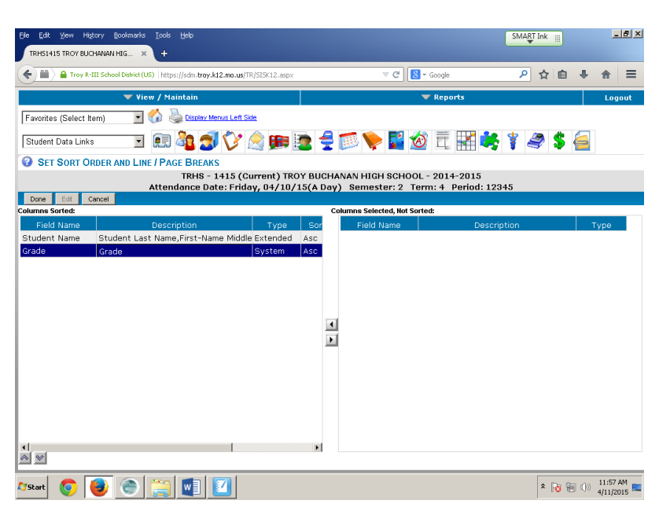
- Log in to SIS
- Click on the LARGE Three People Icon (16) above the individual class lists.
- Click on the Far Left Icon, Boy in Front of School
- Click on the AZ Button with the Green Down Arrow
- Click on the word Grade
- Click on the UP ARROW in the bottom left corner
- Click Done
You should now have a list of students in alphabetical order by grade! Since we don’t need to schedule the Seniors, we delete them from the list.

To Delete a Student From a List before emailing or after sorting students
- For individual Student(s) highlight the name you want to eliminate, you can hold down the control key to select multiple students at once, Clikc on Action, Remove 1+ Highlighted Rows
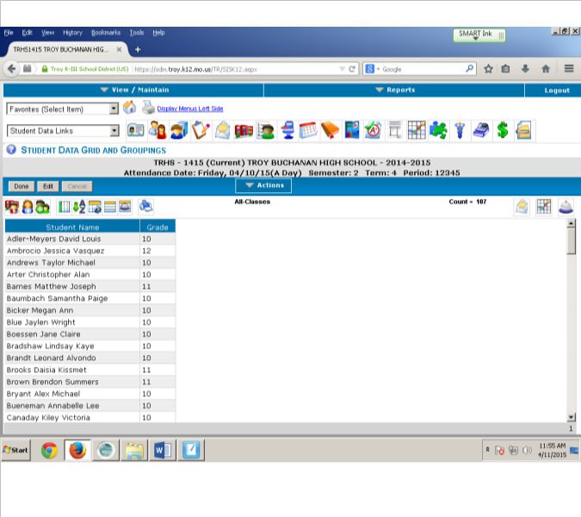
- You can then Print or Email the list

To print a list of student information for your ac lab kids (User ID, Locker Number, Locker Combination, Lunch Pin, etc...)

- Open your ac lab roster by clicking on Three People Icon (15)
- Click on the Select Columns to Display Icon it’s a Green Vertical Bar
- Choose any item you want from the right column by clicking on it, then choosing the left arrow button in the center of the screen to “add” it to the left side.
- Once you have all the information you want moved to the left side, click Done.
- Print by going to Actions, Print this Grid, Start Report
To print a Student Update Form
- Click on the Contact Info Icon (2) – Boy in blue shirt with file cabinet behind him
- Click on Actions
- Letters
- Click on the arrow for TBHS STUDENT UPDATE FORM (be patient, it may take a few seconds)
- Click on Start Report
- Choose the printer, then OK

Troubleshooting:

A. I entered an assignment and it doesn’t show up…..
Check to make sure that the DATE you entered is within the current term window.
  - My semester or term grades are figuring incorrectly……
Check your formulas
  - How do I know whose email did not go through?
The error email you get fives you the EMAIL address that doesn’t work, but it does not give you the student’s name. The easiest thing to do is have a print out of this information for all your classes. Look at page 15 and follow instructions for: To print a list of student information for your ac lab kids. When you select columns to display look for PrntAltEmail and PrntPriEmail

Entering Semester Grade Formulas - 40% 1st Qtr; 40% 2nd Qtr; 20% Final

Enter the class you wish to change
Make sure that the selected view has both term grades and the semester column showing.
Add an assignment column for the Semester Exam (SGX)
Click on the first grade in the semester column (Sem–1)
Click on edit properties of current assignment (blank sheet icon with the pencil)
Click on FORMULA button (left side)
Click on Percent (right side)
Click on Set Up Formula (left side)

USING THE RIGHT SIDE OF THE SPLIT SCREEN
Click on SGT 1; SGT 2; and scroll down to click on SGX
Click done on upper left side of screen
Double click on the 0.00 under the percent column and change SGT1 and SGT2 to 40 and SGX to 20
Click Done (upper left hand side)
Verify that the formula is correct on this page, then click done.

