7th Grade Social Studies Yearbook

Name:
Date:

As we begin 8th grade social studies, we are going to be “picking up” where we left off in United States’ history at the end of 7th grade. In order for us to successfully continue with American history, we need to be sure that we remember what happened so far in our studies. We can’t finish the story of America without reviewing its beginning. When you look back at your Middle School experience, you will probably look to your school yearbook to remind you of different people, events, and activities that took place. Unfortunately, we don’t have a 7th grade social studies yearbook to help you remember the people, events, and ideas that you learned about in 7th grade. So….you are going to create one!

THE PROJECT
This project will require you to create a 7th grade social studies yearbook complete with cover, pictures/illustrations, appropriate factual information, and an autograph page.

THE COVER
Use color, creativity and history to create your personalized 7th grade social studies yearbook. The cover MUST have your name, class period, date, a title, and an illustration.

SECTION 1: SAY CHEESE
No yearbook would be complete without people. In this section you must choose 5 people (or groups of people) studied in 7th grade social studies. You will need to include a “photograph” in the form of a picture or symbol that represents the person you chose. You will also need to include a short description of their contribution to United States history. Your choices MUST be from different time periods (Example: You cannot have 5 people from the Revolution). Be sure to include a description that includes the most pertinent information. Prove that you learned something.

Example:
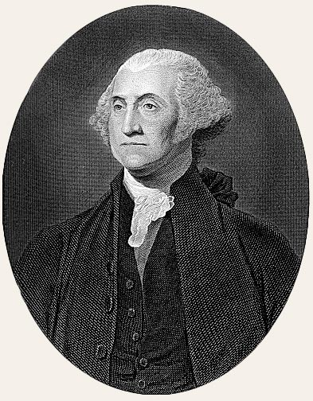

George Washington
Commander of the Continental Army, First President of the United States
Senior Quote: “Stay out of foreign affairs and don’t form political parties” (Farewell Address)
Nickname: The Precedent Setter

List your 5 people/groups of people here:

1.)

2.)

3.)

4.)

5.)

SECTION 2: REMEMBER WHEN…

Memories are what make a yearbook great. Choose 5 events studied in 7th grade social studies that you would consider memorable (or at least important enough that you think you may have to know it again). Illustrate AND describe your five events in this section of your yearbook. When describing the events that you have chose, remember to answer the basic questions of who, what, when, where, why, and how. Again, as with the people, you MUST choose events from multiple time periods (I do NOT want to see five generals from the Revolution).

Example:

Remember when….
The Spanish explorer Juan Ponce de Leon searched for the fountain of youth during the Age of Exploration but found Florida instead. Bummer! LOL

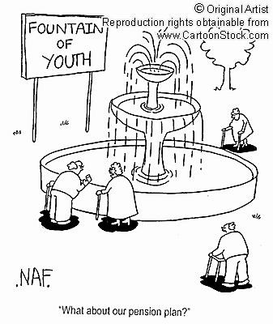

List your 5 events here:

1.)

2.)

3.)

4.)

5.)

SECTION 3: TALK OF THE TIMES
Your parents said “groovy”, I have been known to say “awesome”, your older siblings said “phat”, and you say___________________. The terms of the times are always an interesting section in any yearbook. In this section of your seventh grade social studies yearbook choose 10 important terms from 7th grade social studies and define them in your own words. You must then choose five to illustrate.

Example:

Democracy- ruled by the people

List your 10 terms here:

1.)

2.)

3.)

4.)

5.)

6.)

7.)

8.)

9.)

10.)

AND FINALLY,

The reason that everyone buys a yearbook…

SO THAT YOUR FRIENDS CAN SIGN IT!!!

FINAL SECTIONS: SIGNATURE PAGE
On this page (or pages) you will need to get at least 3 people in class to sign your yearbook. They will write a SHORT explanation of their most exciting memory of 7th grade social studies and the most important thing that they learned. This will be completed in class on the day that your project is due.

CONCLUSION- aka: The Reason that I am asking you to do this.

After completing this project you will hopefully have stirred up some memories of 7th grade social studies that will help you as you enter into the world of 8th grade social studies this year. Don’t forget that this information is also on your state assessment at the end of the year. By the time that you have completed this project, you should have a new tool that you can use to reminisce about 7th grade social studies and early American history. ☺

Name:

YEARBOOK RUBRIC

_______________COVER –10 POINTS: Must include all requirements

_______________PEOPLE—20 POINTS (4 points each person)
(Do you have 5 people? Are they correct? Are they from different time periods in history? Did you explain them thoroughly?)

_______________EVENTS—20 POINTS (4 points each event)
(Do you have 5 events? Did you answer all of the main questions? Do you have accurate information? Are the events from different time periods?)

______________TERMS—20 POINTS (2 points each term)
(Do you have 10 terms? Are they correct? Are they in your own words? Did you illustrate at least 5 of them?)

______________SIGNATURES—10 POINTS
(Did you get at least 3 classmates to sign your yearbook?)

______________TEACHER’S THOUGHTS—15 POINTS
(Creativity, Class time, Overall effort)

______________HANDED IN ON TIME—5 POINTS (you will lose 5 points each day the project is late)

Due date: __________________________

_________________Final Grade (This will count as a test and a quiz in your first quarter average.)

