My 5th Grade Math
Summer Practice Booklet
Answer Key

Name __________________

Number Sense

- Write a ratio (fraction) comparing the number of rectangles to the number of triangles. Then write a ratio (fraction) comparing the number of triangles to the total number of figures.

Number of rectangles 3
Number of triangles 2

Number of triangles 2
Number of total figures 5

- Show why 7 is equivalent to 14. 7 x 2 = 14
8 16 8 2 16
“1”
Many other ways to show such as a visual of a rectangle where 7 out of 8 equal parts are shaded and the same size rectangle where 14 out of 16 equal parts are shaded, etc.

3. Write the decimal and percent equivalent for the fraction ¼.
¼ = 0.25 = 25%
- The fraction 5/8 is closest to 1/2.
a. 0 b. ½ c. 1
- A perfect square is a number which is a value of another number to the second power. An example is the number 4 because 2² = 4. Another example is the number 25 because 5² = 25. Give your own example of a perfect square.
Examples include 36, 49, 64, 81, 100, 121, 144, etc.

- A temperature of -7º is 7 degrees below 0. A temperature of 37º is 37 degrees above 0.
- When adding 37 + 29 + 63, it is best to rearrange the order of the numbers using the Commutative Property of Addition because adding 37 to 63 to get 100 then adding 29 to get 129 is easier than adding in the original order given. (Property choices are associative, commutative, distributive, and identity)

- If you want to check your answer to a division problem, you would use the inverse operation of multiplication.

- Use order of operations to solve the following problems. (Remember PEMDAS – parentheses, exponents, multiply/divide, add/subtract)
37 + 15 x 3 – 12 =
37 + 45 – 12 = 70
2² + 5 x 6 – 10 =
4 + 30 – 10 = 24 (Do 2² first then 5 x 6)

- In order to add or subtract fractions, they must have
common or same denominators.
(Think about this: 2/5 + 1/5 = 3/5)

- Show how to add the decimals 4.5 + 12.3 by lining up
the decimal points.
12.3
+ 4.5
16.8

- Add! 3/8 + 5/8 = 8/8 = 1 whole.

- Estimate the cost of 8 balloons for $0.89 each. Show
your work!
8 x $1.00 = $8.00

Measurement

- An angle is measured in degrees. Give the measure for each angle below.
90° (angle where vertical meets horizontal)

180º

15.

Check to see that point C is at (3, 1), that D is at (2, 4) and that E is at (4, 4)

Using grid lines, how many units is point C from point D? 4 units

Using grid lines, how many units is point E from point D? 2 units

16. When carpeting a room, we would need to know the room’s

area. When filling a swimming pool, we

would need to know the pool’s volume.

(Choices are perimeter, area, and volume.)

17. Perimeter is always given in units, area is always

given in square units, and volume is always given

in cubic units.

18. The distance around the field is 393 feet. How many yards is this? 131 yards (Remember how many feet are in one yard!) Do 393 ÷ 3 = 131 yards
- A rectangle can be divided into 2 congruent triangles. This means a triangle’s area is half of a rectangle’s area when the length (base) and the width (height) are the same. If a rectangle measures 3 feet by 4 feet, find the area of the rectangle and then the area a triangle with the same dimensions.

Area of rectangle = 12 square feet
Area of triangle = 6 square feet

20. Draw an obtuse angle below. Estimate the degree of your angle.

Should be greater than 90 but less than 180º.

Estimate in degrees: 110°
Sample Answer!

Geometry

21. Label the radius of this circle. The diameter is 2 times the radius. Be sure radius is labeled as the center to any point on the circle.

22. Draw a pair of parallel lines below. Draw a pair of
perpendicular lines below.

Parallel | Perpendicular

23. The vertex is where two rays of an angle meet. The

inside of an angle is the interior angle and the

outside is the exterior. (Choices are interior,

exterior, and vertex.)

24. Congruent figures must have the same exact size and shape. These two shapes are congruent!

25. The interior angles of a triangle always add up to 180°.

- In the ordered pair (-7, 5), the x value is a negative number. Negative numbers are below 0 on the number line.
- The measure of an angle is determined by the rotation of one side to the next side. What is the angle of rotation for the sides of this figure?

90°

- What 3-D object will result from folding this 2-D net?

cylinder

Patterns, Functions, and Algebra
29. ☻♥♥♣ ☻☻♥♥♥♥♣♣

Identify the rule used!

Double the number of each shape as the sequence repeats

30. Finish the table and
x | y
1 | 6
2 | 12
3 | 18
4 | 24
5 | 30
identify the rule.

y = 6x or 6 • x

- In the rule d = r • t, d stands for distance, r stands for rate or speed, and t stands for time. Why are variables used in formulas like this one? Remember where the word “variables” comes from!

Variables are amounts that can vary or change. The rate, the time and the distance can change!

- In the equation m < $35.00 where m stands for money, we interpret this as having less than $35.00.

33. Predict what comes next in the pattern:

πππ♫♫ ππππ♫♫♫ πππππ♫♫♫♫

34. y = 2x – 7 As x gets larger, y gets larger.
(Choices include stays the same, gets larger, gets smaller.)
Substitute values in for x to help you!

Data Analysis and Probability

Severe Storms
Year | Frequency | Cumulative Frequency
2006 | 17 | 17
2007 | 30 | 47
2008 | 27 | 74
35.

Using the cumulative frequency table above, tell which year had the greatest number of severe storms. 2007

Tell how many severe storms occurred altogether from 2006-2008. 74

- When showing progress over time (such as YPP progress), a line graph is best.

37. Most Popular iPods for Ages 15-29 Use this triple bar graph to answer the following questions:
a. The most popular iPod for ages 15-19 is the
iPodNano

- 10 more 25-29 year olds prefer the iPod Touch
over the iPod Nano.
38. To find out the most popular summer activity of your
classmates, you would conduct a survey and ask the
question “What is your favorite summer activity?”

39. The first 5 people surveyed said their favorite summer activity was swimming. Would you predict the next person surveyed would also say swimming was their favorite summer activity? Yes (based on the survey so far!) How would your prediction change if the next 15 people said riding their bicycle with friends was their favorite summer activity?
I might think that the next person would say riding their
bicycle because the experiment or survey results so far
show this to be most popular. (sample answer)

- Find the mean, median, mode, and range of the following set of numbers. Show your work!

37, 45, 52, 37, 19

Mean = 38 Median = 37

Mode = 37 Range = 52 – 19 = 33

- When tossing a coin twice, the possible outcomes are:
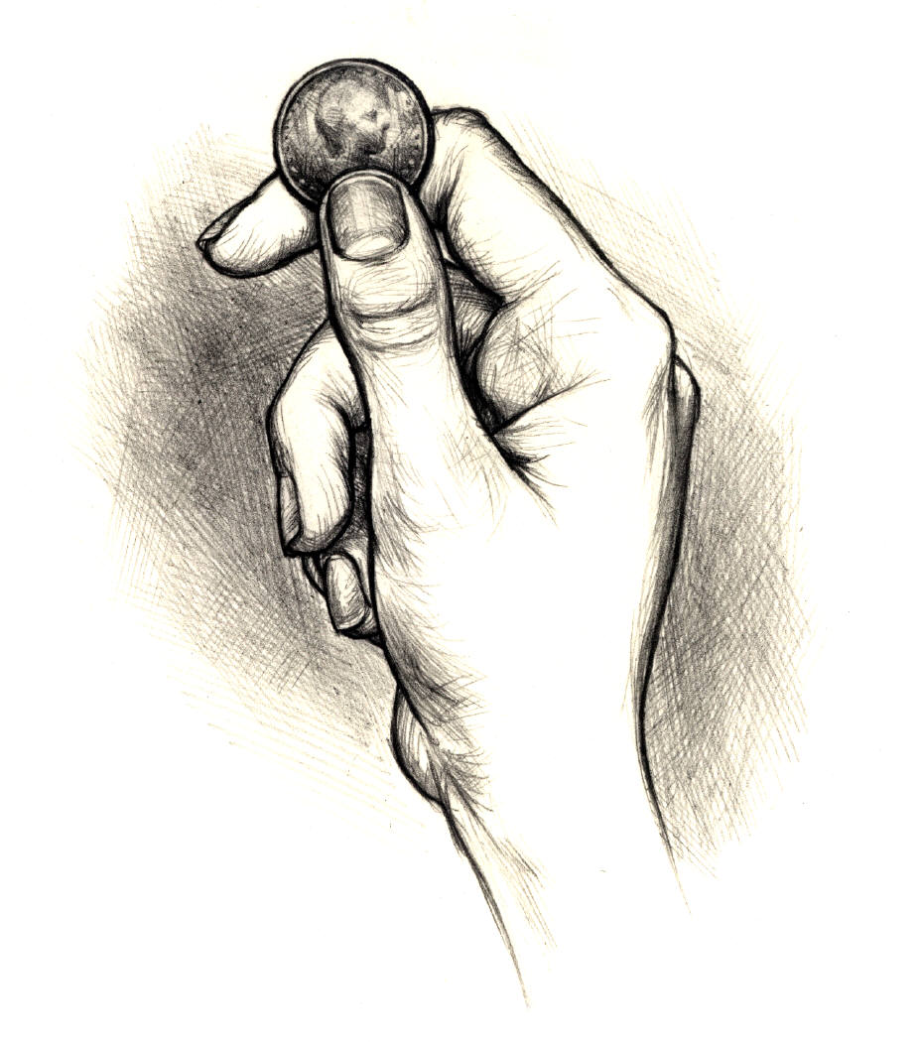 HH HT TH TT

- What is the probability of tossing a number greater than 4 when tossing a regular number cube? 2
6

- A probability of ½ means the event is “as likely as
not” or “equally as likely” to happen as not happen. Flipping heads on a coin is equally as likely as flipping tails on a coin.

- Theoretical probability is what should happen
based on theory and experimental probability is what does happen when you perform the experiment.

- If you make 6 out of 10 baskets, your probability of making the next shot would be 6. If shooting 30 times, how many
10
times would you expect to make a basket?
18 times (10 x 3 = 30 and 6 x 3 = 18)

