“The strength of our democracy is no greater than the collective well-being of our people. The vigor of our country is no stronger than the vitality and will of our countrymen. The physical, mental, moral, and spiritual fitness of every American citizen must be our constant concern.” - John F. Kennedy

PHYSICAL EDUCATION EXPECTATIONS FOR ALL CLASSES
PURPOSE  The purpose of this handout is to acquaint you with the procedures and regulations that will help you attain success in your Physical Education class.  In our curriculum we include a wide variety of physical activities, a high intensity fitness unit and team sports units that emphasize the relationship that regular exercise and good nutrition have with disease prevention and a healthy lifestyle.  Reinforcement of these principles at home can further enhance this very important message.  If you have any questions regarding the Physical Education Department, please feel free to contact us at Baldwin High School, 377-9304 or 377-9292. You may also email your teacher via emails listed below.  Physical Education Staff | Introduction To PE Grade 9  - Safety  - Care of Equipment  - Care of Property  - Uniform Requirements  - Personal Hygiene  - Graduation Requirements  - Grading Policies  - Make-up Policies  - Sportsmanship  - Units:  - Football, Soccer, Tennis, Basketball, Volleyball, Softball, Badminton, Fitness Testing, Personal Fitness, Floor Hockey  3-4 Week Units  PE 10-12  Student may select one of three blocks. Each block represents a series of units that are designed to focus on one area (team sports, individual sports and fitness). The units may vary depending on the teacher and their expertise and the interest of the students.  Block 1  Team Sports    Football  Volleyball  Basketball  Team Handball  Floor Hockey  Softball  6 Week Units  Block 2  Individual Sports  Tennis/Pickle Ball  Recreational Games  Golf  Badminton  6 Week Units  Block 3  Personal Fitness Activities |  | PHYSICAL EDUCATION EXPECTATIONS FOR ALL CLASSES  - On time and in correct attire  - Active participation during stretches  - Active participation during activities  - Attention to personal hygiene  - Physical Fitness Assessment  **Physical Education is based largely on participation in activities. When students are absent for any reason (guidance, deans, lessons, field trips, etc…, they miss out on information and active time. Therefore, students will be afforded the opportunity to make up 4 legal absences each quarter at scheduled make up sessions. During quarter four, students will be allowed to make up 6 legal absences. Cuts and unprepared sessions cannot be made up.  BALDWIN SENIOR HIGH SCHOOL PHYSICAL FITNESS ASSESSMENT WILL BE ADMINISTERED TWICE A YEAR.  :  - Sit and Reach  - Curl-ups  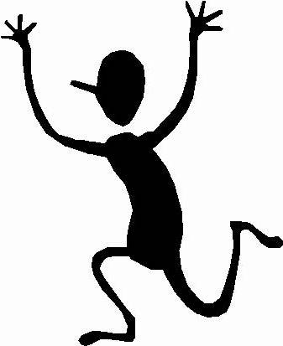  - Push-Ups  - 1-mile run  Grading  1st Absence ……………………………………..-5 pts.  Legal Absence (2 or more)…………..-10 pts  Illegal Absence (cuts)………………....- 10 pts  No warm up/failure to stretch…..- 2 pts  Poor Effort/Poor Behavior…………..- 2 pts  Late to Class…………………………………….- 2pts
  Eduardo Ramirez,
  Department Chairperson
  ramireze@baldwin.k12.ny.us
  Darius Burton
  burtonda@baldwin.k12.ny.us
  Steve Carroll
  carrollst@baldwin.k12.ny.us
  Tom Durnin
  durninto@baldwin.k12.ny.us
  Kathleen Durnin
  durninka@baldwin.k12.ny.us
  Tara Graf
  grafta@baldwinschools.org
  Lauren Jarmel
  jarmella@baldwinschools.org
  Tom Llewellyn
  llewellymth@baldwinschools.org
  April Mosca
  moscaap@baldwin.k12.ny.us
MEDICAL EXCUSES  Students are required to have a note from their doctor to be medically excused. These notes must be presented to the nurse at the beginning of the student’s physical education period. The nurse will send the student back to the instructor who will record the dates excused and make arrangements. Any student that will be unable to participate on a short term basis (one week to a quarter) will be assigned an alternative written assignment by their teacher. These assignments are due weekly and must be in on time. During their P.E. period, these students will report to the library to work on their assignment and shall remain there for the period. It is important that students sign in as that will count for their attendance. IT IS THE STUDENTS RESPONSIBILITY TO SIGN IN. Student medically excused for long term (more than one marking period) will be placed in a modified program (APE) or will have other arrangements made.  OFF LIMITS  Students are not allowed in the locker room during periods other than assigned PE period.  PHYSICAL EDUCATION DRESS REQUIREMENT  Baldwin High School students enrolled in Physical Education are required to wear appropriate physical education attire. The attire consists of the following:  - SHORTS  - T-SHIRT  - SWEAT PANTS  - SWEAT SHIRT  - SOCKS.  - SNEAKERS  NO CELL PHONES OR I-PODS SHOULD BE BROUGHT TO CLASS. STUDENTS ATTIRE MUST ADHERE TO SCHOOL DRESS CODE. |  | FOOD  Food, candy, or gum are NOT allowed in the locker room, gymnasium or in class.  LOCKER ROOM SECURITY  The locker room will be locked during class time to keep all students out. This is to protect you against theft. Please encourage your student to always lock their belongings inside their locker while in their PE class. It is highly recommended that students lock coats, wallets, and other valuables in their hallway lockers. The PE locker are small and should only be used to secure a change of clothing.  LOCKER ROOM PROCEDURE  - Double check that your locker is locked and do not let anyone know your combination.  - Only use the locker that has been assigned to you.  - Mark your clothing so that your name is highly visible.  - Always double check to insure that your locker is locked and secured properly.  - The majority of missing items are not due to theft, but the unauthorized sharing of lockers and items not being locked up carefully.  - DO NOT BRING VALUABLES (i.e. cell phones, iPods etc.) or large sums of money to P.E.  PROCEDURE IF ITEMS ARE MISSING FROM YOUR P.E. LOCKER  - Report this incident to your P.E. teacher and the Deans office immediately.  - A theft report will be filled out and your locker assignment changed if your instructor feels it is necessary.  - Check lost and found in the cafeteria.  BALDWIN HIGH SCHOOL IS NOT RESPONSIBLE FOR ITEMS LOST OR STOLEN.  INJURIES  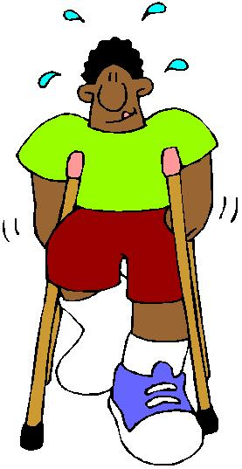  Report all injuries to your teacher. CAUTION – Horseplay or fighting will not be tolerated. The hard surface in the locker room makes for a dangerous situation.  HOLDING LINE  Students must remain in the gym until the passing bell rings at the end of the period. Students who disregard this directive and exit into the commons or the cafeteria will be referred to the Deans office.
Physical Education is a discipline through which students not only learn the skills necessary to perform physical activities successfully, but also understand the importance of those skills and transfer them to other areas of instruction

Through participation in physical education, students learn to establish goals and develop the perseverance needed for high achievement and the confidence needed to pursue excellence. In addition, they learn to perceive and appreciate similarities and differences among individuals and to cooperate and compete fairly.

I can think of no better place to teach students these basic skills than in the Physical Education classroom.

Eduardo Ramirez, Director of Physical Education

