
201 West Holly Avenue
Sterling, VA 20164
School Phone: …………………………...571-434-4520
School Fax #:…………………………….703-444-7492
Absentee Line:…………………………...571-434-4522
http://www.lcps.org/sms

sTERLING
mIDDLE sCHOOL
“Pioneer Pride
Breaking Barriers”
MR. GUS MARTINEZ
(PRINCIPAL)
Email: Gus.Martinez@lcps.org

MR. GUINTHER MRS. BARHAM MRS. CALDERON
ASST. PRINCIPAL ASST. PRINCIPAL DEAN GRADE 8
Joseph.Guinther@lcps.org Elena.Barham@lcps.org Diana.Calderon@lcps.org

MRS. BARKLEY MRS. SEDOR MRS. JOHNSON
GRADE 6 COUNSELOR GRADE 7 COUNSELOR GRADE 8 COUNSELOR
Ashley.Barkley@lcps.org Gina.Sedor@lcps.org Mary.Johnson@lcps.org

MRS. BIEVER MRS. LIVINGSTON MRS. RIGGINS
GRADE 6 SECRETARY GRADE 7 SECRETARY GRADE 8 SECRETARY
Sharon.Biever@lcps.org Sheri.Livingston@lcps.org Jill.Riggins@lcps.org

Main office staff:

Mrs. Bartow Mrs. Bendel
Main Office Secretary Main Office Secretary
Judy.Bartow@lcps.org Dolores.Bendel@lcps.org

Mrs. Colleran Mrs. Welsch
School Nurse Bookkeeper
Jo.Colleran@lcps.org Ronni.Welsch@lcps.org

2014-15 SCHOOL CALENDAR

September 2 FIRST DAY OF SCHOOL FOR STUDENTS
October 13 Holiday (Columbus Day)
October 31 End of First Grading Period
November 3-4 Student Holiday (Planning/Records/Conference Days)
November 26-28 Holiday (Thanksgiving)

December 22-31 WINTER BREAK
January 1 Holiday (New Year’s) (Classes Resume January 5)
January 2 WINTER BREAK
January 19 Holiday (Martin Luther King Jr. Day)
January 23 End of Second Grading Period
January 26 MOVEABLE STUDENT HOLIDAY (Planning/Records)

February 16 Holiday (Presidents’ Day)
March 27 End of Third Grading Period
March 30 April 3 SPRING BREAK

April 6 Student Holiday (Planning/Records/Conference Day)
May 25 Holiday (Memorial Day)
June 16 Last Day of School for Students
End of Fourth Grading Period

Back to School Nights:
6th Grade Students September 17, 2014
7th and 8th Grade Students September 10, 2014

Interim Report Dates:
1st Quarter: October 1 3rd Quarter: February 25
2nd Quarter: December 10 4th Quarter: May 13

Sterling Middle School Goals
Each Student will be expected to be the best student they can be and focused on learning. IN OTHER WORDS. . .
Keep Your Eye On The Prize!
Git R Done!
Just Do It!

Knowledge Is Power!

Si Se Puede!

Success in School
Middle School can be a rewarding experience. Success requires commitment and hard work. Students who are positive, respectful, participate in class, and devote time each day to serious study experience academic success and still find ample time for many other activities.
Sterling Middle School is determined to assist students in realizing success in all aspects of their schoolwork. We stand ready to provide support to any student who is experiencing difficulty. Any student that wishes to seek assistance is advised to:
1-- Arrange special help with a teacher
2--Discuss concerns with their grade level administrator or counselor
3--Review concerns with the school administration

Invitation to Parents
Sterling Middle School is proud of our students and faculty, and we are fully aware that we could not effectively educate your children without your support. Therefore, we encourage parents to visit school and participate in the many class activities and programs during the school year. We also encourage parents to become involved with the PTSA. If you just wish provide feedback or voice a concern, please call the school. At Sterling we value the interests and concerns of parents and look forward to working with you to provide a quality education for our children.

Homework Requests
The school will provide homework assignments to students who have been absent 2 or more days. Please be aware that compiling make-up work will be completed within 48 hours of the request and you will need to come to the school to pick up the work.

IT IS THE STUDENT’S RESPONSIBILITY to check with each teacher after an absence to determine what assignments have been missed. Students will be given a reasonable amount of time to complete the work. For the convenience of both students and parents, all assignments will be posted on the school’s website under individual teacher names. In addition, parents are encouraged to monitor their child’s progress through the parent portal of CLARITY.

Change of Address or Phone Number
Please notify the school if you have a change of address or telephone number. A telephone number can be changed by calling or emailing the school. However, to change your address you need to come to the school and bring proof of residency. It is important that office personnel have correct contact information for you at all times.

Library
The library will be open to students Monday–Friday from 8 a.m. to 3:30 p.m. Students can sign up for lunch passes in the cafeteria at lunch time. From class, you must have an agenda pass from your teacher and sign in at the checkout desk. All library materials must be checked out before being removed from the library. Items are checked out for a period of two weeks and may be renewed for an additional two weeks. Fees apply for lost or damaged books.

Clinic
A school nurse is on duty in the clinic each day. A student must have a pass from the classroom teacher and must sign out in the house office before going to the clinic. The school nurse will contact the parent or guardian when necessary. Students who are sick should be picked up immediately after the nurse calls the parent. Students who are sick MUST report to the clinic to be evaluated. They SHOULD NOT call or text their parents to come pick them up themselves.

PARENTS MUST BRING IN AND TURN IN THE MEDICATION (PRESCRIPTION AND OVER THE COUNTER) FORM to the nurse. Medication should be BROUGHT IN THE ORIGINAL CONTAINER with directions for dosage, name of drug, and the name of the doctor.

EXPECTATIONS

Dress Code
The primary responsibility for the proper dress and grooming of students rests with the parent or guardian of each student. Appropriate good grooming standards should be used when dressing for school. All students are expected to dress appropriately for a K-12 educational environment.
Any clothing that interferes with or disrupts the educational environment is unacceptable. Clothing with language or images that are vulgar, lewd, discriminatory, or obscene, or clothing that promotes illegal or violent conduct, the unlawful use of weapons, drugs, alcohol, tobacco, or drug paraphernalia, or clothing that contains threats is prohibited.
Clothing should fit, be neat and clean, and conform to standards of safety, good taste, and decency. Clothing that exposes cleavage, private parts, the midriff, or undergarments, or that is otherwise sexually provocative, is prohibited. Examples of prohibited clothing include, but are not limited to: sagging or low-cut pants, low-cut necklines that show cleavage, tube tops, halter tops, backless blouses or blouses with only ties in the back, studded belts, chain belts, clothing constructed of see-through materials, and head coverings unless required for religious or medical purposes.
Parents or guardians of students requiring accommodation for religious beliefs, disabilities, or other good causes should contact the principal.
Students not complying with this code will be asked to cover the noncomplying clothing, or change clothes. Repeated infractions will result in disciplinary action.

School Bus Safety
All students who ride buses to and from school and on field trips must observe bus safety rules. These rules will be reviewed by the deans and discussed by bus drivers. Strict compliance with these rules will help avoid accidents. Failure to adhere to these rules could result in loss of privileges that include removal from the bus. It is also important that a student ride the bus that they have been assigned to ride by the department of transportation. A student who may be riding a different bus for a single day should bring in a parent note and obtain a bus pass in the main office before 8:45 AM.

Student Conduct
Each student will be expected to:
- Demonstrate respect for themselves, peers and staff
- Attend each class and be in the scheduled area at all times
- Come prepared for class with appropriate materials
- Walk while in the building
- Respond appropriately in class and avoid disruptive behavior
- Accept the consequences of misbehavior
- Avoid any activity that endangers the safety of others
- Avoid verbal and physical confrontations with others
- Refrain from selling any items in school unless approved
- Follow the same rules traveling to and from school that are followed in
school
Each student is prohibited from:
- Possession of laser pens/pointers and shocking devices while on any LCPS property
- Operating cell phones or other personal communication devices while on the grounds of Sterling Middle School during school hours UNLESS there is a signed permission to use as part of instruction
- Bullying or harassing any other student
- Possession of any weapon or fireworks
- Possession, use or distribution of drugs, “Look Alike” drugs, or any item purported to be a drug which includes tobacco and alcohol.

Students should conduct themselves in a manner that will make school a better place for everyone. The items listed above are not an inclusive listing but are intended to serve as a general guide for student behavior.

Weapons
No student shall possess any weapon for any reason while under school control or supervision. The term weapon is intended to be construed broadly to cover and include any instrument that could injure, harm, or endanger the physical well being of another person.
If a student inadvertently brings a weapon to school they cannot be in violation of the weapon policy by using “Safe Harbor”. This is defined below.
Safe Harbor
The following shall not constitute a violation of this policy:
(a) The accidental or inadvertent possession of a weapon by such student if the student accidentally or inadvertently brought the weapon onto school property or to a school-sponsored activity, provided the student immediately reports the same to a teacher or administrator upon discovery thereof by such student and before it is discovered or seen by a teacher, administrator, or other school employee or by another student; or
(b) The possession of a weapon by a student if such weapon was found on school property or at a school-sponsored activity by such student, provided the student immediately reports the same to a teacher or administrator and before such weapon is discovered or seen by a teacher, administrator, or other school employee or by another student.

Disciplinary Action
The overwhelming majority of students are good school citizens and require little or no formal discipline. When necessary, action to maintain order and provide for the safety and security of staff and students will be taken. Various forms of disciplinary action are utilized by the school administration. These include detention (lunch and after-school), in-school restriction, exclusion from extracurricular activities, removal from class, suspension from school, transfer to another school, and legal prosecution.

ATTENDANCE

Daily
Students are expected to be in attendance every day for the entire school year. Parents are encouraged to arrange appointments, trips, or other activities so their children do not miss learning time. Absences other than illness, death in the family, medical appointments, court appearances, or religious holidays, must be approved IN ADVANCE by the school administration.

Student Absences
Regular attendance is an important part of a student’s school record. Parents are required to provide the school with an explanation for each student absence. Parents are requested to call the Pioneer Hotline at 571-434-4522 to report a student’s absence from school. This program is available to parents from 4:00PM to 8:30AM during the school week and 24 hours a day on the weekends.
Designated school personnel will make telephone checks of students on the daily absentee list. If no contact has been made a written excuse must accompany the student upon return to school. It is both a state and county requirement that the school verify absences. We ask parents for cooperation in implementing this policy.

Early Dismissal
Students desiring early dismissal from school should bring a written request, signed by a parent or guardian, stating time and reason for dismissal to the House Office. PARENTS PICKING UP THEIR CHILDREN FOR AN EARLY DISMISSAL MUST COME INTO THE OFFICE AND SIGN OUT THEIR CHILD.

Emergency School Closing:
The Superintendent may close schools when conditions exist which endanger the safety of students and teachers. When school is canceled, it is announced over the telephone, radio, and TV stations. Announcements will be made each day schools are closed. If there is no announcement, it shall be presumed that schools will operate as usual.
In the event that weather necessitates the closing of schools after it is in session, announcements will be made over the same stations. Parents who work outside the home can help by making prior arrangements for their child. Parents should make sure their child knows of these arrangements. HAVE A PLAN!

Arrivals, Activities, Departures:
The school building will be open at 8:00 AM, students must be in class with all learning materials by 8:30 AM. Students may only enter the building from the front of the building and then report to their class. Students who arrive late to school must report to their House Office to be marked present on the attendance record. Students are dismissed for the day at 3:18 PM. If parents need to pick up their child before dismissal, please call ahead and arrive before 3:05 PM.
Students who remain in the building for a school sponsored activity after school must have written permission from a parent. Post-school activities are terminated at 4:25 PM (unless otherwise indicated). Parents should pick up students by 4:30 PM but NO LATER than 4:45 PM. If parents are habitually late, students will not be allowed the privilege to participate in after-school activities.
Students not involved in a post-school activity must leave the building by 3:25 PM and are expected to report directly home. Students are to cross the boulevard to the shopping center only at the traffic light or at a designated crossing area south of the school. This is a busy street and everyone must be careful.
Parents picking up students at dismissal should do so at the student pick-up area at the front of the building

Bus Passes:
Guest bus passes are given out in the Main Office in the morning before the start of classes. Written permission signed by parent/guardian must be submitted by 8:45AM. Bus passes will not be issued without written permission.
Notes brought to our attention at the end of the school day will not be honored because it does not allow time for school personnel to verify and call parents about the change in routine.
PBIS AT STERLING MIDDLE
To be successful, students must learn to manage their behavior. They often need help from the adults around them in order to learn and consistently demonstrate appropriate behavior. The entire staff at Sterling Middle School is committed to helping each student be successful in school. For that reason, the staff at Sterling Middle has implemented the Positive Behavior Intervention Support model (PBIS) to our school. Below is a matrix of the behaviors we want every student to focus on.

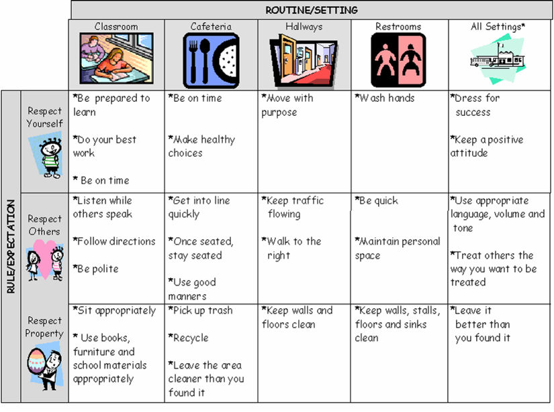

MISCELLANEOUS

Physical Education
All students are expected to “dress out” and participate in physical education. A standard gym uniform is available to all students at the beginning of the year for a fee. Students may also wear a shirt and shorts that are appropriate for PE, however, these clothes must not be the same clothes they wore to school that day. In addition to appropriate attire, students are responsible for having white socks and tennis shoes. Students may be excused from participation in P.E. with a note from a doctor. A note from home will only excuse a student from participation, not dressing. Notes from home are valid for three instructional blocks.

Lockers
Students are provided with hall and gym lockers by the school for the purpose of storing their clothing, books, lunches and other materials. Students should not share lockers or give their locker combinations to others. Students are permitted to go to their lockers before school, between instructional blocks, at the end of the day, and at the discretion of the dean or teacher.

