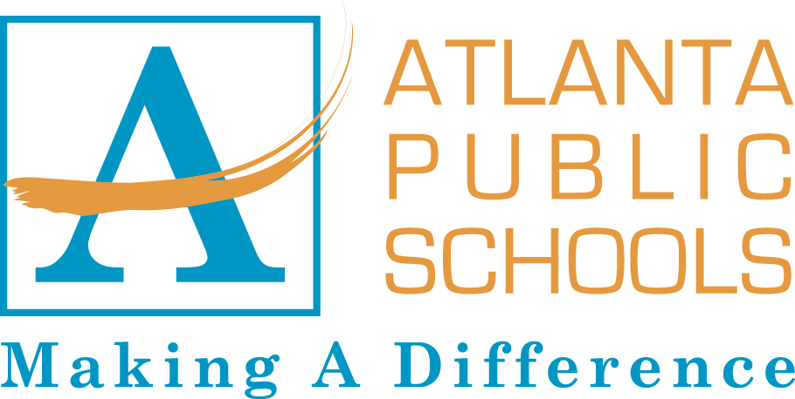
Science Curriculum: Grade 7 - Life Science
Georgia Performance Standards: Year Curriculum Map

This document is part of a framework that is designed to support the major concepts addressed in the Seventh Grade Science Curriculum of the Georgia Performance Standards.. Each unit integrates laboratory experiences and field work using the process of inquiry. NOTE: There are several strategies that are common throughout the units such as the use of a laboratory notebook, written laboratory reports, and common teaching strategies. Keeping in mind that the standards are recursive in nature, it should be noted that many of the standards are revisited in different units throughout the year.
UNIT I |  |  | UNIT II | UNIT III |  | UNIT IV |  | UNIT V
Ia |  | Ib |  | IIIa | IIIb | IVa | IVb
Structure and Function of Cells |  | Tissues, Organs, and Organ Systems | Genetics and Heredity | Organization of Life | Evidence of Evolution | Ecology Part 1  Interdependence of Life | Ecology Part 2 Interdependence of Life | Culminating Activities
S7L2 |  |  | S7L3 | S7L1 | S7L5 | S7L4 | S7L4
4 Weeks | 4 Weeks |  | 5 Weeks | 4 Weeks | 4 Weeks | 5 Weeks | 4 Weeks | 5 Weeks
Focus:  In this unit students will investigate organisms’ organization from basic to complex. | Focus:  In this unit students will investigate organisms’ organization from basic to complex. Students will investigate processes associated with systems that function in the acquisition and utilization of energy e.g. digestion and respiration, and excretion. |  | Focus:  In this unit students will examine biological traits and heredity. Students will explore the roles that genes and chromosomes have in how traits are passed through generations by sexual or asexual reproduction in organisms, how selective breeding can be used to produce desired traits in plants and animals. | Focus:  In this unit students will investigate organisms’ organization from basic to complex. Students will examine system processes through a comparative study of the six kingdoms of life. | Focus:  In this unit students will examine the evolution of living organisms through inherited characteristics and natural selection. Students will investigate the survival of organisms and their successive generations as related to their inherited characteristics and adaptation and use of the fossil records. | Focus:  In this unit students will explore the sun as the primary source of energy, and will understand that organisms depend on one another as well as their environment for survival. Students will use and create a food web to demonstrate that matter and energy is transferred and recycled among organisms and their environment. | Focus:  In this unit students will identify organisms in biomes and aquatic communities. Feeding and symbiotic relationships and human and environmental conditions are also part of this unit. | Focus:  Students will complete problem-based activities using concepts learned in Quarters 1-3.
*Note: Beginning of the Year - Unit 0: Getting Ready for Science = 1 Week End of the Year - Unit V: Culminating Essential Lab = 5 weeks
Updated Working Draft
06/30/11

