PERFORMANCE ASSESSMENT TASK
Grade 7

UNIT II: Reconstruction- Extending Citizenship to Freedmen

STANDARDS: CE.2d, CE.3a, b; USII.3a, b; USII.4c

ENDURING UNDERSTANDING: Amendments and laws can be passed to protect the rights of the people, but attitudes cannot be legislated.

CONCEPTUAL UNIT QUESTION: Was Reconstruction a success?

SCENARIO: You are a reporter for The Washington Bee, the main newspaper in Washington, D.C. You have just heard Frederick Douglass, an abolitionist and African-American leader, speak on the Twenty-Fourth Anniversary of Emancipation in the District of Columbia, on April 16, 1886. In his speech, Douglass argues that although slavery has been abolished for more than 20 years, much remains to be done to ensure equal rights for African Americans in the United States. Since you heard the speech and have been covering African American issues for the paper, your editors have asked you to write a response to Douglass’ speech. Do you agree with him? Has Reconstruction been a failure? Or does the evidence persuade you that it has been a success?
TASK: You will collect information from the documents provided to
- identify and explain Frederick Douglass’ opinion about Reconstruction.
- identify the positive and negative outcomes of Reconstruction.
- interpret different viewpoints on Reconstruction.
- develop a written argument (editorial) that supports your point of view and persuades others of the accuracy of your point of view.
- give evidence of the arguments/outcomes that support your point of view.

DOCUMENTS: Use each of the documents provided to research information on your task. Use the DOCUMENTS GRAPHIC ORGANIZER to organize your information. Include and cite evidence from at least 3 of the documents in your product.
Document A: excerpt from Frederick Douglass Speech on 24th Anniversary of
Emancipation in the District of Columbia
Document B: Reconstruction timeline, teacher-created
Document C: Heroes of the Colored Race, portraits of Blanche Kelso Bruce,
Frederick Douglass, and Hiram Revels
Document D: The First Vote, illustration in Harper’s Weekly
Document E: First African American Senators and Representatives illustration
Document F: Worse Than Slavery illustration and editorial from Harper’s
Weekly

PRODUCT: Your editorial should include
- a position that either supports or opposes Douglass’ claim that Reconstruction was a failure.
- at least 3 reasons that support your opinion.
- evidence from at least 3 documents included in the task.
- related content vocabulary.
- mechanics and spelling that are accurate.

REFLECTION: Think about life in the United States today. Do you think Frederick Douglass would be pleased with the civil rights progress that has been made since his speech, or would he feel that there is still progress to make? Write a 3-5 sentence paragraph explaining your ideas.

PAT RUBRIC: Newspaper Editorial Responding to Frederick Douglass Speech about the Failures of Reconstruction
Category | 4 Exceeds Expectations | 3 Meets Expectations | 2 Approaching Expectations | 1 Below Expectations | Score
Content | Demonstrates thorough and accurate understanding of the successes and failures of Reconstruction. | Demonstrates a complete and accurate understanding of the successes and failures of Reconstruction. | Demonstrates an incomplete understanding of the successes and failures of Reconstruction. | Demonstrates inaccuracies and misconceptions about the successes and failures of Reconstruction.
Basic Skills | Identifies and thoroughly describes specific positive and negative outcomes of Reconstruction without error. | Identifies and describes specific positive and negative outcomes of Reconstruction, without significant error. | Demonstrates a number of errors when describing specific positive and negative outcomes of Reconstruction but can complete a basic identification of them. | Demonstrates many critical errors when identifying and describing specific positive and negative outcomes of Reconstruction.
Analysis/Interpretation  Skills | Examines thoroughly all of the given documents.  Analyzes and evaluates information from the documents to make meaningful conclusions about the positive and negative outcomes of Reconstruction. | Examines several of the given documents.  Makes a credible effort to analyze and evaluate information from some of the documents to make meaningful conclusions about the positive and negative outcomes of Reconstruction. | Examines some of the given documents.  Makes little effort to analyze and/or evaluate information.  Makes weak or irrelevant conclusions about the positive and negative outcomes of Reconstruction. | Gives no evidence that given documents were examined.  Fails to analyze and evaluate information to make any conclusions about the positive and negative outcomes of Reconstruction.
Application/Synthesis  Skills | Cites and elaborates on evidence from at least three of the given documents to develop an in-depth position on the accuracy of Douglass’ argument that Reconstruction was a failure. | Cites some evidence from 1-2 of the given documents to identify a position on the accuracy of Douglass’ argument that Reconstruction was a failure. | Cites little evidence from the given documents and/or merely restates information.  Does not construct a position on the accuracy of Douglass’ argument that Reconstruction was a failure. | Cites no evidence from the given documents.  Does not construct a position on the accuracy of Douglass’ argument that Reconstruction was a failure.
Communication Skills | Product is well organized with clearly stated, complex ideas supported by citations from the documents.  Editorial effectively conveys the message. | Product is somewhat organized with clearly stated basic ideas supported by citations from the documents.  Editorial adequately conveys the message. | Product is poorly organized. Unclear ideas are weakly supported by the documents.  Editorial poorly conveys the message. | Product is unorganized with irrelevant statements and no document citations.  Editorial fails to convey the message.

Document A
Page Glossary
Barbarism: cruel & offensive ideas or actions
The occasion: the day it happened
Emancipating: setting slaves free
Enfranchising: giving the right to vote to a group of people
Unfulfilled: not complete
Twilight: the dawn (the start)
Ballot: the vote
Accused: a person who people think may have broken the law
assistance of counsel: help of a lawyer
convicted: proven guilty of a crime
alleged: suggested but not proven
lynching: a hate-crime murder/hanging of someone (usually innocent), often done by a group of people instead of having a court trial
presumed: assumed

Southern Barbarism Speech on the occasion of the Twenty-Fourth Anniversary of Emancipation in the District of Columbia, Washington, D.C., April 16, 1886
By Frederick Douglass

... Fellow-citizens, while I [thank] the Republican party [for] emancipating and enfranchising the colored people of the United States, I do not forget that the work of that party is most sadly incomplete. We are yet, as a people, only half free. The promise of liberty remains unfulfilled. We stand to-day only in the twilight of American liberty. The sunbeams of perfect day are still behind the mountains, and the mission of the Republican party will not be ended until the persons, the property, and the ballot of the colored man, shall be as well protected in every State of the American Union as are such rights in the case of the white man.

[The American tradition of "due process of law" is designed to protect a person accused of a crime. This tradition means that the] accused shall be brought face to face with his accusers; that he shall be allowed to call witnesses in his defence, and that he shall have the assistance of counsel; it means that [no] harm shall come to him [until] he is fairly tried, convicted [by a jury of his peers, and sentenced by an impartial judge]. This protection is given to the [worst] white criminal in the land. [But] to the colored man accused of crime in the Southern States, a different rule is almost everywhere applied. With him, to be accused is to be convicted. The court in which he is tried is a lynching mob. This mob takes the place of "due process of law," of judge, jury, witness, and counsel. [The mob] does not come to [judge him; they come] to hang, shoot, stab, burn, or whip him to death. Neither courts, jails, nor marshals are allowed to protect him. … We are presumed to be guilty until we are proved to be innocent. ……….
Document A cont.
Page Glossary

denied : not given
poverty: being poor
prevails: wins
conspiracy : a secret plan against someone
oppress: to hurt
Landlord system: refers to the sharecropping system
wretchedness: dirt & poverty
forbidding: not allowing; banning
the old master class: this means white landowners
suppress: keep down, prevent
Insurrections: revolts
enforce: protect
guaranteed: promised
despised: hated

The American people have this lesson to learn: That where justice is denied, where poverty is enforced, where ignorance prevails, and where [people feel] that society is an organized conspiracy to oppress [them], neither persons nor property will be safe.

The (situation) of the Negro since leaving slavery has not been much of an improvement [compared to what he had as a slave]. Individuals of the race have here and there enjoyed large benefits from emancipation … but [most] have had their liberty [tied to] hardships which tend strongly to keep them [oppressed].

In the Southern States to-day a landlord system is in operation which keeps the Negroes [in] rags and wretchedness, almost to the point of starvation. As a rule, this system [prevents] the Negro [from owning] land. There is, to be sure, no law forbidding the selling of land to the colored people, but there is an understanding which has the full effect of law. That understanding is that the land must be kept in the hands of the old master class. The colored people can rent land, it is true, and many of them do rent many acres, and find themselves poorer at the end of the year than at the beginning, because they are charged more a year for rent [than the land is worth].
… If in the days of slavery the army could be used to hunt slaves, and suppress slave insurrections, why, in the days of liberty, may it not be used to enforce rights guaranteed by the Constitution? Alas! fellow-citizens, there is no right so neglected as the Negro's right. There is no flesh so despised as the Negro's flesh. There is no blood so cheap as the Negro's blood. …”
Text adapted from Douglass, Frederick. “Southern Barbarism Speech on the occasion of the Twenty-Fourth Anniversary of Emancipation in the District of Columbia, Washington, D.C., April 16, 1886.” The Frederick Douglass Papers at the Library of Congress. <http://memory.loc.gov/cgi-bin/ampage?collId=mfd&fileName=24/24014/24014page.db&recNum=41&itemLink=/ammem/doughtml/dougFolder5.html&linkText=7>
Document B
RECONSTRUCTION TIMELINE
When? | What happened?
1865 | The 13th Amendment abolished slavery.
 | The Freedmen’s Bureau was set up to help newly freed slaves and other war refugees in the South learn to read, find jobs and resolve conflicts.
 | Southern state governments passed Black Codes, which limited the rights of freedmen, restricted their job opportunities, and prevented them from voting, serving on juries and owning guns.
1866 | The 14th Amendment said former slaves (and all people born in the United States) were citizens with civil rights, entitled to equal protection under the law.
1867 | Reconstruction Act of 1867 removed many southern state governments and imposed military rule. The military helped register African Americans to vote.
 | Sharecropping became a way of life, as freedmen and poor whites went to work as farm laborers in exchange for a share of the crops they produced. Many sharecroppers were never able to earn enough money to get out of debt.
1868 | 15th Amendment guaranteed black men the right to vote.
 | New state constitutions were written, new state governments were formed, and many African Americans served as mayors, sheriffs, state legislators, and judges and as U.S. Senators and Representatives.
 | The Ku Klux Klan and other secret societies were formed to terrorize African Americans and prevent them from exercising their rights.
1877 | Rutherford B. Hayes was elected President and agreed to withdraw troops from the South, ending Reconstruction.
 | With the official end of Reconstruction, African Americans lost rights as new southern state governments passed laws such as grandfather clauses, poll taxes, and literacy tests to prevent them from voting. They also passed Jim Crow Laws, which required segregation in all areas of public life.

Document C
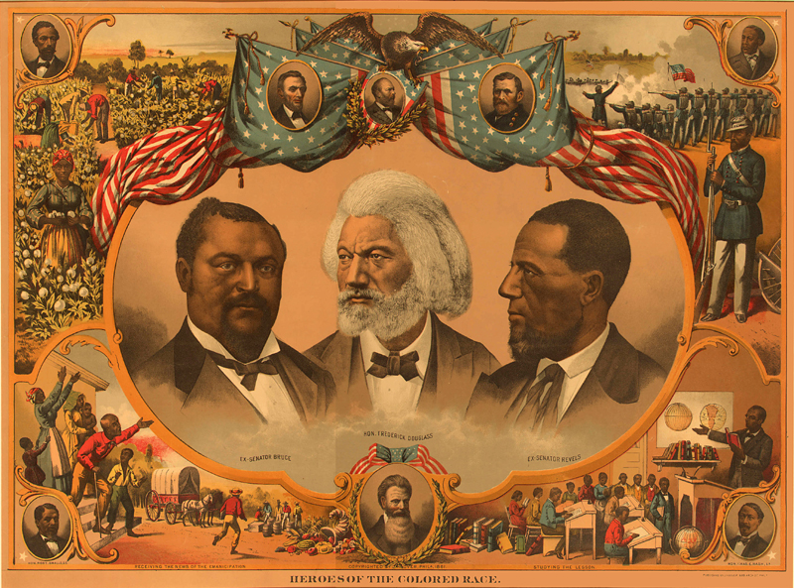
Heroes of the Colored Race, Philadelphia, 1881. Color lithograph with portraits of Blanche Kelso Bruce, Frederick Douglass, and Hiram Revels.

“The only two African Americans to serve as United States Senators in the nineteenth century were Blanche K. Bruce and Hiram Revels, both of Mississippi. Frederick Douglass was appointed to several important governmental positions in the years after the Civil War, including Minister Resident and Counsel General to Haiti, Recorder of Deeds, and U. S. Marshall.”
C-1

Description from African American Odyssey: Reconstruction and Its Aftermath Exhibit at the Library of Congress, http://lcweb2.loc.gov/ammem/aaohtml/exhibit/aointro.html

J. Hoover. Heroes of the Colored Race. Philadelphia, 1881. Color lithograph with portraits of Blanche Kelso Bruce, Frederick Douglass, and Hiram Revels. Library of Congress: Prints and Photographs Division. Reproduction Number: LC-USZC2-10180 (5-7) http://lcweb2.loc.gov/ammem/aaohtml/exhibit/aopart5b.html

Document D
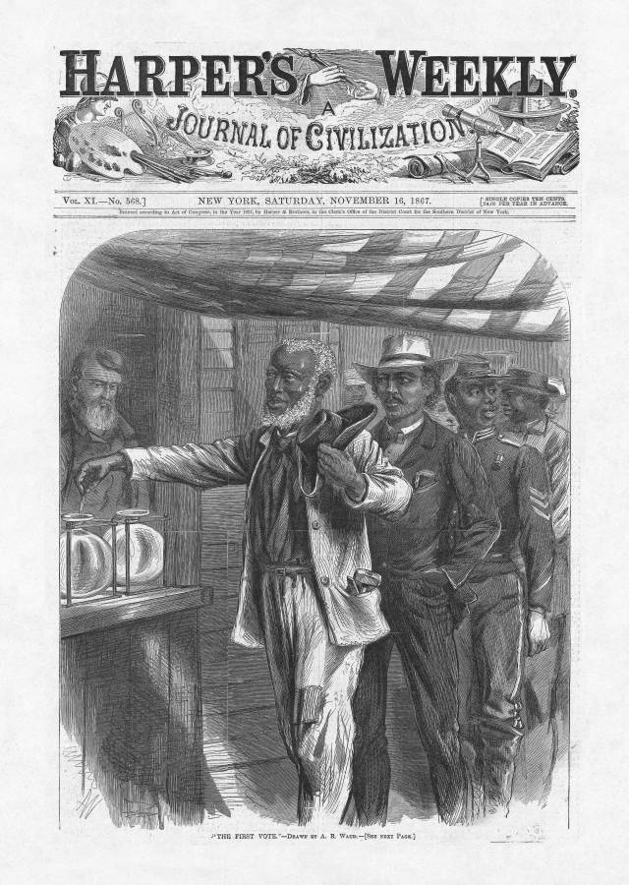

THINK ABOUT:

Who is watching the African Americans vote?

Will that affect the decision on who to vote for?

“The First Vote” November 16, 1867, by A.R. Waud, in Harper’s Weekly
Alfred R. Waud. "The First Vote." From Harper's Weekly, November 16, 1867. Copyprint. Prints and Photographs Division. Reproduction Number: LC-USZ62-19234 (5-21) http://lcweb2.loc.gov/ammem/aaohtml/exhibit/aopart5b.html

Document E
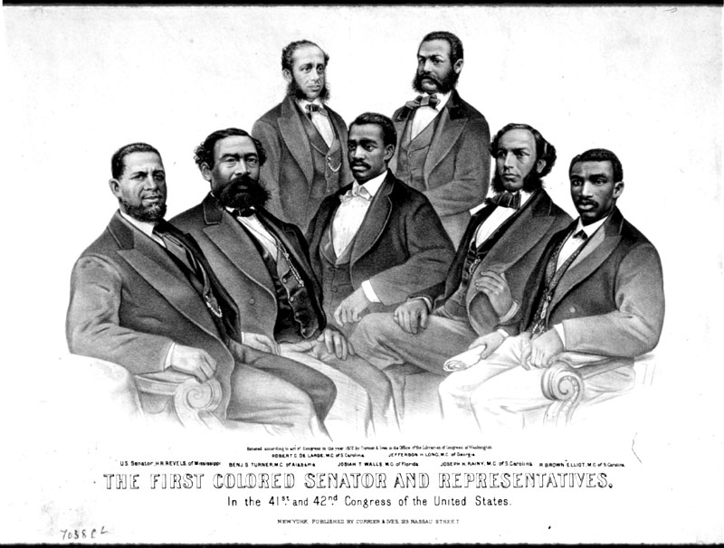

The First Colored Senator and Representatives, in the 41st and 42nd Congress of the United States.1872. (Left to right) Senator Hiram Revels of Mississippi, Representatives Benjamin Turner of Alabama, Robert DeLarge of South Carolina, Josiah Walls of Florida, Jefferson Long of Georgia, Joseph Rainey and Robert B. Elliot of South Carolina.

Currier and Ives. The First Colored Senator and Representatives, in the 41st and 42nd Congress of the United States.1872. Prints and Photographs Division. Reproduction Number: LC-USZC2-2325, LC-USZ62-2814 (5-6) http://lcweb2.loc.gov/ammem/aaohtml/exhibit/aopart5b.html

Document E cont.

The Fifteenth Amendment to the U.S. Constitution gave the vote to all male citizens regardless of color or [whether or not they had been a slave in the past]. African Americans became involved in the political process not only as voters but also as governmental representatives at the local, state and national level. Although their elections were often [challenged] by whites, and members of the legislative bodies were usually [unwilling] to receive them, many African American men ably served their country during Reconstruction.

Pictured here are (Left to right) Senator Hiram Revels of Mississippi, Representatives Benjamin Turner of Alabama, Robert DeLarge of South Carolina, Josiah Walls of Florida, Jefferson Long of Georgia, Joseph Rainey and Robert B. Elliot of South Carolina.

Text adapted from Description found at African American Odyssey: Reconstruction and Its Aftermath Exhibit at the Library of Congress, http://lcweb2.loc.gov/ammem/aaohtml/exhibit/aointro.html

Document F
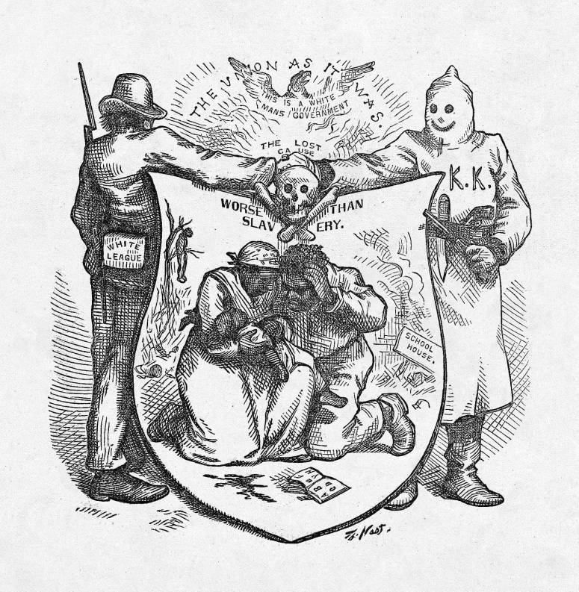

Worse Than Slavery, by Thomas Nast, from Harper’s Weekly

Nast, Thomas. Worse than slavery.” Harper’s Weekly, October 24, 1874, p. 878 (Illustration and News Story).
http://blackhistory.harpweek.com/4Reconstruction/ReconLevelOne.htm

Document F cont.
Document Glossary

maddened with whisky: drunk & angry
demoniac passions: doing the work of the devil; violence
perpetrate unheard-of enormities: commit outrageous crimes
denounce: speak out against
Ku Klux Klan: a hate-group which used violence & political power to oppress African Americans
ruffians: bullies, lawbreakers
roused to a proper indignation: angered by something unfair or unjust
marked in this way: boycotted by prejudiced whites
White Leaguers: supporters of the KKK
unimpeded: no stopped or slowed by

WORSE THAN SLAVERY … A band of wild and desperate young men, maddened with whisky and torn by demoniac passions, is the governing power in Texas and Alabama, Georgia, and even Kentucky. Masked, armed, and supplied with horses and money by the Democratic candidates for office, they ride over the country at midnight, and perpetrate unheard-of enormities. [They] rob, they murder, they whip, they intimidate; yet no man, white or black, dares to denounce them. If a colored man [tries to tell others what he saw the KKK do] he is himself dragged from the prison where he had been placed for safety and slaughtered, as happened recently in Tennessee. [In] Alabama and Louisiana the bands of young ruffians patrol the country by day as well as night, shooting down Republican voters. … Nor does any Southern paper in Georgia, or Alabama, or Texas, and scarcely in Tennessee, [even] denounce the murderers or the violators of the laws; or if any Northern [newspaper or magazine writes about these crimes and calls for justice, they are quickly threatened by supporters of the KKK]. Such journals (exclaims the Austin Daily Statesman) "are more to be hated than the rattlesnake." Harper’s Weekly has been especially marked in this way, and its sale is forbidden [in] Austin [Texas]. The White Leaguers are resolved that the power of a free press shall never be felt in the South, and hope to pursue their career of crime unimpeded by the voice of humanity or reason.

Text adapted from Nast, Thomas. Worse than slavery.” Harper’s Weekly, October 24, 1874, p. 878 (Illustration and News Story).
http://blackhistory.harpweek.com/4Reconstruction/ReconLevelOne.htm
PAT DOCUMENT ORGANIZER: Reconstruction- Extending Citizenship to Freedmen
Evidence Chart | Task Skill:  Identify and explain Douglass’ opinion about Reconstruction. | Task Skill:  Identify positive and negative outcomes of Reconstruction. | Task Skill:  Agree or Disagree with Douglass’ view.  (Circle)
Document A
Excerpt from Frederick Douglass’ speech on the 24th Anniversary of Emancipation in Washington, DC
Document B  Reconstruction Timeline |  |  | AGREE DISAGREE  BOTH
Document C  Heroes of the Colored Race illustration |  |  | AGREE DISAGREE  BOTH
Document D  “The First Vote” illustration |  |  | AGREE DISAGREE  BOTH
Document E  “First African American Senators and Representatives” illustration |  |  | AGREE DISAGREE  BOTH
Document F  “Worse Than Slavery illustration” and News Story |  |  | AGREE DISAGREE  BOTH

PAT TASK CHECKLIST
Reconstruction Editorial

UNIT II: Reconstruction- Extending Citizenship to Freedmen

DECISION: After I review the documents, I will write an editorial responding to Frederick Douglass’ argument that Reconstruction was a failure in his 1874 speech. I will try to convince readers that:

(Choose one)
- Reconstruction WAS a success (I disagree with Douglass).
- Reconstruction WAS NOT a success (I agree with Douglass).
- Reconstruction WAS BOTH a success and a failure. (I both agree and disagree with Douglass).

PRODUCT: Newspaper Editorial

PRODUCT CHECKLIST:
- I have reviewed the documents and images for this task.
- I have filled out the graphic organizer, gathering information from
the documents.
- My product has strong details supporting my opinion of
Reconstruction.
- My product includes some content-related vocabulary.
- My written product includes an introduction, body, and conclusion.
- My product is in final form and reflects my best effort.
Writing Your Reconstruction Editorial:

Introduction:
- Answer the Question! Do you agree with Frederick Douglass? Was Reconstruction a failure?
- Support your opinion! Briefly list three reasons to support your opinion.
- Aim for 3-5 clear, persuasive sentences.

Reason/Supporting
Evidence #1:

- Identify and describe your first reason.
- Be sure to refer to the documents.
- Aim for 3-5 sentences.
Reason/Supporting
Evidence #2:

- Identify and describe your first reason.
- Be sure to refer to the documents.
- Aim for 3-5 sentences.

Reason/Supporting
Evidence #3:

- Identify and describe your first reason.
- Be sure to refer to the documents.
- Aim for 3-5 sentences.

Conclusion:
- Restate your answer. Use persuasive language.
- Restate your three reasons, briefly.
- End with a concluding sentence that sums up your opinion based on the documents and what you have learned!
- Aim for 3-5 sentences.

Writing Your Reconstruction Editorial:

Introduction:

Reason/Supporting
Evidence #1:

Reason/Supporting
Evidence #2:

Reason/Supporting
Evidence #3:

Conclusion:

PAT Score Form

Teacher: Unit #: Date: ____________________

Student Name | Content |  |  |  | Basics |  |  |  | Analysis |  |  |  | Application |  |  |  | Communication |  |  |  | Total
Student Name | 4 | 3 | 2 | 1 | 4 | 3 | 2 | 1 | 4 | 3 | 2 | 1 | 4 | 3 | 2 | 1 | 4 | 3 | 2 | 1 | Total

