Berkshire Middle School
Seventh Grade Course Catalog
2022-2023
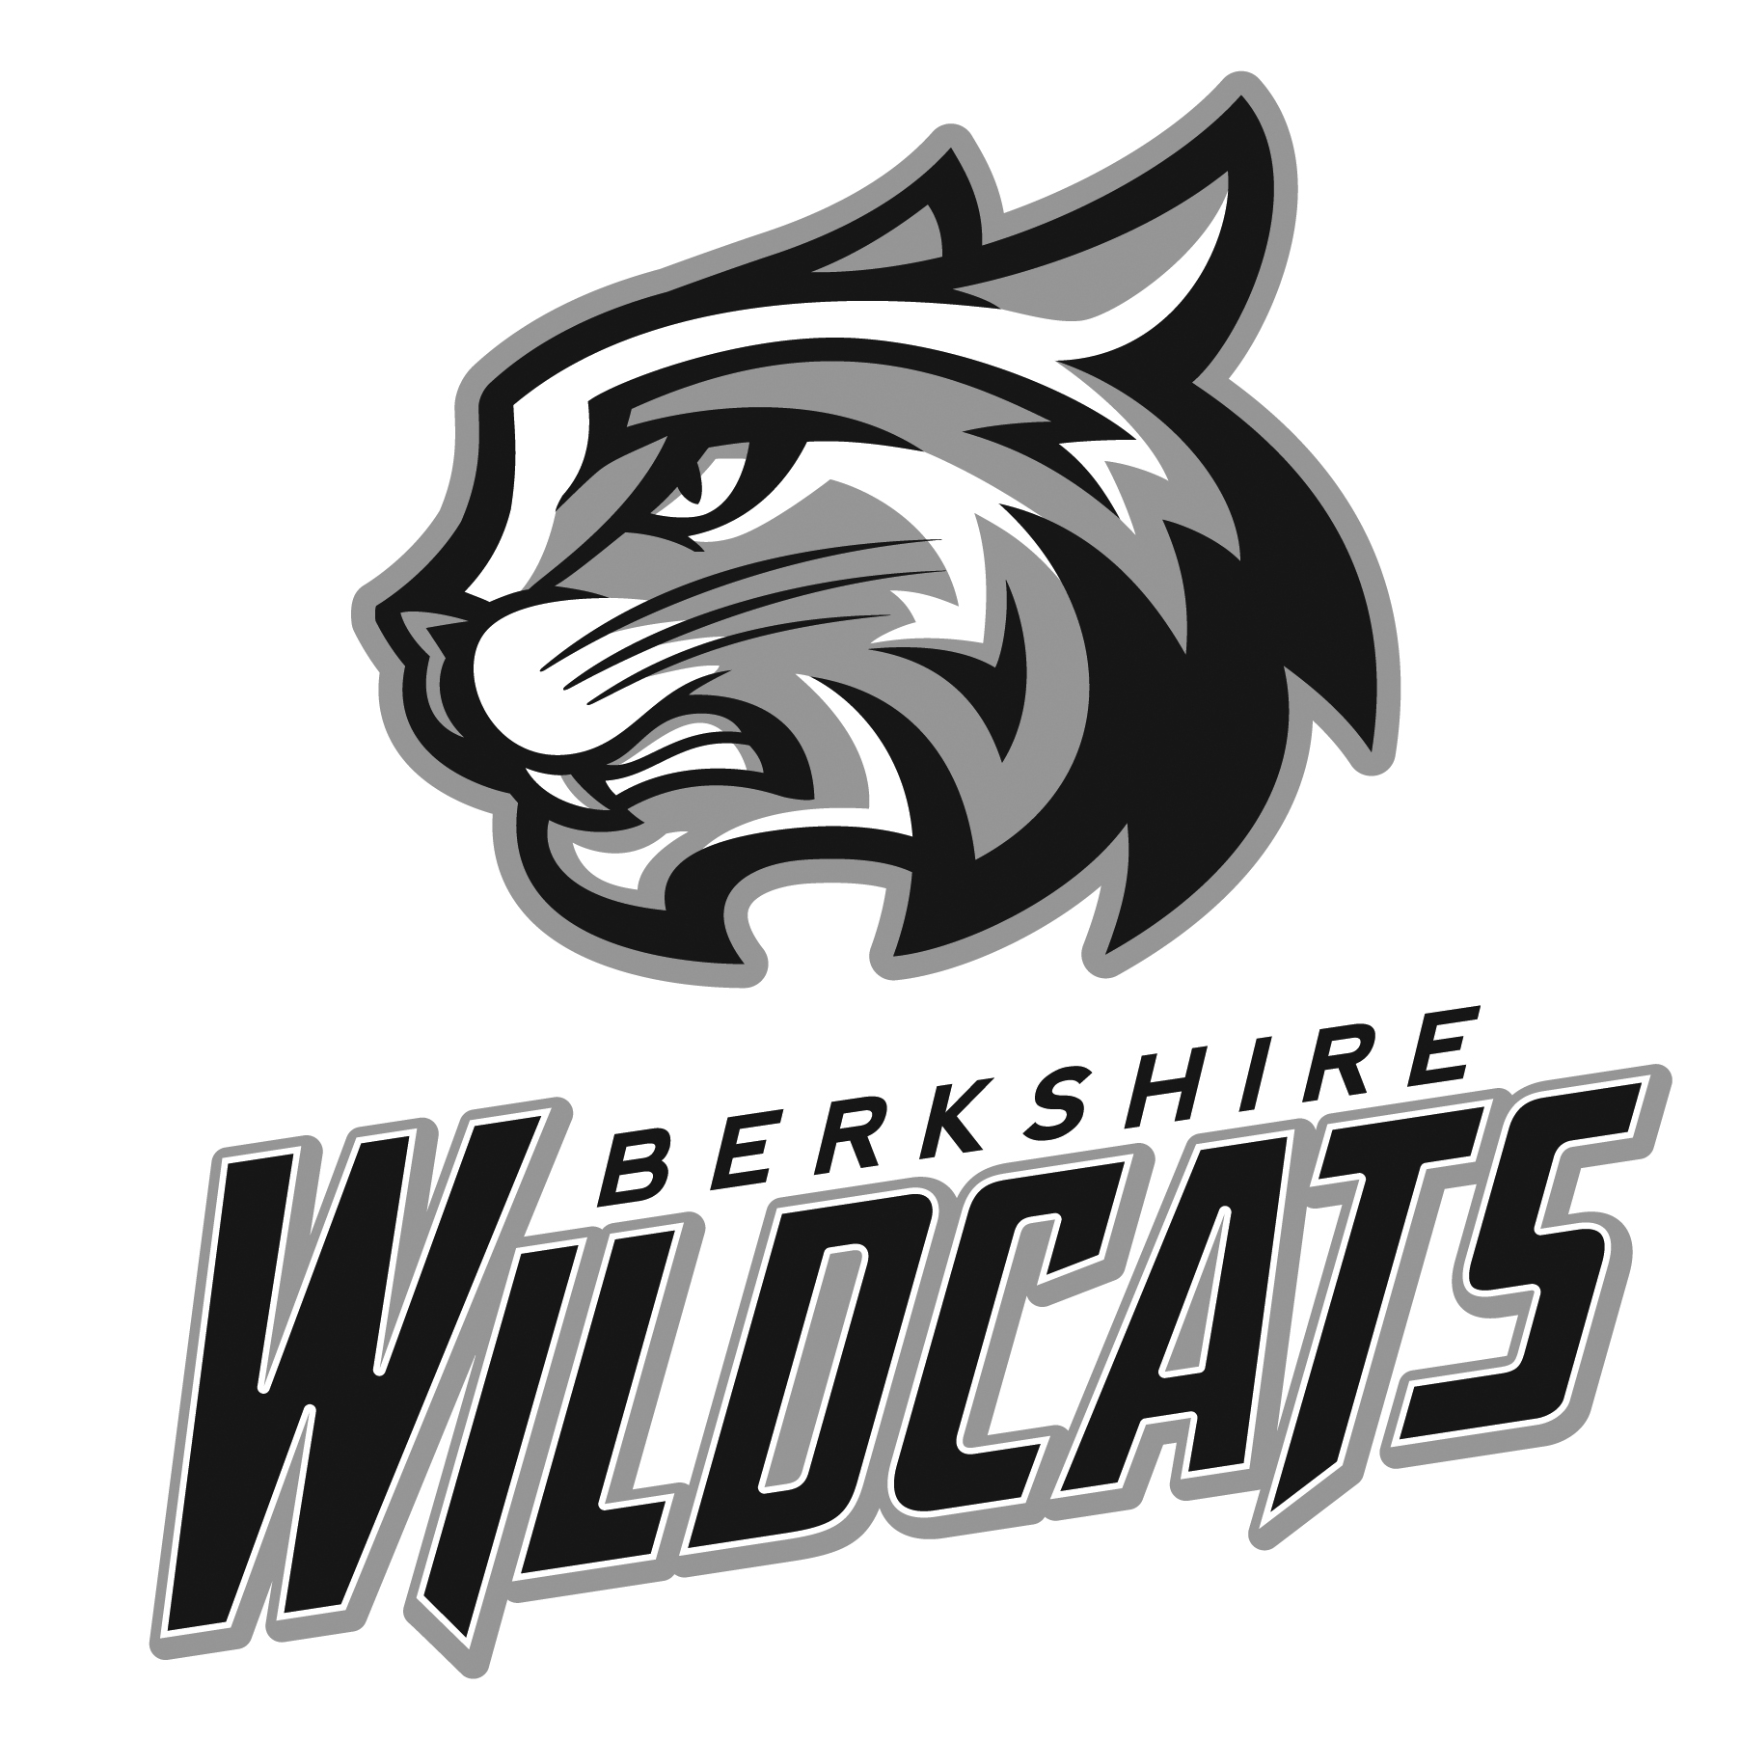

21707 West Fourteen Mile Road
Beverly Hills, MI 48025

REQUIRED COURSES

Social Studies (all year every day)
Social Studies is the integrated study of the social sciences (geography, history, civics, and economics) to prepare students to become responsible citizens. Course studies include: The Core Democratic Values, Basic Economic Reasoning and Principals, South America, Europe, Russia, Canada, the United States, Oceania, Australia and Career Planning.

Language Arts (all year every day)
Seventh Grade English Language Arts develops strength in reading, writing, speaking, and listening skills.
Areas of study include: Grammar/Writing Conventions, Novels, Research and MLA Citation, Drama and Poetry, Major Papers/Journals/Close Reading with Textual Evidence, and Mythology.

Science (all year every day)
Students will have the opportunity to further their understanding of life, physical, as well as earth science during 7th grade. Topics include chemistry, energy, body systems/processes, and weather/climate. Special focus on students engaging in the behaviors of scientists by building models and constructing explanations about their experiences.

Mathematics (all year every day)
This program is a broad, concept-driven curriculum that reflects the full breadth of relevant mathematics in our society with connections to real life and its interrelationships with technology. The program is built on five overall goals for the students: learning to value mathematics, becoming confident in their ability, becoming a mathematical problem solver, learning to communicate mathematically, and learning to reason mathematically. The seventh grade curriculum concentrates on proportional reasoning, including: integers, ratios, mastery of fractions, applying algebraic properties, recognizing and representing linear relationships in a variety of forms, and the fundamentals of algebraic and geometric concepts.

Physical Education and Health (semester or all year every other day if you have a Vocal/Instrumental Course)
Students will experience a higher level of skill development and play in lifetime sports such as basketball, volleyball, swimming, soccer, and softball. These skills will be used in both competitive activities and non-competitive task related challenges. Physical fitness activities will also be incorporated into all units, as well as personal/social skills needed to be active for a lifetime. Health curriculum components that focus on decision-making skills, nutrition, substance use/abuse and reproductive health will be taught in a classroom environment during this course as well.

ELECTIVE COURSES

World Language – Spanish-1B, French-1B, or Chinese-1B (semester)
(Prerequisite: Sixth Grade World Language)
Students will continue their studies of French/Chinese/Spanish language and culture from the sixth grade. This is a semester course that will meet daily for a full class period. Successful completion of this class allows students to go on to eighth grade French/Chinese/Spanish. Studying a world language in grades 6 though 8 is important for students who plan to benefit from taking an AP language course in high school.

Creative Communications (semester) Students will focus on building tangible, necessary, and beneficial skills of speaking and presentation in authentic situations. During the first marking period, students will explore and have the opportunity to participate in Forensics – a debate and public speaking and presenting competitive forum. Students will be able to choose from a variety of categories of presentation: Interpretation, Storytelling, Informative, Sales, Debate, Impromptu, Broadcast, etc.; there are opportunities for each student to participate in a local and regional middle-school competition. The second marking period will focus on honing skills centered around debate while also continuing to encourage the interpretation of stories and informative speeches to present to a wider audience.

Skills For Living (semester) In this class 7th and 8th grade students will use cooperative and hands on learning to prepare for a successful future. Using the book 7 Habits of Highly Effective Teens, by Sean Covey, students will learn the importance of creating healthy habits. Other units include kitchen safety, foods labs, nutrition, interpersonal communication/ relationships and keyboarding.

Skills For Success (semester)
7th and 8th grade students will learn various 21st century skills. It is a cooperative learning style class with opportunities for hands on, project-based learning. Students will gain independence, self-awareness and life skills. Units include: growth mindset, personal finance, career exploration, kitchen safety, foods labs, nutrition and keyboarding.

Adventures in Art (semester)
This course offers students a comprehensive art experience with detailed explorations in the classics, such as: painting, drawing, printmaking, ceramics, sculpture, graphic design, and crafts. In addition to gaining confidence and proficiency working with a variety of mediums, students will learn about the history, analysis, and interpretation of art. Lessons focus on material use, design theory, historical and cultural influences, and an introduction to the process of the aesthetic merit of selected works of art. Sample projects may include, but are not limited to: self-portraits, color theory, refining drawing skills, printmaking, plaster, and the formation of sculptural objects.

Art by Design (semester)
This course will focus on how to create good design using the Elements and Principles of Art. Artists do this when they design and improve upon products we use every day. Posters, brochures, flyers, and magazine and newspaper advertisements are all created by graphic artists. Students will create projects revolving around design for both new and existing products using traditional art media. This class may be repeated as projects are changed to meet student needs.

Exploration in Art (semester)
This course continues to form the foundation for further attitudes and the development of artistic skills and techniques. The units of study include a focus on design elements, art production, aesthetics, art history, and art criticism. The focus will include contemporary artists, both living and working today, as well as a primary focus on three-dimensional artworks. Lessons are designed to help students develop perceptual awareness and critical thinking skills. Using a variety of materials such as found objects, recycled materials, paper, glass, clay, metals, plastics, fabric, and plaster, we will primarily create expressive works of 3D art.

Engage (semester)
The design and purpose of this course is to provide a collaborative space for students to inquire, design and create through inquiry-based learning. Students will explore questions, challenges, topics or technologies of interest, at their own pace, and in directions of their choosing with the guidance of the teacher. Students will plan and reflect on their creations, processes, successes and difficulties through multimodal learning. The goal of this program is to prepare students for global learning opportunities by engaging their interest and imagination in science, technology, engineering, arts and math. Students will develop their cognitive processes of analysis, comparison, inference, evaluation, and synthesis applied to a range of academic domains and problem solving contexts.

Exploring Engineering (semester)
The Exploring Engineering Technology class is for students interested in designing and building individual projects using the design process as a guide. After learning “shop” safety and how to properly use the design process to come up with a working, to scale design of their project, students will have the opportunity to build their project in the lab. Two projects commonly produced are a CO₂ race car and a wooden candy machine. Students will have the opportunity to use a variety of materials, hand tools, and power tools, to complete their projects.

Applied Engineering (semester)
The applied engineering technology program is a twenty-week experience where several different areas of technology will be explored. The course is designed where there will be more emphasis placed on group projects and designs emphasizing real world working environments. This class will explore major areas such as design, simple and complex machines, and research development. A strong emphasis will be placed on problem solving activities in which both individual and group efforts are developed. Projects may include: cardboard chair, catapults, mouse trap car, and electricity and electrical wiring.

Computer Aided Drafting and Design (CADD) (semester)
The CADD class is designed to help prepare the engineers of tomorrow. This class is designed for those students considering a field of engineering in their future. Throughout this class students will learn the fundamentals of drafting and different CAD software programs such as AutoCAD and TinkeCAD. Students will have the opportunity to see their drawing come to life using a 3-D printer and laser cutter. This is a great class for students looking to take high school engineering courses as it will give them a great start. Much of what they will need to know in their first course of high school will be taught in this class.

Strategies (semester)

Students will investigate a variety of strategies, which will help them develop habits to be successful, life-long learners. Students will explore a variety of physical, mental, and emotional strategies to ensure a well-rounded approach to academics, friendships, and life! Through movement and play, close-reading, goal-setting, group discussions, vocabulary-building, and test-taking strategies, students will learn how to problem solve and achieve intended, successful results.

Theatre Arts (semester)
Theater Arts, a one-semester elective for 7th and 8th graders, is an activity-based course. The objectives are for students to gain knowledge and experience in performing and to improve communication skills. The emphasis is on participation, individually and in groups. Students will create and perform improvisations and scripted scenes applying the skills and knowledge gained in the course. The students will participate in pantomimes; the use of voice, improvisations, extemporaneous activates, and planned performances.

Yearbook A and Yearbook B (semester OR all year, every day)
Students will learn the basics of journalism, layout and design, copy writing, digital photography, and photo editing. While working in teams to develop the yearbook, students will develop leadership skills. Students will design, create, and produce the Berkshire Yearbook for the school community. No prior knowledge or skills are required to take this class. Yearbook can be taken in either semester. To be considered for the yearbook staff, students must request two teacher/staff recommendations. Students should get the necessary form from Mrs. Gacki and politely ask two of their teachers or Berkshire staff members to complete the form on their behalf (the form will be returned to Mrs. Gacki by the staff member).

Music Options

Choir 7 (all year every other day)
This intermediate choir is open to all students; previous middle school choir experience is not required for this group. A moderate performance schedule, including out of school travel can be expected. This choir prepares students for the 8th grade and high school choral programs. A wide variety of music from pop and folk to classical and Broadway will be studied. Participation in Choral Festival is required at this level. Participation in Solo & Ensemble and MSVMA Honors Choir is encouraged at this level. Attendance is required at all choir performances.

Advanced Band (all year every other day)
The concentration is on refining the basic music skills: tone production, rhythmic accuracy, and technical fluency. Students are expected to participate in four or five out-of-school performances. Participation in band festival is required at this level. Participation in solo-ensemble is encouraged at this level. Daily practice is expected and attendance is required at all full band performances.

Advanced Orchestra (all year every other day)
The Seventh Grade Orchestra is open to all students who have previous experience playing a string instrument, and who want to have fun making music! Playing in orchestra improves your rhythmic accuracy, bowing, tuning, shifting, and vibrato. Students will participate in approximately four (4) performance opportunities throughout the year. Class requirements include: averaging twenty (20) minutes of practice daily, some written assignments, bi-monthly playing tests, and attendance at all performances.

COURSES RECOMMENDED BY TEACHERS

Literacy (semester)
Literacy provides an opportunity for students to learn and practice reading strategies through teacher modeling, cooperative learning, and independent practice. In this strategy-based course, students will benefit from this additional practice by using reading strategies for comprehension, decoding, and fluency when reading fiction and non-fiction text. Reading Specialist recommendation is required.

Math Lab (all year every day)
Math Lab is taken in conjunction with College Prep Math (two math classes per day). This class is designed to support and pre-teach concepts and skills that are being taught in the college prep class. Teacher recommendation is required.

Language Arts for Emerging Bilinguals A (all year everyday)
Language Arts for Emerging Bilinguals A is a class for newcomers to the U.S. Students learn English in the four domains: listening, speaking, reading and writing. Students learn interpersonal communication skills and begin developing the academic language needed to be successful in their content area classes. This class is based on English level rather than grade level, and students may be in 6th, 7th, or 8th grade.

Language Arts for Emerging Bilinguals B (all year everyday)
Language Arts for Emerging Bilinguals B is a language arts class that is aligned with the BPS language arts curriculum, with modifications to meet the needs of English language learners. Students work on the same reading and writing strategies, genres, literary analysis, and themes and skills as their native English-speaking classmates. The goal of this class is to help students develop increased fluency in their reading and to read increasingly difficult texts in English for multiple purposes. This class focuses on the application of multiple reading strategies in a variety of genres, the continued learning of high-frequency vocabulary, note-taking in academic settings and further development of listening and speaking skills. Students develop increased skill in the use of more complex grammatical conventions, such as identification of all parts of speech, singular and plural nouns, verb usage in past, present and future, subject-verb agreement, and compound and complex sentences. Writing skills are developed from the paragraph to the essay level using various organizational patterns. Students increase their proficiency in the use of multimedia as tools for language development. This class is based on English level rather than grade level, and students may be in 6th, 7th, or 8th grade.

Language Arts for Emerging Bilinguals C (all year everyday)
Language Arts for Emerging Bilinguals C is aligned with the BPS language arts curriculum, with modifications to meet the needs of English language learners. Students work on the same reading and writing strategies, genres, literary analysis, and themes and skills as their native English-speaking classmates. The goal of this class is to help students develop increased fluency in their reading and to read increasingly difficult texts in English for multiple purposes. This class focuses on the application of multiple reading strategies in a variety of genres, particularly with a focus on their ability to analyze, synthesize, and evaluate information and increase their independent reading. Furthermore, students continue to develop their mastery of academic vocabulary, note-taking in academic settings and more extensive listening and speaking skills. Students develop increased skill in the use of complex grammatical conventions, such as more sophisticated verb usage, comparatives and superlatives, prepositions, dependent and independent clauses, and compound and complex sentences. Writing skills are developed at the five-paragraph essay level using various organizational patterns. Students increase their proficiency in the use of multimedia as tools for language development. This class is based on English level rather than grade level, and students may be in 6th, 7th, or 8th grade.

Language Arts for Emerging Bilinguals (LAEB) Tutorial (all year everyday)
Language Arts for Emerging Bilinguals (LAEB) Tutorial is an elective offered to English language learners in ESL A, B, or C. In this class, students receive help with their content area classes such as science, social studies, math, and language arts. The staff works in conjunction with the mainstream teachers to provide additional support. Tutorial may also be used for more instruction in the English language or in American culture.

