

ARRIVAL and DISMISSAL ROUTINES 2019-2020

Child’s Name: Grade:

Teacher’s Name:

Please complete this form by checking the appropriate routines for your child. You are encouraged to discuss routines with your child. Please notify your child’s teacher if their FIRST DAY DISMISSAL will be different from their regular routine.

 | ARRIVAL |  |  | DISMISSAL
BUS | - Bus Rider |  | BUS | - Bus Rider
WALKER | - Walker (Side A)  - Walker (Side B) |  | WALKER | - Walker (Side A)  - Walker (Side B)
CAR RIDER | - Car Rider (Parking Lot A)  - Car Rider (Parking Lot B) |  | CAR RIDER | - Car Rider (Parking Lot A)  - Car Rider (Parking Lot B)
Before-Care | - YMCA  - Other:_____________________ |  | After-Care | - YMCA  - Other:_____________________

Parent/Guardian Signature: Date:
Special Notes:
_______________________________________________________________________
_______________________________________________________________________



ARRIVAL AND DISMISSAL PROCEDURES
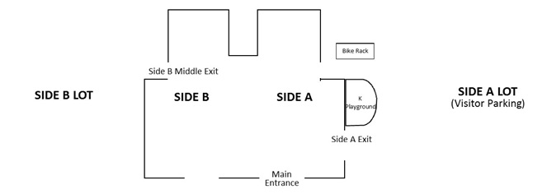
ARRIVAL
- The school day is 8:50 AM – 3:20 PM. Supervision begins at 8:30 AM. All students are expected to arrive at school by 8:50 AM each day. Classes begin promptly at 9:00 AM.
- Grades 1-6 report to the back playground and kindergarten reports to the kindergarten playground.
- On inclement weather days INDOOR ARRIVAL is noted with YELLOW SIGNS posted on doors. Grades K- 4 are directed to the gym, grade 5 to Café A, and grade 6 to Café B.
- All students are greeted by staff and directed to the proper location.

Car Riders at ARRIVAL–
- Cars must obey all traffic signs and/or directions of staff along the car drop-off zone. A drop-off zone is located on the SIDE A and SIDE B of the school. Both are clearly marked.
- Cars are not permitted to pass other vehicles in the drop-off zones. The staff on duty assists students in exiting vehicles. For safety reasons, child(ren) should exit curb side only.
- Parents/guardians must remain in their cars.
- Parents/guardians should pull up along the curb in the marked drop-off zone forming a single line and pulling up as far forward as possible.
- When exiting, do not pull-out around a stationary car, please wait for vehicles in front to move.
- Car traffic is NOT permitted in the bus zone during arrival (8:30AM-9:00AM)

DISMISSAL –
- There are three primary student groups at dismissal time: bus riders, walkers, and car riders.
- Bus riders are escorted to the gym or cafeteria to wait for their bus. Buses are dismissed one-at-a-time to the front loop of the school.
- Walkers heading SOUTH on Easton Road are escorted out the front entrance of the building.
- Walkers heading NORTH on Easton Road are escorted out of the building through the SIDE B Middle Exit. A staff member escorts the children through the playground to avoid the parking lot.

Car Riders at DISMISSAL –
- Car riders are dismissed from designated exits (see map) by staff as parents/guardians arrive in the pick-up zone. Drivers must have a Copper Beech Family Placard, listing the (1) the name of the child(ren) and (2) grade.
- Parents/guardians should pull up along the curb in the marked pick-up zone forming a single line and pulling up as far forward as possible. Once in queue a staff member will call the name from the family placard to call students from the building to the pick-up zone. Please display your placard clearly on your front dashboard.
- For safety reasons, parents may not congregate around the SIDE A Exit during dismissal. Parents/guardians who wish to meet their child(ren) must then consider their child(ren) walkers, and meet their child(ren) in front of the building where the walker line exits. Cars must be parked in a visitor parking spot.
- Car traffic is NOT permitted in the bus zone during dismissal (3:00PM-4:00PM).

Early Dismissals—
- Parents/ guardians must make the school aware of early dismissals with either a handwritten note, email or Skyward attendance request.
- You will be required to come into the office and show a valid ID in order to sign your child out early
- Once you have signed your child out, office staff will call the classroom and have you child sent to the office for dismissal.
- Car traffic is not permitted in the bus zone after 3:00 PM

IMPORTANT NOTES:
- CHANGES to a student’s dismissal routine are not permitted without written notice to the child’s teacher. If a parent/guardian must make a last minute change to a child’s dismissal plan (i.e. during the school day), the office must be called to ensure the child’s teacher and the child are informed before the end of the day.
- Siblings WILL NOT be permitted to go to classrooms to pick up their siblings during dismissal. This includes K siblings. This procedure will assist us with ensuring the safety of all students.

Our safety and traffic procedures are carefully monitored and adjusted as necessary. They are established for the safety of our students – not for convenience. We thank our families in advance for their cooperation, support, and patience in helping to provide safe and orderly arrival and dismissal procedures for our students.

