Name ________________________ Period ______ Date ____________

Grade 6 Unit 2 Model Curriculum Assessment

For multiple-choice questions, circle the best answer.
For all other questions, respond in the space provided.

1. Which of the following terms describes the 5 in the expression

a. Coefficient
b. Constant
c. Term
d. Variable

2. Indicate whether each statement is true or false by checking the appropriate box in the table below.

 | True | False
is a factor of the expression
is a factor of the expression
is a sum of two terms.
is a product of two terms.

3. Which of the following represents the quotient of and

a.
b.
c.
d.

4. Part A List the terms in the expression below. Place a comma between each term.

Part B List the coefficients in the expression below. Place a comma between each coefficient.

5. Write the expression using exponents. Use each base once.

6. What is the value of the expression

a. 21
b. 19
c. 3
d. 1

7. Write a numerical expression that satisfies all of the following conditions.

- The only number used in the expression is 3.
- At least one exponent other than 1 is used.
- When the expression is evaluated, the answer is greater than 30 and less than 40.

8. Which of the following is equivalent to

a.
b.
c.
d.

9. What is the value of the expression
where and

a. 8
b. 28
c. 30
d. 503

10. Part A Write an expression in simplest form for the area of a rectangle with length meters and width 2 meters.

Part B Find the area, in square meters, of the rectangle when

11. The volume of a cube is given by the formula where s is the length of a side of the cube. What is the volume, in cubic feet, of the
cube shown below? Show your work.

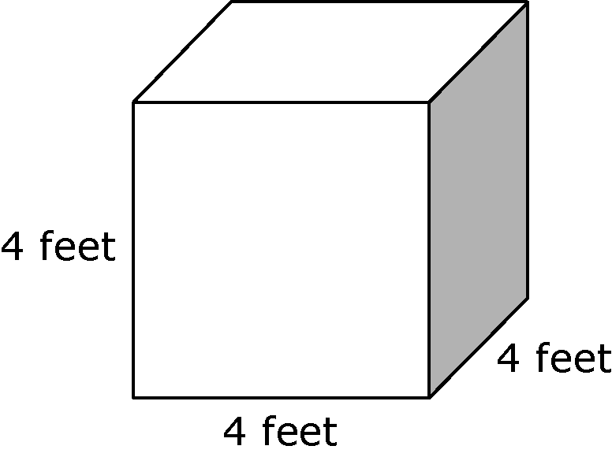

12. An object is dropped from a starting height that is a certain number of feet above ground. The number of feet the object falls after it is dropped can be found by performing the following steps.

1. Let t represent the amount of time, in seconds, since the object was dropped.
2. Square the variable from step 1.
3. Multiply the result of step 2 by 16.

Part A Let s represent the starting height, in feet, of the object. Write an algebraic expression that can be evaluated to find the height of the object t seconds after it was dropped.

Part B An object is dropped from a starting height of 400 feet and falls for 5 seconds. Evaluate your expression from part A using these values to find the height, in feet, of the object
5 seconds after it was dropped. Show your work and explain your answer.

13. What is the value of F in the formula when

a. 302
b. 86
c. 62
d. 54

14. Write an expression in simplest form that is equivalent to the expression

15. Which of the following is equivalent to the expression

a.
b.
c.
d.

16. Use 2 as a factor to write an expression that is equivalent to the expression

17. Write an expression in simplest form that represents the perimeter of the rectangle shown below. Show your work.

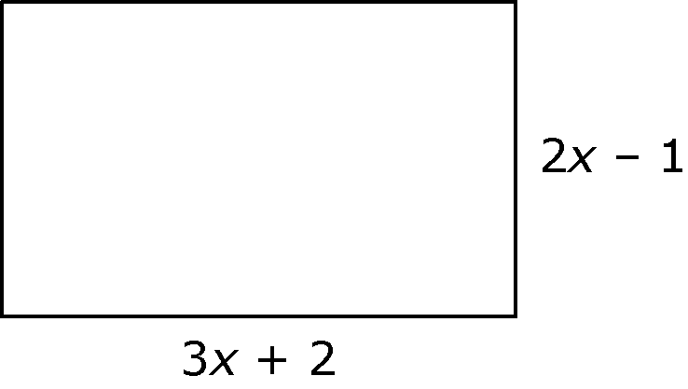

18. Which of the following expressions is equivalent to the expression

a.
b.
c.
d.

19. Indicate whether each expression is equivalent to the expression by checking the appropriate box in the table below.

 | Equivalent | Not Equivalent

20. Is the expression equivalent to the expression Explain your answer.

21. Which of the following equations must be true?

a.
b.
c.
d.
22. Karen has a red ribbon that is 18 feet long and a blue ribbon that is
12 feet long. She wants to cut both ribbons into pieces that are all the same length, and she wants to have no ribbon left over when she is done. What is the greatest length, in feet, of each piece of ribbon that she can cut?

a. 3
b. 6
c. 36
d. 72

23. Find the greatest common factor of 14 and 42. Show your work.

24. Bridget’s Bakery sells cupcakes in packages of 6. Perry’s Pastries sells cupcakes in packages of 10. Sheldon wants to buy the same number of cupcakes from each bakery for a party, and he can only buy cupcakes in packages. Which of the following could be the number of cupcakes he buys from each bakery?

a. 2
b. 16
c. 20
d. 30

25. Write a pair of whole numbers that satisfy the following conditions.

- Both numbers are less than 13.
- The least common multiple of the numbers is 36.

