SOUTHWESTERN ELEMENTARY SCHOOL
KINDERGARTEN - 5TH GRADE
CAFETERIA LUNCH COLLECTION SYSTEM & POLICIES
AUGUST 12, 2019

The Southwestern Jefferson County Consolidated School Corporation uses the computer system, Harmony, for record keeping and the collection of money. This program works like a bank account. Each student is assigned an account number and an associated card, much like a debit card. When students go through the breakfast and lunch lines, the cashier scans their cards and the computer automatically deducts money from the students’ accounts (lunch only). Please note, all students receive free breakfast, but account numbers are still scanned for record keeping and reimbursement purposes. By using this system, only the computer will know if your child is FULL PAID, REDUCED, or FREE.

Our goal is to provide nutritious and delicious meals to our students. All meals will follow the nutrition standards set forth by the U.S. Department of Agriculture (USDA) for the National School Lunch and School Breakfast Programs. Breakfast is served daily and is FREE for ALL students. When students arrive to school each morning, they will go directly to the cafeteria for breakfast. Breakfast is optional; however, please encourage your child to eat breakfast each day, whether that is at school or at home before school. Studies have shown that eating breakfast not only provides important nutrients, but it helps improve school performance!

SPECIAL DIETARY NEEDS

If your child has any particular dietary needs, please send a doctor’s note describing these needs to Katie King, Director of Child Nutrition. Examples of special dietary needs may include the following:
- Food intolerance or food allergy
- Diabetes, needs a snack at certain times of the day
- Chewing or swallowing difficulties and needs modified food consistencies

PAYMENT

Payments to your child’s account can be made online, but cash and checks are also accepted. We recommend depositing at least two weeks’ worth of lunch money into your child’s account. We do not recommend paying day by day as this increases the chance of money getting lost. If paying with cash, please send money in a sealed envelope with the following information:

Student’s name and grade
Name of student’s teacher
Cash amount

Example: Jordan Jones, 5th grade
Mrs. Brawner
$40.00
*If sending cash for multiple students, please list ALL names, grades, and teachers’ names.

Please make checks payable to Southwestern Elementary Cafeteria. Please include all of the student’s information as outlined above (this can be done in the Notes section of the check or on an additional piece of paper inside the envelope; again, if sending one check for multiple students, please include name, grade, and teacher’s name for each student. Checks should be mailed to the following address:

Mrs. Shannon Ritchie
Southwestern Elementary School
273 S. Main Cross St.
Hanover, IN 47243

If money is sent for multiple students, negative balances will be paid first, and then any money leftover will be distributed equally to each account.

Harmony will provide an itemized account of your child’s day-to-day eating activity. This will allow you to see if your child is eating breakfast, lunch, or both.

Extra milk, juice, and ice cream cannot be taken out of students’ accounts. If your child wishes to purchase these extra items, he/she will need to bring additional money each day.

PRICES
 | FULL PAID | REDUCED  (for those eligible) | FREE  (for those eligible)
Breakfast | FREE | FREE | FREE
Lunch | $1.80/Day  $9.00/Week | $0.40/Day  $2.00/Week | FREE
Extra Milk | $0.50 | $0.50 | $0.50
Juice | $0.35 | $0.35 | $0.35
Bottled water | $0.75 | $0.75 | $0.75
Ice Cream | $0.50 | $0.50 | $0.50
Cheese stick | $0.50 | $0.50 | $0.50

It is the responsibility of parents/guardians to ensure adequate funds are available in students’ accounts so that they may purchase lunch. To avoid negative balances, families must set up their accounts to receive notifications that a student’s balance is at or below $5. To do this, follow these easy steps (steps are shown on following page):
- Log in to Harmony with your username and password
- Scroll down the page to “Lunch account options”
- Place a ✓ in the box next to “notify me if the account balance is at or below”
- Enter the number 5 in the box next to “enter a dollar amount”
- Select your method of notification by placing a ✓ in the box next to “email me at this address” and/or “text me at this number”
- Enter your email address and/or cell phone number in the appropriate boxes
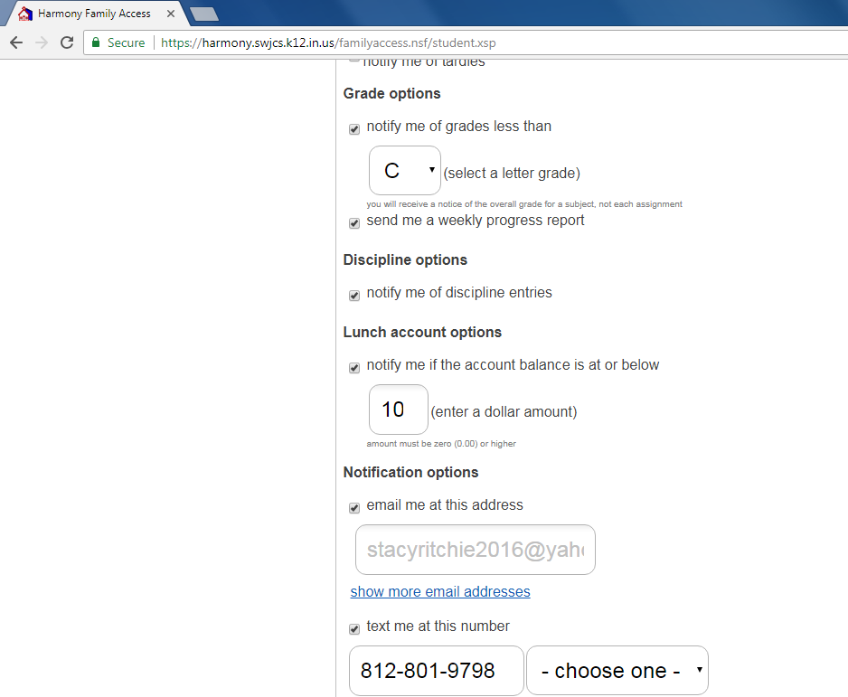

5

You may pay weekly, monthly, by semester, or for the entire school year.

5

Number of school days/month |  | Full Paid  (monthly cost) | Reduced  (monthly cost)
August | 17 | $30.60 | $6.80
September | 20 | $36.00 | $8.00
October | 18 | $32.40 | $7.20
November | 19 | $34.20 | $7.60
December | 15 | $27.00 | $6.00
January | 19 | $34.20 | $7.60
February | 19 | $34.20 | $7.60
March | 12 | $21.60 | $4.80
April | 21 | $37.80 | $8.40
May | 20 | $36.00 | $8.00
Full Paid Reduced
Fall semester total cost: $160.20 $35.60
Spring semester total cost: $163.80 $36.40
Yearly cost: $324.00 $72.00

We invite you to come and eat with your child anytime! If you choose to purchase your meal in the cafeteria, the cost is $2.70. You can purchase your meal via cash or check; unfortunately, we cannot accept credit card payment.

POLICY FOR CHARGING MEALS

Please read the attached document regarding our updated meal charging policy.

If you have further questions, suggestions, or comments about our program, please don’t hesitate to contact us! We look forward to serving your child this year!

Katie King, MA, RDN
Director of Child Nutrition
812-866-6254

Shannon Ritchie
Assistant Director of Child Nutrition
812-866-6211

This institution is an equal opportunity provider.
Southwestern Jefferson County School Corp.
Meal Charge Procedure Policy 5.07
Revised 07-22-19

I. Purpose/Policy:
The SWJCSC Food Service Department is self-supporting. We do not receive money from the district’s General Fund. School Nutrition is funded by federal reimbursement and student and adult payments; these are used to pay operating expenses and fees. By federal law, School Nutrition revenues must meet or exceed expenditures. Unpaid charges affect the ability of School Nutrition to support itself. The purpose of this policy is to establish consistent meal account procedures. The goals of this policy are:
- To ensure that all students have a healthy meal and that no child goes hungry.
- To treat all students with dignity and confidentiality regarding meal accounts.
- To establish fair practices that can be used at the elementary, middle, high schools.
- To encourage parent/guardian to assume the responsibility of meal payments.
- To establish a consistent practice regarding charges and collection of charges.

II. School Meal Policy
All students will receive a lunch card with a bar code to purchase meals. Elementary students keep their cards in the classroom and bring them to lunch daily where they are collected by the Director of Child Nutrition and the Assistant Director of Child Nutrition. They are then scanned and returned to the teacher. Middle/high school students have their cards scanned at the end of the serving line; middle/high school students can also use their student ID to purchase lunch. Lunch cards/student IDs must be used when purchasing any item from the cafeteria.

Please note, students will NOT be denied a meal should they forget their card or student ID; however, disciplinary action may be taken by the school principal if this becomes habit.

All students can prepay for their meals by depositing cash or check into their accounts. Prepayments are accepted daily in the cafeteria or online. Online payments could take up to 24 hours to be processed.

All parents/guardians have the right to apply for free/reduced meal assistance.
Applications are available online, during registration, at the front office, at the central office, and in the cafeteria. We encourage parents/guardians to apply online before the start of a new school year or during registration, but parents/guardians can apply anytime throughout the year.

III. Allowable School Meal Charges
Any paid student in grade PK-5 will be allowed to charge up to a total of $18.00 (10 paid lunches).
Any reduced student in grade PK-5 will be allowed to charge up to a total of $4.00 (10 reduced lunches).
Any paid student in grade 6-12 will be allowed to charge up to a total of $20.50 (10 paid lunches).
Any reduced student in grade 6-12 will be allowed to charge up to a total of $4.00 (10 reduced lunches).
A la carte items are not allowed to be charged.

Adults will be allowed to charge up to a total of $27.00 (10 paid lunches.)
After reaching the charge limit, the negative balance must be paid in order to make future purchases.

For any student negative balance, contact with a parent/guardian will be made daily via account statement (sent home with student) or email.

Once a child reaches the charge limit, the Director of Child Nutrition or the Assistant Director of Child Nutrition will call the parent/guardian informing them that the student has reached the maximum charge limit. Payment is to be received ASAP. The building principal is also contacted.

Please note, students will NOT be denied a meal should they reach their charge limit; however, students will not be allowed to charge a la carte items.

If payment is not received after 5 school days (totaling 15 unpaid lunches), the school administration recognizes that failure of the parent/guardian to provide for the nourishment of his/her child during the school day may be evidence of neglect, and that such failure may constitute grounds for the Director of Child Nutrition or the Assistant Director of Child Nutrition to file a report and notify Child Protective Services.

After 30 days, collection procedures will be initiated on all negative balance accounts.

