How Living Things Grow and
Reproduce
Study Guide
Vocabulary

- Which of the following best describes a species?
 the next more specific classification following an order
 a group in which organisms of different kinds are closely related
 a unique kind of organism
 another name for a family or genus

2. . Which of the following describes the process called incomplete metamorphosis?
newborn → toddler → child → adult
egg → nymph → adult
egg → larva → pupa → adult
egg → hatchling → adult
3. The simplest plants, such as mosses and liverworts, are examples of which of the following plant groups?
vascular plants
nonvascular plants
gymnosperms
angiosperms
Science Concepts

5. Which of the following are examples of vertebrates?
ferns, conifers, mosses
brittle stars, sea stars, basket stars
camels, falcons, frogs
crabs, grasshoppers, jellyfish
6. A scientist is studying how a certain factor affects how quickly a seed germinates. She keeps the soil, amount of light, and water the same. She puts one seed in a room that is 5 °C, one in a room that is 10 °C, one in a room that is 15 °C, and the last seed in a room that is 20 °C. What variable is she testing?
light temperature
soil water

4. What are vertebrates?
animals with body parts in segments
animals with spiny skin
animals with backbones
animals without backbones

7. Scientists organize living things into a number of different levels of classification. As you continue down the levels of classification, which of the following is true?
Each level refers to a unique kind of organism.
The members of each classification level have more and more differences.
The organisms are grouped more and more by their behavior.
The organisms are more and more closely related to each other.

8. Hakim wants to make a dichotomous key that a person could use to identify all the different types of plants shown below.
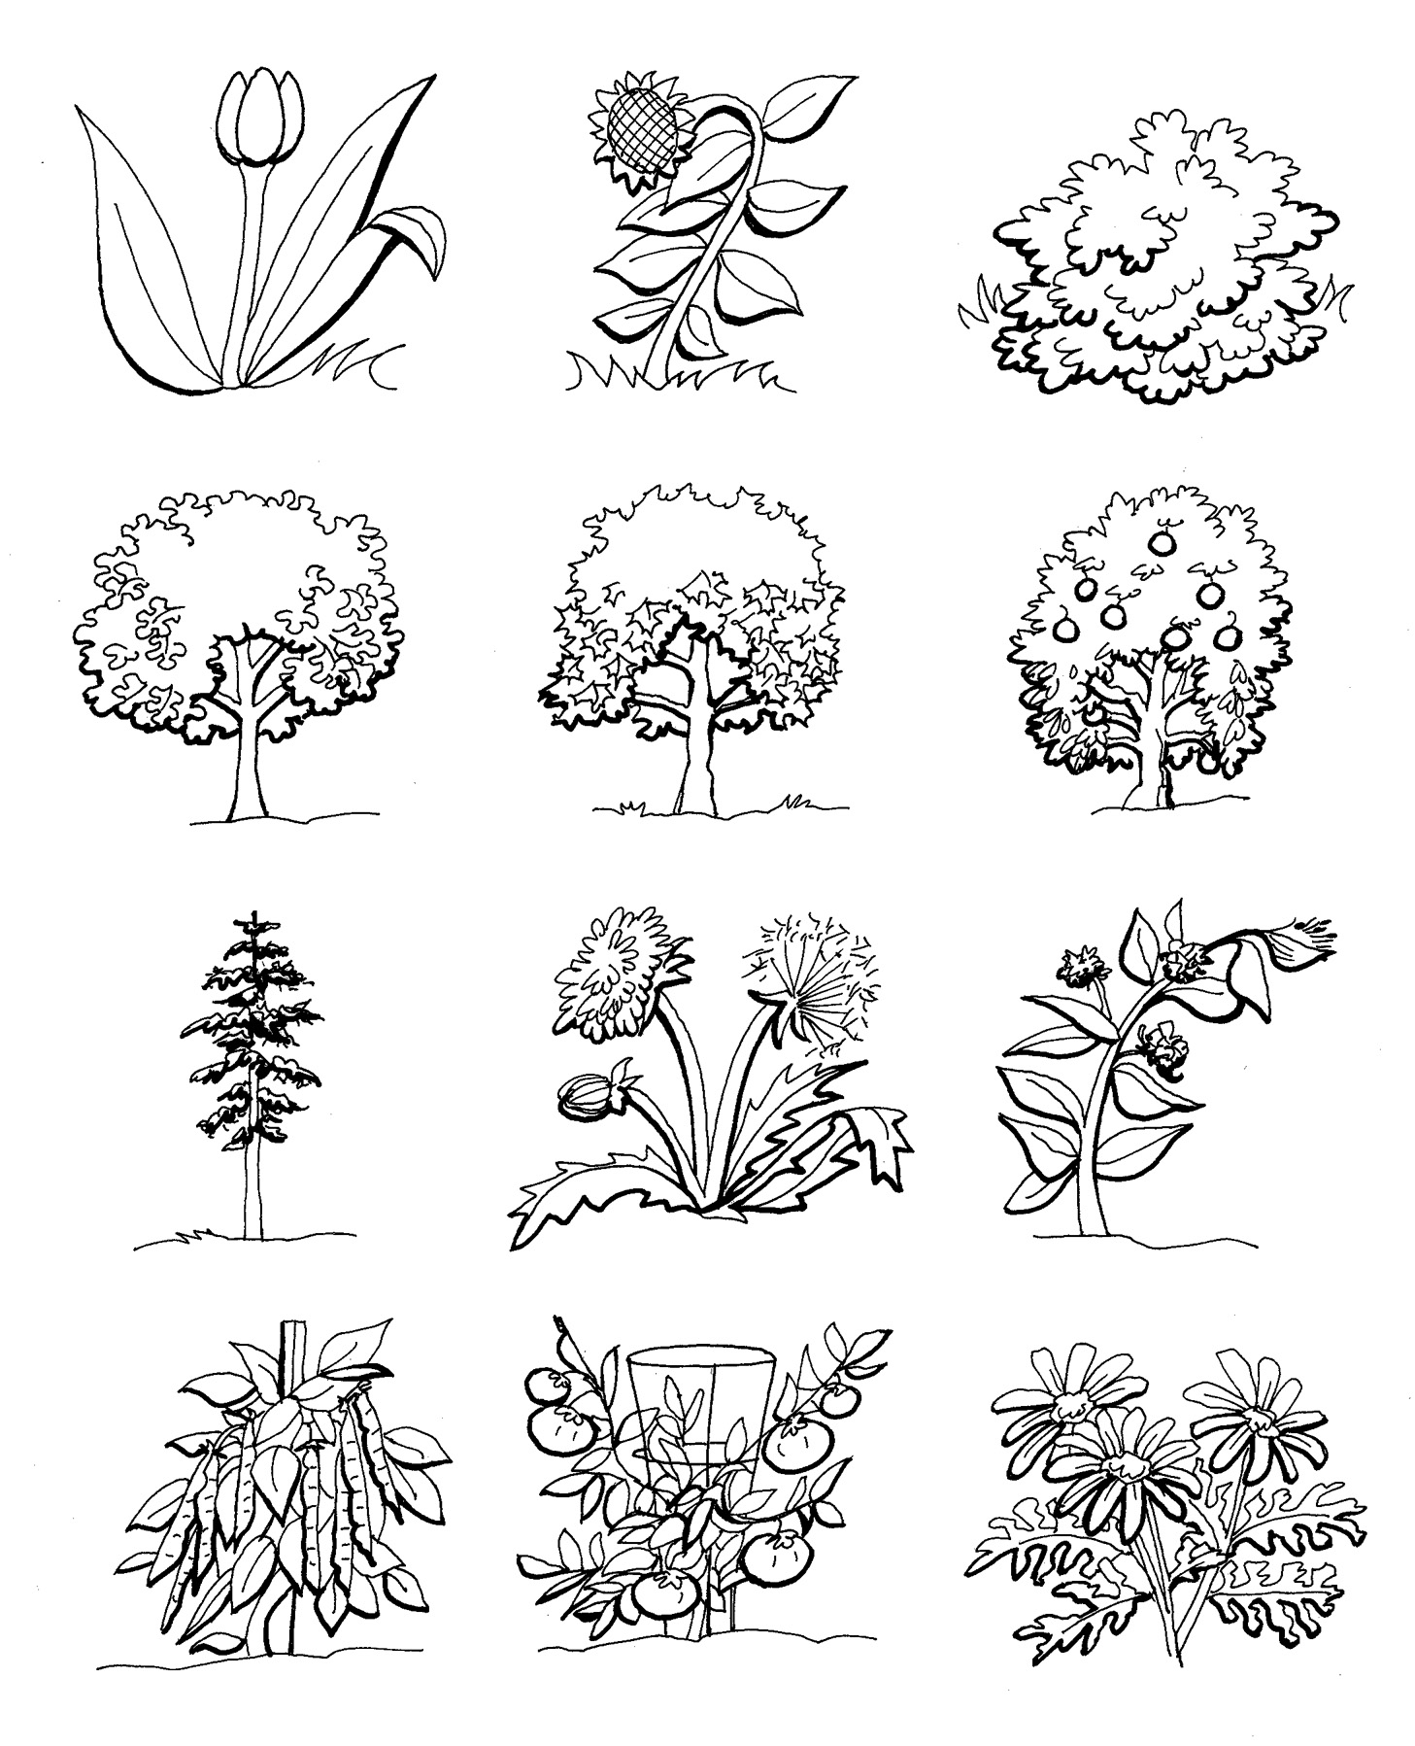
Which set of questions would be correct to include in his dichotomous key?
Does this plant give shade? Is this plant a weed? Does this plant have many flowers on one stem?
Is this plant a tree? Is this plant a bush? Is this plant a flower?
Is this plant a vegetable or fruit? Is this plant healthy or sick? Is this plant still growing or fully mature?
Does this plant bear fruit? Is this plant very tall? Does this plant need a wire support to grow?
9. Betty observed moss growing on rocks and trees in a shady and moist area of a forest. The moss was very short. She also observed that no moss grew in dry or sunny areas. Which of the following is true about the moss?
Moss is a vascular plant, so it has true leaves and roots.
Moss is a nonvascular plant, without true leaves or roots.
Moss reproduces by seeds that are protected inside a fruit.
Moss is the sexual generation of a fern plant.

10. Which of the following is a list of invertebrate groups?
amphibians, fish, reptiles
sloths, spiders, sea urchins
frogs, salamanders, sea turtles
mollusks, arthropods, echinoderms

11. Sally is testing whether bean seeds germinate more quickly in soil than in water alone. She places several bean seeds into plastic bags. She makes sure each seed is in the same area and receives the same amount of water and sunlight. What does she need to do to make this a controlled experiment?
plant a bean seed in soil and keep it in the same conditions
plant a bean seed in the shade and keep the other conditions the same
plant a bean seed without water and keep the other conditions the same
plant a bean seed in a cold place and keep the other conditions the same
12. In warm weather, the egg of a house fly takes about seven days to mature. In cooler weather this takes much longer. What type of adaptation does this illustrate?
change in habitat
change in behavior
change in life cycle
change in environmental conditions
13 The fig wasp is a beneficial insect because it is helpful to another organism. The female fig wasp spreads pollen to fig flowers at the same time that she lays her eggs. What is the next stage of the eggs’ life cycle?
adult
larva
molting
pupa

14. How are vascular and nonvascular plants similar? What are the main differences between vascular plants and nonvascular plants?

15. Noor observed bees and butterflies going from flower to flower in a garden. Describe the effect that bees and butterflies have on the process of fertilization in flowering plants. How does fertilization take place? What causes seeds to form and develop?

