Practice: Grade 5 Open Response Questions

Some questions are open response. They will require you to enter a numerical answer, rather than select an answer from several choices.

Guidelines
- Write only one digit or symbol in each box. Spaces are permitted before or after your answer, but not within the answer. Darken the corresponding circle below each box. The computer scores based on the darkened circles.
- Do not use symbols such as commas or dollar signs. See Examples D and E. Use only symbols that are provided in the circles.
- If an answer is a mixed number, it must be changed and entered as an improper fraction or a decimal. Example C has the mixed number four and one-half, which is 9/2 as an improper fraction or 4.5 as a decimal.

Examples
Enter the numbers below into the grids. (See the notes for more guidance.)

A | B | C | D | E
5/10 | 3/2 | 4 1/2 | 5,600 | $25.99
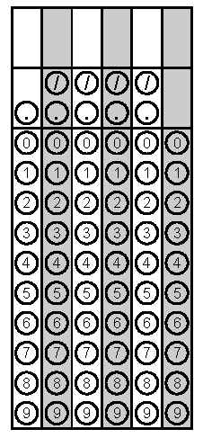

A 5/10 can be also answered as 1/2, as 0.5 or as .5. (Equal numbers are fine.)
B 3/2 is an improper fraction. It may be entered as 3, then /, then 2. It may also be entered as 1.5.
C 4 1/2 can be answered as 9/2 or as 4.5. Spaces in a number are not permitted. Also, the entry 41/2 with no space would be interpreted as 41 divided by 2.
D 5,600 should be answered as 5600. (Commas are not permitted.)
E $25.99 should be answered as 25.99. (Dollar signs are not permitted.)

