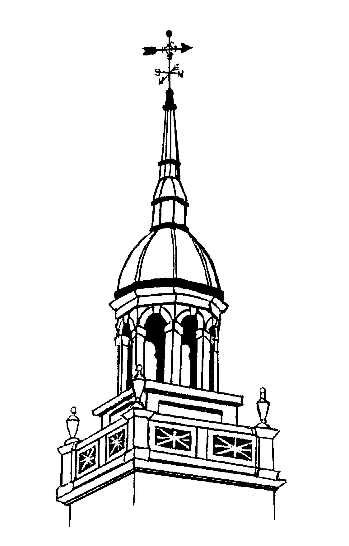
GARDEN CITY PUBLIC SCHOOLS
56 Cathedral Avenue • P.O. Box 216 • Garden City, NY 11530-0216

Inspiring Minds
Empowering Achievement
Building Community

March 11, 2020

Dear Parent/Guardian:

The Garden City School District is conducting a voluntary survey about school climate. The survey will be administered to students during regular school hours during the week of March 16, 2020. It will ask students about their perceptions on topics such as student engagement, school environment, and school safety.

The data your child provides may also be used by the school and district to better understand the current climate in their school. Your child’s answers will be combined with the answers of other students at their school and district and used to create records about the climate of their school. These reports will not identify any person or their responses.

If you do not want your child to participate in this survey, please complete, sign, and have your child return it to their teacher (grade 5 - classroom teacher), (grades 6 - 12 social studies teacher) by March 18, 2020. If you sign and return this letter by March 18, 2020, it means your child will not participate in the survey.

If you have any questions about this study or about your child’s participation please email me at mclaughlinn@gcufsd.net or call us at 478-1020.

I understand that by completing and signing the form below and returning this letter, my child will not be allowed to take the School Climate Survey.

Please return to your child’s (grade 5 Classroom Teacher) (grades 6-12 Social Studies Teacher).

Parent/Guardian Signature: Date:

Student Signature: Date:

Student Printed Name: Date of birth:

If you agree to allow your child to take the survey, you do not have to sign or send back anything.
Thank you for your partnership!
Sincerely,
Nanine McLaughlin
Assistant Superintendent for Human
Resources & Leadership Development

